**Web Programming : Lab Session**

**Name: UMA KAVYA**

**USN:19MCAR0039**

# Session 1:Introduction to HTML Exercise:

1. **Write HTML code to develop a web page having the background in red and title**

“My First Page” in any other color. Source code:

<!DOCTYPE html>

<HTML>

<HEAD>

<TITLE>My First Page</TITLE>

</HEAD>

<BODY BGCOLOR="red">

</BODY>

</HTML>

Output:

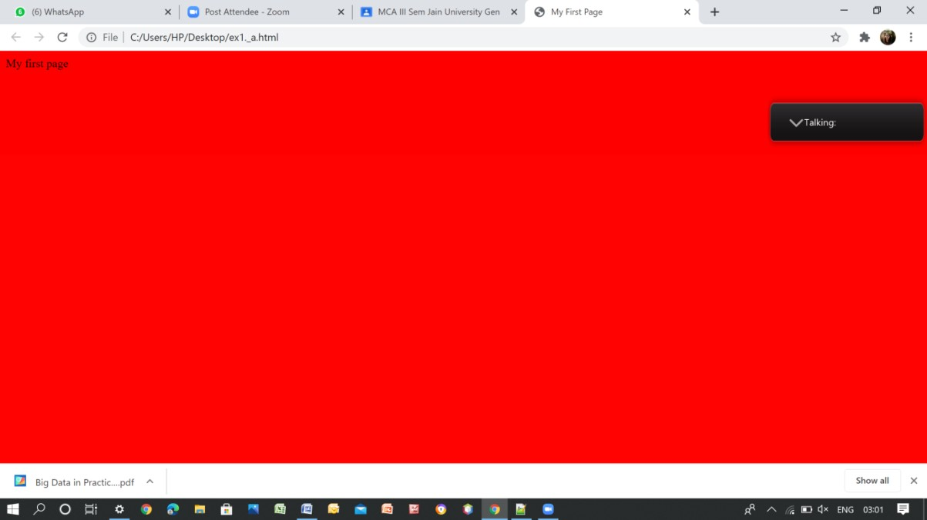

# Create a HTML document giving details of your name, age, telephone, address, TLC code & enrollment no. aligned in proper order

Source code:

<HTML>

<HEAD>

<TITLE>Details</TITLE>

</HEAD>

<BODY>

<P><B>Name:</B>&nbsp;&nbsp;&nbsp;Umakavya</P>

<P><B>Age:</B>&nbsp;&nbsp;&nbsp;23</P>

<P><B>Telephone Number:</B>&nbsp;&nbsp;&nbsp;9481634384</P>

<P><B>TLC Code:</B>&nbsp;&nbsp;&nbsp;574219</P>

<P><B>Enrollment Number:</B>&nbsp;&nbsp;&nbsp;19MCAR0039</P>

</BODY>

</HTML>

Output :

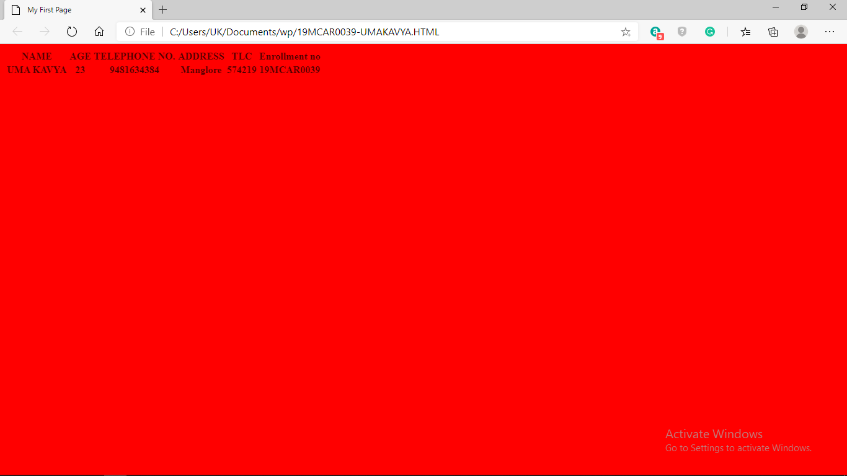

# Write HTML code to design a page containing a text in a paragraph give suitable heading style.

Source code:

<!DOCTYPE html>

<HTML>

<HEAD>

<TITLE>Web Programming </TITLE>

</HEAD>

<BODY>

<H1>Web Programming</H1>

<P ALIGN="justify"><B><I><BIG>About Web Programming</BIG></I></B><BR> Web programming refers to the writing, markup and coding involved in Web development,

which includes Web content, Web client and server scripting and network security. The most common languages used for Web programming are XML, HTML, JavaScript, Perl 5 and PHP. Web programming is different from just programming, which requires interdisciplinary knowledge on the application area, client and server scripting, and database technology.

</P>

<P ALIGN="justify"><B><I><BIG>CSS</BIG></I></B><BR>

CSS stands for Cascading Style Sheets. CSS describes how HTML elements are to be displayed on screen, paper, or in other media. CSS saves a lot of work. It can control the layout of multiple web pages all at once. External stylesheets are stored in CSS files.

</P>

</BODY>

</HTML>

Output:

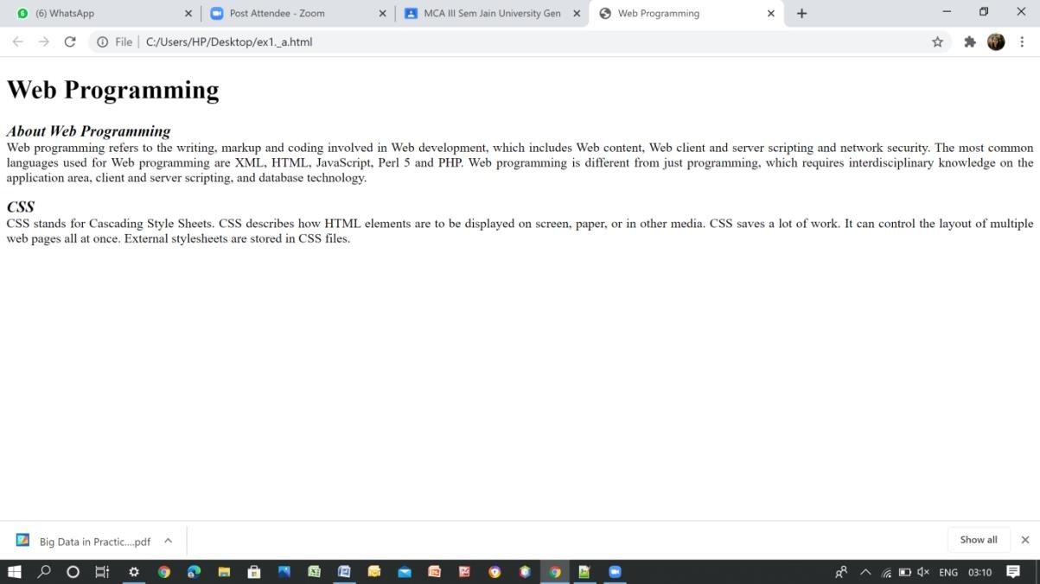

# Session 2: Tags in HTML Exercise:

* 1. **Create a page to show different attribute of Font tag.**

Source code:

<HTML>

<HEAD>

<TITLE>Web Programming </TITLE>

</HEAD>

<BODY>

<FONT FACE="VERDANA" SIZE="6" COLOR="BLUE">Web

Programming</FONT>

<P><FONT FACE="ARIAL" SIZE="8" COLOR="RED">Web Programming</FONT>

</P>

<P><FONT FACE="Times New Roman" SIZE="12" COLOR="GREEN">Web

Programming</FONT>

</P>

<P><FONT FACE="Comic Sans MS" SIZE="16" COLOR="PURPLE">Web

Programming</FONT>

</P>

</BODY>

</HTML>

Output:

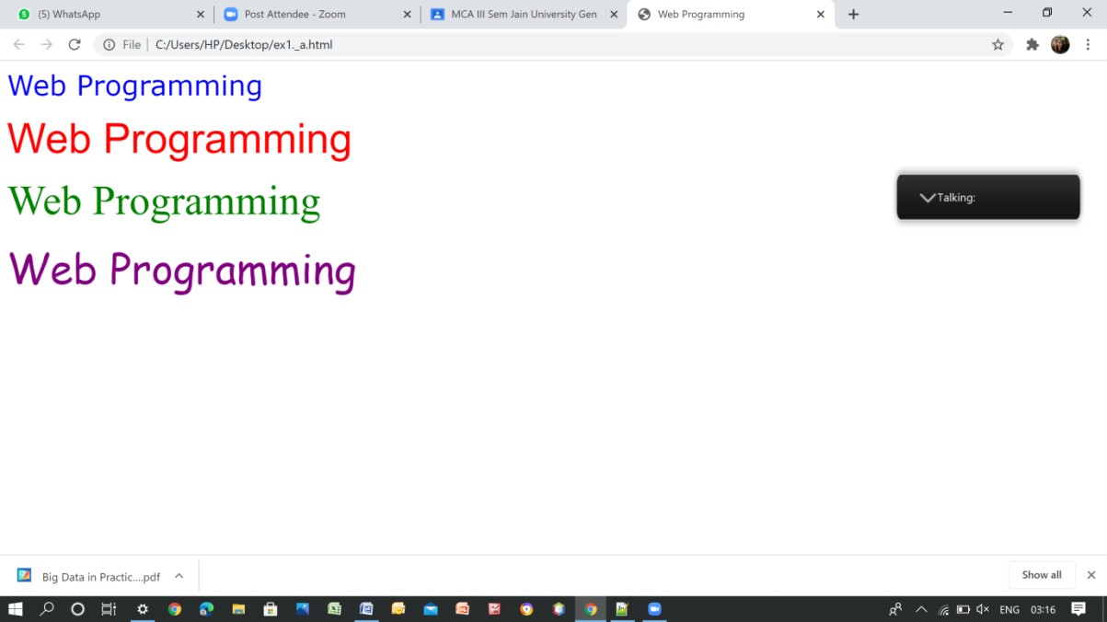

2.

# Create a page to show different attribute italic, bold, underline.

Source code:

<!DOCTYPE html>

<HTML>

<HEAD>

<TITLE>Web Programming</TITLE>

</HEAD>

<BODY>

<FONT><B>Web Programming</B></FONT>

<P><FONT><I>Web Programming</I></FONT>

</P>

<P><FONT><U>Web Programming</U></FONT>

</P>

</BODY>

</HTML>

Output:

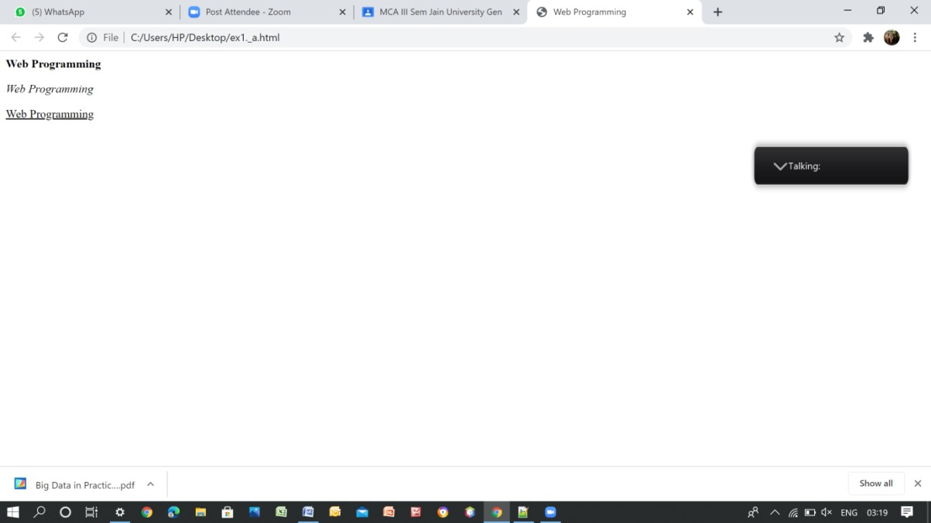

# Design a page having background color given text color red and using all the attributes of font tab

Source code:

<!DOCTYPE html>

<HTML>

<HEAD>

<TITLE>Computer Science </TITLE>

</HEAD>

<BODY>

<FONT><B>Computer Science</B></FONT>

<P><FONT><I>Computer Science</I></FONT>

</P>

<P><FONT><U>Computer Science</U></FONT>

</P>

</BODY>

</HTML>

Output:

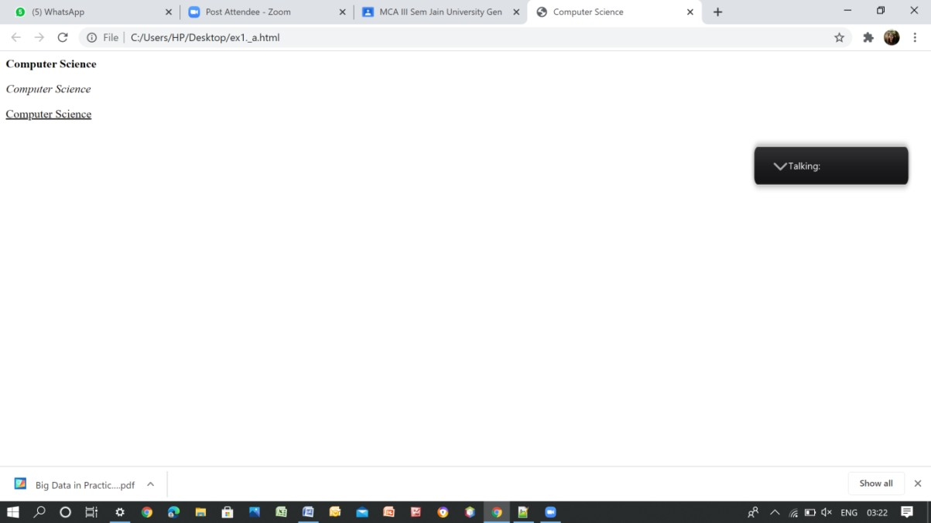

# Session 3: Tags in HTML Exercise:

1. **Write a HTML code to create a web page of blue color and display links in red color.**

Source Code:

<HTML>

<HEAD>

<TITLE>Links</TITLE>

</HEAD>

<BODY BGCOLOR="blue" TEXT="red">

<P ALIGN="center"><FONT FACE="verdana" COLOR="white" SIZE="5"><B>Links..</B></FONT></P>

<BR><A HREF="https://[www.w3schools.com/whatis/](http://www.w3schools.com/whatis/)"><FONT COLOR="red" SIZE="4">Web Programming</FONT></A>

<BR><A HREF="https://[www.w3schools.com/css/default.asp"](http://www.w3schools.com/css/default.asp)><FONT COLOR="red" SIZE="4">CSS</FONT></A>

<BR><A HREF="https://[www.w3schools.com/html/html_xhtml.asp"](http://www.w3schools.com/html/html_xhtml.asp)><FONT COLOR="red" SIZE="4">XHTML</FONT></A>

</BODY>

</HTML>

Output:

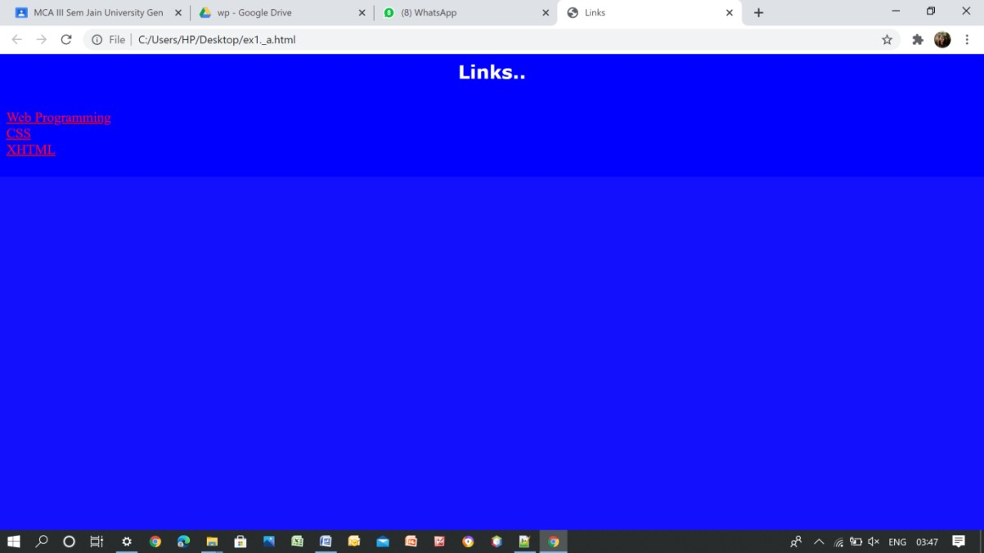

# Write HTML code to create a WebPages that contains an Image at its center.

Source code:

<!DOCTYPE html>

<HTML>

<HEAD>

<TITLE>Image</TITLE>

</HEAD>

<BODY>

<P ALIGN="center"><IMG BORDER="0" WIDTH="600" HEIGHT="200"

SRC="https://cdn.mos.cms.futurecdn.net/hFm4iWXhbw4c4rdcMH8tUD.jpg"</P>

</BODY>

</HTML>

Output:

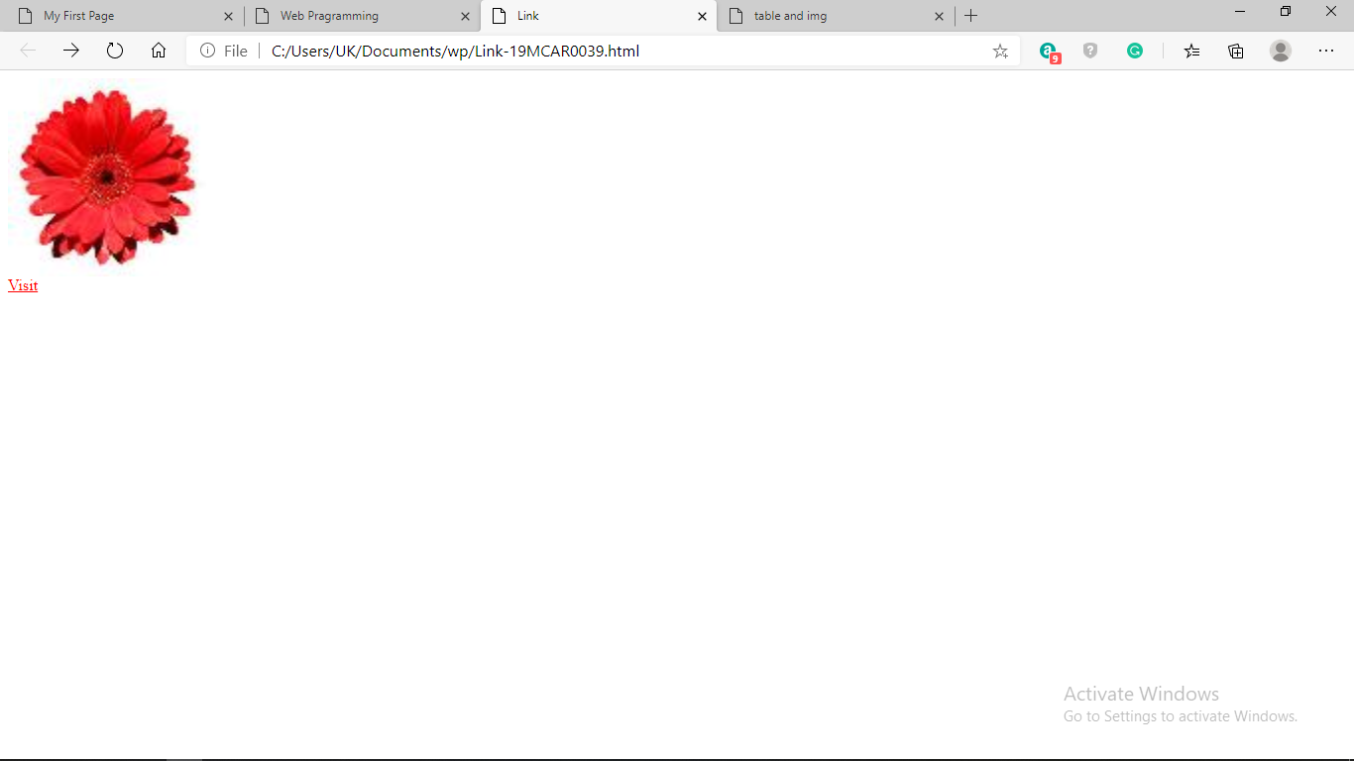

# Create a web page with appropriate content and insert an image towards the left hand side of the page when user clicks on the image. It should open another web page.

Source code:

<!DOCTYPE html>

<HTML>

<HEAD>

<TITLE>IMAGE</TITLE>

</HEAD>

<BODY>

<P ALIGN="left">

<A HREF="test.html">

<IMG BORDER="0" SRC="https://thumbs.dreamstime.com/b/click-bar-finger-vector-web- button-icon-template-click-bar-finger-vector-web-site-click-button-icon-template-design- 131969420.jpg" WIDTH="250" HEIGHT="100"

ALT = "IMAGE IS TURNED OFF" ALIGN = "BOTTOM" BORDER = 2>

</A>

</P>

</BODY>

</HTML>

Test.html

<html>

<title>Test</title>

<body>

<h1>TEST</h1>

</body>

</html>

Output:

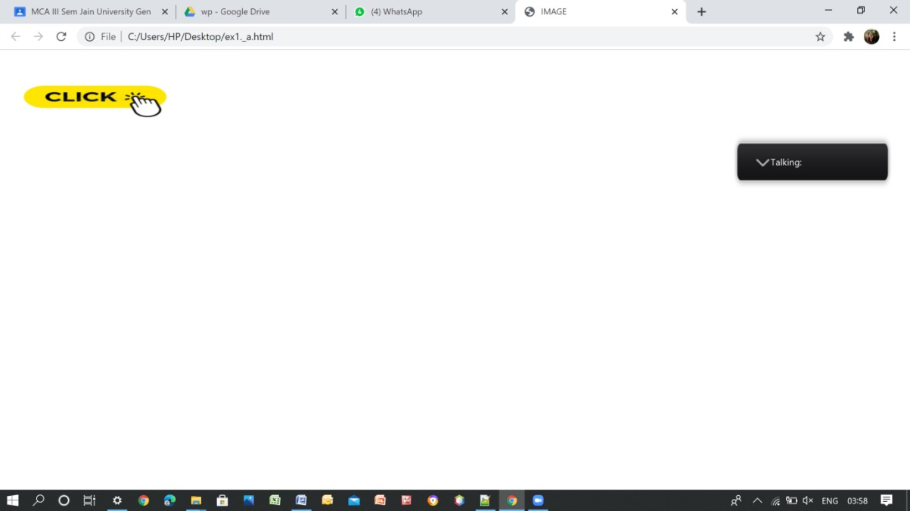

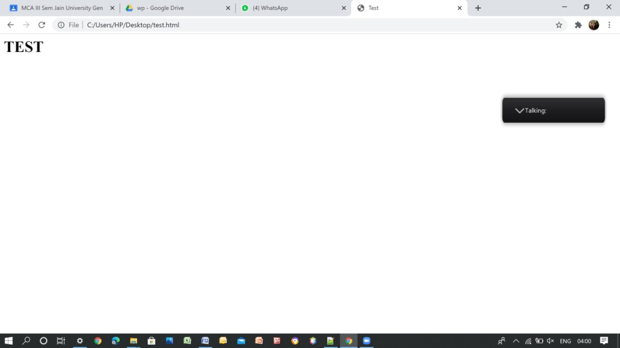

# Session 4: Tags in HTML Exercise:

1. **Create a web Page using href tag having the attribute alink, vlink etc.**

Source code:

<HTML>

<BODY bgColor="white" Text="blue" Link="Orange" VLink="green" ALink="purple">

<P ALIGN="center"><FONT SIZE="5"><B>Links</B></FONT></P>

<BR><A HREF="https://[www.techopedia.com/definition/26268/cascading-style-sheet-](http://www.techopedia.com/definition/26268/cascading-style-sheet-) css#:~:text=Cascading%20Style%20Sheets%20(CSS)%20is,Extensible%20HyperText%20M arkup%20Language%20(XHTML)"><FONT>CSS</FONT></A>

<BR><A HREF="https://[www.techopedia.com/definition/1889/extensible-hypertext-](http://www.techopedia.com/definition/1889/extensible-hypertext-) markup-language- xhtml#:~:text=Techopedia%20explains%20Extensible%20Hypertext%20Markup,%2C%20X HTML%20is%20XML%2Dbased.&text=It%20is%20a%20restrictive%20subset,help%20of

%20standard%20XML%20parsers."><FONT>XHTML</FONT></A>

</BODY>

</HTML>

Output:

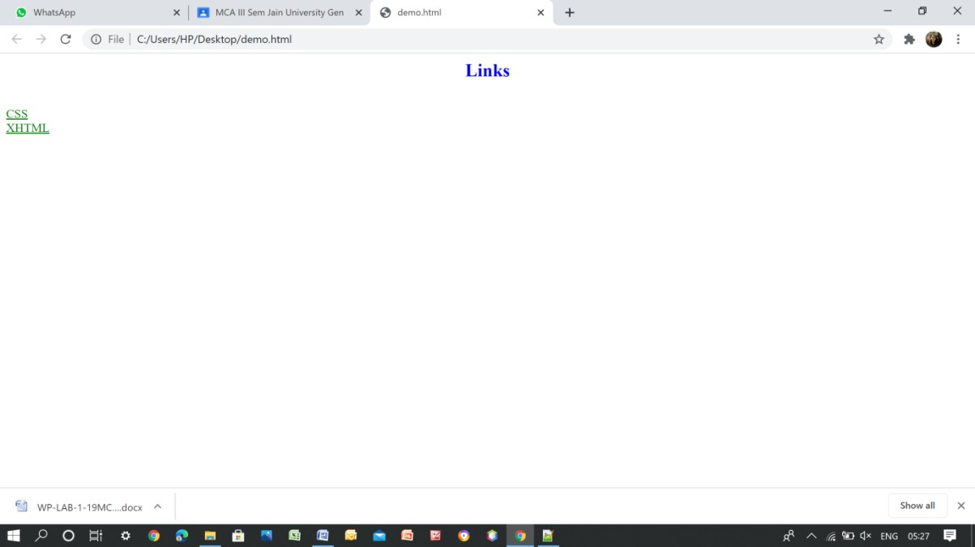

# Create a web page, when user clicks on the link it should go to the bottom of the page.

Source code:

<HTML>

<BODY bgColor="white" Text="blue" Link="blue" VLink="green" ALink="red">

<P ALIGN="center"><FONT FACE="verdana" SIZE="5"><B>Dishes</B></FONT></P>

<P ALIGN="left"><A HREF="#bottom">Bottom</A>

<OL>

<LI>Punjabi</LI>

<UL>

<LI>Veg. Muglai</LI>

<LI>Veg. Tawa Masala</LI>

<LI>Paneer Tikka Masala</LI>

<LI>Paneer Makhanwala</LI>

<LI>Paneer Pasanda</LI>

</UL>

<LI>Chinese</LI>

<UL>

<LI>American Copsuey</LI>

<LI>Veg. Hakka Noodels</LI>

<LI>Veg. Shezwan Rice</LI>

<LI>Veg. Fried Rice</LI>

<LI>Veg. Triple Rice</LI>

</UL>

<LI>Soups</LI>

<UL>

<LI>Sweet Corn Soup</LI>

<LI>Veg. Manchow Soup</LI>

<LI>Tomato soup</LI>

<LI>Hot n Saur Soup</LI>

<LI>Palak Soup</LI>

</UL>

<LI>Juices</LI>

<UL>

<LI>Mosambi</LI>

<LI>Pineapple</LI>

<LI>Orange</LI>

<LI>WaterMelon</LI>

<LI>Grapes</LI>

</UL>

<LI>Soups</LI>

<UL>

<LI>Sweet Corn Soup</LI>

<LI>Veg. Manchow Soup</LI>

<LI>Tomato soup</LI>

<LI>Hot n Saur Soup</LI>

<LI>Palak Soup</LI>

</UL>

<LI>Juices</LI>

<UL>

<LI>Mosambi</LI>

<LI>Pineapple</LI>

<LI>Orange</LI>

<LI>WaterMelon</LI>

<LI>Grapes</LI>

</UL>

</OL>

<A NAME="bottom">

</BODY>

</HTML>

Output:

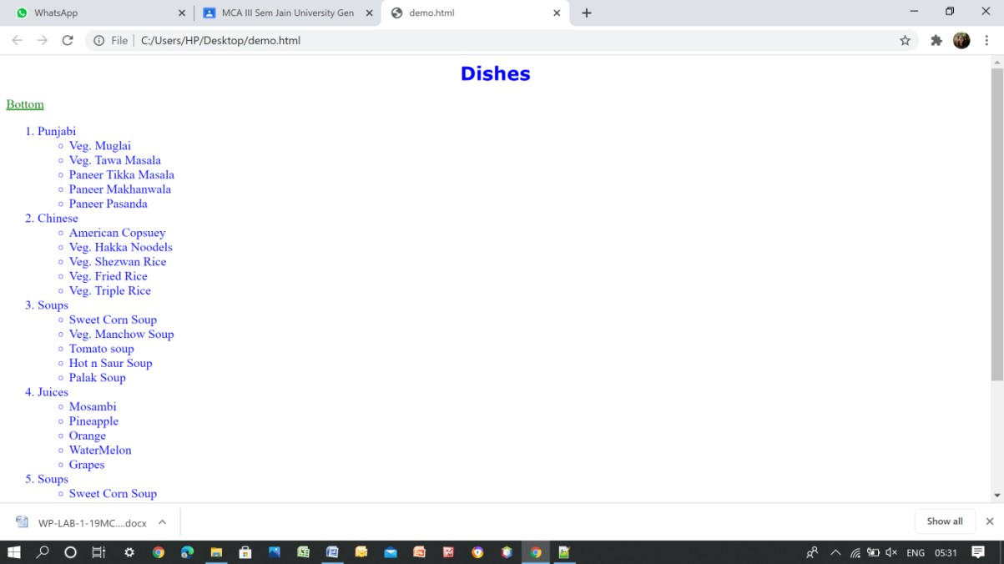

# Write a HTML code to create a web page of pink color and display moving message in red color.

Source code:

<HTML>

<BODY BGCOLOR="pink">

<MARQUEE>

<FONT FACE="verdana" COLOR="red" SIZE="5">

<B>HyperText Maekup Language</B>

</FONT>

</MARQUEE>

</BODY>

</HTML>

Output:

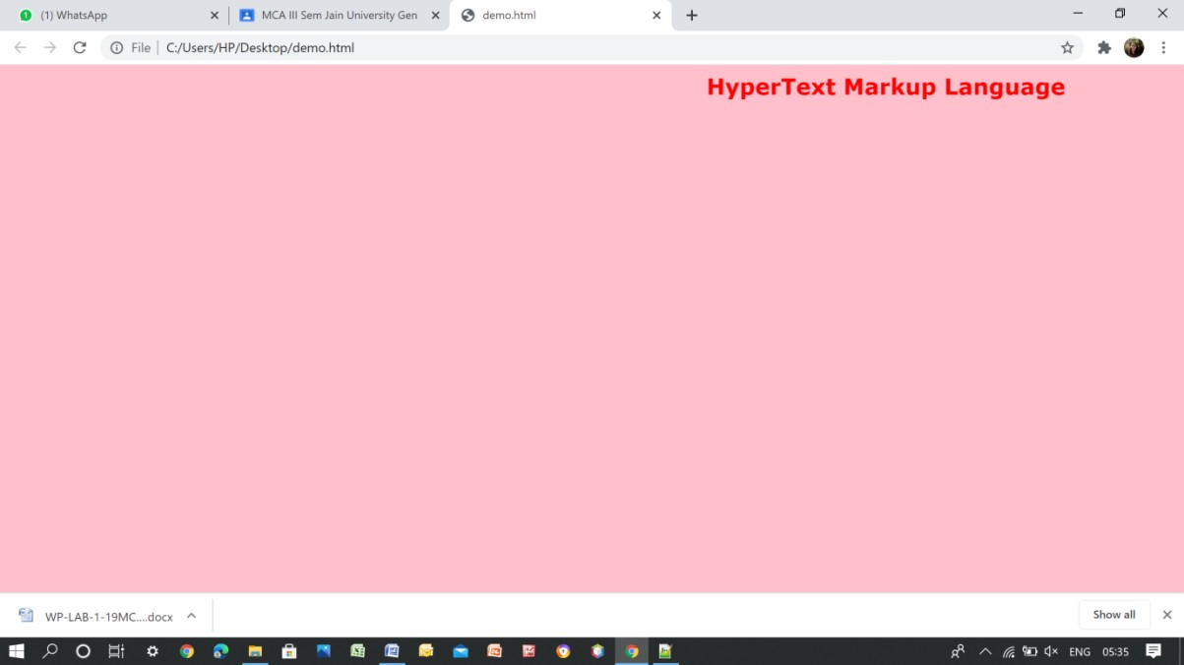

# Session 5: Tags in HTML Exercise:

**Demonstrating lists.**

Source code: Unordered list

<HTML>

<BODY>

<H2>GROCERY LIST</H2>

<UL>

<LI>BREAD</LI>

<LI>EGGS</LI>

<LI>MILK</LI>

<LI>COFFEE</LI>

</UL>

</BODY>

</HTML>

Output:

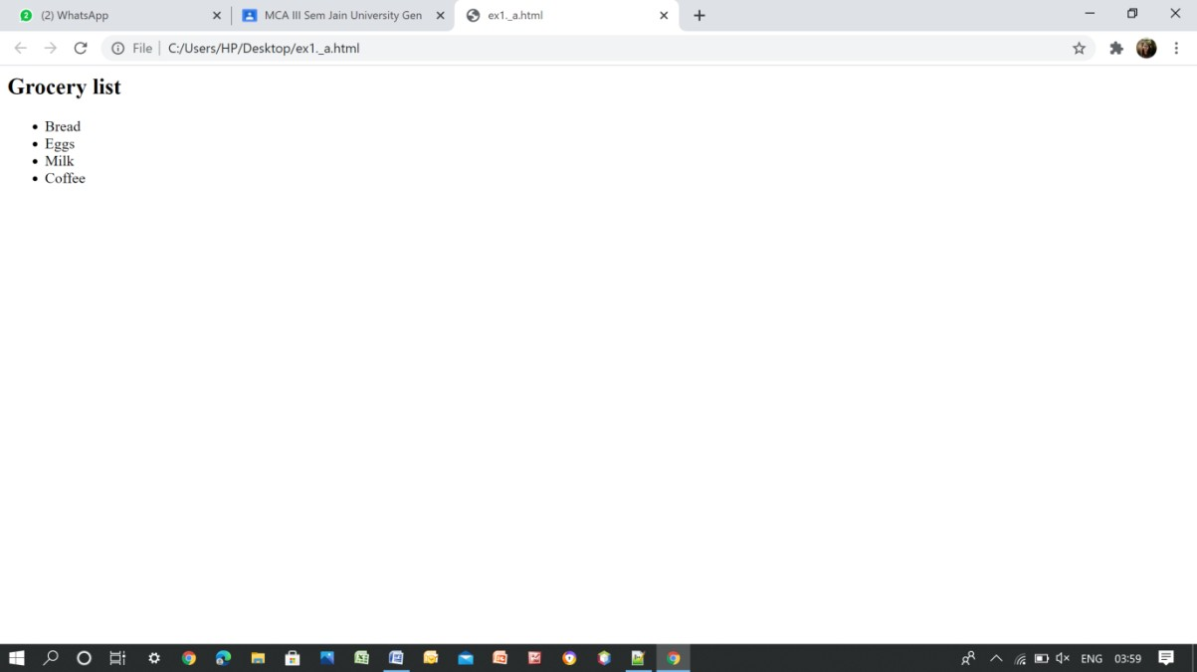

Ordered list:

<html>

<body>

<h2>Grocery List</h2>

<ol>

<li>Bread</li>

<li>Eggs</li>

<li>Milk</li>

<li>Coffee</li>

</ol>

</body>

</html> Output:

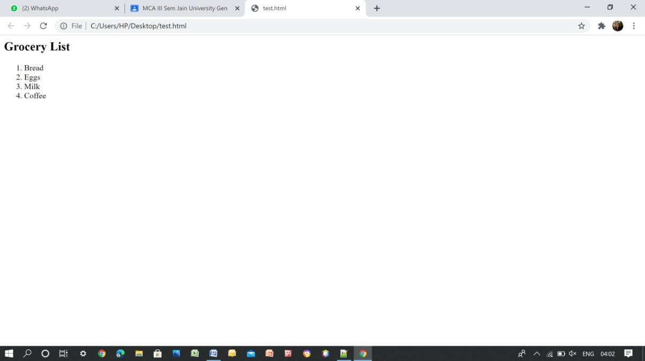

Description list:

<html>

<body>

<h2>A Description List</h2>

<dl>

<dt>Coffee</dt>

<dd>- 500 gms</dd>

<dt>Milk</dt>

<dd>- 1 ltr Tetra Pack</dd>

</dl>

</body>

</html> Output:

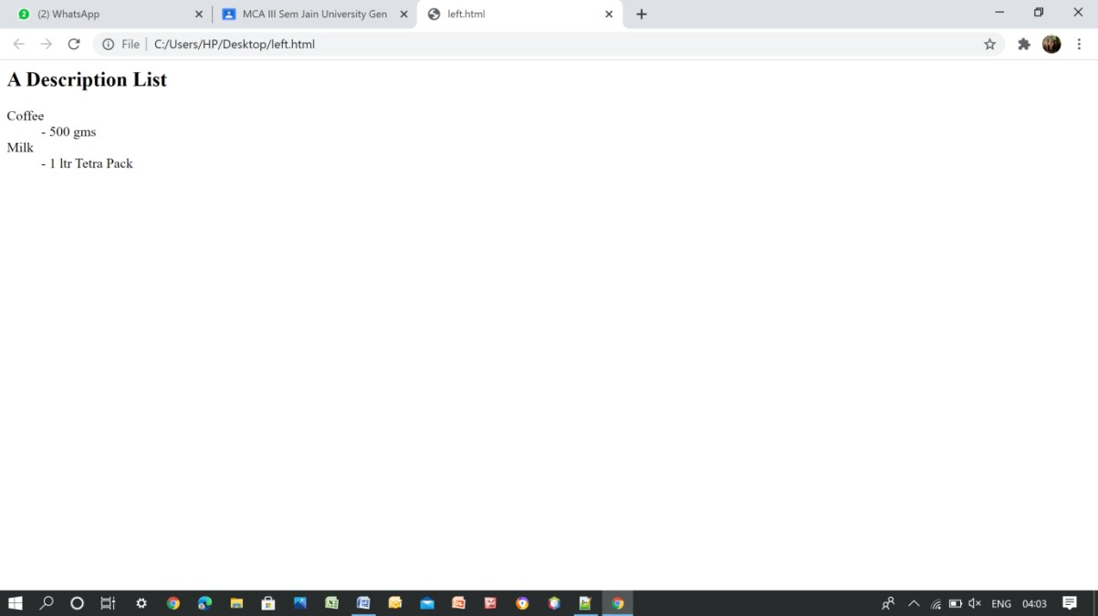

Nested List

<html>

<body>

<h2>A Nested List</h2>

<ul>

<li>Coffee</li>

<li>Tea

<ul>

<li>Black tea</li>

<li>Green tea</li>

</ul>

</li>

<li>Milk</li>

</ul>

</body>

</html> Output:

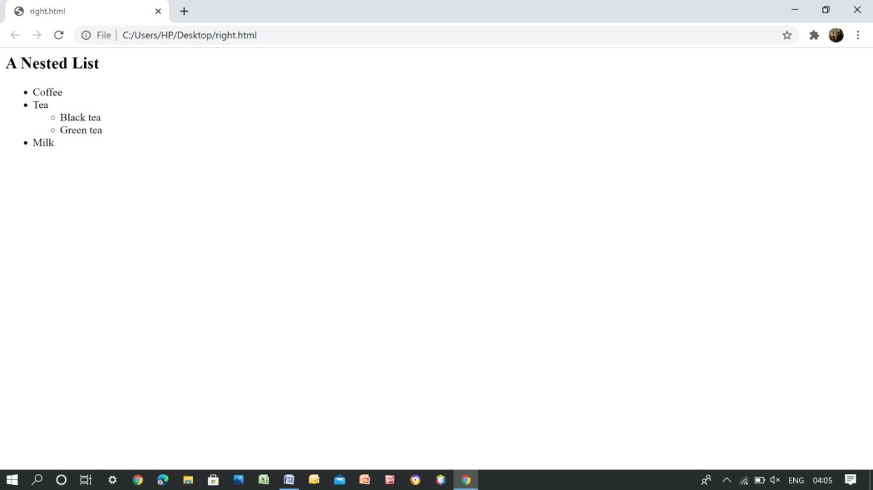

# Session 6: Tags in HTML Exercise:

1. **Create a web page which should contain a table having two rows and two columns.**
2. **fill in the data in the table created by you in question 1.**

Source code**:**

<!DOCTYPE html>

<html>

<head>

<style>

table, th, td {

border: 1px solid black; border-collapse: collapse;

}

th, td {

padding: 5px; text-align: left;

}

</style>

</head>

<body>

<table style="width:100%">

<tr>

<th>Name:</th>

<td>Abcd</td>

</tr>

<tr>

<th rowspan="2">Telephone:</th>

<td>9125577854</td>

</tr>

<tr>

<td>8565557785</td>

</tr>

<tr>

<th>Name:</th>

<td>Efgh</td>

</tr>

<tr>

<th>Telephone:</th>

<td>9167564534</td>

</tr>

</table>

</body>

</html>

Output:

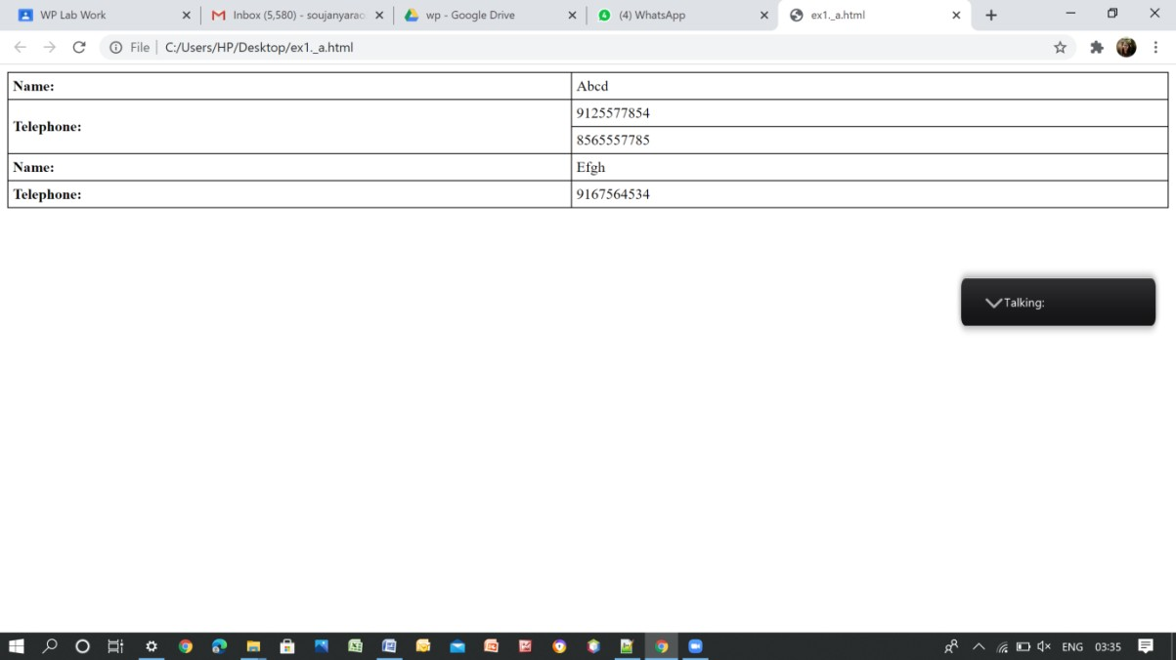

# create the following table in HTML with Dummy Data

Source code:

<HTML>

<BODY>

<TABLE BORDER="5" WIDTH="100%">

<TR>

<TD WIDTH="5%" ROWSPAN="2"><B>TrainNo.</B></TD>

<TD WIDTH="15%" ROWSPAN="2"><B>Name of Train</B></TD>

<TD WIDTH="15%" ROWSPAN="2"><B>Place</B></TD>

<TD WIDTH="15%" ROWSPAN="2"><B>Destination</B></TD>

<TD WIDTH="30%" ALIGN="center" COLSPAN="2"><B>Time</B></TD>

<TD WIDTH="15%" ROWSPAN="2"><B>Fare</B></TD>

</TR>

<TR>

<TD WIDTH="15%"><B>Arrival</B></TD>

<TD WIDTH="15%"><B>Departure</B></TD>

</TR>

<TR>

<TD WIDTH="5%">657689</TD>

<TD WIDTH="15%">Intercity</TD>

<TD WIDTH="15%">Bangalore</TD>

<TD WIDTH="15%">Delhi</TD>

<TD WIDTH="15%">6.45</TD>

<TD WIDTH="15%">11.50</TD>

<TD WIDTH="15%">2500</TD>

</TR>

<TR>

<TD WIDTH="5%">345463</TD>

<TD WIDTH="15%">Rajdhani</TD>

<TD WIDTH="15%">Delhi</TD>

<TD WIDTH="15%">Goa</TD>

<TD WIDTH="15%">10.15</TD>

<TD WIDTH="15%">19.00</TD>

<TD WIDTH="15%">1600</TD>

</TR>

</TABLE>

</BODY>

</HTML>

Output:

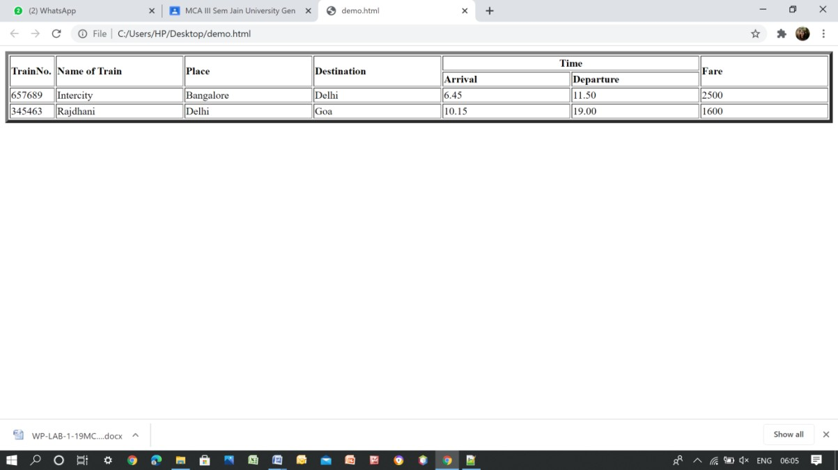

# Session 7: Tags in HTML Exercise:

* 1. **Create the following table**

Source code:

# A)

<!DOCTYPE html>

<HTML>

<HEAD>

<TITLE>Table</TITLE>

</HEAD>

<BODY>

<TABLE BORDER="1" WIDTH="100%">

<TR>

<TD WIDTH="100%" align="center" COLSPAN="3">Color(White)</TR>

<TR>

<TD WIDTH="33%" >RED</TD>

<TD WIDTH="33%">GREEN</TD>

<TD WIDTH="33%">BLACK</TD>

</TR>

<TR>

</TR>

</TABLE>

</BODY>

</HTML>

# B)

<!DOCTYPE html>

<html>

<head>

<title>HTML rowspan Attribute</title>

<style>

table, th, td {

border: 1px solid black;

BORDER-COLLAPSE: COLLAPSE; PADDING: 6PX;

}

</STYLE>

</HEAD>

<BODY STYLE = "TEXT-ALIGN:CENTER">

<TABLE>

<TR>

<TD ROWSPAN="3">WEATHER</TD>

</TR>

<TR>

<TD>DELHI</TD>

<TD>MUMBAI</TD>

</TR>

<TR>

<TD>40</TD>

<TD>35</TD>

</TR>

</TABLE>

</BODY>

</HTML>

Output: A)

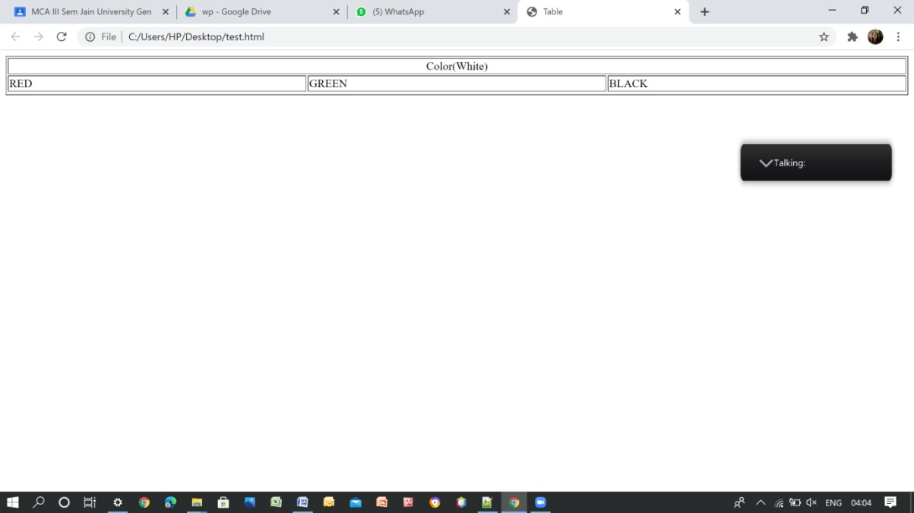

# B)

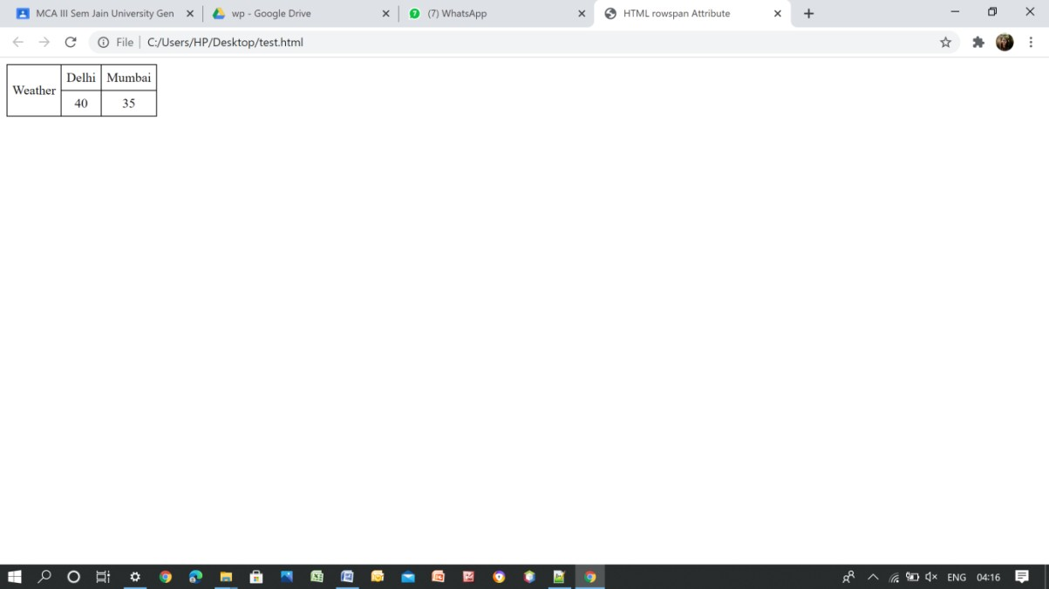

1. **Write HTML code to generate following output**

Source code

<!DOCTYPE html>

<html>

<head>

<title>HTML rowspan Attribute</title>

<style>

table, th, td {

border: 1px solid black; border-collapse: collapse; padding: 6px;

}

</style>

</head>

<body style = "text-align:center">

<table>

<tr>

<td>1</td>

<td>2</td>

<td>3</td>

<td>4</td>

</tr>

<tr>

<td>5</td>

<td rowspan = "2" colspan="2"><IMG BORDER="0"

WIDTH="600" HEIGHT="200"

SRC="https://cdn.mos.cms.futurecdn.net/hFm4iWXhbw4c4rdcMH8tUD.jpg"> </td>

<td>6</td>

</tr>

<tr>

<td>7</td>

<td>8</td>

</tr>

<td>9</td>

<tr>

<td>10</td>

<td>11</td>

<td>12</td>

</tr>

</table>

</body>

</html>

Output:

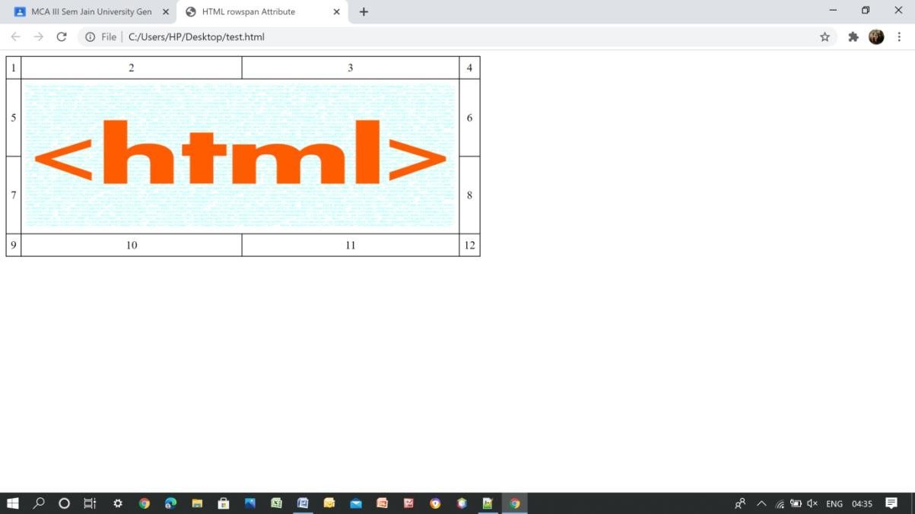

# Session 8: Frames in HTML Exercise:

* 1. **Create a web page which should divide page into two equal frames**

Source code

<!DOCTYPE html>

<html>

<head>

<title>HTML Frames</title>

</head>

<frameset cols = "50%,50%">

<frame name = "left" src = "left.html" />

<frame name = "right" src = "right.html" />

<noframes>

<body>Frame</body>

</noframes>

</frameset>

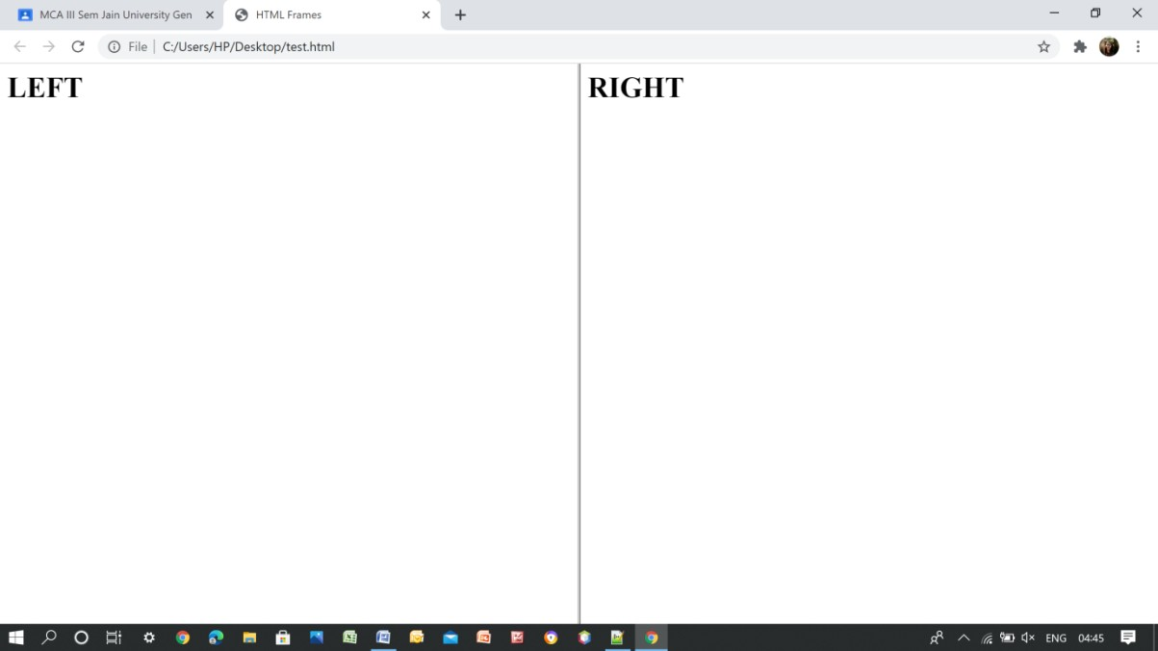</html> Output:

# Create a web page which should generate following output

Source code:

Frame.html

<HTML>

<HEAD>

<TITLE>A simple frameset document</TITLE>

</HEAD>

<FRAMESET cols="50%, 50%">

<FRAME src="left.html">

<FRAMESET rows="50%, 50%">

<FRAME src="right.html">

<FRAME src="ex1._a.html">

</FRAMESET>

</FRAMESET>

</HTML>

Frame1.html

<html>

<body>

<h1>Frame1</h1>

</body>

</html> Frame2.html

<html>

<body>

<h1>Frame2</h1>

</body>

</html> Frame3.html

<html>

<body>

<h1>Frame3</h1>

</body>

</html>

Output:

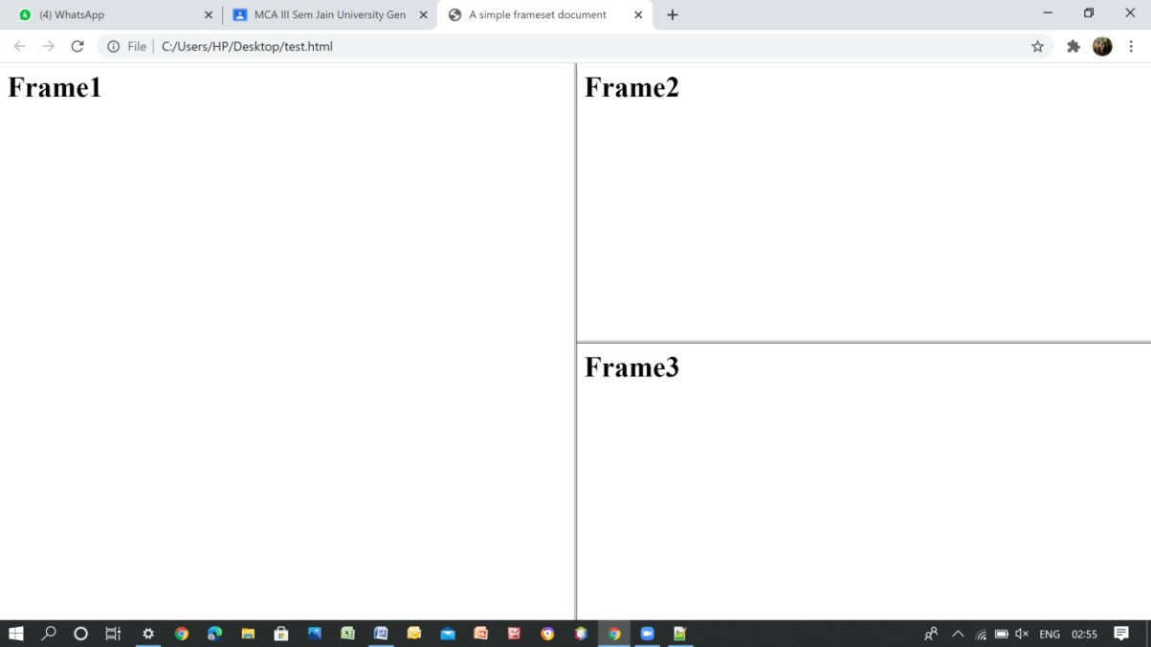

# Create a web page having two frames one containing lines and another with contents of the link. When link is clicked appropriate contents should be displayed on Frame

Source code:

Frame1.html

<HTML>

<HEAD>

<TITLE>A simple frameset document</TITLE>

</HEAD>

<FRAMESET cols="50%, 50%">

<FRAME src="left.html">

<FRAME src="right.html">

</FRAMESET>

</HTML>

Left.html

<html>

<body>

<h1>HTML</h1>

<h1>CSS</h1>

<h1>XHTML</h1>

</body>

</html>

Right.html

<html>

<body>

<A HREF="https://[www.techopedia.com/definition/23898/web-programming"](http://www.techopedia.com/definition/23898/web-programming)><FONT COLOR="red" SIZE="4">Web Programming</FONT></A>

<BR><A HREF="https://[www.techopedia.com/definition/26268/cascading-style-sheet-](http://www.techopedia.com/definition/26268/cascading-style-sheet-) css#:~:text=Cascading%20Style%20Sheets%20(CSS)%20is,Extensible%20HyperText%20M arkup%20Language%20(XHTML)"><FONT COLOR="red" SIZE="4">CSS</FONT></A>

<BR><A HREF="https://[www.techopedia.com/definition/1889/extensible-hypertext-](http://www.techopedia.com/definition/1889/extensible-hypertext-) markup-language- xhtml#:~:text=Techopedia%20explains%20Extensible%20Hypertext%20Markup,%2C%20X HTML%20is%20XML%2Dbased.&text=It%20is%20a%20restrictive%20subset,help%20of

%20standard%20XML%20parsers."><FONT COLOR="red" SIZE="4">XHTML</FONT></A>

</body>

</html> Output:

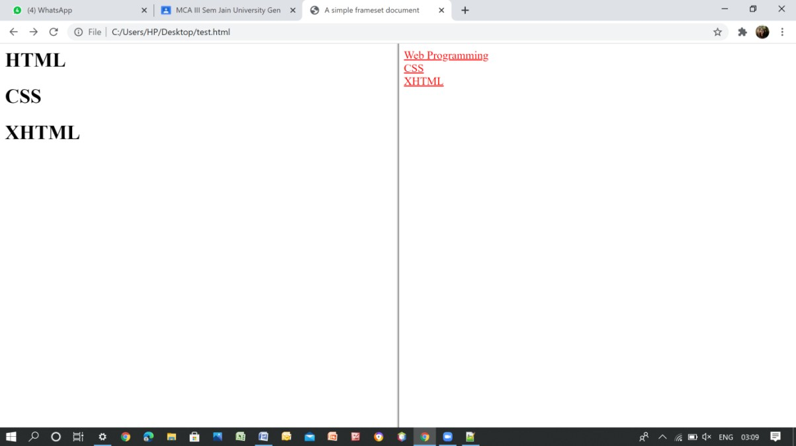

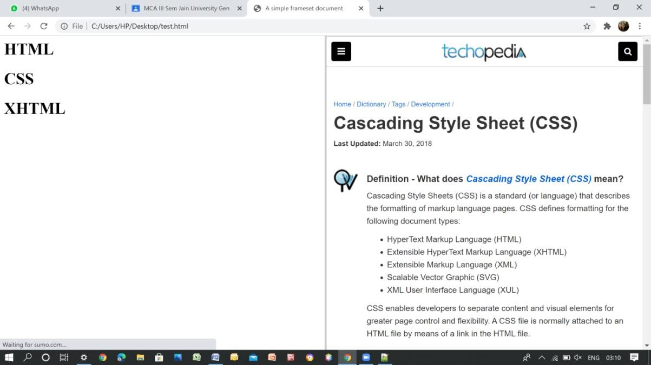

# Session 9: Frames in HTML Exercise:

**1. Create a home page for a TLC in following format**

Source:

<!DOCTYPE html>

<html>

<head>

<style>

**ul** {

}

*.bg* {

}

**li** {

}

list-style-type: *none*; margin: *0*;

padding: *0*; overflow: *hidden*;

background-color: *#000407*;

background-position: *500px 200px*; background-repeat: *repeat*; background-size: *30%*;

float: *left*;

**li a,** *.dropbtn* {

display: *inline-block*; color: *white*;

text-align: *center*; padding: *14px 16px*; text-decoration: *none*;

}

**li a***:hover***,** *.dropdown:hover .dropbtn* { background-color: *transparent*;

}

**li***.dropdown* {

display: *inline-block*;

}

*.dropdown-content* {

display: *none*; position: *absolute*;

background-color: *white*; min-width: *160px*;

box-shadow: *0px 8px 16px 0px rgba(0, 0, 0, 0.2)*;

}

*.dropdown-content* **a** {

color: *black*; padding: *12px 16px*;

text-decoration: *none*; display: *block*;

text-align: *left*;

}

*.dropdown-content* **a***:hover* { background-color: *#f1f1f1*

}

*.dropdown:hover .dropdown-content* { display: *block*;

}

</style>

</head>

<body >

<ul>

<li class=*"dropdown"*><a href=*"https://cdn.technadu.com/wp- content/uploads/2020/02/TCL-Logo.png"* class=*"dropbtn"*>Home</a>

*group.html"*>About Us</a> US</a>

</li>

</ul>

</body>

</html> Output:

<a href=*"https://*[*www.tcl.com/in/en/about-tcl/the-*](http://www.tcl.com/in/en/about-tcl/the-)

<a href=*"https://*[*www.tcl.com/in/en/service.html*](http://www.tcl.com/in/en/service.html)*"*>Contact



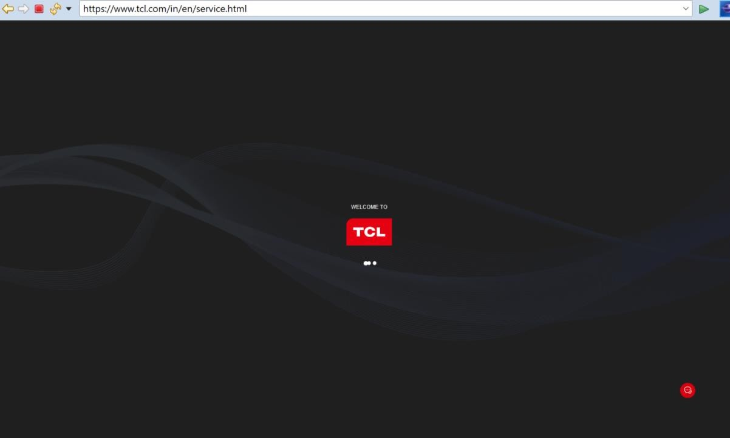

# Exercise: 10

1. **Design a form using all input types.**
2. **Create a simple form accepting Name**

**Enrollment No. and Submitbutton**

Source code:

@charset "ISO-8859-1";

.registerbox {

width: 320px; height: 620px; background: #333; color: White;

top: 50%;

left: 50%; position: absolute;

transform: translate(-50%, -50%); box-sizing: border-box;

padding: 70px 30px;

}

h1 {

}

margin: 0;

padding: 0 0 20px; text-align: center; font-size: 22px;

.registerbox p {

margin: 0;

padding: 0;

font-weight: bold;

}

.registerbox input {

width: 100%;

margin-bottom: 20px; color: white;

}

.registerbox input[type="text"], input[type="text"], input[type="email"], input[type="text"], input[type="password"] {

border: none;

border-bottom: 1px solid #fff; background: transparent; outline: none;

}

.bg {

}

height: 40px; color:white;

background-color: grey; background-position: 500px 200px; background-repeat: repeat; background-size: 30%;

.registerbox input[type="submit"]{ color:black;

}

Output:

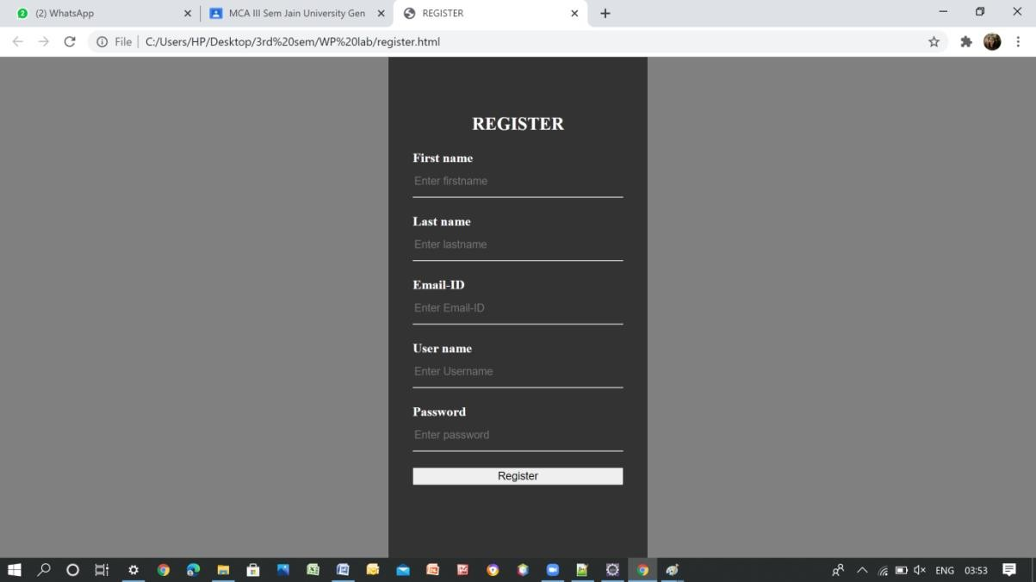

# Exercise: 11 , 12 , 13 , 14.

**Create a site for HTML tutorials with proper examples and samples**

Output:



