Write a program to calculate Electricity bill in PHP using class

<!DOCTYPE html>

<head>

    <title>Electricity Bill Calculator</title>

</head>

<body>

    <center>

        <h3>Electricity Bill Calculator</h3>

    <form action="" method="post">

            <input type="number" name="units" placeholder="Please enter no. of Units" />

            <input type="submit" name="unit-submit" value="Submit" />

    </form>

<?php

class electric

{

    public $units;

    function set_units($units)

    {

        $this->units=$units;

    }

    function calculate_bill()

    {

        $unit_cost_first = 4.50;

        $unit_cost_second = 5.00;

        $unit_cost_third = 6.60;

        $unit_cost_fourth = 8.00;

        if($this->units <= 50)

        {

            $bill = $this->units * $unit_cost_first;

        }

        else if($this->units > 50 && $this->units <= 100)

        {

            $temp = 50 * $unit_cost_first;

            $remaining_units = $this->units - 50;

            $bill = $temp + ($remaining_units * $unit_cost_second);

        }

        else if($this->units > 100 && $this->units <= 200)

        {

            $temp = (50 * 4.5) + (100 * $unit_cost_second);

            $remaining_units = $this->units - 150;

            $bill = $temp + ($remaining_units * $unit_cost_third);

        }

        else

        {

            $temp = (50 * 4.5) + (100 * $unit_cost_second) + (100 * $unit_cost_third);

            $remaining_units = $this->units - 250;

            $bill = $temp + ($remaining_units * $unit_cost_fourth);

        }

        return number_format((float)$bill, 2, '.', '');

    }

}

$u=new electric();

if (isset($_POST['unit-submit']))

{

    $units = $_POST['units'];

    $u->set_units($units);

    echo "<br><br>Dear Customer.....<br><br>The Electric city bill amount for ".$units." units is ".$u->calculate_bill();

}

?>

</center>

</body>

</html>

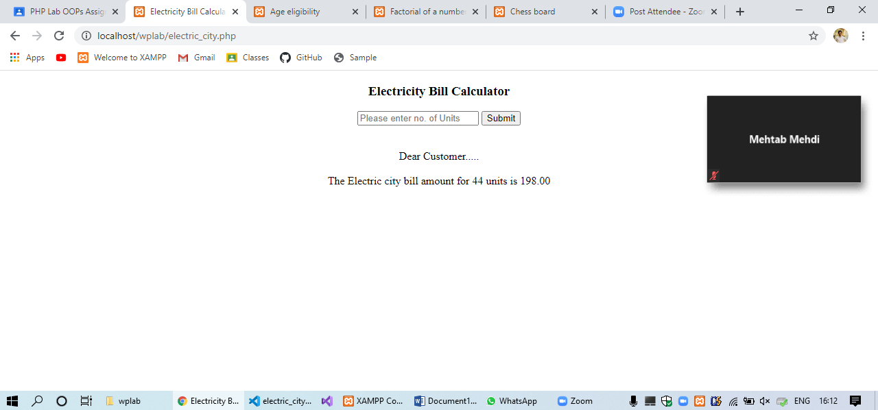

Write a PHP program to check if a person is eligible to vote using class

<!DOCTYPE html>

<head>

    <title>Age eligibility</title>

</head>

<body>

    <center>

        <h3>Age eligibility for election checker</h3>

    <form action="" method="post">

    <input type="number" name="age" placeholder="Please enter age" />

    <input type="submit" name="submit" value="Submit" />

    </form>

<?php

class vote

{

    public $age;

    function set_age($age)

    {

        $this->age=$age;

    }

    function check_eligibility()

    {

        if($this->age <= 18)

        {

            echo "<br><br>Oops!! Sorry...You are not eligible for voting in this year!";

        }

        else  if($this->age>18 && $this->age <= 100)

        {

            echo "<br><br>Hey!! Great news!! You are eligible for vote!!";

        }

        else

        {

            echo "<br><br>Invalid age";

        }

    }

}

$checkeligible=new vote();

if (isset($_POST['submit']))

{

    $age = $_POST['age'];

    $checkeligible->set_age($age);

    $checkeligible->check_eligibility();

}

?>

</center>

</body>

</html>

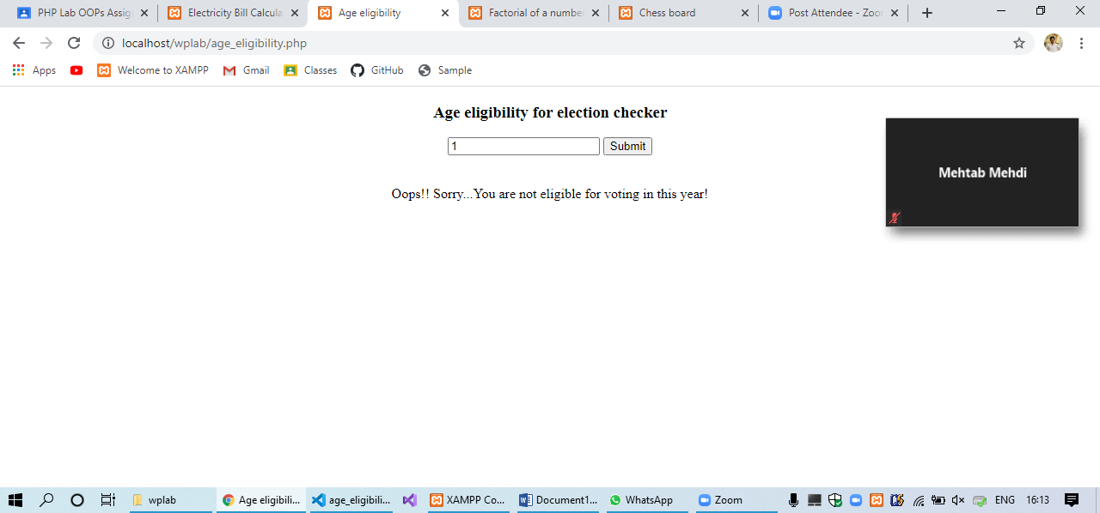

find the factorial of a number using php oops

<!DOCTYPE html>

<head>

    <title>Factorial of a number</title>

</head>

<body>

    <center>

        <h3>Factorial of a number</h3>

    <form action="" method="post">

    <input type="number" name="num" placeholder="Please enter a number to calculate factorial of a number" />

    <input type="submit" name="submit" value="Submit" />

    </form>

<?php

class factt

{

    public $num;

    function set_fact($num)

    {

        $this->num=$num;

    }

    function factorialnum()

    {

        $factorial = 1;

        for ($x=$this->num; $x>=1; $x--)

        {

            $factorial = $factorial * $x;

        }

        echo "<br><br>Factorial of $this->num is $factorial";

    }

}

$checkfact=new factt();

if (isset($_POST['submit']))

{

    $num = $_POST['num'];

    $checkfact->set_fact($num);

    $checkfact->factorialnum();

}

?>

</center>

</body>

</html>

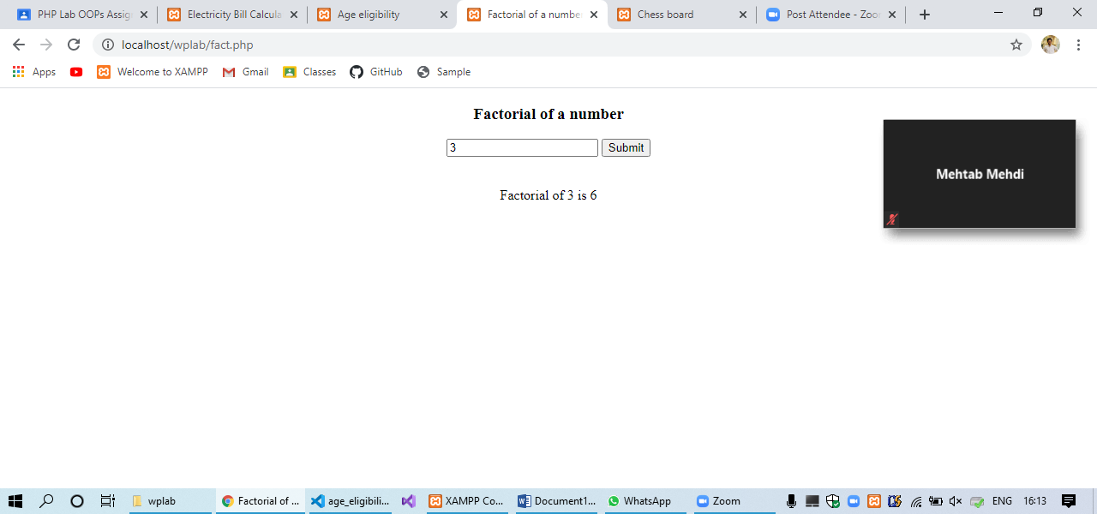

Write a PHP program using nested for loop that creates a chess board. you can use html table

<!DOCTYPE html>

<html>

    <head>

  <title>Chess board</title>

  <meta http-equiv="Content-Type" content="text/html; charset=UTF-8">

  </head>

  <body>

  <h3>Chess Board</h3>

   <table width="450px" cellspacing="0px" cellpadding="0px" border="1px">

      <?php

      class chessboard

      {

        function __construct()

        {

            for($row=1;$row<=8;$row++)

            {

                echo "<tr>";

                for($col=1;$col<=8;$col++)

                {

                    $total=$row+$col;

                    if($total%2==0)

                    {

                    echo "<td height=30px width=30px bgcolor=#FFFFFF></td>";

                    }

                    else

                    {

                    echo "<td height=30px width=30px bgcolor=#000000></td>";

                    }

                }

                echo "</tr>";

            }

        }

    }

    new chessboard();

    ?>

  </table>

  </body>

  </html>

