Exercise 1

HTML

<button id="clicker">Click me to show a hidden secret!</button>

<div id="secret" style="display: none">I am a hidden secret.</div>

Instructions:

1. Add jQuery code that fades in the text "I am a hidden secret" whenever the button is clicked.

2. Change your jQuery code so it slides down the text instead of fading it in.

3. Change the button text to say "Click me to toggle a hidden secret!" and make the text toggle

between fading in and out each time it is clicked.

Source code:-

<!DOCTYPE html>

<html>

<head>

<script src="https://ajax.googleapis.com/ajax/libs/jquery/3.5.1/jquery.min.js"></script>

<script>

$(document).ready(function(){

$("button").click(function(){

$("p").toggle();

$("#secret").fadeTo("slow",0.9);

$("#secret1").fadeOut("slow",0.5);

$("#slide").slidedown("slow");

$("Clicker").prop('value','click');

});

});

</script>

</head>

<body>

<button id="Clicker">Click me to show a hidden secret</button>

<div id="secret" style="display:none">I am a hidden secret,</div>

<div id="slide" >Hellow</div>

<div id="secret1" style="display:none">hi,</div>

</body>

</html>

Output:-

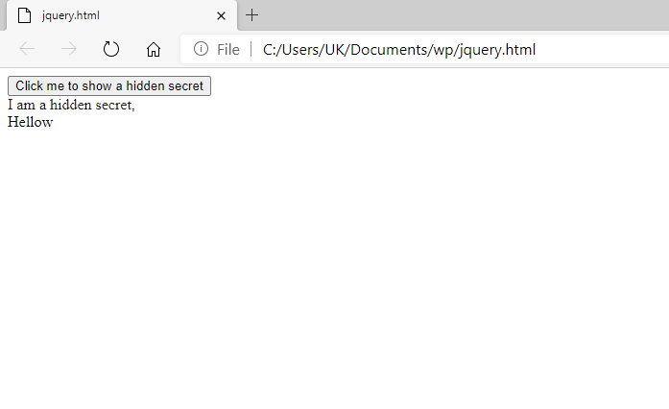

Exercise 2

HTML

<span>Enter your name:</span>

<input type="text" id="name">

<button id="greet">Greet me!</button>

JavaScript

// Call say("Hi!") to have your computer say hi!

// This only works on recent versions of Safari

// and Chrome at the moment.

function say(text) {

var msg = new SpeechSynthesisUtterance(text);

window.speechSynthesis.speak(msg);

}

Instructions:

Add jQuery that greets the user by calling the above say function whenever the user clicks the "Greet me!"

button, taking into account the value of the text field.

For example, if the user types the word "Bob" into the text field, then the computer should say "Hello

Bob!" when the button is clicked.

Source code:-

<!doctype html>

<html lang="en">

<head>

<meta charset="utf-8" />

<title>Exercise 2</title>

</head>

<body>

<form>

<div>Your name:</div>

<input name="enterName" id="enterName" type="text">

<div style="margin-top:10px;" class="submit">

<input value="Greet Me!" id="submit_this" type="button">

</div>

</form>

<br>

<div id="result"></div>

<script>

$(document).ready(function() {

var greeting = function(name) {

var name = $('#enterName').val();

name = 'Hello,' + ' ' + name;

console.log('Hello,' + '' + name);

$('#result').text(name);

};

$('#submit_this').click(function() {

greeting();

//prompt('Great to see you,' + '' + name);

});

});

</script>

</body>

</html>

Output:-

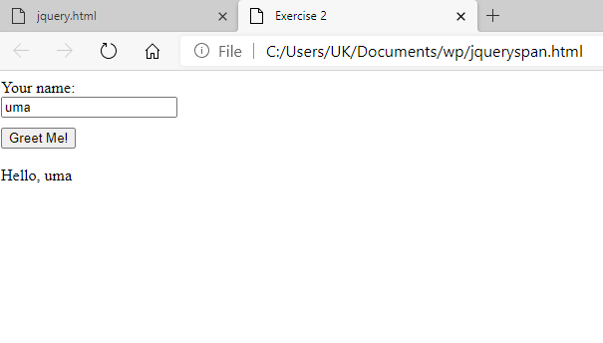

Exercise 3

HTML

<button id="clicker">Click me to hide the hidden secrets!</button>

<p class="secret">I am hidden secret #1.</p>

<p class="secret">I am hidden secret #2.</p>

<p class="secret">I am hidden secret #2.</p>

<p>I am <em>not</em> a hidden secret.</p>

Instructions:

Add jQuery code to modify the page so that when the user clicks the button, the paragraphs that start

with the words "I am a hidden secret" slide up.

Source code:-

<!DOCTYPE html>

<html>

<head>

<script src="https://ajax.googleapis.com/ajax/libs/jquery/3.5.1/jquery.min.js"></script>

<script>

$(document).ready(function(){

$("button").click(function(){

$("p").toggle();

$("#secret").fadeTo("slow",0.9);

$("#secret1").fadeOut("slow",0.5);

$("#slide").slidedown("slow");

$("Clicker").prop('value','click');

});

});

</script>

</head>

<body>

<button id="Clicker">Click me to show a hidden secret</button>

<p class="secret">I am hidden secret #1.</p>

<p class="secret">I am hidden secret #2.</p>

<p class="secret">I am hidden secret #3.</p>

<p>I am <em>not</em>a hidden secret.</p>

</body>

</html>

Output:-

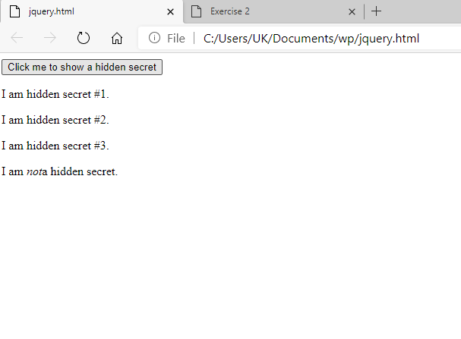

Exercise 4

<img src="http://hackasaurus.toolness.org/images/goggles/supergirl.png">

<p>

<button id="clicker">Click me to change the picture</button>

</p>

Instructions:

Change the page with jQuery so that when the button is clicked, the image changes to this:

Source Code:-

<!DOCTYPE html>

<html>

<head>

<script src="https://ajax.googleapis.com/ajax/libs/jquery/3.5.1/jquery.min.js"></script>

<script>

$(document).ready(function(){

$("#Clicker").click(function(){

$("img").before("Rose");

});

});

</script>

</head>

<body>

<img src="rose.jpg" alt="jQuery"width="50" height="50"><br><br>

<button id="Clicker">Click me to show a hidden secret</button>

</body>

</html>

Output:-

