SYNCHRONOUS FIFO
SVA-BASED VERIFICATION
Simulation, Assertions, Functional Coverage and Waveform Results
Design | 8-bit synchronous FIFO
FIFO depth | 8 entries
Verification | SystemVerilog Assertions + SystemVerilog testbench
Simulation | Verilator 5.032 with VCD tracing
Waveform | GTKWave — waves/fifo.vcd
Verification status: SUCCESSFUL

1. Objective
The objective is to verify an 8-bit, depth-8 synchronous FIFO using a SystemVerilog testbench, SystemVerilog Assertions (SVA), functional coverage, and waveform analysis. The completed environment exercises reset, normal FIFO operation, full/empty boundaries, data ordering, simultaneous read/write, and illegal boundary operations.

2. Verification Environment
The testbench instantiates the synchronous FIFO and a functional-coverage block. The captured testbench configuration uses DATA_WIDTH = 8, DEPTH = 8 and a count width derived from $clog2(DEPTH + 1). It also generates waves/fifo.vcd for waveform inspection.
- DUT: sync_fifo
- Testbench: fifo_tb
- Assertions: fifo_sva.sv
- Functional coverage: fifo_coverage.sv
- Clock: 10 ns period
- Waveform: waves/fifo.vcd
- Simulator: Verilator 5.032
- Waveform viewer: GTKWave

3. Test Plan and Results
Test | Stimulus | Expected result | Status
1. Reset | Apply and release reset | EMPTY, not FULL, count=0 | PASS
2. Write 8 values | Write values 1 through 8 | FIFO reaches depth 8 | PASS
3. FIFO FULL | Check full condition | full=1, count=8 | PASS
4. Read 8 values | Read all entries | FIFO data order verified | PASS
5. FIFO EMPTY | After all reads | empty=1, count=0 | PASS
6. Write after EMPTY | Write 0xA5 | count=1 | PASS
7. Read after write | Read 0xA5 | Returned data=0xA5 | PASS
8. Corner cases | WRITE/FULL, RD+WR, drain, READ/EMPTY | Occupancy remains legal | PASS
9. Final state | Final FIFO check | EMPTY, not FULL, count=0 | PASS
The testbench source explicitly contains the nine verification stages above, including data-order checks and coverage-directed corner cases.

4. SVA Verification
Assertions were enabled during simulation. The verification checks the legal FIFO occupancy range and boundary behavior, including the protection of the FULL and EMPTY states. No assertion failure was reported in the completed simulation output.
- FIFO occupancy remains within the legal range.
- FIFO does not overflow beyond DEPTH.
- WRITE while FULL does not increase occupancy.
- READ while EMPTY does not corrupt occupancy.
- Reset establishes the EMPTY state.
- The final state returns to EMPTY.

5. Functional Coverage Results
Coverage item | Observed | Meaning
Writes | 19 | Write operations
Reads | 19 | Read operations
Simultaneous RD + WR | 1 | Both operations in one cycle
EMPTY | 10 | EMPTY state samples
FULL | 5 | FULL state samples
PARTIAL | 60 | Intermediate occupancy
COUNT = 0 | 10 | Zero occupancy
COUNT = 1 | 10 | One entry
COUNT = MID | 40 | Intermediate count
COUNT = DEPTH-1 | 10 | One below full
COUNT = DEPTH | 5 | Full occupancy
WRITE while FULL | 1 | Boundary operation
READ while EMPTY | 1 | Boundary operation
EMPTY -> NONEMPTY | 3 | State transition
NONEMPTY -> EMPTY | 3 | State transition
NONFULL -> FULL | 2 | State transition
FULL -> NONFULL | 2 | State transition
Total sampled cycles | 75 | Coverage sampling
Reset cycles | 1 | Reset activity

6. Waveform Evidence
GTKWave successfully opened waves/fifo.vcd. The waveform shows clock, reset, FIFO count, EMPTY/FULL flags, read/write enables and read/write data. The displayed simulation reaches approximately 756 ns.
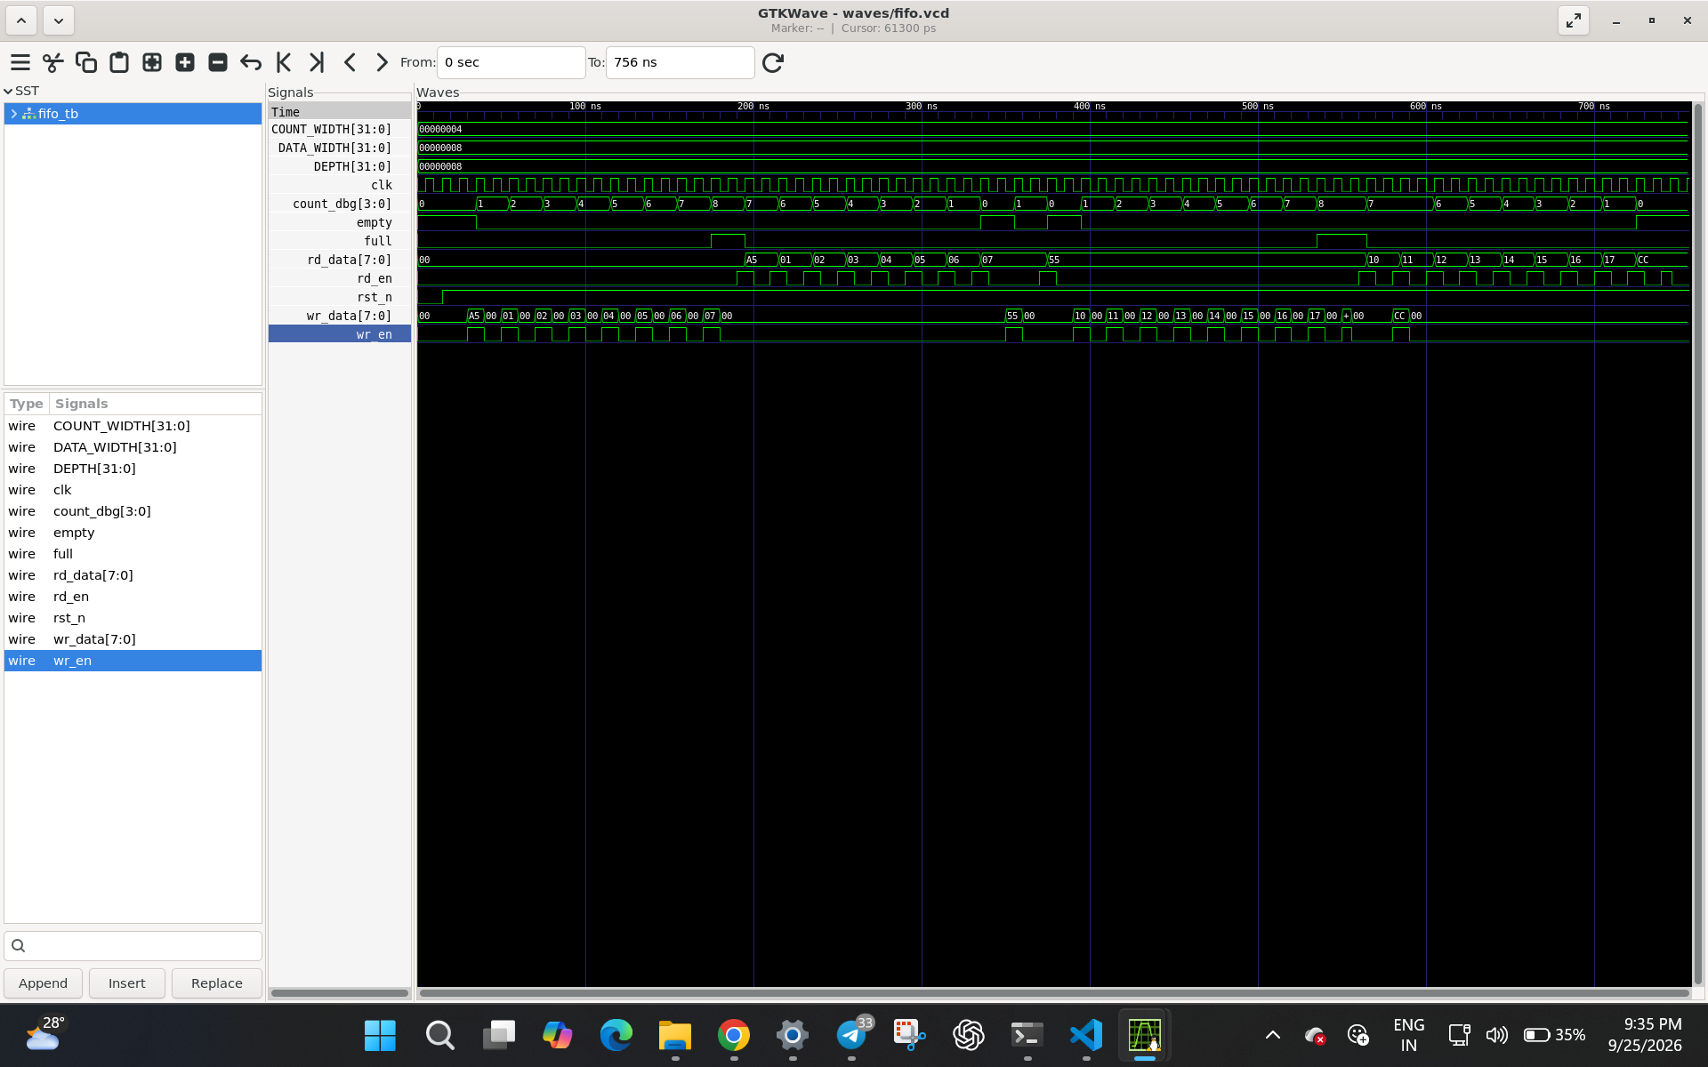
Figure 1. GTKWave waveform generated from waves/fifo.vcd.

7. Functional Coverage Evidence
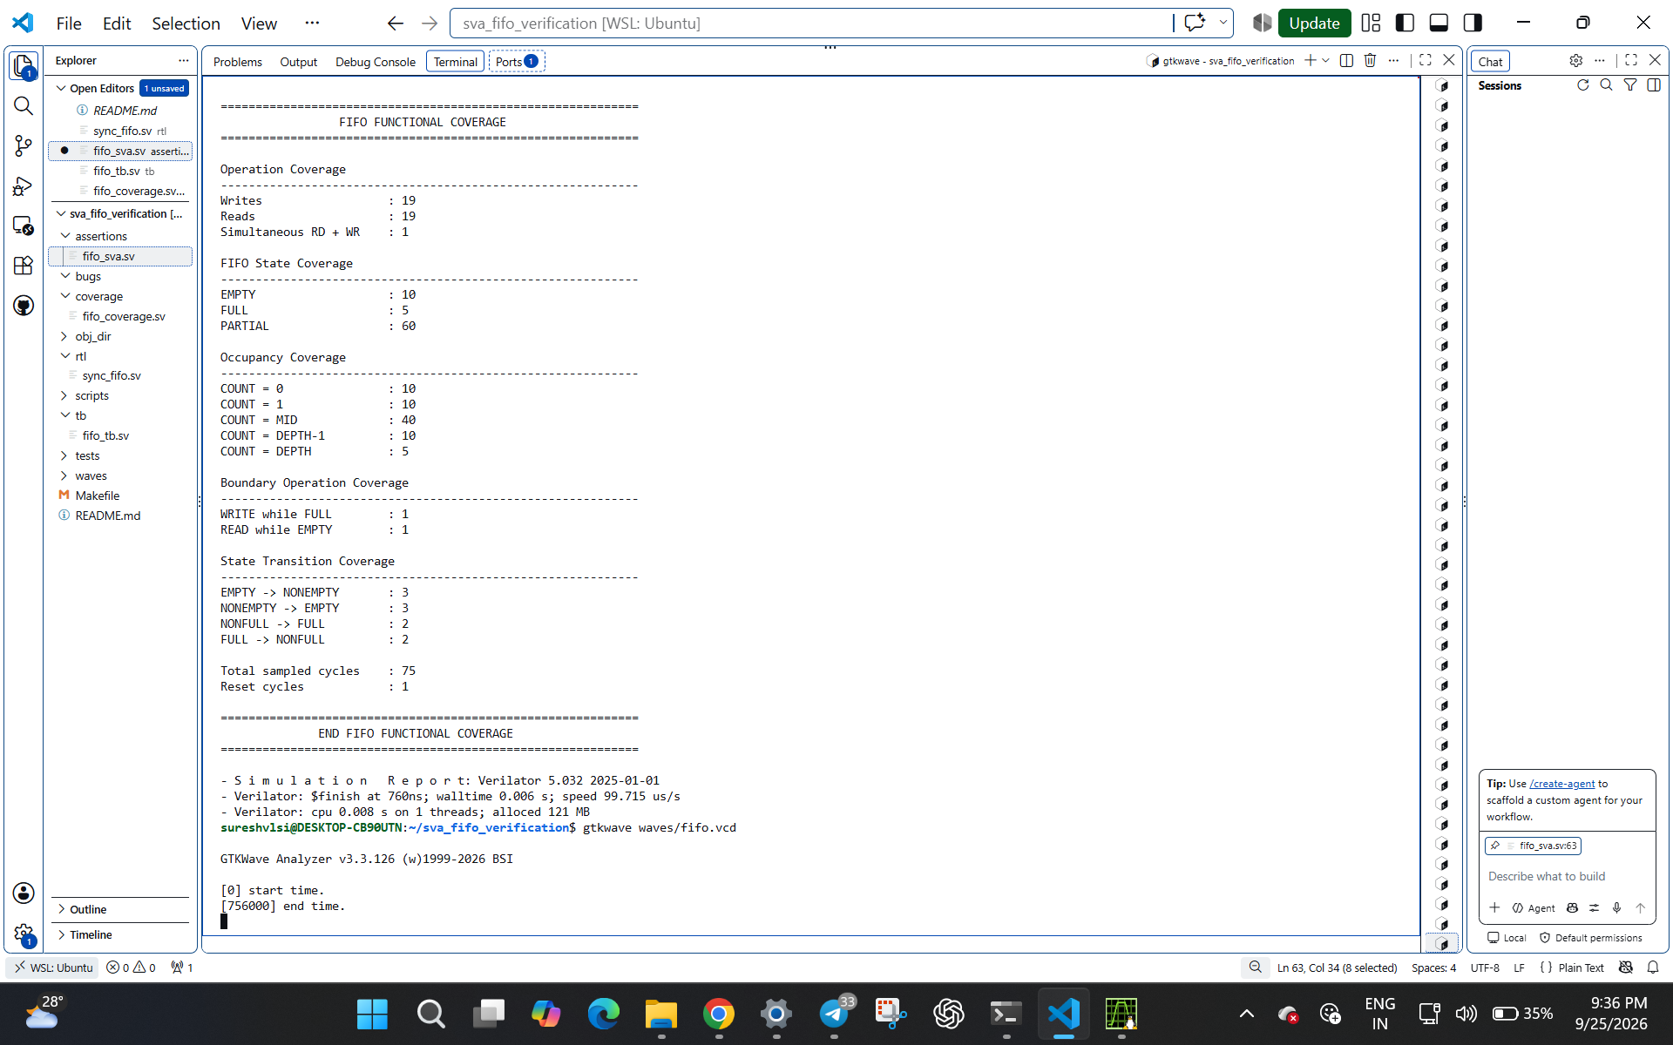
Figure 2. Terminal output showing the completed FIFO functional coverage report.

8. Result Discussion
The completed run demonstrates successful execution of the FIFO test sequence and generation of both functional-coverage data and a VCD waveform. The coverage report shows that normal operation, EMPTY/FULL/PARTIAL states, occupancy boundaries, state transitions, simultaneous read/write, WRITE while FULL and READ while EMPTY were all exercised.
The corner-case test sequence intentionally attempts illegal boundary operations and then checks that FIFO occupancy remains unchanged. This provides direct verification of the boundary behavior rather than relying only on normal-operation tests.

9. Conclusion
The synchronous FIFO verification environment completed successfully. The final evidence consists of the completed test sequence, SVA-enabled simulation, functional coverage report, and GTKWave waveform. The verification covers the principal FIFO operating states and the specified boundary cases.

10. Reproduction Commands
verilator --binary --timing --trace --assert --top-module fifo_tb -Wno-WIDTH \
rtl/sync_fifo.sv assertions/fifo_sva.sv coverage/fifo_coverage.sv tb/fifo_tb.sv
./obj_dir/Vfifo_tb
gtkwave waves/fifo.vcd

11. Configuration Summary
- DATA_WIDTH = 8 bits
- DEPTH = 8 entries
- COUNT_WIDTH = $clog2(DEPTH + 1)
- Clock period = 10 ns
- Top testbench = fifo_tb
- VCD file = waves/fifo.vcd

