1) Open a command prompt from your PC , type ftp <ipaddress or hostname >. Login as root ID once you get the login prompt on your screen.
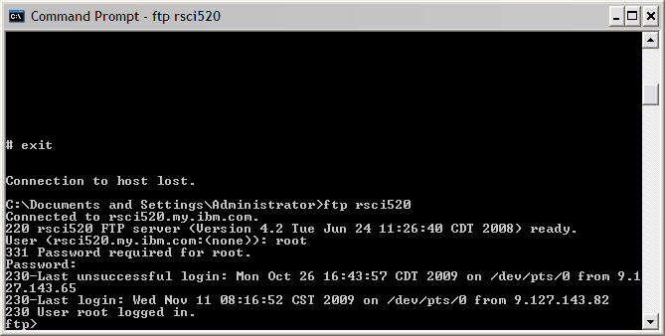

2) change directory to /tmp/ibmsupt : cd /tmp/ibmsupt
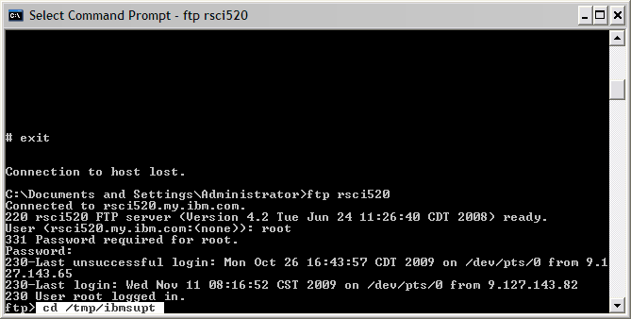

3) Change it to BINARY format.
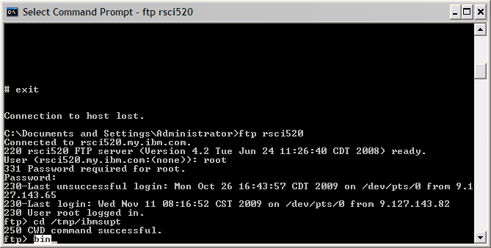

4) Check your current directory : pwd
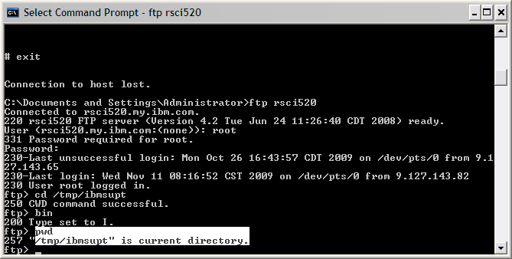

5) ftp snap.pax.Z to your PC : get snap.pax.Z. You should get “transfer complete” if the process is successful.
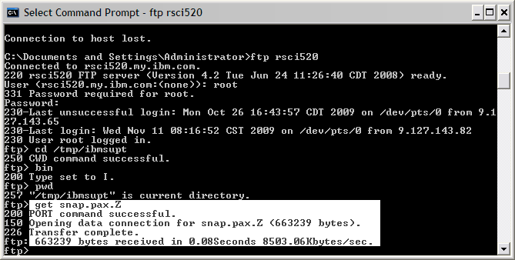

6) exit from ftp : bye.
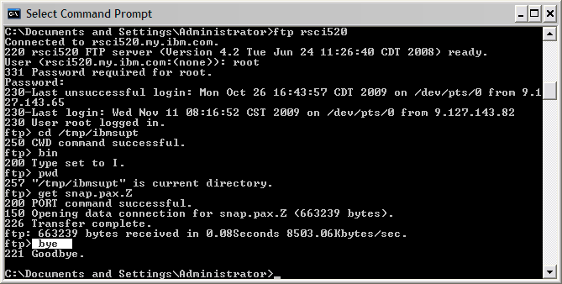

7) Now, back to your PC command prompt window. Make sure you are currently in the desired directory which you’ve ftp the snap.pax.Z file earlier.
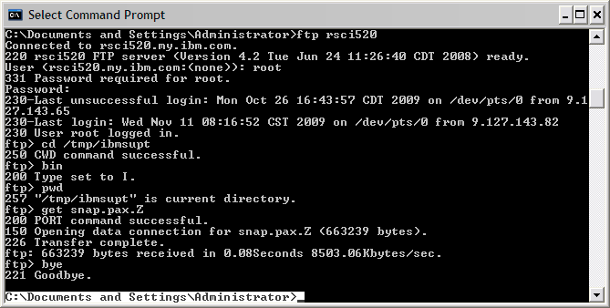

8) Verify whether snap.pax.Z is present : dir/w
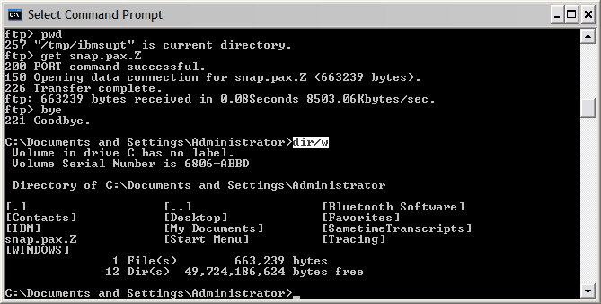

9) Yes it is.
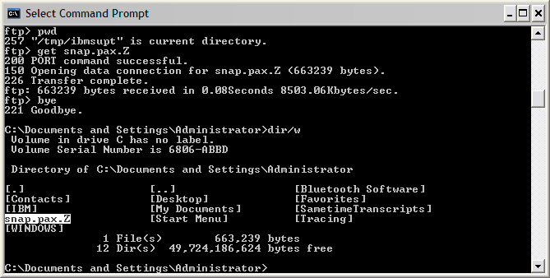

10) Now, open window explorer and identify the snap.pax.Z file and you may attach snap.pax.Z file to email ID rsc@my.ibm.com and cc to aseanrsc@gmail.com .
