Kickstart server in 10 Steps
This is a quick tutorial on how to setup an Apache based Kickstart install server for provisioning Red Hat or CentOS hosts in your environment. By Kickstarting a host/s you can save time and standardize your environment by defining a configuration file that all hosts will use to perform automated installs.
1. Head over to centos.org and download the iso of the CentOS release you are interested in. I will be using CentOS 5.4 for the purposes of this tutorial.
2. Install Apache.
Check your system for Apache being installed using:
[root@kickstart kickstart]# rpm -qa |grep -i httpd
If nothing returns issue:
yum -y install httpd
This should download and install the dependencies for Apache.
3. Create a install root where we will be installing the contents of the cdrom to. I’ll be using the default document root in /var/www/html.
mkdir /var/www/html/centos5
4. Mount the iso you downloaded to a mount point.
[root@kickstart iso]# mount -o loop CentOS-5.4-i386-bin-DVD.iso /mnt
5. Copy the contents of the iso into the directory you created.
cp -ar /mnt/* /var/www/html/centos5/
6. Create a directory to house your kickstart configurations. Once again I’ll be using Apache’s default document root of /var/www/html. I will be creating a directory called ks to store my configurations.
mkdir /var/www/html/ks
7. Create the kickstart configuration file. I named my configuration ks.cfg and dropped it in the ks directory we created in step 6. Here is what I use for my kickstart profile. Very minimal config.
text
install
url --url http://192.168.3.128/centos5
lang en_US.UTF-8
keyboard us
langsupport --default=en_US.UTF-8 en_US.UTF-8
network --device eth0 --bootproto dhcp
rootpw --iscrypted $1$/KEoeArl$f5TokNUdzGIqlvRCLFWW9/
firewall --disabled
selinux --disabled
authconfig --enableshadow --enablemd5
timezone America/New_York
bootloader --location=mbr --append="console=xvc0"
#
zerombr yes
clearpart --all
part /boot --asprimary --fstype="ext3" --size=100 --bytes-per-inode=4096
part swap --asprimary --fstype="swap" --recommended --bytes-per-inode=4096
part / --asprimary --fstype="ext3" --grow --size=1 --bytes-per-inode=4096
reboot
#
%packages --nobase
authconfig
crontabs
kbd
kudzu
man
ntp
openssh-clients
openssh-server
passwd
pciutils
rootfiles
rpm
system-config-securitylevel-tui
traceroute
yum
yum-updatesd
vim-minimal
vixie-cron
which
wget
unzip
kudzu
man
ntp
openssh-clients
openssh-server
passwd
pciutils
rootfiles
rpm
system-config-securitylevel-tui
traceroute
yum
yum-updatesd
vim-minimal
vixie-cron
which
wget
unzip
sudo
%post
(
chkconfig --level 3 ip6tables off
chkconfig --level 3 kudzu off
chkconfig --level 3 netfs off
chkconfig --level 3 yum-updatesd off
#
useradd -p 'myreallycomplexpass' someuser
) 2&gt;&amp;1 | tee /root/post-install.log
8. Use the dvd you downloaded or grab a copy of the boot.iso from the install root. You can either use the install DVD iso you or use the 10MB boot.iso located in centos5/images/boot.iso I choose to use the boot.iso since its 10MB and is easily distributable.
9. Start up the Apache process
[root@kickstart images]# service httpd start
Starting httpd: [ OK ]
10. Now for the Moment of truth. Boot the system with boot.iso or install DVD. At the boot prompt enter:
linux ks=http://your_kickstart_ip/ks/ks.cfg
If all went well the system should boot and fetch the kickstart config. Then the installation will begin hands off.

RAID 0a, RAID 1, RAID 5, RAID 10 Explained with Diagrams
RAID stands for Redundant Array of Inexpensive (Independent) Disks.
On most situations you will be using one of the following four levels of RAIDs.
- RAID 0
- RAID 1
- RAID 5
- RAID 10 (also known as RAID 1+0)
In all the diagrams mentioned below:
- A, B, C, D, E and F – represents blocks
- p1, p2, and p3 – represents parity

RAID LEVEL 0
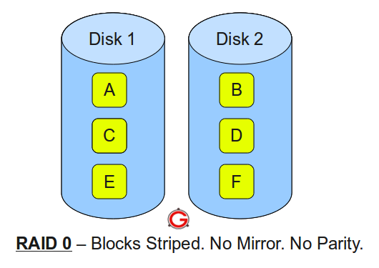
Following are the key points to remember for RAID level 0.
- Minimum 2 disks.
- Excellent performance ( as blocks are striped ).
- No redundancy ( no mirror, no parity ).
- Don’t use this for any critical system.

RAID LEVEL 1
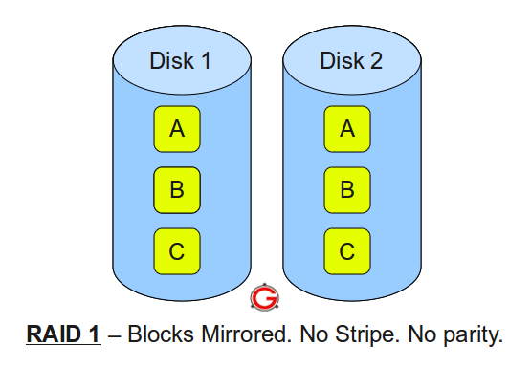Following are the key points to remember for RAID level 1.
- Minimum 2 disks.
- Good performance ( no striping. no parity ).
- Excellent redundancy ( as blocks are mirrored ).

RAID LEVEL 5
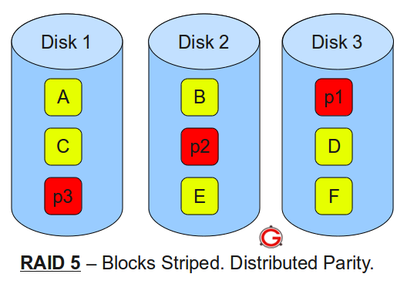
Following are the key points to remember for RAID level 5.
- Minimum 3 disks.
- Good performance ( as blocks are striped ).
- Good redundancy ( distributed parity ).
- Best cost effective option providing both performance and redundancy. Use this for DB that is heavily read oriented. Write operations will be slow.

RAID LEVEL 10
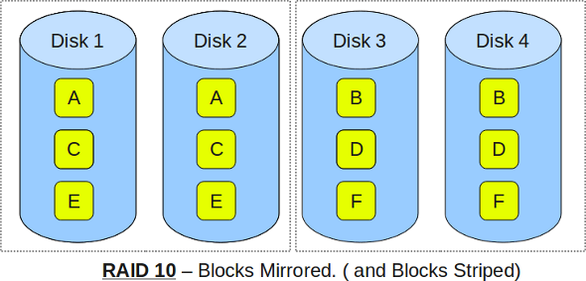Following are the key points to remember for RAID level 10.
- Minimum 4 disks.
- This is also called as “stripe of mirrors”
- Excellent redundancy ( as blocks are mirrored )
- Excellent performance ( as blocks are striped )
- If you can afford the dollar, this is the BEST option for any mission critical applications (especially databases).

Additional RAID Tutorials:
- RAID 2, RAID 3, RAID 4, RAID 6 Explained with Diagram
- RAID 10 Vs RAID 01 (RAID 1+0 Vs RAID 0+1)

An experienced Linux sysadmin knows the importance of running the routine maintenance jobs in the background automatically.
Linux Cron utility is an effective way to schedule a routine background job at a specific time and/or day on an on-going basis.
This article is part of the on-going Productivity Tips For Geeks series. In this article, let us review 15 awesome examples of crontab job scheduling.

Linux Crontab Format
MIN HOUR DOM MON DOW CMD
Table: Crontab Fields and Allowed Ranges (Linux Crontab Syntax)
Field | Description | Allowed Value
MIN | Minute field | 0 to 59
HOUR | Hour field | 0 to 23
DOM | Day of Month | 1-31
MON | Month field | 1-12
DOW | Day Of Week | 0-6
CMD | Command | Any command to be executed.

1. Scheduling a Job For a Specific Time
The basic usage of cron is to execute a job in a specific time as shown below. This will execute the Full backup shell script (full-backup) on 10th June 08:30 AM.
Please note that the time field uses 24 hours format. So, for 8 AM use 8, and for 8 PM use 20.
30 08 10 06 * /home/ramesh/full-backup
- 30 – 30th Minute
- 08 – 08 AM
- 10 – 10th Day
- 06 – 6th Month (June)
- * – Every day of the week

2. Schedule a Job For More Than One Instance (e.g. Twice a Day)
The following script take a incremental backup twice a day every day.
This example executes the specified incremental backup shell script (incremental-backup) at 11:00 and 16:00 on every day. The comma separated value in a field specifies that the command needs to be executed in all the mentioned time.
00 11,16 * * * /home/ramesh/bin/incremental-backup
- 00 – 0th Minute (Top of the hour)
- 11,16 – 11 AM and 4 PM
- * – Every day
- * – Every month
- * – Every day of the week

3. Schedule a Job for Specific Range of Time (e.g. Only on Weekdays)
If you wanted a job to be scheduled for every hour with in a specific range of time then use the following.

Cron Job everyday during working hours
This example checks the status of the database everyday (including weekends) during the working hours 9 a.m – 6 p.m
00 09-18 * * * /home/ramesh/bin/check-db-status
- 00 – 0th Minute (Top of the hour)
- 09-18 – 9 am, 10 am,11 am, 12 am, 1 pm, 2 pm, 3 pm, 4 pm, 5 pm, 6 pm
- * – Every day
- * – Every month
- * – Every day of the week

Cron Job every weekday during working hours
This example checks the status of the database every weekday (i.e excluding Sat and Sun) during the working hours 9 a.m – 6 p.m.
00 09-18 * * 1-5 /home/ramesh/bin/check-db-status
- 00 – 0th Minute (Top of the hour)
- 09-18 – 9 am, 10 am,11 am, 12 am, 1 pm, 2 pm, 3 pm, 4 pm, 5 pm, 6 pm
- * – Every day
- * – Every month
- 1-5 -Mon, Tue, Wed, Thu and Fri (Every Weekday)

4. How to View Crontab Entries?

View Current Logged-In User’s Crontab entries
To view your crontab entries type crontab -l from your unix account as shown below.
ramesh@dev-db$ crontab -l
@yearly /home/ramesh/annual-maintenance
*/10 * * * * /home/ramesh/check-disk-space

[Note: This displays crontab of the current logged in user]

View Root Crontab entries
Login as root user (su – root) and do crontab -l as shown below.
root@dev-db# crontab -l
no crontab for root

Crontab HowTo: View Other Linux User’s Crontabs entries
To view crontab entries of other Linux users, login to root and use -u {username} -l as shown below.
root@dev-db# crontab -u sathiya -l
@monthly /home/sathiya/monthly-backup
00 09-18 * * * /home/sathiya/check-db-status

Edit Current Logged-In User’s Crontab entries
To edit a crontab entries, use crontab -e as shown below. By default this will edit the current logged-in users crontab.
ramesh@dev-db$ crontab -e
@yearly /home/ramesh/centos/bin/annual-maintenance
*/10 * * * * /home/ramesh/debian/bin/check-disk-space

[Note: This will open the crontab file in Vim editor for editing.
Please note cron created a temporary /tmp/crontab.XX... ]
When you save the above temporary file with :wq, it will save the crontab and display the following message indicating the crontab is successfully modified.

Edit Root Crontab entries
Login as root user (su – root) and do crontab -e as shown below.
root@dev-db# crontab -e

Edit Other Linux User’s Crontab File entries
To edit crontab entries of other Linux users, login to root and use -u {username} -e as shown below.
root@dev-db# crontab -u sathiya -e
@monthly /home/sathiya/fedora/bin/monthly-backup
00 09-18 * * * /home/sathiya/ubuntu/bin/check-db-status
- When you specify */5 in minute field means every 5 minutes.
- When you specify 0-10/2 in minute field mean every 2 minutes in the first 10 minute.
- Thus the above convention can be used for all the other 4 fields.

7. Schedule a Background Cron Job For Every 10 Minutes.
Use the following, if you want to check the disk space every 10 minutes.
*/10 * * * * /home/ramesh/check-disk-space
It executes the specified command check-disk-space every 10 minutes through out the year. But you may have a requirement of executing the command only during office hours or vice versa. The above examples shows how to do those things.
Instead of specifying values in the 5 fields, we can specify it using a single keyword as mentioned below.
There are special cases in which instead of the above 5 fields you can use @ followed by a keyword — such as reboot, midnight, yearly, hourly.
Table: Cron special keywords and its meaning
Keyword | Equivalent
@yearly | 0 0 1 1 *
@daily | 0 0 * * *
@hourly | 0 * * * *
@reboot | Run at startup.

8. Schedule a Job For First Minute of Every Year using @yearly
If you want a job to be executed on the first minute of every year, then you can use the @yearly cron keyword as shown below.
This will execute the system annual maintenance using annual-maintenance shell script at 00:00 on Jan 1st for every year.
@yearly /home/ramesh/red-hat/bin/annual-maintenance

9. Schedule a Cron Job Beginning of Every Month using @monthly
It is as similar as the @yearly as above. But executes the command monthly once using @monthly cron keyword.
This will execute the shell script tape-backup at 00:00 on 1st of every month.
@monthly /home/ramesh/suse/bin/tape-backup

10. Schedule a Background Job Every Day using @daily
Using the @daily cron keyword, this will do a daily log file cleanup using cleanup-logs shell scriptat 00:00 on every day.
@daily /home/ramesh/arch-linux/bin/cleanup-logs "day started"

11. How to Execute a Linux Command After Every Reboot using @reboot?
Using the @reboot cron keyword, this will execute the specified command once after the machine got booted every time.
@reboot CMD

12. How to Disable/Redirect the Crontab Mail Output using MAIL keyword?
By default crontab sends the job output to the user who scheduled the job. If you want to redirect the output to a specific user, add or update the MAIL variable in the crontab as shown below.
ramesh@dev-db$ crontab -l
MAIL="ramesh"

@yearly /home/ramesh/annual-maintenance
*/10 * * * * /home/ramesh/check-disk-space

[Note: Crontab of the current logged in user with MAIL variable]
If you wanted the mail not to be sent to anywhere, i.e to stop the crontab output to be emailed, add or update the MAIL variable in the crontab as shown below.
MAIL=""

13. How to Execute a Linux Cron Jobs Every Second Using Crontab.
You cannot schedule a every-second cronjob. Because in cron the minimum unit you can specify is minute. In a typical scenario, there is no reason for most of us to run any job every second in the system.

14. Specify PATH Variable in the Crontab
All the above examples we specified absolute path of the Linux command or the shell-script that needs to be executed.
For example, instead of specifying /home/ramesh/tape-backup, if you want to just specify tape-backup, then add the path /home/ramesh to the PATH variable in the crontab as shown below.
ramesh@dev-db$ crontab -l

PATH=/bin:/sbin:/usr/bin:/usr/sbin:/home/ramesh

@yearly annual-maintenance
*/10 * * * * check-disk-space

[Note: Crontab of the current logged in user with PATH variable]

15. Installing Crontab From a Cron File
Instead of directly editing the crontab file, you can also add all the entries to a cron-file first. Once you have all thoese entries in the file, you can upload or install them to the cron as shown below.
ramesh@dev-db$ crontab -l
no crontab for ramesh

$ cat cron-file.txt
@yearly /home/ramesh/annual-maintenance
*/10 * * * * /home/ramesh/check-disk-space

ramesh@dev-db$ crontab cron-file.txt

ramesh@dev-db$ crontab -l
@yearly /home/ramesh/annual-maintenance
*/10 * * * * /home/ramesh/check-disk-space
Note: This will install the cron-file.txt to your crontab, which will also remove your old cron entries. So, please be careful while uploading cron entries from a cron-file.txt.

TOP

1° Row — top

This first line indicates in order:
- current time (11:37:19)
- uptime of the machine (up 1 day, 1:25)
- users sessions logged in (3 users)
- average load on the system (load average: 0.02, 0.12, 0.07) the 3 values refer to the last minute, five minutes and 15 minutes.

2° Row – task
The second row gives the following information:
- Processes running in totals (73 total)
- Processes running (2 running)
- Processes sleeping (71 sleeping)
- Processes stopped (0 stopped)
- Processes waiting to be stoppati from the parent process (0 zombie)

3° Row – cpu
The third line indicates how the cpu is used. If you sum up all the percentages the total will be 100% of the cpu. Let’s see what these values indicate in order:
- Percentage of the CPU for user processes (0.3%us)
- Percentage of the CPU for system processes (0.0%sy)
- Percentage of the CPU processes with priority upgrade nice (0.0%ni)
- Percentage of the CPU not used (99,4%id)
- Percentage of the CPU processes waiting for I/O operations(0.0%wa)
- Percentage of the CPU serving hardware interrupts (0.3% hi — Hardware IRQ
- Percentage of the CPU serving software interrupts (0.0% si — Software Interrupts
- The amount of CPU ‘stolen’ from this virtual machine by the hypervisor for other tasks (such as running another virtual machine) this will be 0 on desktop and server without Virtual machine. (0.0%st — Steal Time)

4° and 5° Rows – memory usage
The fourth and fifth rows respectively indicate the use of physical memory (RAM) and swap. In this order: Total memory in use, free, buffers cached. On this topic you can also read the following article

Following Rows — Processes list
And as last thing ordered by CPU usage (as default) there are the processes currently in use. Let’s see what information we can get in the different columns:
- PID – l’ID of the process(4522)
- USER – The user that is the owner of the process (root)
- PR – priority of the process (15)
- NI – The “NICE” value of the process (0)
- VIRT – virtual memory used by the process (132m)
- RES – physical memory used from the process (14m)
- SHR – shared memory of the process (3204)
- S – indicates the status of the process: S=sleep R=running Z=zombie (S)
- %CPU – This is the percentage of CPU used by this process (0.3)
- %MEM – This is the percentage of RAM used by the process (0.7)
- TIME+ –This is the total time of activity of this process (0:17.75)
- COMMAND – And this is the name of the process (bb_monitor.pl)

