ELK Server Details:
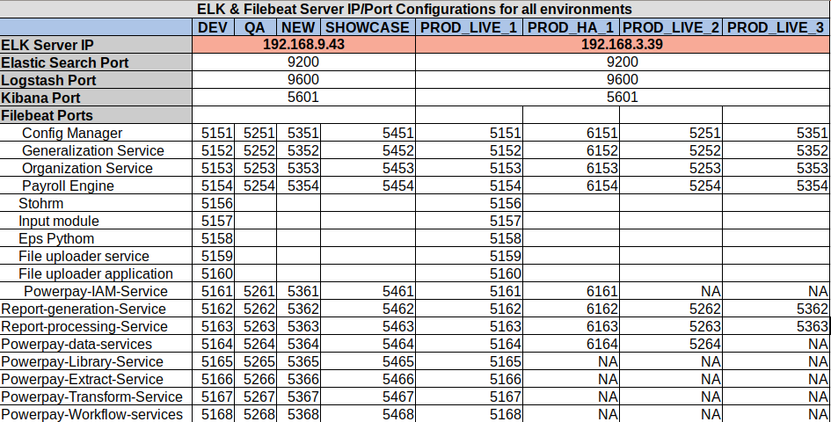
**Filebeat ports: Ports enabled in ELK servers for logstash – Filebeat communication

ELK Installation:
ELK can be installed through ansible script frombelow repository location:
https://gitlab.ascent-online.com/powerpay/power-pay-k8s

1. Login to 192.168.9.16 as root
2. Clone above git repository to a location in above server.
3. cd power-pay-k8s/blob/master/Ansible_modules/All-in-one/
4. Run ‘ansible-playbook elk-playbook.yml -i All-in-One/inv.ini -e ‘hosts=ELK’

Run elk-playbook.yml file to install elasticsearch, logstash and kibana. Filebeat will be installed as part of application deployment through ansible.
Related Files & Location:
- Elasticsearch:
Configuration Files: /etc/elasticsearch/elasticsearch.yml
Data Files Path: /var/lib/elasticsearch
Log File Path: /var/log/elasticsearch
- Logstash:
  - Configuration Files:
    - /etc/logstash/pipelines.yml
    - /etc/logstash/conf.d/<env>/ogstash-<app_name>.conf
  - Log File:
    - /var/log/logstash/logstash-plain.log
- Kibana Configuration files:
/etc/kibana/kibana.yml
- Filebeat:
/etc/filebeat/filebeat.yml

Steps for configuration:
- Elasticsearch:
  - cd /etc/elasticsearch & open elasticsearch.yml for editing.

  - Update below settings if not already present/enabled
    - http.cors.enabled: true
    - http.cors.allow-origin: "*"
    - network.host: 0.0.0.0
    - http.port: 9200
    - discovery.seed_hosts: ["0.0.0.0","host1"]

  - Save and close the file.
  - Restart elasticsearch by running ‘sudo systemctl restart elasticsearch.service’

- Logstash:
  - cd /etc/logstash
  - Update pipelines.yml file with required configuration. Refer https://gitlab.ascent-online.com/powerpay/power-pay-k8s/blob/master/Ansible_modules/All-in-one/roles/logstash/templates/powerpay-apps/pipelines.yml
for sample
  - cd /etc/logstash/conf.d
  - Add logstash conf file for the application. Refer https://gitlab.ascent-online.com/powerpay/power-pay-k8s/blob/master/Ansible_modules/All-in-one/roles/logstash/templates/powerpay-apps/conf.d/prod_live/logstash-config-manager.conf or sample.
  - Restart Logstash service by running ‘sudo systemctl restart logstash.serice’

- Kibana:
  - Copy kibana.yml from below location into /etc/kibana
  - Restart Kibana service by running ‘sudo systemctl restart kibana.service’

- Filebeat:
  - Filbeat configuration is automated using ansible scripts. Refer https://gitlab.ascent-online.com/pnbhat/provisional-deployment-scripts/tree/master/roles/filebeat-app for scripts.
  - For configuring filebeat for new applications:
    - Add filebeat configuration file into /etc/filebeat/filebeat-<app_name>.yml
    - Refer https://gitlab.ascent-online.com/pnbhat/provisional-deployment-scripts/blob/master/roles/filebeat-app/templates/filebeat.yml for template.
    - Create a systemd service for running app specific filebeat service. Refer https://gitlab.ascent-online.com/pnbhat/provisional-deployment-scripts/blob/master/roles/filebeat-app/templates/application.service for systems service script.

    - Restart Filebeat service by running ‘sudo systemctl restart filebeat-<app_name>.service’

Restart hierarchy for ELK :

- Stop Filebeat
- Stop Kibana
- Stop Logstash
- Stop Elasticsearch

- Start Elasticsearch
- Start Logstash
- Start Kibana
- Start Filebeat

