Community DAO Treasury – Phase 1 Documentation
Suresh Veeraboina-Web3 & Blockchain Developer Intern,EtherAuthority
sureshyadav6114@gmail.com

Table of Contents
- Executive Summary
- Project Overview
- Technical Architecture
- System Components
- Implementation Phases
- Testing & Validation
- Security Framework
- Deployment Strategy
- Success Criteria
- Conclusion

1. Executive Summary

1.1 Project Purpose
This document describes the development of a Community DAO On-Chain Treasury Module - a blockchain-based system that enables democratic, transparent management of community funds through smart contracts and decentralized governance.

1.2 Key Objectives
- Build a non-custodial treasury where no single entity controls funds
- Implement DAO-governed spending through democratic voting
- Ensure complete transparency of all financial operations
- Automate trustless execution of approved proposals

1.3 Core Deliverables
✅ Three interconnected smart contracts
✅ Backend API for blockchain data indexing
✅ Comprehensive testing framework
✅ Complete technical documentation
✅ Live demonstration on test network

1.4 Learning Outcomes
By completing this project, interns will understand: - DAO governance mechanisms - Smart contract architecture patterns - Blockchain event indexing - Security best practices - End-to-end dApp development

2. Project Overview

2.1 Business Context
The platform serves as a community-centric blockchain where cities and communities operate as autonomous DAOs (Community DAOs or cDAOs). Each cDAO requires a treasury system to: - Accept community contributions - Store funds securely on-chain - Enable members to propose spending initiatives - Vote democratically on fund allocation - Execute approved transactions automatically

2.2 Problem Statement
Traditional community fund management suffers from: - Lack of transparency - unclear how funds are used - Centralized control - single points of failure and trust issues - No oversight - members have no say in spending decisions - Manual processes - slow, error-prone approval workflows

2.3 Solution Approach
A blockchain-based system that provides: - On-chain storage - funds held in smart contracts - Democratic governance - all members can vote - Full transparency - every transaction is public - Automated execution - approved proposals execute trustlessly - Immutable records - complete audit trail

2.4 Scope Definition
What This Module Does: - Securely holds community funds - Accepts deposits from any address - Creates and manages proposals - Conducts democratic voting - Executes approved fund releases - Logs all operations transparently
What This Module Does NOT Do: - Member identity verification (KYC) - Service marketplace operations - Token trading or exchange - Cross-chain transfers - Lending or borrowing

3. Technical Architecture

3.1 System Overview
The system consists of three layers:
Blockchain Layer: - Three smart contracts managing treasury, governance, and execution - Deployed on Ethereum-compatible blockchain - Immutable business logic
Backend Layer: - Event indexing service - REST API server - MongoDB database for query optimization
Frontend Layer (Optional): - Web dashboard for user interaction - MetaMask integration for transactions

3.2 Architecture Diagram
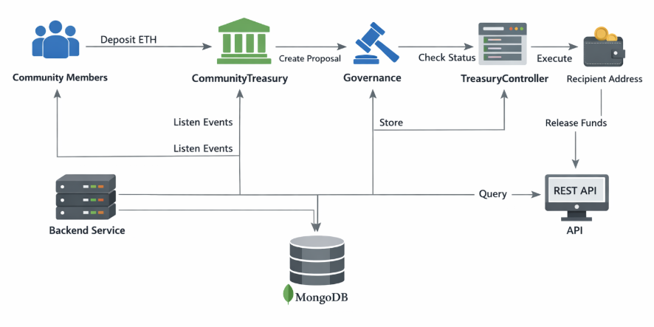

3.3 Smart Contract Architecture
Contract 1: CommunityTreasury - Role: Secure vault for funds - Key Functions: - Accept deposits - Store funds safely - Release funds only via authorized controller - Track all transactions
Contract 2: Governance - Role: Democratic voting system - Key Functions: - Create spending proposals - Manage voting periods - Count votes and determine outcomes - Track proposal lifecycle
Contract 3: TreasuryController - Role: Execute approved proposals - Key Functions: - Verify proposal approval - Transfer funds to recipients - Prevent double execution - Maintain execution logs

3.4 Data Flow
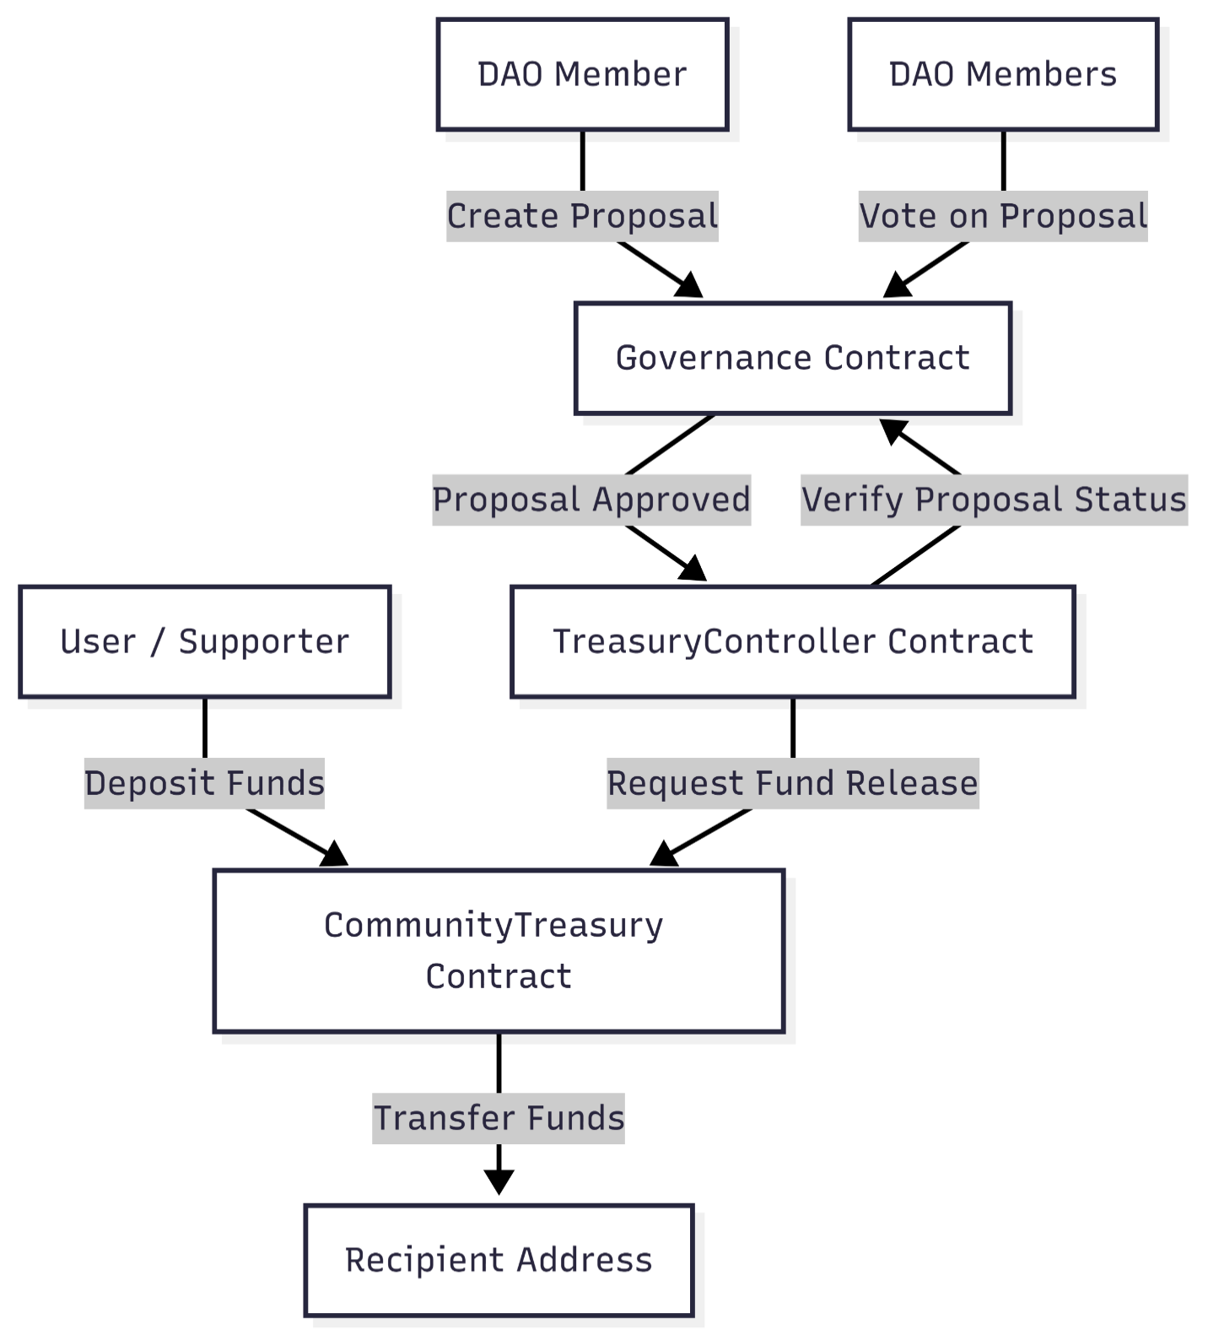

Complete User Journey:
- Deposit Phase
  - Member sends ETH to Treasury contract
  - Contract records contribution and emits event
  - Balance updated transparently
- Proposal Phase
  - Member creates spending proposal with recipient and amount
  - Governance contract validates and creates proposal
  - Voting period begins automatically
- Voting Phase
  - DAO members cast votes (yes/no)
  - One vote per address
  - Votes counted in real-time
- Finalization Phase
  - Voting period ends
  - System checks if quorum met
  - Proposal marked as Passed or Rejected
- Execution Phase
  - Anyone can trigger execution (permissionless)
  - Controller verifies approval status
  - Funds transferred to recipient
  - Proposal marked as executed

3.5 Technology Stack
Component | Technology | Purpose
Smart Contracts | Solidity 0.8.x | Business logic
Development Framework | Hardhat | Testing & deployment
Testing | Chai, Mocha | Quality assurance
Backend Runtime | Node.js | Server environment
API Framework | Express.js | REST endpoints
Database | MongoDB | Event storage
Blockchain Library | ethers.js | Contract interaction
Network | Ethereum Sepolia | Test deployment

4. System Components

4.1 CommunityTreasury Contract
Purpose: Secure storage and controlled release of community funds.
State Management: - Tracks individual contributions per address - Maintains total balance - Stores controller and governance addresses
Core Functionality: - Deposit: Anyone can contribute ETH to the treasury - Release: Only controller can release funds after approval - Balance Query: Public view of current treasury balance - Access Control: Role-based permissions prevent unauthorized access
Events: - FundsDeposited(address from, uint256 amount, uint256 timestamp) - FundsReleased(address to, uint256 amount, uint256 timestamp)
Security Features: - Reentrancy protection using OpenZeppelin guards - Access control modifiers - Balance validation before transfers - Comprehensive event logging

4.2 Governance Contract
Purpose: Democratic proposal creation and voting mechanism.
Proposal Structure: Each proposal contains: - Unique ID - Proposer address - Recipient address - Requested amount - Description - Vote counts (yes/no) - Voting period timestamps - Current state
Proposal States: - Pending: Just created - Active: Voting in progress - Passed: Approved by voters - Rejected: Did not meet requirements - Executed: Funds released - Cancelled: Withdrawn by proposer
Voting Mechanism: - Voting Period: 3 days (configurable) - Quorum Requirement: 10% of members must vote - Decision Rule: Simple majority (yes votes > no votes) - One Vote Per Address: Prevents double voting
Core Functions: - createProposal: Start new spending proposal - vote: Cast vote on active proposal - finalizeProposal: Determine outcome after voting ends - getProposalState: Query current proposal status

4.3 TreasuryController Contract
Purpose: Execute approved proposals with safety checks.
Execution Logic: 1. Verify proposal exists 2. Check execution hasn’t occurred 3. Confirm proposal is in “Passed” state 4. Retrieve proposal details from Governance 5. Call Treasury to release funds 6. Mark proposal as executed 7. Emit execution event
Safety Mechanisms: - Idempotency: Cannot execute same proposal twice - State Verification: Cross-checks with Governance contract - Execution Records: Maintains mapping of executed proposals - Permissionless Execution: Any address can trigger (trustless)
Events: - ProposalExecuted(uint256 proposalId, address recipient, uint256 amount)

4.4 Backend System
Event Indexing Service: - Listens to all contract events in real-time - Parses event data and stores in MongoDB - Handles blockchain reorganizations - Provides fast query access to historical data
Database Collections:
Deposits Collection: - Depositor address - Amount in wei - Timestamp - Transaction hash - Block number
Proposals Collection: - Proposal ID - Proposer and recipient addresses - Amount requested - Description - Vote counts - State and timestamps - Execution status
Votes Collection: - Proposal ID reference - Voter address - Vote decision (yes/no) - Timestamp - Transaction hash
API Endpoints:
Endpoint | Method | Description
/api/treasury/balance | GET | Current treasury status
/api/treasury/deposits | GET | Deposit history with pagination
/api/proposals | GET | List proposals with filters
/api/proposals/:id | GET | Specific proposal details
/api/proposals/:id/votes | GET | Votes for a proposal

5. Implementation Phases

Phase 1: Concept & Design (Week 1)
Objectives: - Understand DAO treasury fundamentals - Research existing implementations - Design system architecture - Create technical specifications
Activities: - Study real-world DAOs (Uniswap, Compound, MakerDAO) - Research governance mechanisms and voting systems - Draw system architecture diagrams - Define contract interfaces and data structures - Identify security requirements
Deliverables: - Research document (2-3 pages) - System architecture diagram - Contract specifications - Security threat analysis
Key Concepts to Master: - Non-custodial treasury management - DAO governance principles - Smart contract design patterns - Blockchain transparency benefits

Phase 2: CommunityTreasury Contract (Week 2)
Objectives: - Implement secure fund storage - Enable deposit functionality - Create controlled release mechanism - Ensure comprehensive testing
Activities: - Set up Hardhat development environment - Implement Treasury smart contract - Add OpenZeppelin security libraries - Write comprehensive unit tests - Test edge cases and validations - Optimize gas usage - Create deployment script
Key Features to Implement: - Deposit function with event emission - Access-controlled release function - Balance query methods - Reentrancy protection - Role management
Deliverables: - Fully functional CommunityTreasury contract - Unit test suite (>90% coverage) - Deployment script - Gas optimization report - Security self-audit checklist
Testing Focus: - Deposit acceptance and tracking - Unauthorized access prevention - Balance calculations - Event emissions - Error handling

Phase 3: Governance Contract (Week 3)
Objectives: - Build democratic voting system - Implement proposal lifecycle management - Create vote counting mechanism - Handle edge cases properly
Activities: - Implement proposal creation logic - Build voting mechanism with safeguards - Create proposal finalization function - Test voting scenarios extensively - Implement quorum calculations - Add time-based validations
Key Features to Implement: - Proposal data structure - Vote tracking per address - Time period management - State transitions - Quorum verification
Deliverables: - Complete Governance contract - Integration tests with Treasury - Voting scenario test suite - Documentation of governance parameters
Edge Cases to Handle: - Voting after period ends - Double voting attempts - Proposals exceeding treasury balance - Quorum not met scenarios - Same-block voting attacks

Phase 4: TreasuryController Contract (Week 4)
Objectives: - Implement proposal execution logic - Prevent double execution - Ensure state synchronization - Complete end-to-end integration
Activities: - Build execution verification logic - Implement cross-contract calls - Add execution tracking - Create comprehensive integration tests - Test full DAO workflow - Document contract interactions
Key Features to Implement: - Execution status tracking - Proposal approval verification - Treasury fund release coordination - Execution event emission
Deliverables: - TreasuryController contract - Full integration test suite - End-to-end workflow tests - Contract interaction documentation
Integration Testing: - Complete flow: deposit → propose → vote → execute - Multiple concurrent proposals - Insufficient funds scenarios - Unauthorized execution attempts - State consistency validation

Phase 5: Backend & API Development (Week 5)
Objectives: - Index blockchain events - Build REST API - Optimize data queries - Enable real-time updates
Activities: - Set up Node.js + Express server - Configure MongoDB database - Implement event listening service - Build API endpoints - Create data aggregation queries - Add error handling and logging - Write API documentation
Backend Components: - Event listener service - Database models and schemas - API route handlers - Treasury analytics service - Proposal status tracker
Deliverables: - Running backend server - MongoDB integration - Complete API endpoints - API documentation (Swagger) - Postman test collection
API Features: - Treasury balance and statistics - Deposit history with pagination - Proposal listing with filters - Vote tracking per proposal - Real-time data updates

Phase 6: Testing & Demonstration (Week 6)
Objectives: - Conduct comprehensive testing - Deploy to test network - Create live demonstration - Document complete project
Activities: - Run full test suite on all contracts - Measure test coverage - Deploy to Sepolia testnet - Verify contracts on Etherscan - Create demo scenario - Record walkthrough video - Prepare presentation materials - Document lessons learned
Test Categories: - Unit tests for each contract - Integration tests across contracts - Security vulnerability tests - Gas optimization verification - API endpoint testing - End-to-end user flows
Demo Scenario: 1. Deploy all contracts to testnet 2. Fund treasury from multiple accounts 3. Create three different proposals 4. Conduct voting with various outcomes 5. Execute approved proposal 6. Show transaction on block explorer 7. Display data via API dashboard 8. Demonstrate transparency features
Deliverables: - Test coverage report (>90%) - Testnet deployment addresses - Demo video (5-10 minutes) - User guide document - Presentation slides - Project retrospective

6. Testing & Validation

6.1 Testing Strategy
Multi-Layer Testing Approach:
Unit Testing: - Test each contract function independently - Verify expected behavior with valid inputs - Test error handling with invalid inputs - Validate event emissions - Check state changes
Integration Testing: - Test contract interactions - Verify cross-contract calls - Validate data consistency - Test workflow sequences - Check authorization flows
Security Testing: - Test access control mechanisms - Validate reentrancy protection - Check for overflow/underflow - Test authorization bypass attempts - Verify double-execution prevention
Performance Testing: - Measure gas costs per operation - Optimize expensive operations - Test under load conditions - Validate scalability limits

6.2 Test Coverage Goals
Component | Target Coverage | Critical Areas
CommunityTreasury | >95% | Fund release, access control
Governance | >90% | Voting logic, state transitions
TreasuryController | >95% | Execution logic, verification
Backend API | >85% | Event indexing, data accuracy

7. Security Framework

7.1 Security Principles
Defense in Depth: - Multiple layers of security controls - No single point of failure - Fail-safe defaults
Principle of Least Privilege: - Contracts only have necessary permissions - Role-based access control - Minimal trust assumptions
Transparency: - All operations logged via events - Public state variables for critical data - Open-source code for auditing

7.2 Threat Model
Threat | Impact | Mitigation
Reentrancy Attack | Fund drainage | ReentrancyGuard, Checks-Effects-Interactions
Unauthorized Access | Improper fund release | Role-based modifiers, access control
Double Execution | Duplicate fund release | Execution tracking mapping
Integer Overflow | Incorrect calculations | Solidity 0.8+ built-in checks
Front-Running | Vote manipulation | Commit-reveal (future enhancement)
Gas Limit DoS | Service disruption | Avoid unbounded loops
Timestamp Manipulation | Voting period abuse | Use block.timestamp carefully

7.3 Security Best Practices
Code Quality: - Use audited libraries (OpenZeppelin) - Follow established patterns - Keep contracts simple and focused - Avoid complex logic
Access Control: - Implement role-based permissions - Use modifiers for authorization - Validate all external calls - Restrict privileged functions
State Management: - Follow Checks-Effects-Interactions pattern - Update state before external calls - Validate state transitions - Use reentrancy guards
Event Logging: - Emit events for all state changes - Include relevant data in events - Use indexed parameters for filtering - Log both success and failure
Testing: - Achieve high test coverage - Test attack scenarios - Use security analysis tools - Conduct peer reviews

7.4 Audit Preparation
Pre-Audit Checklist: - [ ] Code freeze with version tag - [ ] Complete documentation - [ ] High test coverage achieved - [ ] Security tools run clean - [ ] Known issues documented - [ ] Access control verified - [ ] Event emissions validated - [ ] Gas optimization completed

8. Deployment Strategy

8.1 Testnet Deployment
Environment Setup: - Network: Ethereum Sepolia - Wallet: MetaMask with test ETH - RPC Provider: Infura or Alchemy - Block Explorer: Sepolia Etherscan
Deployment Steps: 1. Configure Hardhat for Sepolia network 2. Secure private key in environment variables 3. Deploy Governance contract 4. Deploy CommunityTreasury contract 5. Deploy TreasuryController contract 6. Link contracts (set controller address) 7. Verify contracts on Etherscan 8. Test basic functionality 9. Document contract addresses
Post-Deployment Validation: - Verify contract source code - Test deposit function - Create test proposal - Conduct test voting - Execute approved proposal - Verify all events emitted - Check block explorer visibility

8.2 Mainnet Deployment Considerations
Pre-Mainnet Requirements: - [ ] Professional security audit completed - [ ] Audit findings resolved - [ ] Bug bounty program launched - [ ] Multi-sig wallet for admin functions - [ ] Emergency pause mechanism - [ ] Upgrade strategy defined - [ ] Insurance coverage obtained - [ ] Legal review completed - [ ] Monitoring and alerts configured - [ ] Incident response plan ready
Deployment Checklist: - [ ] Final code freeze - [ ] Comprehensive testing completed - [ ] Gas costs optimized - [ ] Documentation finalized - [ ] Community notified - [ ] Deployment transaction reviewed - [ ] Multi-sig approval obtained - [ ] Contracts deployed - [ ] Verification completed - [ ] Monitoring activated

8.3 Ongoing Maintenance
Monitoring: - Track contract balance - Monitor proposal activity - Alert on unusual patterns - Track gas costs - Monitor API uptime
Community Management: - Respond to questions - Document common issues - Publish governance updates - Share treasury reports - Facilitate voting process

9. Success Criteria

9.1 Technical Metrics
Metric | Target | Measurement
Test Coverage | >90% | Hardhat coverage report
Deposit Gas Cost | <50,000 gas | Gas reporter analysis
Security Issues | 0 critical | Security tool outputs
API Response Time | <200ms | Load testing
Contract Uptime | 100% | Blockchain inherent
Event Indexing Delay | <1 minute | Backend monitoring

9.2 Functional Requirements
✅ Funds Are Safe: - No unauthorized withdrawals possible - Reentrancy protection verified - Access control enforced - Balance tracking accurate
✅ All Actions Are Transparent: - Every operation emits events - All data publicly queryable - Transaction history complete - Audit trail maintained
✅ DAO Controls Treasury: - No single admin can release funds - Democratic voting determines outcomes - Execution requires proposal approval - Community has full oversight

9.3 Learning Objectives Achieved
Technical Knowledge: - DAO treasury mechanics understood - Governance patterns mastered - Smart contract architecture skills - Blockchain transparency benefits
Practical Skills: - Solidity development proficiency - Testing best practices applied - Backend integration experience - Deployment and verification skills
Professional Growth: - Project management experience - Documentation capabilities - Problem-solving skills - Blockchain domain expertise

9.4 Sepolia Testnet Deployment

Deployment Summary
The complete Community DAO system has been successfully deployed to the Sepolia testnet and all contracts have been verified on Etherscan for transparency and auditability.
Deployment Details: - Network: Ethereum Sepolia Testnet - Chain ID: 11155111 - Deployment Date: February 10, 2026 - Deployment Time: 21:09:22 IST - Deployer Address: 0x3A875e02c59c75296069DF86709e6C1a6fF58268

Deployed Contract Addresses

1. CommunityTreasury Contract
Address: 0xBA0068A2d4b7425Fd981148fA19252C9f7395338
Purpose: Secure vault for community DAO funds with controlled release mechanism
Etherscan Verification: View on Sepolia Etherscan ✅
Constructor Parameters: - Admin Address: 0x3A875e02c59c75296069DF86709e6C1a6fF58268 - Governance Contract: 0x6DF52A54716f93E211D624C597c4D0D74b2CE280

2. Governance Contract
Address: 0x6DF52A54716f93E211D624C597c4D0D74b2CE280
Purpose: Democratic voting system for Community DAO treasury proposals
Etherscan Verification: View on Sepolia Etherscan ✅
Constructor Parameters: - Admin Address: 0x3A875e02c59c75296069DF86709e6C1a6fF58268
Configuration: - Total Voters: 100 - Voting Period: 3 days - Quorum Requirement: 10%

3. TreasuryController Contract
Address: 0xd7B3C133C93328f3B043Ef1401Bc85063089e05e
Purpose: Controller contract that executes approved governance proposals
Etherscan Verification: View on Sepolia Etherscan ✅
Constructor Parameters: - Admin Address: 0x3A875e02c59c75296069DF86709e6C1a6fF58268 - Governance Contract: 0x6DF52A54716f93E211D624C597c4D0D74b2CE280 - Treasury Contract: 0xBA0068A2d4b7425Fd981148fA19252C9f7395338

Contract Relationships
┌──────────────────────────────────┐
│ Governance Contract │
│ (Proposal & Voting System) │
│ │
│ 0x6DF52A54716f93E211D624C597 │
│ c4D0D74b2CE280 │
└────────────┬─────────────────────┘
│
│ Approved proposals
│ forwarded to
▼
┌──────────────────────────────────┐ ┌──────────────────────────────────┐
│ TreasuryController Contract │ │ CommunityTreasury Contract │
│ (Execution Coordinator) │─────▶│ (Funds Vault) │
│ │ │ │
│ 0xd7B3C133C93328f3B043Ef1401 │ │ 0xBA0068A2d4b7425Fd981148fA │
│ Bc85063089e05e │ │ 19252C9f7395338 │
└──────────────────────────────────┘ └──────────────────────────────────┘
Executes funds Releases funds to
release after approved recipients
verification

Verification Status
All three contracts have been successfully verified on Sepolia Etherscan:
Contract | Status | Verification Link
CommunityTreasury | ✅ Verified | View Source Code
Governance | ✅ Verified | View Source Code
TreasuryController | ✅ Verified | View Source Code
Users can now view the complete source code, read contract documentation (NatSpec comments), and interact with the contracts directly through Etherscan’s interface.

Testing the Deployed Contracts

Prerequisites
Before testing, you’ll need: 1. MetaMask wallet connected to Sepolia network 2. Sepolia testnet ETH - Get free test ETH from Sepolia Faucet 3. Multiple test accounts (optional, for voting simulation)

Method 1: Testing via Etherscan (Recommended for Beginners)
This method allows you to interact with contracts directly through your browser.
Step 1: Deposit Funds to Treasury
- Visit the CommunityTreasury contract: 0xBA0068A2d4b7425Fd981148fA19252C9f7395338
- Click on the “Contract” tab, then “Write Contract”
- Click “Connect to Web3” to connect your MetaMask wallet
- Find the deposit function
- Enter an amount (e.g., 0.01 ETH) in the payableAmount field
- Click “Write” and confirm the transaction in MetaMask
- Wait for confirmation, then verify the balance increased
Step 2: Create a Spending Proposal
- Visit the Governance contract: 0x6DF52A54716f93E211D624C597c4D0D74b2CE280
- Go to “Write Contract” tab
- Find the createProposal function
- Enter the parameters:
  - _recipient: Address to receive funds (e.g., 0x742d35Cc6634C0532925a3b844Bc9e7595f0bEb)
  - _amount: Amount in wei (e.g., 5000000000000000 = 0.005 ETH)
  - _description: “Community event sponsorship”
- Click “Write” and confirm the transaction
- Note the proposal ID from the transaction logs (Events tab)
Step 3: Vote on the Proposal
- Still in the Governance contract, find the vote function
- Enter the parameters:
  - _proposalId: The ID from Step 2 (e.g., 0)
  - _support: true for yes, false for no
- Click “Write” and confirm
- (Optional) Switch to other MetaMask accounts and cast more votes
- Check the proposal status:
  - Go to “Read Contract” tab
  - Use getProposal with your proposal ID
  - View vote counts and current state
Step 4: Finalize the Proposal
Note: You must wait for the voting period (3 days) to end before finalizing. For testing purposes, you can modify this in the contract or test on a local network.
- After the voting period ends, call finalizeProposal
- Enter your _proposalId
- Click “Write” and confirm
- The contract will determine if the proposal passed:
  - Quorum met? (10% of 100 voters = 10 votes minimum)
  - Majority yes? (yes votes > no votes)
- Check the updated proposal state (should be “Passed” if successful)
Step 5: Execute the Approved Proposal
- Visit the TreasuryController contract: 0xd7B3C133C93328f3B043Ef1401Bc85063089e05e
- Go to “Write Contract” tab
- Find the executeProposal function
- Enter your _proposalId
- Click “Write” and confirm
- The controller will:
  - Verify the proposal is approved
  - Check treasury has sufficient funds
  - Release funds to the recipient
  - Mark proposal as executed
- Verify the transaction:
  - Check recipient’s balance increased
  - View the ProposalExecuted event in transaction logs
  - Confirm treasury balance decreased

Testing Checklist
Use this checklist to verify all functionality:
- ☐ Deposit Test
  - ☐ Deposit succeeded and event emitted
  - ☐ Treasury balance increased correctly
  - ☐ Contribution tracked for depositor address
- ☐ Proposal Creation Test
  - ☐ Proposal created with valid parameters
  - ☐ Proposal ID generated correctly
  - ☐ Voting period started automatically
  - ☐ ProposalCreated event emitted
- ☐ Voting Test
  - ☐ Votes cast successfully during voting period
  - ☐ Double voting prevented
  - ☐ Vote counts updated correctly
  - ☐ VoteCast events emitted
- ☐ Proposal Finalization Test
  - ☐ Finalization only works after voting period
  - ☐ Quorum requirement checked
  - ☐ Majority requirement checked
  - ☐ Final state determined correctly (Passed/Rejected)
- ☐ Proposal Execution Test
  - ☐ Execution only works for approved proposals
  - ☐ Funds transferred to correct recipient
  - ☐ Proposal marked as executed
  - ☐ Double execution prevented
  - ☐ ProposalExecuted event emitted
- ☐ Access Control Test
  - ☐ Only controller can release treasury funds
  - ☐ Admin functions restricted properly
  - ☐ Unauthorized actions rejected
- ☐ Edge Cases
  - ☐ Cannot execute unapproved proposals
  - ☐ Cannot vote after voting period ends
  - ☐ Cannot execute with insufficient treasury balance
  - ☐ Cannot finalize proposal twice

Monitoring Deployed Contracts
View Transaction History: - Treasury deposits: Etherscan Events - Proposal activity: Etherscan Events - Executions: Etherscan Events
Read Contract State: - Current treasury balance: Call getBalance() on CommunityTreasury - Proposal details: Call getProposal(id) on Governance - Proposal count: Call getProposalCount() on Governance - Execution status: Call isProposalExecuted(id) on TreasuryController
Important Links: - Sepolia Faucet: https://sepoliafaucet.com/ - Sepolia Explorer: https://sepolia.etherscan.io/ - MetaMask: https://metamask.io/

10. Conclusion

10.1 Project Summary
This project successfully delivers a complete DAO treasury system that enables transparent, democratic management of community funds. Through three interconnected smart contracts and a supporting backend infrastructure, the system provides:
- Security: Non-custodial storage with multi-layer protection
- Democracy: Fair voting mechanism for all members
- Transparency: Complete visibility of all operations
- Automation: Trustless execution of approved decisions

10.2 Key Achievements
✅ Technical Excellence - Production-ready smart contracts - Comprehensive testing (>90% coverage) - Secure architecture following best practices - Efficient gas optimization
✅ Functional Completeness - Full deposit and withdrawal cycle - Democratic governance implementation - Automated proposal execution - Real-time data accessibility
✅ Documentation Quality - Clear technical specifications - Detailed implementation guides - Security analysis - User documentation

10.3 Real-World Impact
This DAO treasury module enables communities to: - Manage shared resources democratically - Make collective financial decisions - Maintain complete transparency - Build trust through blockchain technology
The system demonstrates how blockchain technology can empower communities to govern themselves without centralized intermediaries.

10.4 Future Enhancements
Potential Improvements: - Multi-token support (ERC20 tokens) - Tiered voting (weighted by stake) - Delegation mechanisms - Scheduled recurring payments - Budget allocation categories - Advanced analytics dashboard - Mobile application - Multi-chain deployment

10.5 Lessons Learned
Key Takeaways: - Smart contract simplicity enhances security - Comprehensive testing is essential - Event logging enables transparency - Separation of concerns improves maintainability - User experience matters in blockchain apps

10.6 Final Remarks
This project provides a solid foundation for understanding decentralized governance and blockchain-based financial systems. The implemented DAO treasury showcases the power of code as law and demonstrates how smart contracts can create transparent, fair, and democratic systems for collective resource management.
The successful completion of this project equips interns with valuable blockchain development skills and deep understanding of DAO mechanisms - knowledge that is increasingly valuable in the evolving Web3 ecosystem.

End of Document

