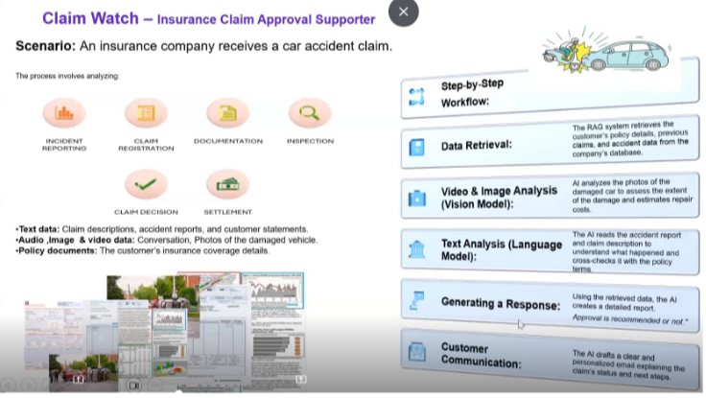

Manual process:

- Incident reporting.
- Claim registration.
- Documentation.
- Inspection.
- Claim decision.
- Settlement.

GenAI Implemented approach:

Step by step workflow:

- Data retrieval: The RAG system retrieves the customer’s policy details, previous claims, and accident data from the company’s database.
- Video & Image Analysis (Vision Models): Ai Analyze the photos of the damaged car to assess the extent of the damage and estimates repair costs.
- Text analysis (Language model): The AI reads the accident report and claim description to understand what happened and cross check with it with the policy terms.
- Generating response: Using the retrieved data , the Ai creates a detailed report. And approval is recommended or not.
- Customer communication: The AI drafts a clear and personalized email explaining the claim’s status and next steps.

