JDBC

---------------

* JDBC stands for Java Database Connectivity.
* JDBC is a Java API to connect and execute the query with the database.
* It is a part of JavaSE (Java Standard Edition).
* JDBC API uses JDBC drivers to connect with the database.

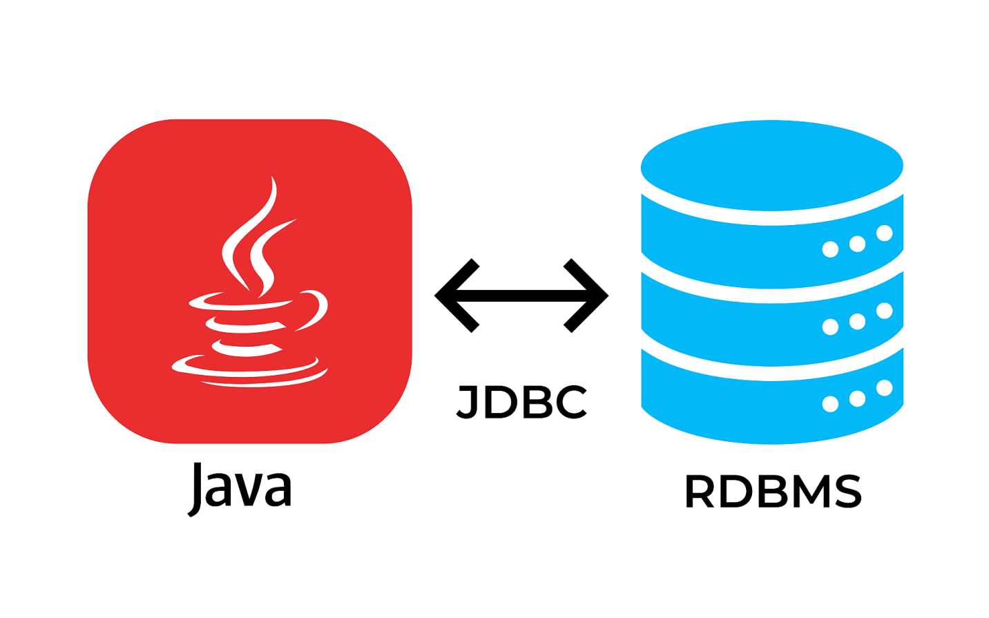

* There are four types of JDBC drivers:

1. JDBC-ODBC Bridge Driver,
2. Native Driver,
3. Network Protocol Driver, and
4. Thin Driver

Sun MicroSystem was released JDBC API, this API consists set of classes and interfaces.

The JDBC related classes and interfaces are available in packages are

* java.sql
* javax.sql

The most important interface names of JDBC is

* Driver
* Connection
* Statement
* PreparedStatement
* CallableStatement
* ResultSet
* DatabaseMetaData
* ResultSetMetaData

The most important class names of JDBC is

* DriverManager
* Types

We can use JDBC API to handle database using Java program and can perform the following activities:

* Connect to the database
* Execute queries and update statements to the database
* Retrieve the result received from the database.

There are 5 steps to connect any java application with the database using JDBC. These steps are as follows:

* Register the Driver class
* Create connection
* Create statement
* Execute queries
* Close connection

**Prerequisite for JDBC**

**Core Java, Mysql Installation, MySql Jar**

In this example we are using MySql as the database. So we need to know following informations for the mysql database:

* **Driver class:** The driver class for the mysql database is **com.mysql.jdbc.Driver**.
* **Connection URL:** The connection URL for the mysql database is jdbc:mysql://localhost:3306/sonoo where jdbc is the API, mysql is the database, localhost is the server name on which mysql is running, we may also use IP address, 3306 is the port number and sonoo is the database name. We may use any database, in such case, we need to replace the sonoo with our database name.
* **Username:** The default username for the mysql database is root.
* **Password:** It is the password given by the user at the time of installing the mysql database. In this example, we are going to use root as the password.