Q) What is data?
Ans) Data is an information about an object. It can be text, numbers, images, video’s and so on.
Ex: Information about a person: Name, age, DOB, sex, address, height and weight.
Q) What are advantages and disadvantages of files?
Ans) When we store data in files then it will store in hard disk. Data will store permanently in the hard disk which is secondary storage area for storing data permanently.
Disadvantages:
- Data Redundancy: Redundancy is nothing but repetition of sample data multiple times. This leads to memory wastage.
- Data Inconsistency: There may be a possibility that two users are maintaining same files data for different applications. Hence a changes made in files by one user does not reflect in files used by second users, which leads to inconsistency of data.
- Difficulty in searching data: Suppose we have 10,000 records and when we want to search for 9000 record, then it will read data from file in sequential order. So there is no random read write option in files.

Q) What is Database?
Ans) To overcome all the problems in files , we will go for the database.
Database is a collection of data, stored in an organized format. It is also called as repository. It is represented in cylindrical form.
We can easily access, update and manage data in database.
Q) What is DBMS?
Ans)It is a software(system) which is used to manage the database.
Database + Management + System
It contains a set of programs that allows users to access and modify these files.
It is used to interact with the database for reading/retrieving data from the database and saving/inserting data into the database and can modify the data in the database.
It facilitates the processes of defining, constructing, manipulating, and sharing databases among various users and applications.
Q) What are different structural types in DBMS?
Ans) There are four structural types/ models of database management systems.
- Hierarchical databases
- Network databases
- Relational databases
- Object-oriented databases

- Relational databases:This model was introduced by E.F.Codd in 1970, now it is most widely used database model.
The basic structure of data in this model is tables. Hence tables are also known as relations in relational model.
Some of the databases:
- MySQL
- MS Access
- Oracle
- Sybase
- Informix
- Postgres
- SQL Server
Q) What is RDBMS?
=> It is subset of DBMS.
Relation + Database + Management + System
It is system which is used to manage the database in the form of tables. It is a concept or structure or data model developed by E.F.Codd.
Q) What are database objects?
Ans)Objects which are used to hold data in the database are nothing database objects. These are used to store or referencedata.
- Table
- Sequences
- Indexes
- Views
- Synonyms
Q) What is table?
Ans) Table is nothing but database object.
The data or information is stored in the database in the form of tables. We can create one or more tables in the database. Each table is made up of rows and columns.
A table has a specified number of columns but can have any number of rows.
Ex: Student, Teacher, Employee are tables in the database.
Q) What is column?
Ans)Columns are defined to hold a specific type of data, such as dates, numeric, or textual data. In the simplest of definitions a column is defined by its name and data type. In simple words, these are metadata of data means data about data.
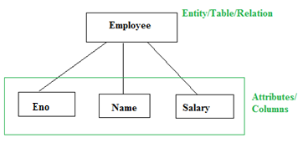
Q) What is row?
Ans)It holds actual data of the object.Each table can contain zero or more rows. When there are zero rows then it is said to be empty table.
Q) What is SQL?
Ans) SQL is a language which is used to querying the structured data from the database.
SQL(Structured Query Language) or see-quel is a standard database language designed for storing, manipulating and retrieving data in databases.
It is developed by Donald Chamberlin and Raymond Boyce in 1974.
It is a language which is used to interact with the database. It is a high level language and very close to English.
SQL is classified into 4 categories:
- Data Definition Language (DDL)
- Data Manipulation Language (DML)
- Data Control Language (DCL)
- Transaction Control Language(TCL)
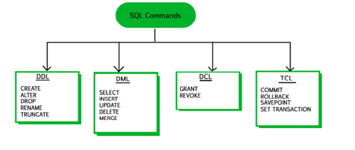
DDL Commands: (Data Definition Language)
These are used to change the structure of the database objects in database, typically by creating , deleting or modifying schema objects such as databases, tables and views.
- CREATE:It is used to create any database object.ss
- ALTER: It is used to modify the definition of existing entities.
- DROP: It is used to remove existing entities.
- RENAME : It used to rename the names of existing entities.
- TRUNCATE :It is used to remove all rows from a table permanently and releases space allocated to them.
DML Commands:(Data Manipulation Language)
These are used to deal with the manipulation of datapresent in the database.
- INSERT: It is used to insert data into the table.
- UPDATE: It is used to update existing data within a table
- DELETE: It is used to delete one or all records from the table
- MERGE: It is used to do conditional insert or update data in the table.
- SELECT:It is used to retrieve data from the table.
DCL Commands: (Data Control Language)
It deals with the rights, permissions and other controls of the database system.
- GRANT:It gives user’s access privileges to database.
- REVOKE : It removes user’s access privileges given by using the GRANT command.
TCL Commands: (Transaction control language)
It deals with the transaction within the database.
- COMMIT :It is used to comments the transaction.
- ROLLBACK : It is used to rollback a transaction in case of any error occurs.
- SAVEPOINT : It is used to sets a savepoint within a transaction.

Q) What are alias names in SQL?
Ans)It is used to give an alias(temporary) name to the table or a column but the actual name does not change in the database. It is mainly used for giving a short alias name for a column or a table which is having large names. It is useful when we are working with more than 3 tables and have to use JOIN’s and subqueries.
Q) What are constraints in SQL?
Ans) SQL constraints are rules used to limit the type of data that can insert into a table.These are used to maintain the accuracy and integrity of the data inside the table.
Constraints Typesare:
- NOT NULL
- UNIQUE
- PRIMARY KEY
- FOREIGN KEY
- CHECK
- DEFAULT
- NOT NULL:These are used to restrict a column from having a NULL value. Once NOT NULL constraint is applied to a column, you cannot pass a null value to that column.
- UNIQUE: This constraint is used to restrict a column that will not have duplicate data. we can apply this constraint at table or column level.
- PRIMARY KEY: It is used to index the data inside the table. This constraint is used to restrict a column that will not have duplicate data and null values.
- FOREIGN KEY: It is used to link two tables. Same key is acts as primarykey in parent table and foreign key in child table.It restricts invalid data to be inserted into the child table.
Foreign key on delete operation:
There are two ways to maintain the integrity of data in child tables, when a particular record is deleted in main table. When two tables are connected with foreign key, and certain data in the main table is deleted, for which a record exits in the child table, then we must have some mechanism to save the integrity of data in the child table.
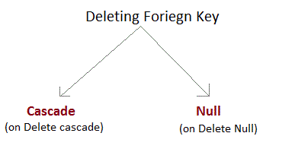
- On Delete Cascade : This will remove the record from child table, if that value of foriegn key is deleted from the main table.
- On Delete Null : This will set all the values in that record of child table as NULL, for which the value of foriegn key is deleted from the main table.
- If we don't use any of the above, then we cannot delete data from the main table for which data in child table exists. We will get an error if we try to do so.
5. CHECK:It is used to restrict the value of a column between a range. It performs check on the values, before storing them into the database.It’s like a condition checking before saving data into a column.
6. DEFAULT: It is used to insert default value into a column. If no value is specified then default value will be added to all new records.
Q) What are operators in sql?
Ans)Operator is nothing but special character which is used to perform operations using operands.
There are four types of operators in sql.
- Arithmetic operators
- Logical operators
- Comparison operators
- Negative operators
1.Arithmetic operators:
Arithmetic operators are basically used to perform the arithmetic calculations between 2 variables or numbers.
Arithmetic operators : +, - ,*,/
- Addition (+ Operator) : It is used to perform the addition of two numbers or variables.
- Subtraction(- Operator): It is used to perform the subtraction of two numbers or variables.
- Multipication(* Operator): It is used to perform the multiplication of two numbers of variables.
- Division(/ Operator): It is used to perform the division of two numbers or variables.
- Mod(% Operator): it returns the remainder.

2. Comparision Operators in SQL:
These are used to compare different variables or different values from the database table.
- equalTo(=): Checks the values between two variables whetheroperands are equal or not.if values are equal then it will return true else false.
- notequal to (!=,<>):Checks the values between two variables whether operands are equal or not.if values are not equal then it will return true else false.
- Greater than (>) : Checks the values between two operands, if leftside operand value is greater than right side operand then it will return true.
- Less than(<):Checks the values between two operands, if leftside operand value is less than right side operand then it will return true.
- Greate than and equal to(>=):Checks the values between two operands, if leftside operand value is greater than or equal to right side operand then it will return true.
- Less than or equal to(<=) :Checks the values between two operands, if leftside operand value is less than or equal to right side operand then it will return true.

3.Logical Operators: (AND, OR)
Logical operators are used to perform the logical operations between two variables.
- AND Operator: It is used to give the multiple conditions at a same time to SQL statement. It is mostly used in WHERE clause.
- OR Operator : It is used to combine multiple conditions in the database. It is simply means either this or that.
- IN Operator : It is used to check whether any member in the given list is equal to the given value. If matches then it fetches those records from the table.
- ALL Operator : It is used to compare all/every value in the list. It uses <,>,= operators to compare.
- ANY Operator : It is used to compare each value in the given list.It uses <,>,= operators to compare.
- BETWEEN.. AND Operator : It is used to fetch the records within a given range. It includes begin and end values.
- LIKE Operator: It is used to compare the values from the table using wildcard operators like ‘%’,’_’ etc.
- EXIST Operator: It is used to specify the presence of specific row which has some specific condition.
4.Negation Operators in SQL:it is used to negate the condition.
These are used for negate condition like ‘Not’ condition.
- NOT Operator:
Q) What are wildcards in SQL?
Ans) Wildcard characters are used with the SQL LIKE operator.
The LIKE operator is used in WHERE clause to search for a specific pattern in a column.
There are two wild cards used with LIKE operator.
- % - The percent sign represents zero or multiple characters.
- _ - The underscore represents a single character.
The wildcards can also be used in combinations.
Q) What are aggregate functions in SQL?
Ans)These are used to group multiple rows/records together as input to form a single value output.
Some of the basic aggregate functions are:
- COUNT() : It gives number of records for a given column
- COUNT(DISTINCT) : It gives number of distinct(different) records for a given column.
- MIN(): It gives a min value for a given column
- MAX():It gives a max value for a given column
- AVG() : It gives a average/mean value for a given column
- SUM() : It gives a sum of total value for a given column

Q) What are functions in SQL?
Ans)
- Character Functions
- Number Functions
- Date Functions
- Conversion Functions
- General Functions

CHARACTER FUNCTIONS:
- UPPER(): It is used to convert value of string column to uppercase characters.
- LOWER() : It is used to convert value of string column to lowercase characters.
- INITCAP():It is used to convert the first character in every word in uppercase and rest in lowercase
- SUBSTR() : It is used to extract substrings from string , for that we need to pass start position and length of characters.
- LENGTH():It is used to find the length of the string.
- CONCAT():It is used to concatenate two or more characters.
- LPAD():It is used to padding the left side of a string with specific set of characters.
- RPAD():It is used to padding the right side of a string with specific set of characters.

NUMBER FUNCTIONS:
- ROUND(): It is used to round a numeric field to number of nearest integer. It is used for decimal point values.
- TRUNC():It returns a number truncated to a certain number of decimal places.

DATE FUNCTIONS:
- TO_DATE():It is used to converts string to date type using the specified format.
- MONTHS_BETWEEN(): it is used to get the number of months between date1 and date2
If date1 is later than date2 then the result is positive.
If date1 is earlier than date2 then the result is negative.
3. NEXT_DAY(): It returns the first weekday that is greater than the date.
4. ADD_MONTHS():It returns a date with a given number of months added.

CONVERSION FUNCTIONS:
- TO_CHAR():It is used to convert datetime value to string in a specified format.
- TO_NUMBER():It is used to convert string to number.

NULL FUNCTIONS:
- NVL():It is used to replace NULL value with another value.
NVL(expr1, expr2)
2. NVL2():It is an extension of NVL function.
NVL(expr1, expr2, expr3)
If expr1 is null, then it returns expr3, if expr1 is not null then it returns expr2.
3. Coalesce:it returnsfirst not null value in a list. We can pass any number of arguments to this function. It will check not null for each and every argument and then return not null value in a list.

Q) What are clauses in sql?
Ans) There are clauses in SQl which are used filtering, sorting, restricting, combining two or more tables and so on.
- Group by clause: It is used to group rows same value.
We can apply group by clause on single column or multiple columns.
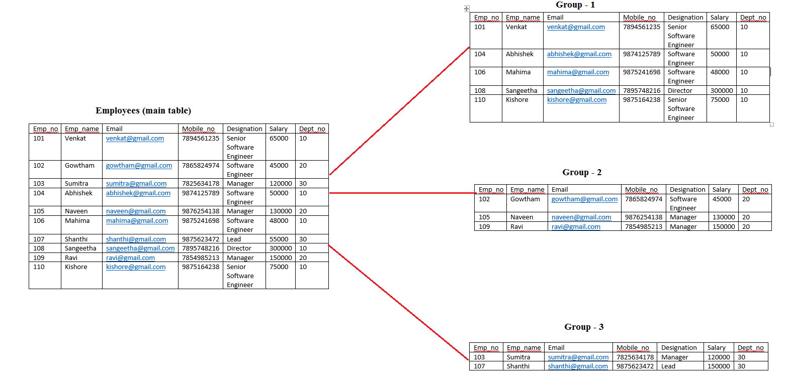

2.Having clause : It is used to filter the grouped records. After group by only we can use having clause.
3.Order by clause: It is used to sort the rows/ records in a table in ascending or descending order based on given column.
It should be in the last position and it will be execute in the last .
Rollup:it is used with group by clause. By using this we can display grand totals of each column.
Cube:it is used with group by clause. By using this we can display each group total along with subtotals and grand totals.
Q) What is UNION operator in SQL?
Ans)It is used to combine the result-set of two or more SELECT statements.
Rules:
- Each SELECT statement within UNION must have the same number of columns.
- The columns must also have similar data types
- The columns in each SELECT statement must also be in the same order.
Note: UNION operator selects only distinct values by default. To allow duplicate values, use UNION ALL.
Q) What are Joins in SQL?
Ans)The purpose of a join is to combine the data from two or more tables.
If a join involves in more than two tables then Oracle joins first two tables based on the joins condition and then compares the result with the next table and so on.
A join queries must have at least one join condition, either in the FROM clause or in the WHERE clause. The join condition compares two columns from two different tables.
Types of Joins:
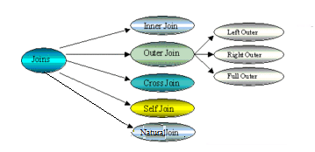
- Equi-joins(inner join)
- Outer Join
  - Left outer join
  - Right outer join
  - Full outer join
- Non-Equi Joins
- Self Join
- Cross Join/ Cartesian Products
- Natural Join

Equi-Join:
An equi-join is a join with a join condition containing an equality operator. This is represented by (=) sign. This join retrieves information by using equality condition.
Inner Join:Selects records that have matching values in both tables.
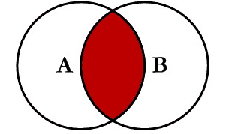
Outer Join: Selects records which are unmatched in both the tables.
Left Outer Join:Selects all rows from the left table and only matched records from the right table.
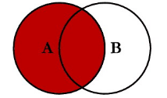
Right Outer Join:Selects all records from the right table and only matched records from the left table.
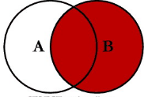
Full Join:Select records all records from the left table and right table, even there is not matched records.
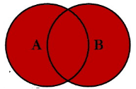
Non- Equi Join:
This join retrieve information using unequal conditions (like <>, >, <, !=, BETWEEN, etc.).
Self Join:
A join in which a table is joined with itself.Self-joins are used to compare values in a column with other values in the same column in the same table.
Cross-Join:It is a join of every row of one table to every row of another table.
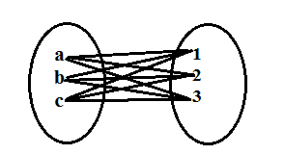
Natural Join: It compares the common columns of both tables with each other.
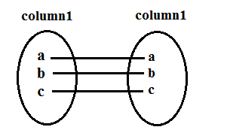

Q) What is subquery in SQL?
Ans)SubQuery is nothing but Query within another SQL Query. It is also called as inner query or nested query.
The output of one query is an input of another query.
First the inner query gets executed, then the output of inner query is supplied to input of outer query.
Subquery can use with DML operations(means main SQL query can be any one of the DML operation but the inner query should be only select statement, because inner query will return some output, this output will be used inmain query as a condition to filter data from the table or resultset )
BETWEEN … AND operator cannot be used with a subquery, but we can use within the subquery.
ORDER BY clause can be ignored.
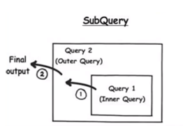
The output can be either single or multiple values.
Q) What are co-related queries?
Ans)The outer query record is passing to the inner query, the inner query evaluates that record and passes that data again back to the outer query.
Every record in the outer query pass to the inner query, the inner query evaluates it and again pass to the outer query.
Subquery is executed once for every record of the outer query.
The inner query needs the values from the outer query and then inner query results are passed back to outer query.
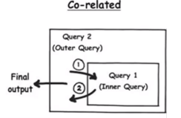
Q) What is a SQL Sequence?
Ans)Sequence is a database object. It is used to generate unique numbers automatically. Generally it is used to create primary key values.
For every new record insertion, It automatically increment the column value by the given increment value.
While creating sequence, we have to specify the following values.
Start with : It specifies the starting value for the sequence. Default value is 1.
Increment by:it is a interval between sequence numbers. Default value is 1.
Minvalue : it is a minimum value for which sequence will start. It is a lower bound/limit.
No Min value: if we are not specify any minimum value then oracle start with 0.
Max Value : it is a maximum value/upper limit up to which sequence will be incremented.
No Max value: if we are not specify the limit, then it generate sequence until it reaches (10^27).
Cycle :After reaching the maximum value, sequence continues to generate numbers starting with the minimum value.
No Cycle: if maximum value exceeds then it stops generating numbers and error will be thrown.
Cache :It caches the sequence numbers to minimize disk IO.We need to specify how many values are kept in memory. Default value is 20.
No Cache:it does not cache the sequence numbers.

Syntax:
CREATE SEQUENCE Sequence_Name
START WITH
INCREMENT BY
MAXVALUE | NOMAXVALUE
MINVALUE|NOMINVALUE
CYCLE|NOCYCLE
CACHE | NOCACHE
Pseudo Columns:
NextVal: It returns next sequence value. It returns unique value in every usage even by different users.
CurrVal:it returns current sequence value. We must use NEXTVAL at least for one time to be able to use currval keyword in our session.
We cannot use nextval, curval with DISTINCT keyword, GROUP BY and HAVING clause.
We use caching sequence values in memory for faster access.
Specified number of sequence values are cached in memory on the first usage, after last sequence in the memory is used , next sequence values are cached.
Sequences are not tied to any table, the same sequence can be used for multiple tables because of that you may lose the order of a column that means Sequence number will start with the initial value in the first time usage that will continue to any column or any table. If we want to start with beginning, we have to drop the sequence and recreate it.
Q) What is Index in SQL?
Ans) An index is a database object. These are special look up tables that are used by the database search engine to speed up the data retrieval.
It is same as text book index. In textbook, by using index, we can directly go to that page instead of looking into each and every page.
Indexes have pointers, it directly points to related row. It locates to the exact location of the data in the disk rather than scanning all the disk(table).
We can create indexes on column, then that column is called index key.
Indexes can be created implicitly or explicitly.Implicit indexes are created with primary key or unique constraints.
Once we create index, we no need to do anything. Oracle server automatically maintains indexes.
Indexes are tied to a table but have no effect on the base table that means if we drop index, nothing changes in the base table.If we drop a table, all the indexes related to this table are also dropped.
Index maintain order data, default order is ascending.Along with ordered values it will maintain address (rowid) of each value.
Rowid is a pseudo column, it contains physical address of each record.
Types of Indexes:
- BTREE
- BITMAP
BTREE Index:its internal structure is tree structure. It is default index.
BITMAP: it stores internally in the form of tables.
Types of B-Tree Index:
- Simple Index
- Composite Index
- Unique Index
- Reverse Index
- Function based Index
1.Simple Index: Create an index on single column that is called simple index
Syntax:
Create index index_name on table_name(col_name)
2.Composite Index: Create an index based on multiple columns.
Syntax:
Create index index_name on table_name(col_name, col_name)
3.Unique Index: Create index on a unique column is called Unique Index. Oracle server automatically creates this index while creating a primary key or unique constraints.
Syntax:
Create unique index index_name on table_name(col_name)
Create unique index index_name on table_name(col_name, col_name)
4.Reverse index:If we want to search data frequently on hightest values.
Syntax:
Create index index_name on emp(sal) reverse.
5.Function based Index:If you use any function on the index called is called function based index. These functions can be sql or user defined functions.
Syntax:
Create index index_name table_name(fun_name(col_name));
BitMap Index:it is used for low cardinality columns.Its interanal structure is two dimensional array.
Bitmap index cant handle multiple concurrent updates it leads to serious dead lock issues. Do not create bitmap index where table is frequently performing updates.
Syntax:
Create bitmap index index_name table_name(col_name);
Note: Indexes cannot be modified. If we want to change the index we just drop and recreate it.
If we drop a table all the indexes associated to the table are also dropped automatically.

Q) What are views in Sql?
Ans)View is a database object. It acts like a interface between base table and user. It stores SELECT statement of a table or view.The view is stored in the data dictionary as a SELECT statement.
There is no data in view.It is a virtural/logical table for the base table. Virtual means object doesn’t have a physical existence.
Views are used forrestricting to access a data and making complex queries easy.
View is a logical virtual table created by select query but the result is not stored anywhere in the disk and every time we need to fire the query when we need data, so always we get updated or latest data from original tables.
Types of views:
- Simple view
- Complex view
- Simple View: it is used to retrieve data from one table and it should not contain functions or groups of data.We can perform all DML operations in this view. It is also called updatable view.
We cannot perform DML operations if the includes:
- Group functions
- GROUP BY clause
- DISTINCT keyword
- ROWNUM keyword
- NOT NULL(if not null column has not a default value)
- Columns defined by expressions.
- WITH READ ONLY keyword
2. Complex view:It is used retrieve data from more than one table and it can contains functions and groups of data.
It supports select command only, we cannot perform DML operations always. It is also called non-updatable view.
Q) What is Materialized view?
Ans)it is a database object that stores a query result.
Suppose, If we want to use complex view frequently which contains multiple tables and huge data, instead of using this query many times just create a materialized view and use that view.
But if we use normal(simple /complex) view, everytime it goes to the base table and perform all join conditions or other conditions to get the data. So, to reduce sql costs, we use materialized views.
Materialized views are also the logical view of our table but result of the query will get stored in the table or disk, and also the definition of the query will store in the database.
These are useful for reducing network loads and improving performance for retrieving data from the database.
These views will not get the latest updated data from the base table, means if we perform any DML operations on the base table, those will not effect in these views. If we want updated data, we need to refresh the table.
One more difference between View and materialized view in the database is that In case of view, we always get latest data but in case of Materialized view we need to refresh the view for getting latest data. Performance of View is less than Materialized view.
Syntax:
Create Materialized View view-name
Build [Immediate | Deferred]
Refresh [Fast | Complete | Force]
On [Commit| Demand]
[[Enable|Disable] Query Rewrite]
[On Prebuilt table]
As Select…;
Build Immediate:Once we create MV , the related tables will be populated by the MV.
Build Deffered: It will populate with the related tables on first refresh request.
Refresh Fast: It will change the existing data instead of repopulated entire MV.
Refresh Complete : The table of MV is truncated and repopulated with the associated query.
Refresh Force : A fast refresh is not possible , complete refresh performed. It is a default option.
On Commit: The refresh is performed on a commit of any dependent tables.
On Demand : The refresh is performed manually or a scheduled task. It is a default option.
Enable Query Rewrite: Allows the optimizer to use query rewrite option to improve performance for expensive and time consuming process of the assosicated SQL query.
Disable Query Rewrite: Disallows the optimizer for query rewriting. This option is default.
On Prebuilt table: If we lose the link between materialized view and its base table, by using this we can easily create materialized view on this table without recreating – refilling it.

Complex Materialized view:
Complex materialized views cannot be fast refreshed.

A Materialized view can be considered as complex when the defining query contains the following statements.

- DISTINCT keyword
- SET operator
- Joins
- Aggregate Functions
- Subqueries
- Corelated Queries
- Group by and Having clauses

Types of Refresh:
- Fast Refresh
- Complete Refresh
- Force Refresh

Manual Refresh:
DBMS_MVIEW.REFRESH(dview_name, refresh_type);
Refresh types: F(Force), C(Complete)
We can use DBMS.SNAPSHOT because DBMS_MVIEW is synonym for DBMS_SNAPSHOT.
Scheduling Periodic Refresh of Materialized Views:
We can set refresh time of a materialized view to be populated periodically.

USER PRIVILEGES AND ROLES
Q) What is privilege ?
Ans) it is a permission/right to work with database.
A database administrator is a user that has all the privileges on the database and database objects.
if a new user has no privilege assigned then the user cannot perform any operations on the database, even cannot connect to the database.
Privilege can be grant to
- USER
- ROLE
- PUBLIC
Database privileges is specified in two categories,
1. System Privilege
2. Object Privilege
System Privilege: Access to the database in the system level(username-passwords, system operations etc)
Ex: Create table, create view, create sequence, create index, create synonym etc.
Object Privilege: Access to the database objects(DML operations)
To query on a other user table, we need to grant SELECT privilege on that table to a user, to update data or delete data, we need associated privileges.
If we want a user to reach some records or some rows of a table, we need to create a view and grant SELECT privilege to that user for that view.
ROLE:
In big companies, there are a lot of users who have the same privileges. Instead of granting many privileges to all the users we can collect a group of privileges together and grant all these privileges to a user with one process.
Roles are group of related privileges. This will make easier to grant and revoke privileges.
A user can be granted with several roles and vice versa.
Q) What are Synonyms?
Ans)It is a database object. It is used to create permanent alias name or alternate for database objects(table, view, sequence, index and so on).
Once we create alias name to the database object, then we can use the same alias name to perform DDL and DML operations.
To create synonym, we need to get permissions from DBA.
Synonyms are divided into two types:
1. Private Synonym – Default
2. Public Synonym
Private Synonym:
Private synonyms can be created and accessed by only owner of the synonym.
Syntax:
Create synonym alias_name for actual_table.
Public synonym:
Public synonyms are created by DBA and gives access to authenticated users.
Syntax:
Create public synonym alias_name for actual_table.
Q) What is transaction in SQL?
Ans)Transaction is nothing but sequence of operations(DML operations) performed on a database as a single logical unit of
There are four commands to control transactions:
- COMMIT : To save the changes permanently in the database
- ROLLBACK : to roll back the changes.
- SAVEPOINT : it can be placed in the transaction as a maker for rollback;
Transaction control commands are only used with the DML commands. They cannot be used for DDL commands because DDL commands are automatically committed in the database.
Q) What are Analytical Functions?
Ans) Analytical Functions:
Rank:It is used to calculate rank.
Ex: ranks of the employees, ranks of the students. ranks of the products, ranks of the customers
Syntax:
RANK() OVER (EXPR)
If expr values are same then the ranks also same. Rank function generates gaps.
RANK() OVER (PARTITION BY DEPT_NO ORDER BY SAL DESC)
Dense Rank:
Syntax:
RANK() OVER (EXPR)
If expr values are same then the ranks are different. Dense rank function will not generates gaps.
Q) What is Data dictionary?
Ans) Oracle database not only stores data, it also stores data definitions, data structure and meta data(Information about users, tables, constraints, sequences, lndex, views). This information is stored in the form of tables.These are also called data dictionary tables or system tables.
These tables managed by oracle. We cannot manage these tables.

