**CREATE A CHATBOT USING PYTHON**

**NAME:M.SUDALAI MUTHU**

**REG.NO:952821106041**

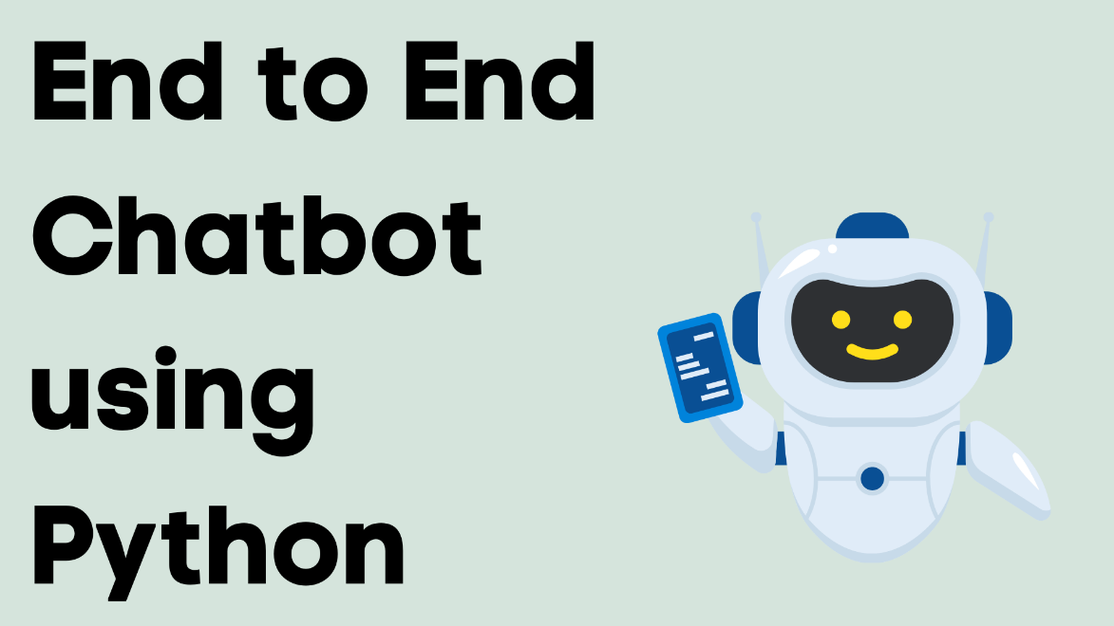

**INTRODUCTION**

Chatbots are computer programs designed to simulate conversation with human users, and they have become increasingly popular in various applications, from customer support to personal assistants. Python is an excellent choice for building chatbots due to its simplicity, versatility, and the availability of powerful natural language processing (NLP) libraries and frameworks

.

**LOADING AND PREPROCESSING THE DATA :**

Creating a chatbot typically involves loading and preprocessing data before training the model. In this example, I'll show you how to load and preprocess text data using Python. For the sake of simplicity, I'll assume you have a dataset of conversation pairs. You can use libraries like TensorFlow, PyTorch, or Hugging Face Transformers for more advanced chatbot development.

**Import necessary libraries:**

You'll need libraries like “numpy”, “pandas”, and “sklearn” for data preprocessing. Additionally, you may need to install libraries for natural language processing, like “nltk” or “spaCy”

**SOURCE CODE:**

import numpy as np

import pandas as pd

import nltk

from sklearn.model_selection import train_test_split

from sklearn.feature_extraction.text import CountVectorizer

from sklearn.preprocessing import LabelEncoder

**Load the data:**

You should have a dataset containing conversation pairs, typically in a CSV or text file. Here, we assume your dataset has two columns: "user" and "bot," where "user" contains user input and "bot" contains the bot's response**.**

data = pd.read_csv('your_dataset.csv')

**Preprocess the data:**

Data preprocessing is a crucial step to prepare your data for training. It typically includes tokenization, text cleaning, and converting text to numerical format.

# Tokenize the text

data['user'] = data['user'].apply(nltk.word_tokenize)

data['bot'] = data['bot'].apply(nltk.word_tokenize)

vectorizer = CountVectorizer()

X = vectorizer.fit_transform(data['user'])

**Split the data:**

You should split your data into training and testing sets to evaluate your chatbot's performance.

X_train, X_test, y_train, y_test = train_test_split(X, data['bot'], test_size=0.2, random_state=42)

**Label encoding** (if you have predefined responses):

If you have predefined bot responses, you might want to label-encode them.

label_encoder = LabelEncoder()

y_train_encoded = label_encoder.fit_transform(y_train)

y_test_encoded = label_encoder.transform(y_test)

**Importance of chatbot using python:**

**Improved Customer Service:**

Chatbots can provide 24/7 customer support, answering frequently asked questions and handling routine queries. This enhances customer satisfaction and reduces response time, making it an essential tool for businesses.

**Cost-Efficiency:**

By automating customer support and handling routine tasks, chatbots can significantly reduce operational costs. Businesses can allocate resources more efficiently and free up human agents to focus on more complex issues**.**

**Scalability:**

Python, with its robust ecosystem and libraries, is an excellent choice for building chatbots that can scale with ease. This means they can handle a growing number of user interactions without a proportional increase in costs.

**Data Collection and Analysis:**

Chatbots can gather user data, preferences, and feedback, which can be valuable for understanding customer behavior and improving products or services. Python has strong data analysis and machine learning libraries, making it easier to process and extract insights from this data.

**Personalization:**

Python-powered chatbots can be highly customizable and offer personalized experiences to users. By analyzing user data, chatbots can tailor responses and recommendations to individual preferences.

**Automation:**

Chatbots can automate a wide range of tasks, from appointment scheduling and order tracking to data retrieval and content recommendations. This automation streamlines processes, making businesses more efficient.

**Reduced Human Error:**

Chatbots perform tasks consistently and without human error, which is especially important in industries like healthcare, finance, and manufacturing, where precision is critical.

**Enhanced User Engagement:**

Well-designed chatbots can engage users in a conversational manner, making interactions more enjoyable and user-friendly. This can lead to higher user engagement and better user retention.

**Multilingual Support:**

Python's natural language processing (NLP) libraries make it easier to develop chatbots that can understand and communicate in multiple languages, expanding their reach to a global audience.

**Cross-Platform Compatibility:**

Python-based chatbots can be integrated with various messaging platforms, websites, and mobile apps, making them versatile and accessible to users on their preferred channels**.**

**Quick Development:**

Python is known for its simplicity and readability, which allows for faster development and easier maintenance of chatbot code.

**AI and Machine Learning Integration:**

Python offers a wide range of libraries for AI and machine learning, enabling chatbots to learn and adapt over time, becoming more intelligent and capable of handling complex tasks.

**Analytics and Performance Monitoring:**

Python provides tools and libraries for monitoring and analyzing the performance of chatbots, allowing for continuous improvement and optimization**.**

**ChatBot Using Python:**

**SOURCE CODE :**

from chatterbot import ChatBot

from chatterbot.trainers import ChatterBotCorpusTrainer

from flask import Flask, request, jsonify

# Create a chatbot instance

chatbot = ChatBot('MyBot')

# Create a new Flask web app

app = Flask(__name__)

# Create a trainer for the chatbot

trainer = ChatterBotCorpusTrainer(chatbot)

# Train the chatbot on the English language corpus data

trainer.train('chatterbot.corpus.english')

# Define a route for the chatbot to receive and respond to messages

@app.route('/get_response', methods=['POST'])

def get_response():

user_message = request.json['user_message']

response = chatbot.get_response(user_message).text

return jsonify({'bot_response': response})

# Run the web app

if __name__ == '__main__':

app.run(debug=True)

* We create a ChatBot instance and a Flask web application.
* The chatbot is trained on the English language corpus data using the ChatterBotCorpusTrainer.
* We define a route /get_response to receive user messages, and the chatbot responds to them.
* The web app runs in debug mode for testing.
* To interact with the chatbot, you can send a POST request to http://localhost:5000/get_response with a JSON body containing the user's message, like this:

{

"user_message": "Hello, chatbot!"

}

The response will be a JSON object with the chatbot's reply.

This is a basic chatbot with a simple web interface. Depending on your project's requirements, you can expand and customize the chatbot further, add more training data, and create a more sophisticated web interface. You can also integrate external APIs for more advanced functionality.

**Conclusion:**

In conclusion, building a chatbot using Python offers a powerful and flexible solution. Python's rich ecosystem of libraries, natural language processing tools like NLTK and spaCy, and frameworks like Rasa or ChatterBot make it well-suited for chatbot development. With advanced techniques such as machine learning and deep learning, you can create intelligent and context-aware chatbots. Additionally, Python's ease of integration with web frameworks and APIs allows you to deploy chatbots on various platforms, making it a popular choice for chatbot development**.**