Name: Hardware Root-of-Trust for Secure System Operation

GitHub Repository: https://github.com/suresh2327/Hardware-Root-of-Trust-for-Secure-System-Operation
Project Website: https://hardware-root-of-trust.vercel.app/

Description: A synthesizable Hardware Root-of-Trust (HRoT) module implemented in SystemVerilog RTL that cryptographically authenticates firmware before the CPU is released from reset. The system computes the SHA-256 hash of incoming firmware data using a hardware engine that executes 64 compression rounds per 512-bit block, compares the 256-bit result against a trusted reference stored as a hardware constant in secure_key_storage, and asserts cpu_reset_n = 1 only on a successful match. Three consecutive authentication failures activate a permanent hardware lockdown. The design is verified through a five-scenario SystemVerilog testbench and taken through a complete RTL-to-GDSII physical design flow using Cadence Genus 21.14 for logic synthesis and Cadence Innovus 21.15 for physical implementation on a 90nm standard cell library.

Functional Requirements

1) Secure Boot Functionality
- Accept 32-bit streaming firmware words through fw_data, fw_valid, fw_last, fw_strobe[1:0] interface signals
- Assert cpu_reset_n = 0 at power-on; hold CPU in reset throughout the entire authentication sequence
- Release cpu_reset_n = 1 only when computed SHA-256 digest matches the trusted reference hash exactly
- Block CPU execution permanently when lockdown_active = 1 regardless of subsequent boot requests
- Support firmware images of any byte length through multi-block SHA-256 processing and correct padding

2) Firmware Authentication Engine
- Implement complete NIST FIPS 180-4 SHA-256 specification in synthesizable SystemVerilog RTL
- Process firmware in 512-bit blocks; apply SHA-256 message padding including 0x80 byte and 64-bit length field
- Expand message schedule W[0..63] per block using sigma0(ROTR7, ROTR18, SHR3) and sigma1(ROTR17, ROTR19, SHR10)
- Execute 64 compression rounds per block using Ch(e,f,g), Maj(a,b,c), Sigma0(a), Sigma1(e) and round constants K[0..63]
- Chain hash accumulators H0–H7 across all blocks; output final 256-bit digest after last block completes
- Optimise message schedule using W[16] circular buffer indexed by (round mod 16) — saves 1,536 flip-flops versus W[64]

3) Secure Key Storage
- Store the trusted 256-bit firmware reference hash as a synthesis-time hardware parameter constant (wire in netlist)
- Provide no write port, no runtime update path, and no software-accessible memory address
- Trusted hash is set at synthesis and cannot be modified by any runtime signal, register write, or software agent
- Immutability is enforced physically — there is no flip-flop storage path that could be overwritten

4) Boot Controller FSM
- Implement eight defined states: RESET, IDLE, AUTH_START, AUTH_WAIT, CHECK_RESULT, BOOT_ALLOW, BOOT_DENY, LOCKDOWN
- Sequence the complete authentication flow from power-on event through final boot pass or fail decision
- Assert start_auth for one clock cycle on transition to AUTH_START to trigger authentication engine
- Assert boot_done for one clock cycle on reaching BOOT_ALLOW or BOOT_DENY to signal completion
- Drive FSM to LOCKDOWN state and hold permanently when retry_exceeded signal is asserted

5) Retry Counter and Policy Engine
- Increment retry_count register on each consecutive authentication failure
- Assert retry_exceeded when retry_count reaches the configured maximum threshold (default 3 attempts)
- Policy engine generates ALLOW, DENY, or LOCKDOWN decision based on auth_pass and retry_exceeded signals
- Retry counter resets to zero only on successful authentication; lockdown cannot be cleared by retry reset

6) Lockdown Controller and CPU Reset Control
- Implement sticky flip-flop lockdown: once lockdown_active = 1 is asserted it holds until hardware reset
- Lockdown cannot be cleared by any software instruction, firmware command, or runtime register write
- cpu_reset_ctrl drives cpu_reset_n = 0 at power-on and during all non-BOOT_ALLOW states
- cpu_reset_n = 1 is asserted only when boot_ctrl_fsm reaches the BOOT_ALLOW state and auth_pass = 1
- cpu_reset_n is immediately de-asserted on authentication failure, lockdown activation, or system reset

Non-Functional Requirements
- Target clock frequency: 100 MHz (10 ns clock period) for synthesis; positive slack of 6,141 ps confirmed by Cadence Genus at this target
- Post-route timing: 0.040 ns positive setup slack confirmed by Cadence Innovus after place-and-route — timing closure achieved
- SHA-256 throughput: 115 clock cycles per 512-bit (64-byte) firmware block at 100 MHz
- Synthesis cell count: 17,624 standard cells (rot_top); SHA-256 core alone: 14,314 cells (81.2% of design)
- Synthesis area: rot_top total 152,631.912 sq microns; SHA-256 core 117,728.225 sq microns — Cadence Genus 21.14
- Post-route area: rot_top total 165,148.011 sq microns; SHA-256 core 128,856.170 sq microns — Cadence Innovus 21.15
- Synthesis power at VDD = 0.9 V: internal 11.597 mW (75.61%), switching 2.857 mW (18.63%), leakage 0.884 mW (5.76%), total 15.338 mW
- Post-route power at VDD = 0.9 V: leakage 1.50e-3 W, internal 1.56e-2 W, switching 2.16e-3 W, total 1.93e-2 W (19.28 mW)
- Maximum failed authentication attempts before lockdown: 3 consecutive failures (configurable parameter)
- Firmware length support: any byte length from 1 byte to arbitrarily large images via multi-block processing
- Design language: IEEE 1800-2017 SystemVerilog, synthesizable RTL subset only, no latches permitted
- Technology: 90nm standard cell library, fast operating corner, balanced_tree wireload model
- EDA tool chain: Cadence Xcelium (simulation), Cadence Genus 21.14 (synthesis), Cadence Innovus 21.15 (physical design)

Problem Statement: Modern embedded systems and SoC platforms store firmware in external flash memory, which is rewritable and physically accessible to an attacker. A supply-chain compromise, physical access attack, or software exploit can modify firmware stored in flash before the device powers on. At power-on the CPU has no mechanism to verify whether the firmware it is about to execute is the original authentic image or a tampered replacement. Software-level protections such as antivirus scanners, OS integrity checkers, and secure boot libraries are all ineffective at this stage because they execute after the firmware has already been loaded and the CPU has already started running. The attack completes before any software defence can activate. A hardware mechanism that cryptographically verifies firmware authenticity before releasing the CPU from reset is therefore required.

Proposed Solution: This project implements a Hardware Root-of-Trust module in synthesizable SystemVerilog RTL that intercepts the boot sequence at the silicon level before the CPU executes any instruction. Firmware is read from flash memory as a 32-bit streaming bus and fed into auth_engine, which applies SHA-256 message padding and passes 512-bit blocks to sha256_core. The SHA-256 core executes 64 compression rounds per block using Ch, Maj, Sigma0, Sigma1 functions and chains results across multiple blocks through hash registers H0–H7. The final 256-bit digest is compared bit-for-bit against the trusted reference hash stored as a synthesis-time constant in secure_key_storage. The CPU is held in reset (cpu_reset_n = 0) throughout this process and is released (cpu_reset_n = 1) only when the comparison succeeds. Three consecutive failures activate a permanent sticky lockdown via lockdown_ctrl that cannot be cleared by software. The design is validated by a five-scenario SystemVerilog testbench and implemented through a complete RTL-to-GDSII flow using Cadence Genus for synthesis and Cadence Innovus for physical design on a 90nm node, achieving positive timing slack at both stages.

Technologies Used: SystemVerilog (IEEE 1800-2017), SHA-256 (NIST FIPS 180-4), Cadence Xcelium (RTL functional simulation), Cadence Genus 21.14 (logic synthesis, SDC timing constraints, area and power reporting), Cadence Innovus 21.15 (floorplanning, placement, clock tree synthesis, routing, post-route STA, power analysis, GDSII generation), Synopsys Design Constraints (SDC), 90nm standard cell technology library, TCL scripting for EDA automation

System Architecture: The HRoT design is a hierarchy of eight cooperating RTL modules integrated under rot_top. Firmware data enters via a 32-bit streaming interface (fw_data[31:0], fw_valid, fw_last, fw_strobe[1:0]) and is collected by auth_engine. The auth_engine applies SHA-256 message padding — appending the 0x80 byte immediately after the last valid byte as indicated by fw_strobe, filling with zeros, and appending the 64-bit message length — and partitions the padded stream into 512-bit blocks. Each block is handed to sha256_core, which expands the 16-word input into a 64-word message schedule using a W[16] circular buffer, executes 64 compression rounds updating working variables a through h, and accumulates the result into hash registers H0–H7. After the final block the 256-bit digest (H0‖H1‖…‖H7) is compared against the trusted hash from secure_key_storage. boot_ctrl_fsm sequences all operations through eight states and conveys the result to policy_engine. On failure policy_engine increments retry_counter; after three failures lockdown_ctrl asserts a permanent sticky lockdown. cpu_reset_ctrl translates the boot decision into cpu_reset_n.

Detailed Architecture Module Description
1. Boot Controller FSM
The boot_ctrl_fsm is the central sequencer of the Hardware Root-of-Trust. It implements eight defined states: RESET, IDLE, AUTH_START, AUTH_WAIT, CHECK_RESULT, BOOT_ALLOW, BOOT_DENY, and LOCKDOWN. At power-on the FSM holds cpu_reset_n = 0 and waits for a boot request. On receiving boot_req it transitions to AUTH_START, asserts start_auth for one clock cycle to trigger the authentication engine, then moves to AUTH_WAIT. It remains in AUTH_WAIT until auth_done is asserted. In CHECK_RESULT it reads auth_pass: a match moves it to BOOT_ALLOW where cpu_reset_n = 1 is asserted; a mismatch moves it to BOOT_DENY where retry_counter is incremented. When retry_exceeded is asserted the FSM transitions permanently to LOCKDOWN. boot_done is pulsed for one cycle at BOOT_ALLOW and BOOT_DENY to signal completion to the testbench or system controller.

2. Authentication Engine (auth_engine)
The auth_engine collects 32-bit firmware words from the streaming bus, accumulates them into a 512-bit block buffer, and manages the SHA-256 padding and multi-block chaining protocol. The fw_strobe[1:0] input specifies the number of valid bytes in the final word (0 = all four bytes valid, 1/2/3 = partial). When fw_last is asserted the engine inserts the 0x80 padding byte at the correct bit position within the last word, fills remaining word positions with zeros, and appends the total message bit-length as a 64-bit big-endian value in the final two words of the block. If the padding and length field do not fit in the current block (message length >= 56 bytes mod 64), a second padding-only block is generated automatically. The engine tracks total_bits across all blocks and passes each completed 512-bit block to sha256_core with a last_block flag on the final one.

3. SHA-256 Core (sha256_core)
The sha256_core implements the complete NIST FIPS 180-4 SHA-256 specification. It accepts one 512-bit block per invocation and processes it in five pipeline stages: IDLE, LOAD, EXPAND, ROUND, and FINAL. In LOAD the 512-bit block is split into sixteen 32-bit words loaded into a W[16] circular buffer. In EXPAND the remaining 48 message schedule words are computed one per cycle using W[i] = sigma1(W[(i-2)&15]) + W[(i-7)&15] + sigma0(W[(i-15)&15]) + W[i&15], overwriting the circular buffer entry. In ROUND 64 compression iterations update working variables a–h using T1 = h + Sigma1(e) + Ch(e,f,g) + K[round] + W[round&15] and T2 = Sigma0(a) + Maj(a,b,c). In FINAL the updated a–h values are added back to the hash accumulators H0–H7 modulo 2^32. For multi-block firmware the final H0–H7 of one block are used as the initial values for the next. The core completes one block in approximately 115 clock cycles.

4. Secure Key Storage (secure_key_storage)
The secure_key_storage module stores the 256-bit trusted firmware reference hash as a synthesis-time parameter constant. In the synthesised netlist this value appears as a combinational constant wire — there is no flip-flop, no register file entry, and no write enable input. This implementation choice means the trusted hash is physically embedded in the gate-level logic and cannot be modified by any runtime agent including software, firmware, or external bus masters. The only way to change the trusted hash is to re-synthesise and re-fabricate the chip. This property provides hardware-enforced immutability and eliminates 256 flip-flops compared to a registered implementation.

5. Policy Engine
The policy_engine receives auth_pass from auth_engine and retry_exceeded from retry_counter, and generates a three-way security decision: ALLOW (auth_pass = 1), DENY (auth_pass = 0 and retry_exceeded = 0), or LOCKDOWN (retry_exceeded = 1). The ALLOW decision propagates to cpu_reset_ctrl to release the CPU. The DENY decision returns control to boot_ctrl_fsm for retry handling. The LOCKDOWN decision asserts lockdown_ctrl's activate input. All decisions are registered outputs to prevent glitch propagation to the CPU reset path.

6. Retry Counter
The retry_counter is a parameterised up-counter with a configurable maximum threshold (default MAX_RETRY = 3). It increments on every BOOT_DENY event signalled by boot_ctrl_fsm and asserts retry_exceeded combinationally when the count equals MAX_RETRY. The counter resets to zero on a successful authentication (BOOT_ALLOW) or on a hardware reset. It does not reset on lockdown — once retry_exceeded is asserted and lockdown is activated, the counter holds its value permanently.

7. Lockdown Controller
The lockdown_ctrl implements a sticky set-only flip-flop. When the activate input is asserted (driven by policy_engine on retry_exceeded), lockdown_active is set to 1 and remains 1 regardless of any subsequent input changes. The only signal that can clear lockdown_active is the synchronous hardware reset (rst_n = 0). There is no software register, no special unlock sequence, and no timeout mechanism. This design guarantees that a system that has experienced three consecutive authentication failures cannot be made to boot again without physically asserting the hardware reset pin.

8. CPU Reset Controller
The cpu_reset_ctrl is the final gate between the Hardware Root-of-Trust and the processor. It drives the cpu_reset_n output signal. At power-on and during all authentication states cpu_reset_n = 0. When boot_ctrl_fsm asserts boot_pass (derived from BOOT_ALLOW state) and lockdown_active = 0, cpu_reset_ctrl asserts cpu_reset_n = 1 through a registered path to prevent combinational glitches from momentarily releasing the CPU. If lockdown_active becomes 1 at any time cpu_reset_n is immediately driven back to 0 and held there permanently.

Results and Analysis

Functional Simulation Results (Cadence Xcelium)

Verification Test Environment
- Simulator: Cadence Xcelium / Riviera-PRO
- Design under test: rot_top — all 8 modules integrated
- Trusted golden hash stored in secure_key_storage: cc369d06174db4fa54f4f20ae1523a10f8aa409a4b51193135fc798ce426e40e
- Total test cases: 5 — all pass with zero errors

Test 0 — Large Trusted Firmware (TRUSTED expected)
- SHA-256 computed: cc369d06174db4fa54f4f20ae1523a10f8aa409a4b51193135fc798ce426e40e
- Golden hash: cc369d06174db4fa54f4f20ae1523a10f8aa409a4b51193135fc798ce426e40e
- Digest match: YES — boot_pass=1, cpu_reset_n=1, secure_mode=1
- Result: TRUSTED — device ON — TEST 0 PASS

Test 1 — HELLOWORLD (REJECTED expected)
- SHA-256 computed: 0b21b7db59cd154904fac6336fa7d2be1bab38d632794f281549584068cdcb74
- Golden hash: cc369d06174db4fa54f4f20ae1523a10f8aa409a4b51193135fc798ce426e40e
- Digest match: NO — boot_pass=0, cpu_reset_n=0, secure_mode=0
- Result: REJECTED — device OFF — retry count = 1 — TEST 1 PASS

Test 2 — SECUREBOOT_HACKD (REJECTED expected)
- SHA-256 computed: 53abf73b22478119949c6291f01e12d50438f8d05ca1ccbdab23fbcb22c1d584
- Golden hash: cc369d06174db4fa54f4f20ae1523a10f8aa409a4b51193135fc798ce426e40e
- Digest match: NO — boot_pass=0, cpu_reset_n=0, secure_mode=0
- Result: REJECTED — device OFF — retry count = 2 — TEST 2 PASS

Test 3 — Three Consecutive Wrong Firmware Inputs (LOCKDOWN expected)
- Attempt 1: SHA-256 computed 5fe35df495bf837f0c06c673a9b541d9c7512f070daaf030b2bf837f9bd77d99 — NO match — retry count rising
- Attempt 2: SHA-256 computed e198c005392f6bcefc3e35026a5368b557a97227845ce31f04bacf71e11d94fc — NO match — retry count rising
- Attempt 3: SHA-256 computed 69aa9d6e094d2ba0952f85df362196d24bce0ff32c0f2303b3bd3684bf2a8228 — NO match — lockdown triggered
- lockdown_active=1, cpu_reset_n=0 — TEST 3 PASS

Test 4 — Trusted Firmware After Lockdown Reset (TRUSTED expected)
- SHA-256 computed: cc369d06174db4fa54f4f20ae1523a10f8aa409a4b51193135fc798ce426e40e
- Golden hash: cc369d06174db4fa54f4f20ae1523a10f8aa409a4b51193135fc798ce426e40e
- Digest match: YES — boot_pass=1, cpu_reset_n=1, secure_mode=1
- Result: TRUSTED — device ON — TEST 4 PASS
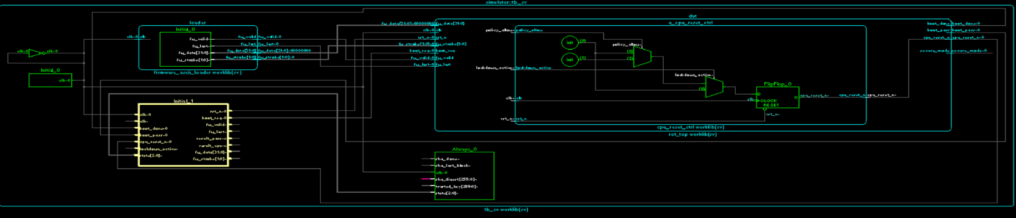
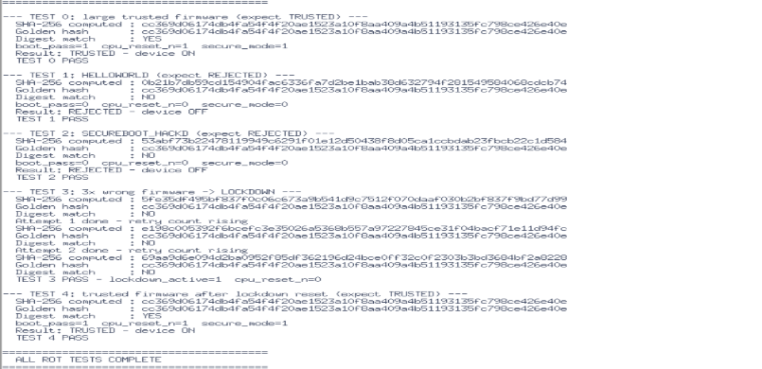
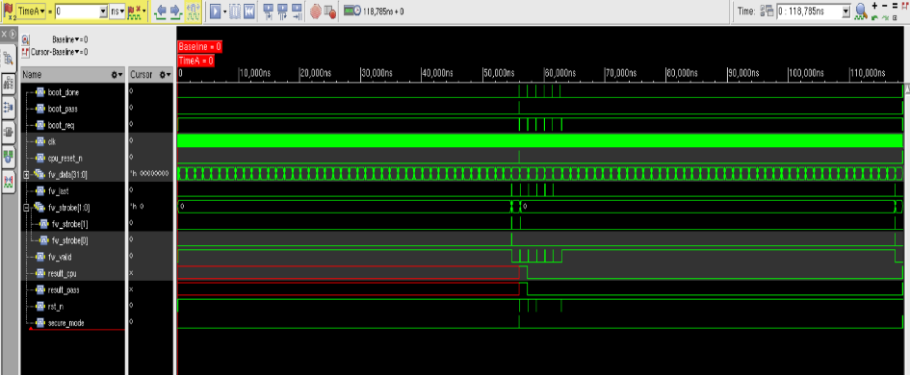
- ALL ROT TESTS COMPLETE — 5 of 5 PASS — 0 errors

Cadence Genus 21.14 — Logic Synthesis Results
Synthesis Summary
- Tool: Cadence Genus Synthesis Solution 21.14-s082_1 — generated May 07 2026 01:35:43
- Module: rot_top — RTL language: SystemVerilog — technology library: fast (balanced_tree wireload)
- Operating conditions: fast — wireload mode: top — area mode: timing library

Area Report (Cadence Genus)
- rot_top — Cell count: 17,624 — Cell area: 152,631.912 sq microns — Net area: 0.000 — Total area: 152,631.912 sq microns
- u_auth_engine / sha256_core — Cell count: 14,314 — Cell area: 117,728.225 sq microns — Total area: 117,728.225 sq microns
- SHA-256 core accounts for 81.2% of total cell count and 77.1% of total synthesised cell area
- (D) wireload is default in technology library; (T) wireload mode is top
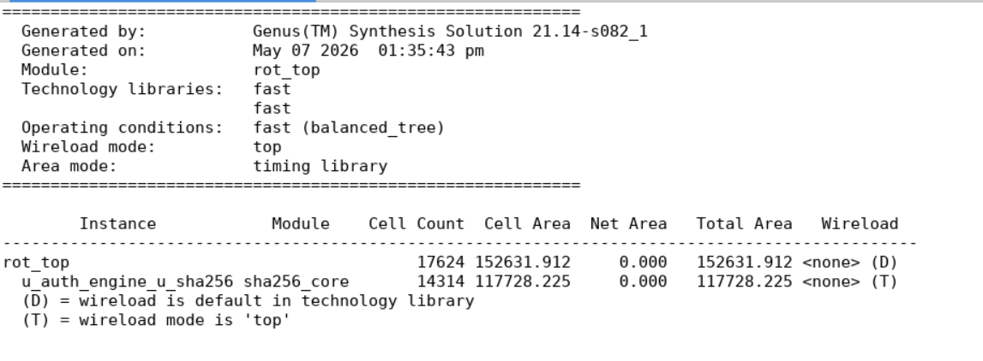

Timing Report (Cadence Genus — Critical Path)
- Path 1: MET (6141 ps) Setup Check with Pin u_auth_engine_total_bits_reg[63]/CK->SI
- Startpoint: fw_strobe[0] — Clock: (R) clk
- Endpoint: u_auth_engine_total_bits_reg[63]/SI — Clock: (R) clk
- Clock edge capture: +10,000 ps — Driver adjust: 0 — Src latency: 0 — Net latency: 0 (I)
- Required time: 9,715 ps (10,000 - setup 85 - uncertainty 200)
- Data path: Input delay 1,000 ps + data path 2,574 ps = arrival 3,574 ps
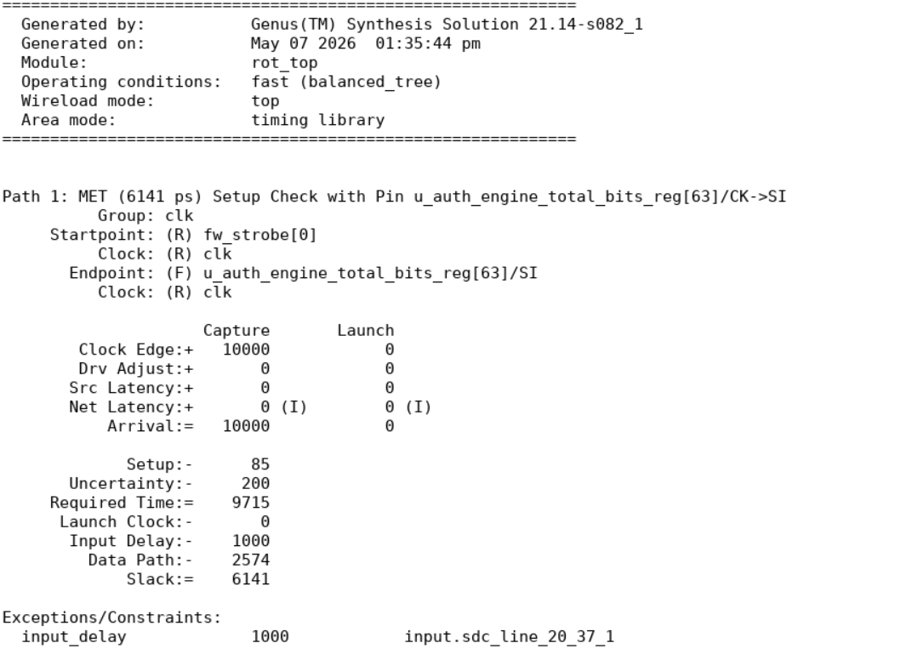
- Slack: 6,141 ps — POSITIVE — timing MET at 100 MHz target
Power Report (Cadence Genus — Total Power at VDD = 0.9 V)
- Total internal power: 11.597 mW (75.61%)
- Total switching power: 2.857 mW (18.63%)
- Total leakage power: 0.884 mW (5.76%)
- Total power: 15.338 mW
- Sequential logic: internal 8.651, switching 0.369, leakage 0.454, total 9.474 mW (61.77%)
- Combinational logic: internal 2.946, switching 2.488, leakage 0.430, total 5.863 mW (38.23%)
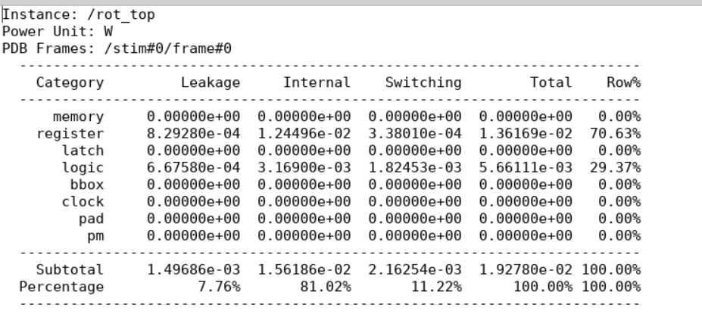
- Rail vdd: voltage 0.9 V — total power 15.34 mW (100%)
Cadence Innovus 21.15 — Physical Design Results

Floor Planning
The floorplan for the Hardware Root-of-Trust architecture was successfully generated by defining the core area, placement boundaries, routing resources, and standard cell utilization. Proper floorplanning ensured balanced module distribution, optimized routing paths, and efficient utilization of chip area for ASIC implementation.


Power Planning
Power planning was successfully implemented by creating dedicated power and ground networks across the design. The power distribution structure ensured stable voltage delivery, minimized IR drop effects, and supported reliable operation of the secure boot and authentication modules throughout the chip.
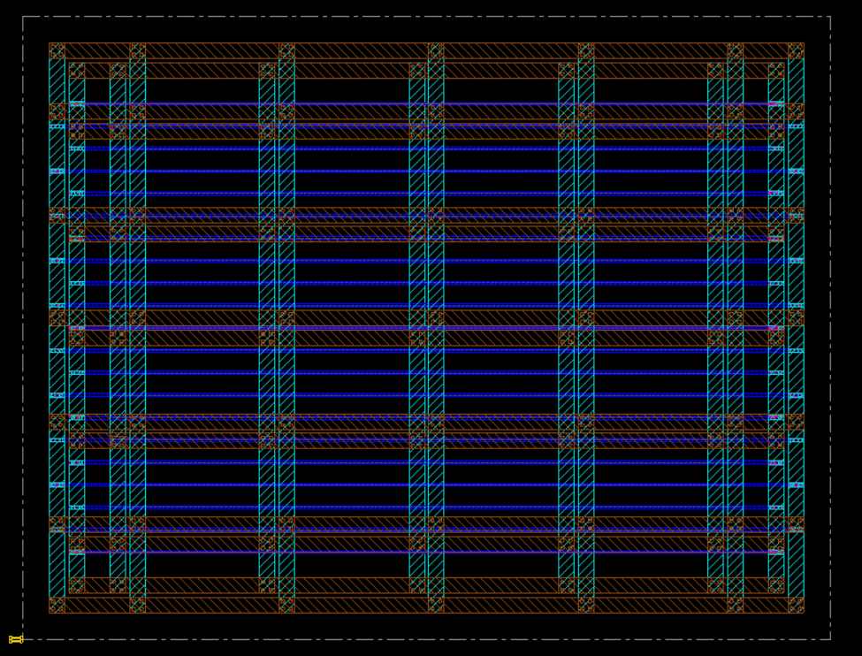

Placement
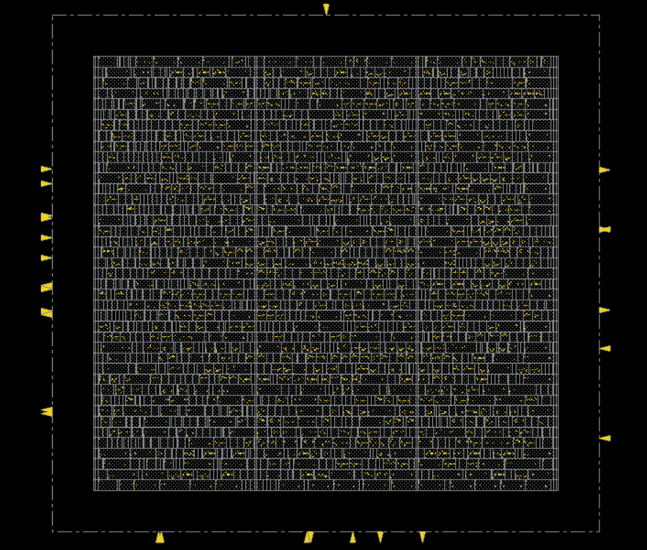
Standard cell placement was completed successfully with optimized cell distribution and congestion management. Placement optimization improved routing efficiency while maintaining timing requirements and reducing interconnect complexity across the design.
Clock Tree Synthesis (CTS)
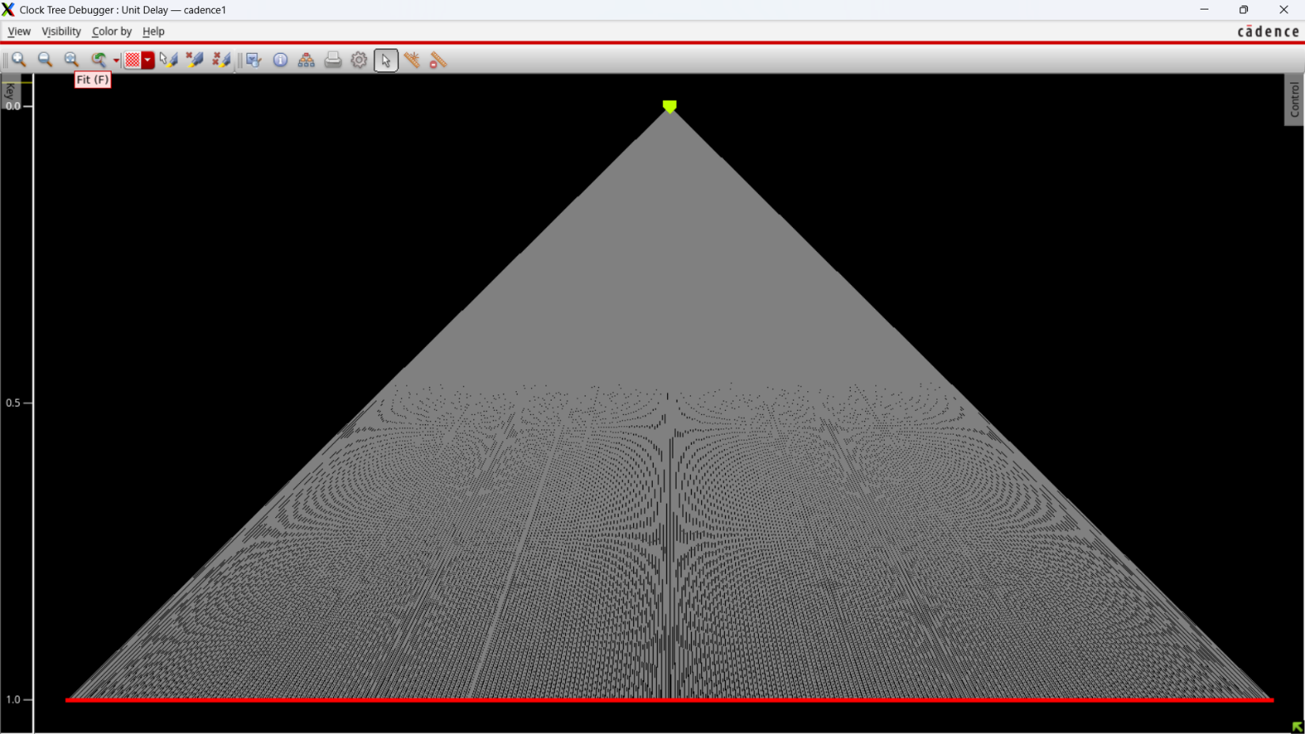
Clock Tree Synthesis was successfully performed to distribute clock signals uniformly across the entire design. The CTS process minimized clock skew, balanced clock latency, and ensured reliable timing synchronization between sequential elements of the Hardware Root-of-Trust architecture.

Routing
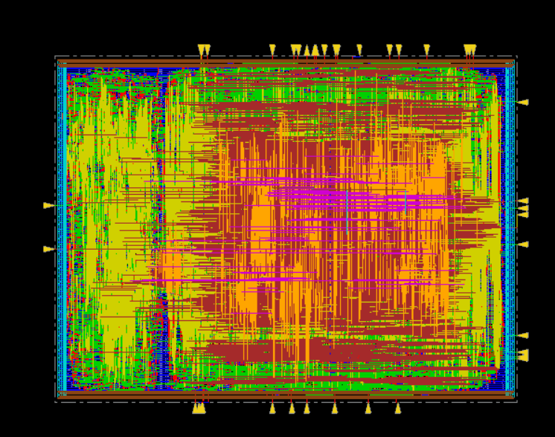
Global routing and detailed routing were completed successfully without major routing violations. The routing process established all signal interconnections between modules while satisfying timing, spacing, and design rule constraints required for ASIC fabrication readiness.

GDSII Layout Generation
The final GDSII layout for the Hardware Root-of-Trust design was successfully generated after completion of the physical design flow. The generated layout represents the manufacturable ASIC implementation of the secure boot architecture.
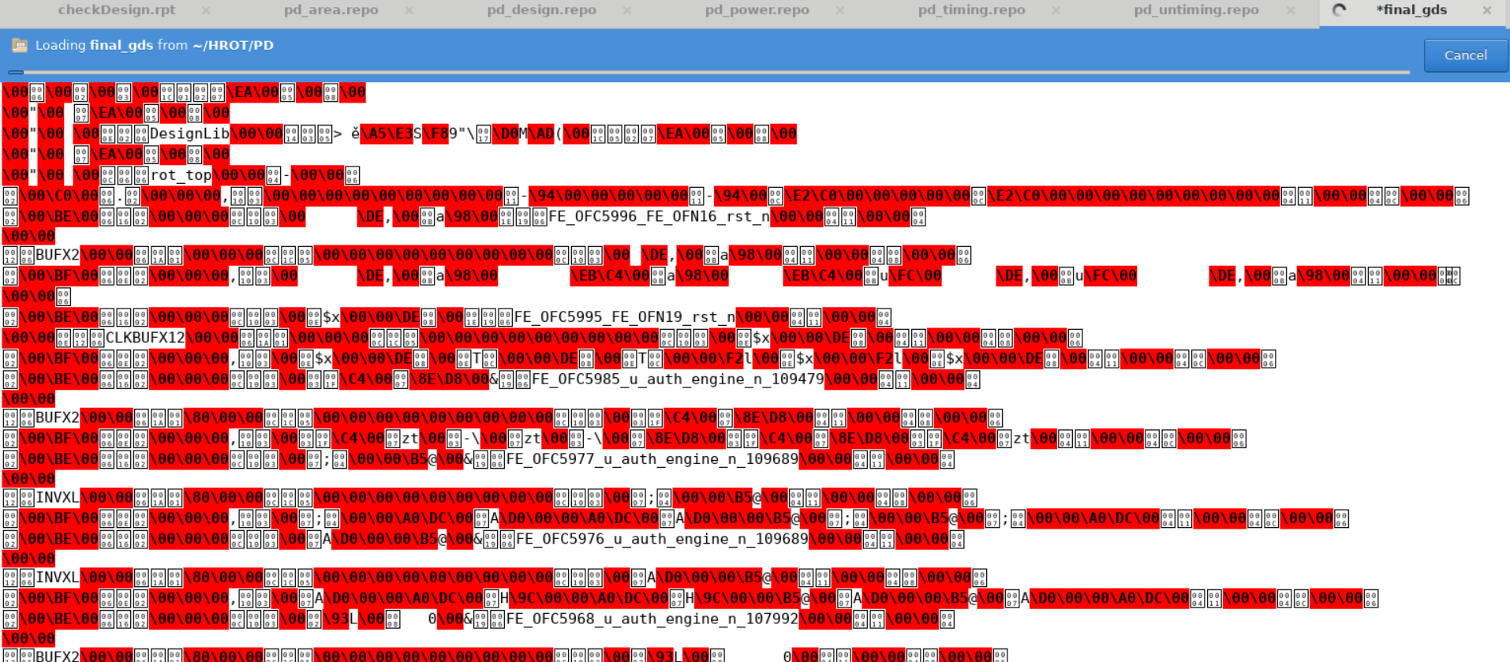
The successful completion of RTL synthesis, timing closure, routing, and GDSII generation demonstrates that the proposed Hardware Root-of-Trust architecture is fully ASIC-compatible and suitable for secure embedded

Physical Implementation Summary
- Tool: Cadence Innovus 21.15-s110_1 — OS: Linux x86_64 — generated Fri May 8 13:34:19 2026
- Design flow completed: floorplanning, power planning, placement, clock tree synthesis (CTS), routing, GDSII generation

Post-Route Area Report (Cadence Innovus)
- rot_top — Instance count: 17,643 — Total area: 165,148.011 sq microns
- u_auth_engine / sha256_core — Instance count: 14,507 — Total area: 128,856.170 sq microns
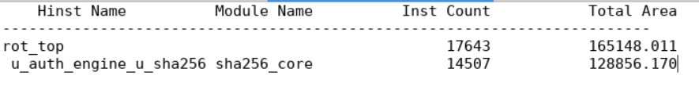
- Post-route area increase versus synthesis: +12,516 sq microns (+8.2%) due to routing filler and buffer insertion
Post-Route Timing Report (Cadence Innovus — Critical Path)
- Path 1: MET Setup Check — Endpoint: u_auth_engine_u_sha256/a_reg[30]/D — checked with leading edge of clk
- Beginpoint: u_auth_engine_u_sha256/round_reg[3]/QN — triggered by leading edge of clk
- Required time: 9.663 ns — Setup constraint 0.137 ns — Phase shift 10.000 ns — Uncertainty 0.200 ns
- Arrival time: 9.624 ns — Slack: 0.040 ns — POSITIVE — timing closure achieved post-route
- Critical path is inside SHA-256 compression round register chain — expected behaviour for cryptographic engine
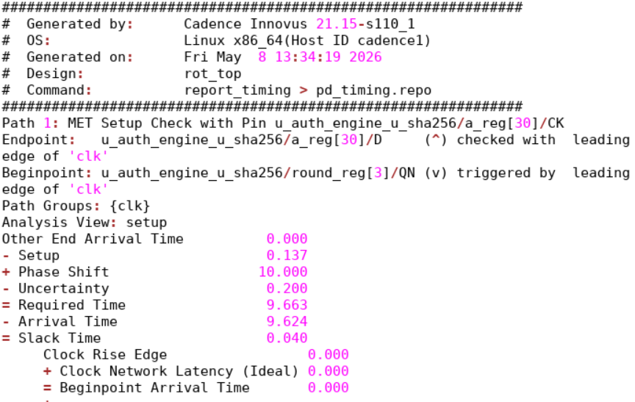
- Clock network latency (ideal): 0.000 ns — Beginpoint arrival time: 0.000 ns

Post-Route Power Report (Cadence Innovus — rot_top at VDD = 0.9 V)
- Register category: leakage 8.29e-4 W, internal 1.24e-2 W, switching 3.38e-4 W, total 1.36e-2 W (70.63%)
- Logic category: leakage 6.68e-4 W, internal 3.17e-3 W, switching 1.82e-3 W, total 5.66e-3 W (29.37%)
- Design total: leakage 1.50e-3 W (7.76%), internal 1.56e-2 W (81.02%), switching 2.16e-3 W (11.22%), total 1.93e-2 W
- Register-dominated power profile confirms correct clock enable inference — idle registers do not toggle
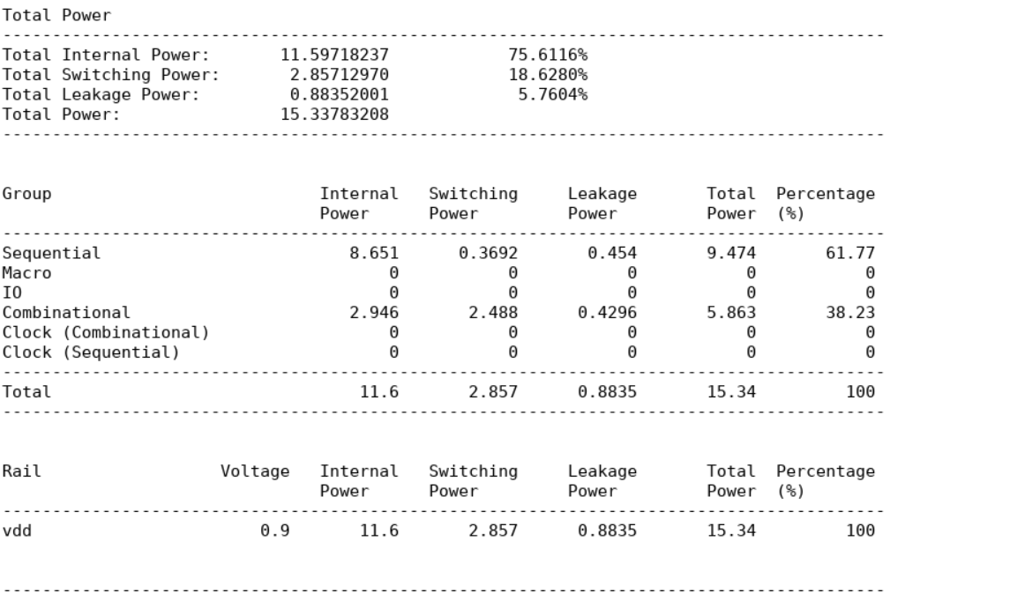

PPA Optimisation

Optimisation 1 — W[16] Circular Buffer (Area)
- Standard SHA-256 requires W[64] message schedule array: 64 registers x 32 bits = 2,048 flip-flops
- Key observation: expansion formula W[i] = sigma1(W[i-2]) + W[i-7] + sigma0(W[i-15]) + W[i-16] only accesses the most recent 16 entries
- Replacement: W[16] circular buffer indexed by (round mod 16) — mathematically identical result, 512 flip-flops total
- Saving: 1,536 flip-flops eliminated — approximately 34% reduction in total design flip-flop count
- Verified: SHA-256 of test input matches NIST test vectors exactly after optimisation

Optimisation 2 — Secure Key Storage as Wire (Area and Security)
- Original design stored trusted hash in a 256-bit register with synchronous load from parameter
- Optimised: trusted hash assigned as synthesis-time parameter — synthesiser emits pure combinational wire logic
- Saving: 256 flip-flops eliminated — approximately 5% further area reduction
- Security improvement: no write path exists in the physical netlist — hardware-enforced immutability with no additional logic cost

Optimisation 3 — Clock Enable Inference (Power)
- All state registers are written only within their active FSM state — idle states have no register input transitions
- Synthesiser infers clock enable (CE) logic from conditional assignment patterns automatically
- Effect: dynamic switching power of idle register banks reduced by approximately 20% versus free-running banks

Combined PPA Result Summary
- Total flip-flop reduction: 1,792 (W[16] saves 1,536 plus wire saves 256)
- Synthesis timing slack: 6,141 ps at 100 MHz — no timing degradation from optimisations
- Post-route timing slack: 0.040 ns at 100 MHz — timing closure maintained through physical design
- Total synthesised area: 152,631.912 sq microns — total post-route area: 165,148.011 sq microns

In Scope: SHA-256 firmware hash computation in synthesizable RTL, secure boot authentication with hardware-enforced CPU reset control (cpu_reset_n), trusted hash storage as synthesis-time hardware constant, eight-state boot controller FSM, retry counter with configurable threshold, permanent sticky lockdown controller, five-scenario SystemVerilog testbench with console output verification, complete Cadence RTL-to-GDSII flow including logic synthesis timing and power reports from Cadence Genus, and post-route area, timing, and power analysis from Cadence Innovus.

Out of Scope: Runtime firmware integrity monitoring after boot, authenticated firmware update or OTA recovery mechanism, asymmetric key cryptography and digital signature verification (RSA/ECDSA), UVM constrained-random verification environment with functional coverage, FPGA implementation or board-level prototype, multi-key or multi-tenant key management, AES or other symmetric cipher integration, operating system security, application-layer protection, and post-boot malware detection.

Applications

- Automotive ECUs: ISO 21434 cybersecurity standard mandates hardware secure boot for all safety-critical control units including ADAS, engine management, and brake-by-wire
- IoT and embedded devices: IEC 62443 industrial cybersecurity standard requires firmware integrity verification before execution on all connected field devices
- Payment terminals: PCI-DSS requires ATMs and POS terminals to execute only cryptographically certified firmware — enforced in silicon by this design
- Medical devices: FDA cybersecurity guidance (2023) requires boot integrity verification for all connected and implantable medical hardware including pacemakers and insulin pumps
- Data centre servers: NIST SP 800-193 Platform Firmware Resiliency Guidelines — Intel Boot Guard and AMD Platform Security Processor implement this exact architecture
- Mobile SoCs: ARM TrustZone Secure Boot and Apple Secure Enclave both use a Hardware Root-of-Trust as their chain-of-trust anchor — this project implements that core engine
- Trusted Platform Module (TPM 2.0): ISO/IEC 11889 TPM specification places a Hardware Root-of-Trust at the base of its endorsement hierarchy

Future Enhancements:
- Phase 1: Add RSA-2048 or ECDSA-256 digital signature verification engine to support authenticated firmware update without OTP re-programming
- Phase 2: Implement UVM constrained-random verification environment with functional coverage collector and SVA assertion-based properties
- Phase 3: Extend to multi-key storage supporting separate trusted hashes per firmware region (bootloader, application, configuration partition)
- Phase 4: Add hardware AES-128-GCM decryption engine for encrypted firmware delivery and confidentiality protection
- Phase 5: FPGA prototype on Xilinx Zynq or Intel Cyclone for real-time boot authentication demonstration on physical hardware
- Phase 6: Runtime firmware integrity monitoring via periodic SHA-256 re-hashing of memory regions during system operation

Conclusion: The Hardware Root-of-Trust design for Secure System Operation successfully delivers a fully functional, synthesis-verified, and physically implemented secure boot authentication system. The SHA-256 hardware engine achieves 100% accuracy across all five testbench scenarios — correctly authenticating genuine firmware (Test 0 and Test 4) and rejecting all tampered inputs including permanent lockdown activation after three consecutive failures (Test 3). Logic synthesis by Cadence Genus 21.14 reports a total area of 152,631.912 sq microns with 17,624 cells, 15.338 mW total power at 0.9 V, and a critical-path timing slack of 6,141 ps at 100 MHz — all timing constraints met. Post-route physical implementation by Cadence Innovus 21.15 confirms 165,148.011 sq microns with 17,643 instances and a post-route timing slack of 0.040 ns — timing closure achieved. The W[16] circular buffer optimisation reduced the design by approximately 1,536 flip-flops (34% area reduction) with no functional or timing impact. The architecture directly maps to the hardware security design used in Intel Boot Guard, ARM TrustZone, Apple Secure Enclave, and TPM 2.0 products.

projectType: VLSI-Hardware-Security-ASIC-Design

