Name: Hardware Root-of-Trust for Secure System Operation
GitHub Repository : https://github.com/suresh2327/Hardware-Root-of-Trust-for-Secure-System-Operation
Project Website : https://hardware-root-of-trust.vercel.app/
Description: A hardware-based security architecture designed to authenticate firmware before CPU execution using SHA-256 cryptographic verification. The system establishes a trusted boot process and prevents unauthorized firmware execution through hardware-enforced security mechanisms.
Functional Requirements
1) Secure Boot Functionality
- Authenticate firmware before CPU startup
- Hold CPU in reset until verification succeeds
- Prevent unauthorized firmware execution
- Establish trusted boot process
2) Firmware Authentication
- Generate SHA-256 hash for firmware data
- Compare generated hash with trusted hash
- Detect firmware modification or tampering
- Support cryptographic integrity verification
3) Secure Key Storage
- Store trusted hash securely in hardware
- Prevent unauthorized key modification
- Provide immutable trust anchor
4) Retry Protection
- Count failed authentication attempts
- Prevent brute-force firmware attacks
- Trigger secure lockdown after retry limit
5) Lockdown Mechanism
- Enter secure lockdown on repeated failures
- Block CPU execution during compromised state
- Maintain secure fail-safe behavior
6) CPU Reset Control
- Release CPU only after successful authentication
- Maintain reset during invalid authentication
- Enforce hardware-level execution control

Non-Functional Requirements
- Synthesizable RTL implementation
- Modular hardware architecture
- ASIC implementation compatibility
- Timing-aware design
- Area optimization support
- Power-aware implementation
- Hardware-level security enforcement
- RTL-to-GDSII flow compatibility
- Verification-friendly architecture

Problem Statement : Modern electronic systems rely heavily on firmware for hardware initialization and system startup. Since firmware is generally stored in rewritable flash memory, it becomes vulnerable to tampering, unauthorized modification, and malicious firmware injection attacks.
If compromised firmware executes during the boot process, it can gain complete control over the system before software-level security mechanisms become active. Existing software-based protections cannot secure the system during this early boot stage, creating a critical security vulnerability.

Proposed Solution : To address this issue, this project implements a Hardware Root-of-Trust architecture that authenticates firmware before CPU execution using SHA-256 cryptographic verification.
The Root-of-Trust establishes a trusted hardware security boundary by comparing the generated firmware hash against a securely stored trusted hash value. If the authentication succeeds, the CPU is released for normal execution. If authentication fails, the system blocks execution by maintaining the CPU in reset mode or entering a secure lockdown state.
This approach ensures that only trusted firmware is allowed to execute, thereby protecting the system from firmware-level attacks and unauthorized control.

Technologies used: SystemVerilog, UVM (Universal Verification Methodology), SHA-256 Cryptographic Algorithm, Cadence Xcelium, Cadence Genus, Cadence Innovus, TCL Scripting, ASIC RTL-to-GDSII Design Flow, Gate-Level Synthesis, Physical Design Implementation, Timing Analysis, Power Analysis, GDSII Layout Generation

System Architecture – Hardware Root-of-Trust (RoT)
The proposed Hardware Root-of-Trust architecture establishes a secure hardware-based boot mechanism that authenticates firmware before CPU execution. The architecture ensures that only trusted firmware is allowed to run, thereby preventing unauthorized access, firmware tampering, and boot-level attacks.
The system begins operation when a power-on event generates a boot request to the Boot FSM Controller. The Boot FSM manages the complete secure boot sequence and initiates the firmware authentication process.
During startup, firmware data is fetched from external memory such as Flash or DDR memory and transferred to the Authentication Engine. Simultaneously, the trusted cryptographic key or reference hash is retrieved from Secure Key Storage, which acts as the hardware trust anchor of the system.
The Authentication Engine performs SHA-256 cryptographic verification by generating a hash value for the incoming firmware and comparing it with the trusted reference value stored securely in hardware.
Based on the authentication result, the architecture operates in two possible modes:

1) Authentication PASS Flow
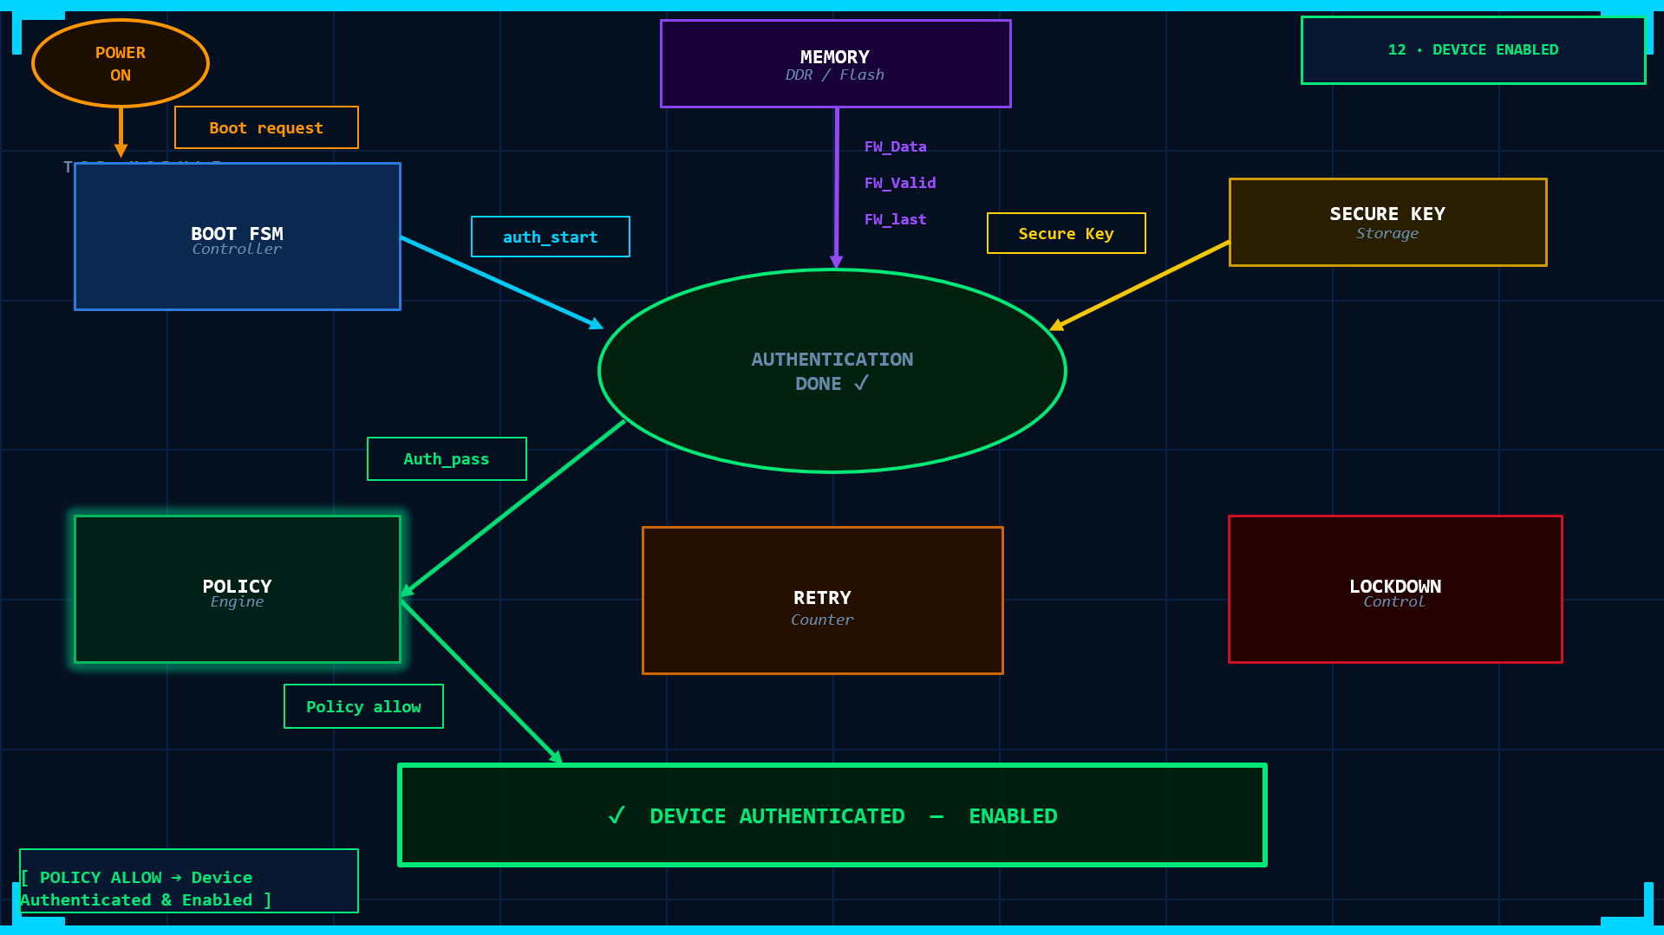
If the generated firmware hash matches the trusted secure hash
- Authentication is successful
- The Policy Engine generates an allow decision
- The CPU reset is released
- The device is enabled for normal operation
In this condition, the system establishes trusted execution and allows the firmware to control the device securely.
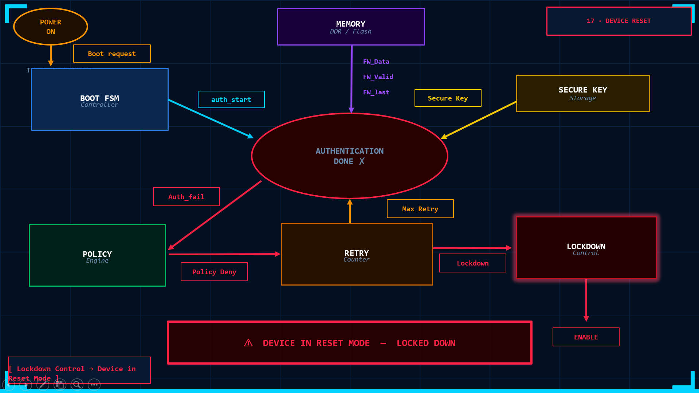
2) Authentication FAIL Flow
If the generated firmware hash does not match the trusted hash:
- Authentication fails
- The Policy Engine generates a deny decision
- The Retry Counter increments failed attempts
- If maximum retry limit is exceeded, the Lockdown Controller is activated
- The CPU remains in reset mode
- The device enters secure lockdown state
This mechanism prevents malicious or modified firmware from executing and protects the system from unauthorized control.

Detailed Architecture Module Description
1. Boot Controller FSM
The Boot Controller FSM (Finite State Machine) is the central control unit of the Hardware Root-of-Trust architecture. It manages the complete secure boot sequence and coordinates communication between different hardware security modules during system startup. The FSM begins operation immediately after power-on and ensures that firmware authentication is completed before CPU execution is allowed. It controls state transitions such as reset initialization, authentication start, authentication wait, result verification, boot allow, boot deny, and lockdown conditions. The Boot Controller FSM ensures that the secure boot process follows a strict sequence, preventing unauthorized or uncontrolled execution during startup.

2. Authentication Engine
The Authentication Engine is responsible for verifying firmware integrity and authenticity using SHA-256 cryptographic hashing. It receives firmware data from external memory and processes it to generate a secure hash value. The generated firmware hash is compared with a trusted reference hash stored in secure hardware storage. Based on this comparison, the engine determines whether the firmware is authentic or modified.
If authentication succeeds, the engine signals successful verification to the policy engine and boot controller. If authentication fails, the system blocks execution and activates secure protection mechanisms.
This module forms the core security verification component of the Root-of-Trust architecture.

3. SHA-256 Core
The SHA-256 Core implements the Secure Hash Algorithm belonging to the SHA-2 cryptographic family. It generates a fixed 256-bit hash value for the firmware data. The SHA-256 algorithm processes firmware data in blocks and performs multiple cryptographic transformation rounds to produce a unique digital fingerprint. Even a single-bit change in firmware results in a completely different hash value. This property makes SHA-256 highly effective for detecting firmware tampering, modification, and unauthorized changes. The SHA-256 Core provides strong cryptographic integrity verification for secure boot operation.

4. Secure Key Storage
The Secure Key Storage module stores the trusted reference hash securely inside hardware. It acts as the hardware trust anchor of the Root-of-Trust architecture. The stored trusted hash represents the original authenticated firmware fingerprint. During startup, the authentication engine compares the generated firmware hash against this trusted value. The secure key storage is designed to prevent unauthorized modification, ensuring that attackers cannot alter the trusted security reference. This module establishes the foundation of trust within the secure boot system.

5. Policy Engine
The Policy Engine is responsible for generating security decisions based on firmware authentication results. It evaluates authentication status and determines whether the firmware should be allowed to execute or denied.
The module generates three possible security responses:
- Allow execution
- Deny execution
- Activate lockdown mode
If authentication succeeds, the policy engine enables trusted execution. If authentication fails repeatedly, the policy engine activates secure lockdown protection.
This module enforces hardware-level security policies within the system.

6. Retry Counter
The Retry Counter module tracks failed firmware authentication attempts. Its primary purpose is to prevent repeated attack attempts and brute-force authentication bypass methods. Every failed authentication increments the retry count. Once the retry count exceeds a predefined limit, the system activates secure lockdown mode. The retry mechanism improves system security by limiting repeated unauthorized verification attempts.

7. Lockdown Controller
The Lockdown Controller manages the secure lockdown state of the system. It is activated when repeated authentication failures or critical security violations occur. Once activated, the lockdown controller prevents CPU execution and blocks further unauthorized operations. The system remains in secure lockdown until valid recovery or firmware restoration is performed. This module ensures fail-safe protection during security compromise conditions.

8. CPU Reset Controller
The CPU Reset Controller provides hardware-level execution control by managing the processor reset signal.
During startup, the CPU is initially held in reset mode to prevent immediate execution. Only after successful firmware authentication does the controller release the CPU reset signal and allow normal operation. If authentication fails, the CPU remains in reset mode, preventing unauthorized firmware execution. This module acts as the final hardware authority controlling system execution.

9. Memory Interface
The Memory Interface module transfers firmware data from external storage such as flash memory or DDR memory to the authentication engine. It enables firmware streaming during startup and supports secure firmware verification flow. The interface ensures reliable transfer of firmware blocks required for SHA-256 authentication. This module provides the communication path between firmware storage and the Root-of-Trust verification system.

Complete Architectural Flow
The complete Hardware Root-of-Trust architecture operates in the following sequence:
- System powers ON
- Boot Controller FSM initializes secure boot process
- Firmware is fetched from memory
- Authentication Engine performs SHA-256 verification
- Generated hash is compared with trusted secure hash
- Policy Engine evaluates authentication result
- CPU Reset Controller either:
  - Releases CPU for execution, or
  - Maintains reset / activates lockdown
This architecture ensures that only authenticated and trusted firmware is allowed to execute, establishing secure and reliable system operation.

Importance of the Project
Modern electronic systems heavily depend on firmware for hardware initialization, device control, and system startup. Since firmware executes before the operating system and directly controls hardware functionality, its integrity is extremely critical for overall system security.

In many embedded and connected devices, firmware is stored in rewritable flash memory, making it vulnerable to tampering, unauthorized modification, malware injection, and firmware-level cyber attacks. If compromised firmware is executed during startup, attackers can gain complete control over the system before software-based protections such as antivirus software, firewalls, or operating system security mechanisms become active.

This project addresses this critical security challenge by implementing a Hardware Root-of-Trust (RoT) architecture that establishes trust before CPU execution begins. The proposed system authenticates firmware using SHA-256 cryptographic verification and ensures that only trusted firmware is allowed to execute.

The importance of this project lies in its ability to provide hardware-level, non-bypassable security during the earliest stage of system operation. Unlike software-based protections, the Root-of-Trust operates before the operating system starts, making it significantly more resistant to attacks.

This project is highly important for modern applications such as automotive systems, IoT devices, industrial automation platforms, medical electronics, and secure embedded systems where firmware integrity directly affects system safety, reliability, and security.

The project also demonstrates a complete ASIC-oriented hardware security solution using SystemVerilog RTL, UVM verification, logic synthesis, and physical design implementation, making it highly relevant in the field of VLSI and hardware security engineering.

Project Objectives
- Design hardware-based secure boot architecture
- Authenticate firmware before CPU execution
- Prevent unauthorized firmware execution
- Implement SHA-256 cryptographic verification
- Develop synthesizable RTL for ASIC implementation
- Validate design using UVM verification methodology
- Complete RTL-to-GDSII implementation flow

Key Features
- Hardware-Enforced Secure Boot
- SHA-256 Firmware Authentication
- Immutable Secure Key Storage
- Retry & Lockdown Protection
- CPU Reset Enforcement
- Hardware-Level Trust Establishment
- RTL-to-GDSII ASIC Flow

In scope: Hardware-based secure boot implementation, SHA-256 firmware authentication, secure key storage, firmware integrity verification, CPU reset control, retry protection mechanism, lockdown security control, hardware trust establishment, SystemVerilog RTL implementation, UVM-based verification, logic synthesis using Cadence Genus, physical design using Cadence Innovus, and RTL-to-GDSII ASIC design flow.
Out scope: Operating system security, application-layer protection, antivirus functionality, runtime malware detection, cloud-based security monitoring, secure network communication, AI-based threat prediction, post-boot security analysis, software firewall mechanisms, and operating system kernel protection.

Verification Scope
The design is verified for:
- Authentication PASS condition
- Authentication FAIL condition
- CPU reset enforcement
- Retry counter operation
- Lockdown activation
- FSM state transitions
- SHA-256 functional correctness

Results and Analysis
Functional Simulation Results(Xcelium)
The Hardware Root-of-Trust (RoT) architecture was functionally verified using Cadence Xcelium simulation environment to validate secure boot functionality, firmware authentication flow, retry protection, CPU reset control, and lockdown operation.
Design Schematic Verification
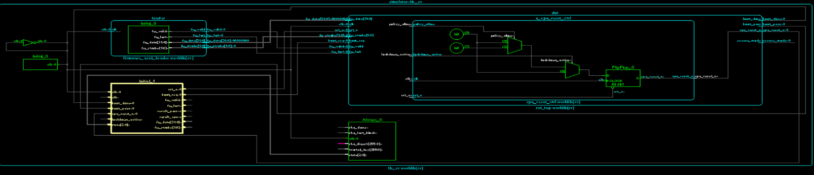
The generated RTL design schematic confirmed successful integration of all major modules including the Boot FSM Controller, Authentication Engine, SHA-256 Core, Policy Engine, Retry Counter, Lockdown Controller, Secure Key Storage, and CPU Reset Control.
The schematic verification ensured correct module connectivity, signal flow, and hardware architecture implementation before synthesis and physical design stages.
Timing Diagram Verification
Simulation timing waveforms verified the correct sequential operation of the secure boot process. The timing diagrams confirmed proper synchronization between firmware loading, SHA-256 authentication, policy decision generation, retry control, and CPU reset release.
The waveform analysis validated both authentication PASS and authentication FAIL scenarios:
- Successful firmware authentication enabled CPU execution
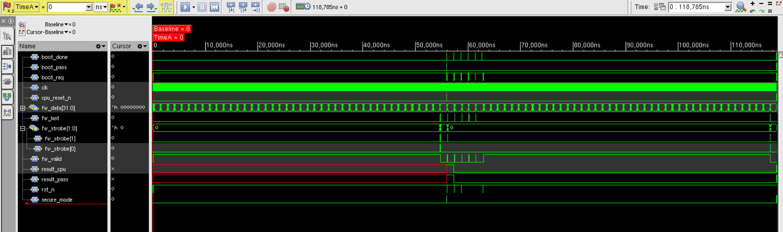
- Failed authentication maintained CPU reset and triggered secure lockdown behavior
The timing results confirmed reliable FSM transitions and secure hardware-level execution control.
Console Output Verification
Simulation console outputs confirmed successful execution of the verification environment and secure boot functionality. The console logs verified:
- Firmware authentication process initiation
- SHA-256 hash generation and comparison
- Authentication PASS and FAIL detection
- Retry counter operation
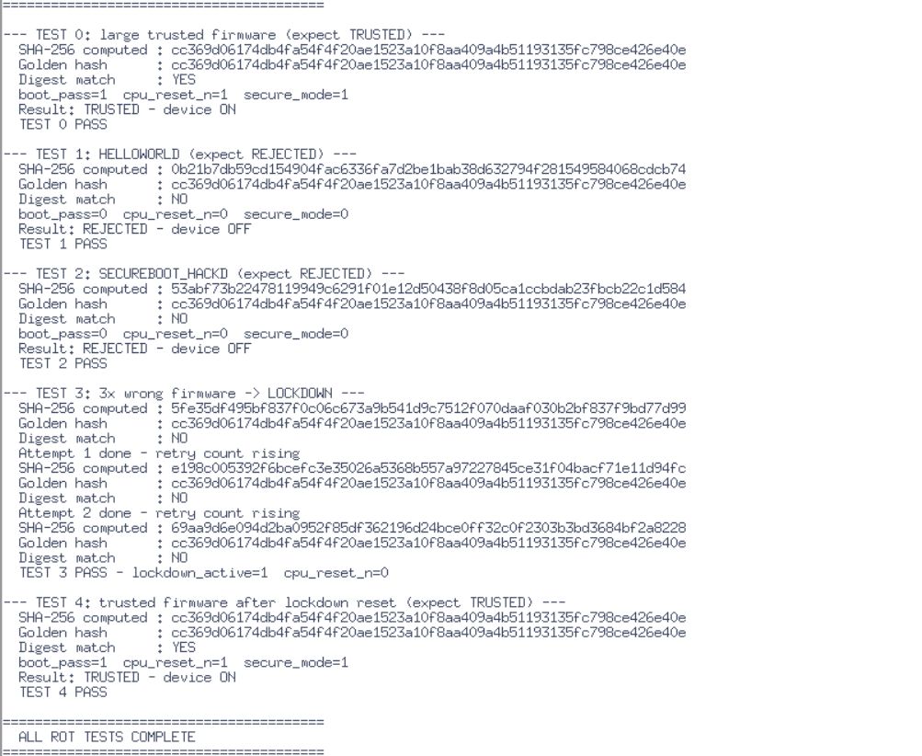
- Lockdown activation during repeated failures
- CPU enable and reset control behavior
The console results demonstrated correct operation of the Hardware Root-of-Trust architecture under different security conditions.
Cadence Genus – Logic Synthesis Results
The Hardware Root-of-Trust (RoT) RTL design was successfully synthesized using Cadence Genus Synthesis Solution targeting ASIC implementation flow. The synthesis process validated the synthesizability of all SystemVerilog RTL modules including the Boot FSM, Authentication Engine, SHA-256 Core, Policy Engine, Retry Counter, and Lockdown Controller.
Synthesis Summary
- Tool Used: Cadence Genus 21.14
- Technology Library: Fast timing library
- RTL Language: SystemVerilog
- Design Top Module: rot_top
- Synthesis Status: Successful
Area Analysis
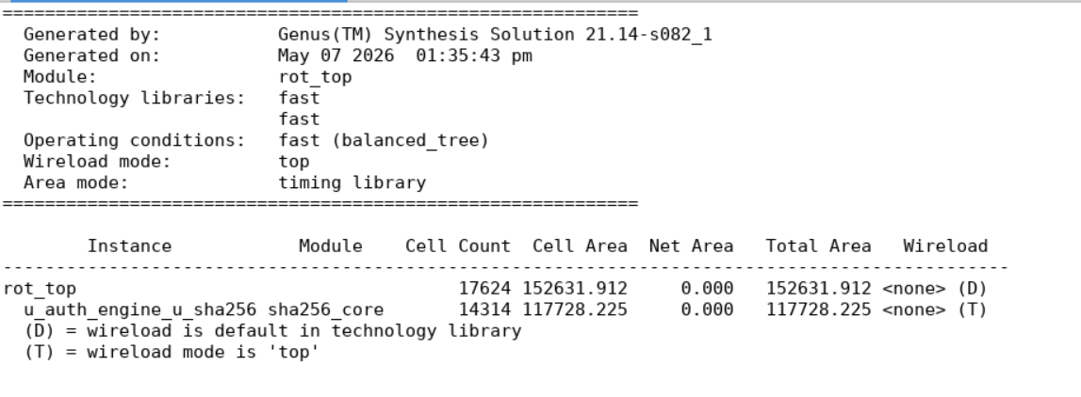
The synthesized design achieved successful area optimization suitable for ASIC implementation.
The SHA-256 authentication engine occupies the majority of the hardware area due to cryptographic computation complexity.
Timing Analysis
Static Timing Analysis (STA) confirmed that the design successfully met setup timing constraints.
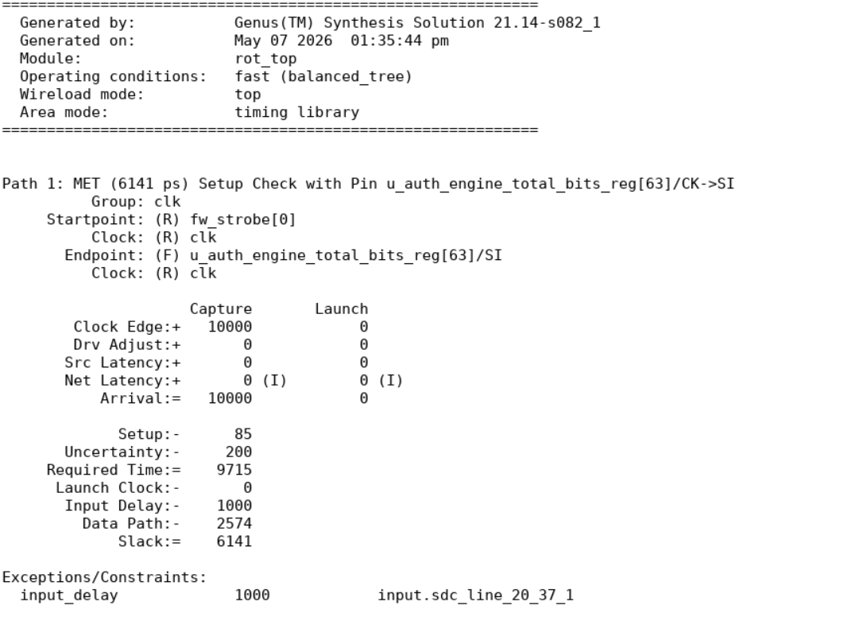
Positive slack indicates that the synthesized design satisfies timing requirements without setup violations.
Power Analysis
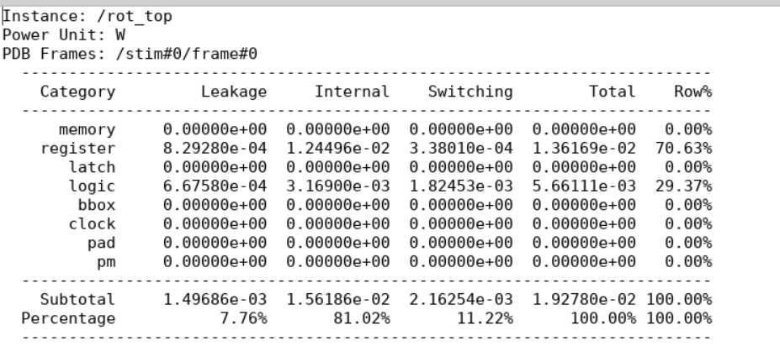
Power estimation was performed during synthesis to evaluate switching, internal, and leakage power.
The results indicate that most power consumption originates from sequential cryptographic operations inside the SHA-256 engine.
Cadence Innovus – Physical Design Results
The synthesized netlist was successfully imported into Cadence Innovus for physical design implementation. The complete RTL-to-GDSII flow was performed including floorplanning, placement, clock tree synthesis (CTS), routing, and layout generation.
Physical Design Summary
- Tool Used: Cadence Innovus 21.15
- Design Flow: RTL-to-GDSII
- Implementation Status: Successful
- Final Routing: Completed
- GDSII Generation: Completed

Floor Planning
The floorplan for the Hardware Root-of-Trust architecture was successfully generated by defining the core area, placement boundaries, routing resources, and standard cell utilization. Proper floorplanning ensured balanced module distribution, optimized routing paths, and efficient utilization of chip area for ASIC implementation.


Power Planning
Power planning was successfully implemented by creating dedicated power and ground networks across the design. The power distribution structure ensured stable voltage delivery, minimized IR drop effects, and supported reliable operation of the secure boot and authentication modules throughout the chip.
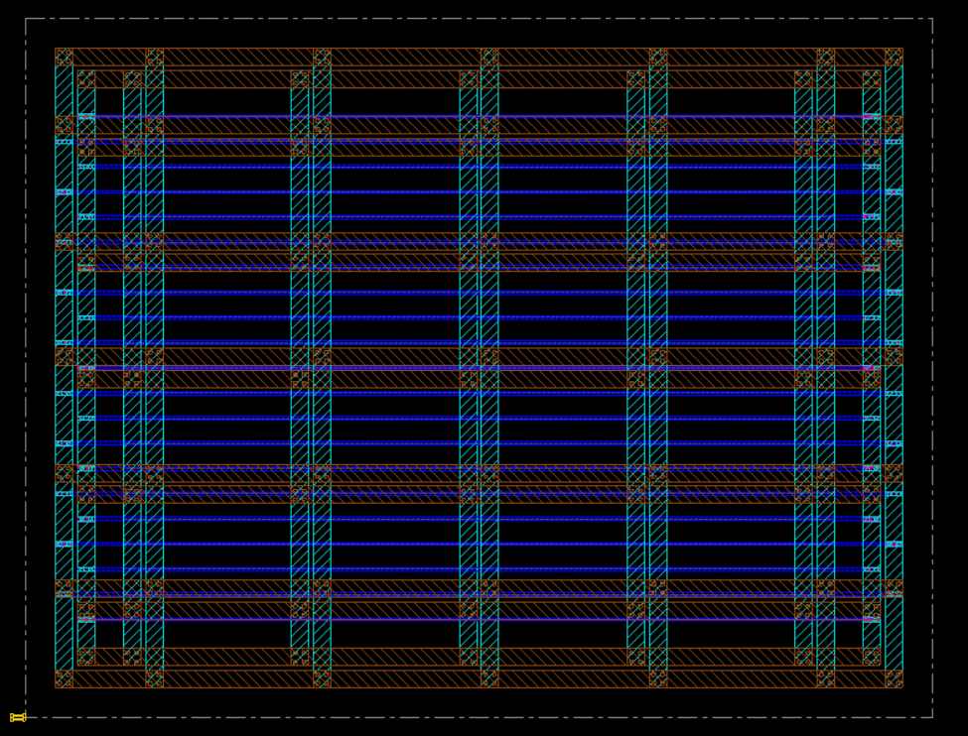
Placement
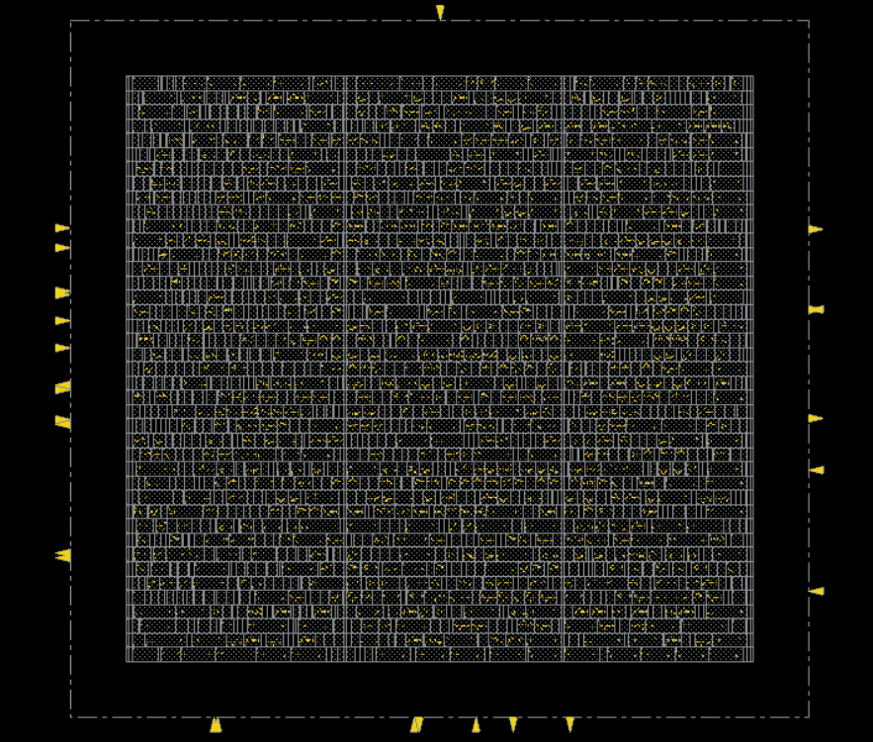
Standard cell placement was completed successfully with optimized cell distribution and congestion management. Placement optimization improved routing efficiency while maintaining timing requirements and reducing interconnect complexity across the design.
Clock Tree Synthesis (CTS)
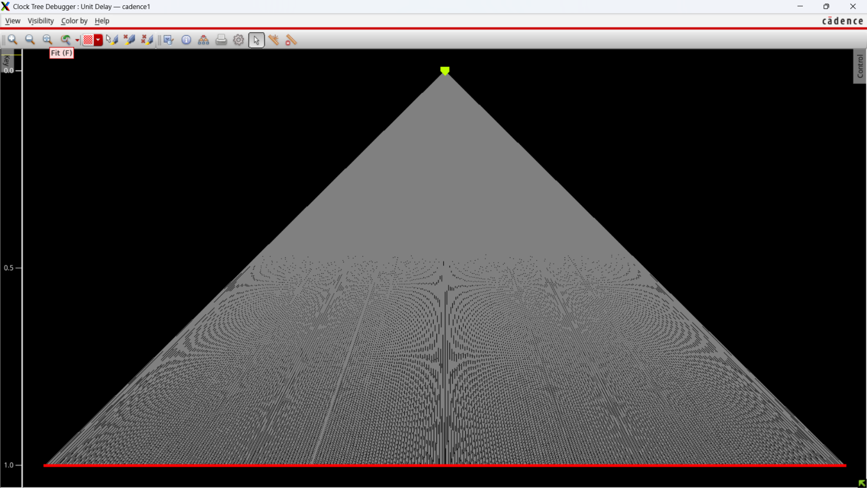
Clock Tree Synthesis was successfully performed to distribute clock signals uniformly across the entire design. The CTS process minimized clock skew, balanced clock latency, and ensured reliable timing synchronization between sequential elements of the Hardware Root-of-Trust architecture.

Routing
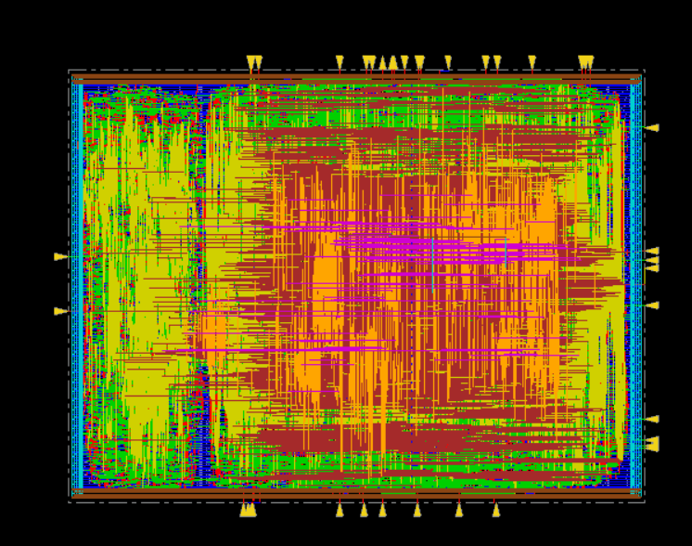
Global routing and detailed routing were completed successfully without major routing violations. The routing process established all signal interconnections between modules while satisfying timing, spacing, and design rule constraints required for ASIC fabrication readiness.

GDSII Layout Generation
The final GDSII layout for the Hardware Root-of-Trust design was successfully generated after completion of the physical design flow. The generated layout represents the manufacturable ASIC implementation of the secure boot architecture.
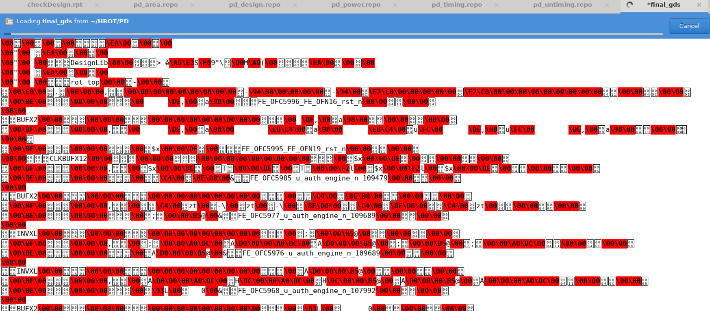
The successful completion of RTL synthesis, timing closure, routing, and GDSII generation demonstrates that the proposed Hardware Root-of-Trust architecture is fully ASIC-compatible and suitable for secure embedded hardware platforms.
Area Analysis
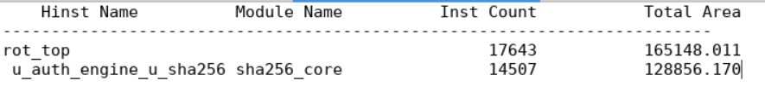
Post-layout area analysis was performed after physical design implementation in Cadence Innovus. The final layout achieved successful standard cell utilization and optimized chip area distribution while maintaining routing feasibility and timing closure. The SHA-256 authentication engine occupied the majority of the hardware area due to the complexity of cryptographic computation and sequential processing logic.

Timing Analysis
Post-route Static Timing Analysis (STA) confirmed that the Hardware Root-of-Trust architecture successfully met setup timing constraints after physical implementation. Positive slack values indicated successful timing closure without critical setup violations, ensuring reliable operation of the secure boot and firmware authentication logic under defined clock conditions.
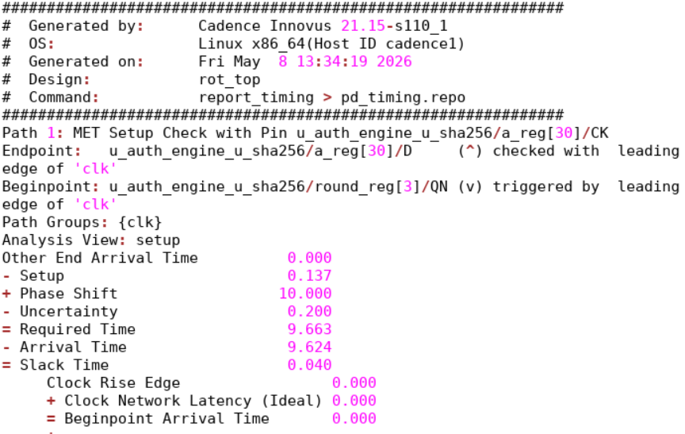

Power Analysis
Post-layout power analysis was carried out in Cadence Innovus to evaluate internal, switching, and leakage power consumption of the complete design. The results demonstrated stable power distribution and acceptable power consumption for ASIC implementation. Internal power contributed the highest percentage due to intensive sequential operations within the SHA-256 cryptographic authentication engine.

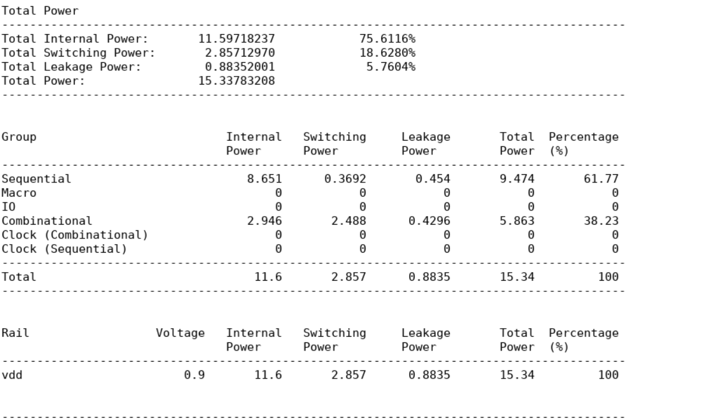

Overall Result Analysis
The implementation results validate the correctness and feasibility of the proposed Hardware Root-of-Trust architecture. The design successfully achieved:
- Hardware-based secure boot functionality
- SHA-256 firmware authentication
- Successful timing closure
- ASIC-compatible RTL synthesis
- Complete physical design implementation
- GDSII layout generation
- Hardware-level trusted execution control
The results confirm that the architecture is suitable for secure embedded systems requiring trusted firmware execution and hardware-level boot security.

Future enhancements: Runtime firmware integrity monitoring, secure OTA firmware update authentication, AI-assisted policy engine for adaptive security decisions, anti-rollback firmware protection, hardware-based intrusion detection, support for advanced cryptographic algorithms, formal verification for security validation, low-power security optimization, multi-core secure boot support, and integration with Trusted Execution Environment (TEE) architectures.
Conclusion: The Hardware Root-of-Trust (RoT) project successfully establishes a secure hardware-based trust mechanism for modern embedded and SoC platforms. By authenticating firmware using SHA-256 cryptographic verification before CPU execution, the system prevents unauthorized firmware execution and protects against boot-level attacks. The project demonstrates a complete RTL-to-GDSII ASIC implementation flow using SystemVerilog, UVM, Cadence Genus, and Innovus, making it a reliable and scalable solution for automotive, IoT, industrial, and security-critical applications.
projectType: VLSI-Hardware-Security-ASIC-Design
Acknowledgement
We sincerely thank our faculty mentors, department staff, and institution for providing guidance and resources throughout the development of this project.

