**LINUX**

**Creating USER (Its not good practice to work in root environment)**

**useradd<name>** : creating the user but by default user is not going to have any privilages.

Whenever you create a user by “useradd <username>” command, by default

Linux will create Primary group with the Same User name n also a directory.

**#passwd** <username> : Assigning password to that particular user

**#man <command>** : To know all the details of particular command

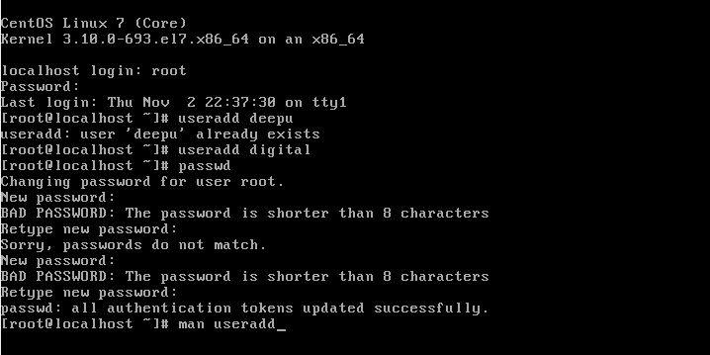

**visudo** : It is a file which contains information about sudoers.

u**sermod –aG <groupname> <username>**  : Adding the user to the particular group.

In Linux “wheel” is a default group. If you add user to that group then user will get

All administrative privilages.

**Id <username>** : To know the details of particular user like : user_id group_id etc.,

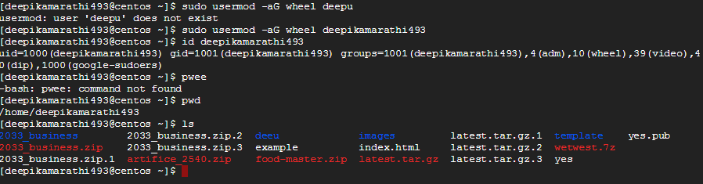

**File hierarchy in Linux:**

**/bin**  Essential command binaries

**/boot**  Static files of the boot loader

**/dev**  Device files

**/etc**  Host−specific system configuration

**/lib**  Essential shared libraries and kernel modules

**/media** Mount point for removeable media

**/mnt** Mount point for mounting a filesystem temporarily

**/opt**  Add−on application software packages

**/sbin**  Essential system binaries

**/srv**  Data for services provided by this system

**/tmp**  Temporary files

**/usr** Secondary hierarchy

**/var**  Variable data

**/ −−** The root directory

**/home** User home directories (optional)

**/lib**  Alternate format essential shared libraries (optional)

**/root**  Home directory for the root user (optional)

**Basic Commands:-**

**File & Directory Management**

**​**

**ls :-**   Display list of directory and files in system.

**clear :-**  Used to clear the screen.

**ls -l :-**  It will display long format of files permissions.

**ls -a :-**  Display files or hidden files.

**ls -la :-** Display long format of file & permission which are in hidden stage.

**ls -r :-** Display the files in reverse order.

**ls -lr :-** Display long format files & permission in reversible

**ls -s :-** Display files along with size.

**ls -ls :-** Display long format of files along with size.

**ls -t :-** Display according to time creation.

**ls -lt :-** Display long format along with time.

**ls -lrt :-** calculates time stand & Display in reverse order.

**Meta characters :-**Using wild card searching will become easy and efficient.

**->** star **\***

**->** Question mark **?**

**->** square Bracket **[ ] 🡺 range operator**

**Example:**

**ls fi* :-** Display all the files starting with fi

**ls *.doc :-** Display all the files starting with .doc

**ls *.??? :-** Display all files having 3 letter extensions.

**ls *.?? :-** Display all files having 2 letter extensions.

**ls [fn]* :-** Display all files start with letter f & n.

**ls *[0-2] :-**  Display all files start with range 0 & 2.

**The ways of Creating a file :**

**----------------------------------------**

1. touch
2. cat
3. vim

touch: **touch a.txt**

it will create an empty file

and we can update the time of file

cat : **cat > <filename>**

It will create a file

To append the data by using cat command—> **cat >> <filename>**

vim :

It will create file if the file is not exists.

If file is present then it will open the file.

In which we can edit/modify the file contents.

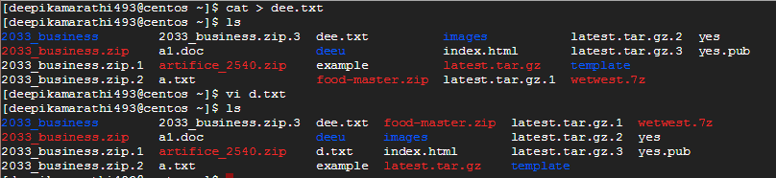

Here you will have 3 modes :

1. Command Mode : You can Navigate in file
2. Insert Mode : You can modify the file contents
3. Extended Command Mode: Here you can save, quit or assign a password to file.

**k :** to move upword direction when u use vi command

**l :** to move right side direction whaen u use vi command

**h :**to move left side direction when u use vi command

**j :** to move downword direction when u use vi command

**I :**  to insert the data( I : beginning of the data)

**a**: to append the data ata the end

**A**: to append the data at the beginning

**o** : new line below the cursor

**O** : new line above the cursor

**gg** : beginning of the page

**G** : end of the page

**w** : moves forword direction word by word

**5w** : moves forword direction by 5 words

**b** : moves the cursor towards backword direction (word by word)

**2b** : moves the cursor towards backword direction (bby 2 words)

**b** : to undo the changes what u have done lastly

**yy** : to copy the particular lline

**5yy** : to copy 5 lines from the cursor

**U** : to undo the changes what u had done all previously

**Cntrl +r** : to redo the changes

**dd** : deleting the particular row

**5dd** : deleting the 5 rows from the cursor

**p** : paste data below the cursor

**P** : paste the data above the cursor

**/** :to search the data what u had given in that particular file .to use this first press escape and then type

the data what u want to search

**w** : to save the file(first press escape and type w)

**q** :to quit the file without saving(escape)

**wq** : to save and quit the file

**!** : to forcefully come out of the file(use it after wq)

**x** : to save and quit(same as wq)

**X** :to give/rename password for a file

**:5** : go for 5th line

**:n** : go for nth line

Echo :

-----------

**echo “welcome to dl”** 🡪 It will directly print the data on console

**echo “welcome” > a.txt** 🡪 It will replace the data in that file

**echo “welcome” >> a.txt** 🡪 It will append the data in that file

**Copying files into directory :-**

**#cp <source filename> <destination directory in which to paste the file>**

**Copying directories from one location to other :-**

**# cp –rvfp <dir name> <destination name>**

**Moving files from one location to other (cut and Paste)**

**#mv <filename> <Destination directory>**

**Moving a Directory from one location to other**

**#mv <dir name> <destination dir name>**

**Renaming a File**

**#mv <old name> <new name>**

**Renaming a Directory**

**->** The procedure and command for renaming the directory is exactly same as renaming a file.

**#mv old name new name**

**Removing a File**

**#rm filename or #rm –f filename (without prompting)**

**Removing an Empty directory**

**#rmdir dirname**

**Removing a directory with files or directories inside**

A dir which is having some contents inside it cannot be removed by rmdir command. There are two ways to delete the directory with contents.

**i. Remove the contents inside the directory and then run rmdir command**

**ii. Run #rm –rf dirname (where r stands for recursive and f stands for forcefully.**

**Operations and redirections :-**

**( grep , more, less, head, tail, sort )**

**Grep :-** It is used to search files in different patterns.

**-> man grep :-** info of grep commands

**-> grep word filename.txt :-** gives the word any number of times present in the file with case sensitive

**-> grep -i word filename.txt :-** give the word any number of times present in the file with non-case sensitive.

**-> grep -r word /directory/ :-** it will find that word in all directories. **‘r’** is recursive.

**-> grep -ir word/directory/:-**All the case sensitive word.

**-> grep -w word filename.txt:-** we get only the specified word not the sub string.

**-> egrep -w ‘word1|word2’ filename.txt:-** we get all the specified words in a multiple we can search multiple words at a time.

**-> grep -c word filename.txt :-** we get how many the word has repeated.

**-> grep -n word filename.txt:-** it will get the word repeated with count.

**-> grep -v word filename.txt:-** it skips the matched word from the file & shows remaining.

**-> grep -l and *.txt :-** show all the words from all.txt files in that directory.

**More :-**just like cat command, Text on screen going through pages or line by line.

**-> man more :-** information of the more command

**-> more filename.txt:-** Display the info in the pager wise to go through it . By using Spacebar.

**-> more -c filename.txt :-** clear the screen before it display the files.

**-> more -10 filename.txt:-** Display only first 10 lines of file.

**-> more +10 filename.txt:-** Display line from 10th line onwards.

**Less:-**opposite of more

**-> less filename.txt:-** to navigate the line by line in the file press enter key.

**-> space bar :-** for page by page use space key.

**-> d::-** for page by page in upward directions.

**-> G :-** to reach the end of the file

**-> g :-** to reach the top of the file.

**-> /word:-** to search a particular word in the file it will highlight that word & by pressing ‘n’ it move to another page in searching the word in downward directions.

**-> ?word:-** To search a particular word in the file it will highlight that word & by pressing ‘n’ it move to another page in search of the word in upward directions.

**-> q :-** To quit from search.

**Head :-** output the first part of file.    ( Or ) Head is  top it display top of the files. .

**-> man head :-** info of head command. To exit press  esc and then :q.

**-> head myfile.txt:-** Display first 10 lines of code its a default behaviour of file.

**-> head -n 5 myfile.txt:-** display first 5 lines of code. We can write any number to display

**-> head file1.txt file2.txt :-** Display first 10 lines of code from both the file with different header number.

**-> ls -l filename.txt :-** display size of file.

**-> head -c 20 filename.txt :-** Display first  20 bites  of program.

**M-Megabyte ; G -Gigabyte ;T-Terabyte.**

**-> head -n 4*.text :-** Display all program ending with .txt 4 lines of code

**Tail:-**Reverse of head. Tail is bottom it display bottom of files.

**-> tail filename.txt :-** Display last 10 lines of files

**-> tail -5 myfile.txt :-** Display bottom 5 lines of code

**-> tail file1.txt fle2.text :-** Display bottom 10 lines of both the file with different numbers.

**-> tail -n 5 file1.txt file2.txt :-** display bottom 5 lines of both the files.

**-> tail -n 2*.text :-** Display all last 2 lines of program in the directories.

**LINKS**

**1) Soft/short/symbolic links**

**2) Hard link**

Soft links: It is just like short cut file which is pointing to original file.

If original file is deleted then soft linked file will also get deleted because link will break.

Process :

**ln -s /home/deepu/z.html <newfilename>**

**2) Hard link: It is just like a Backup file.**

If original file got deleted then we can find the contents in file which was created by the

Help of Hardlink method.

**Process: ln <orginalfile> <newfilename>**

**rm <filename> :** to delete the file

rm –rf <filename> : To delete the file/directory recursively and forcefully.

**location <filename> :**it will search files/directory. It is easy to use.

**yum whatprovides :** It gives the package information so that if we installed particular package

then we can run the respective command.

**ALL THE USERS INFORMATION is STORED IN /etc/passwd**

To change/modify the information/fields

1) username

2) passwd

3) user id

4) group id

5) comments

6) directory

7) shell





1. **username**

**Usermod -l <newusername> <oldusername>**





1. **passwd**

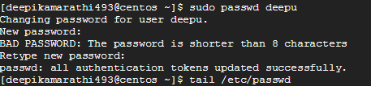



**passwd <username i.e, new username>**

1. **user id**

**usermod –u <new userid> <username>**

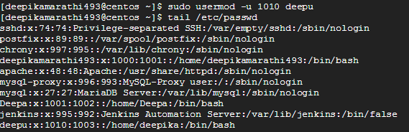

1. **group id**



1. **comments**

**usermod –c “this user belongs to placement dept” <username>**

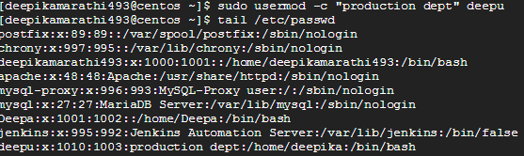

1. **directory**

**usermod –d <newpath> <username>**

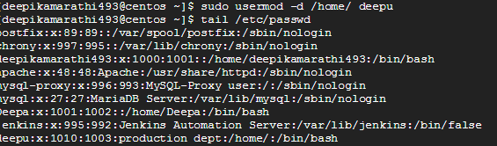

1. **shell**

**usermod –s sh <username>**

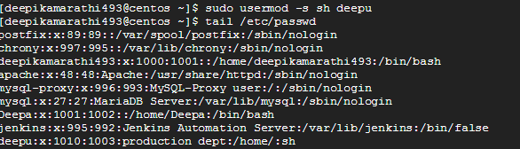

**GIVING USER PERMISSIONS**

**sudo useradd u1**

**touch hi.doc**

**Create group**

**visudo**

**which mv**

**visudo**  ------------------------path

**GIVING FILE PERMISSIONS**

--- --- --- ==owner group otherusers

---->read ,write, execute are the permissions for files

--- to change the permission chmod 777 <filename>

**chmod u+x <filename>**

**chmod u-x <filename>**

**chmod –R 777 <directoryname>**

**chown Digi:DL <filename>**

**chown –R <ownername>:<group directoryname> <directoryname>**

**PACKAGE COMMANDS:**

**rpm -qa**

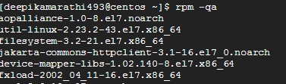

**rpm -qa | wc -l**

**rpm -qi wget**

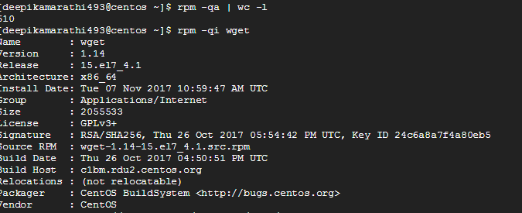

**rpm -ivh <link>**

yum---yellowdog update modifier

**SERVICE COMMANDS:**

**systemctl start httpd**

**systemctl status httpd**

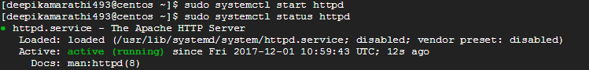

**systemctl stop httpd**



**systemctl enable httpd**



**systemctl disable httpd**



**systemctl status httpd | grep active**

**PROCESS COMMANDS:**

**ps -ef**

information about processers which are running in the system

**ps -ef | wc -l**

to know no.of processers working/running

**ps -ef | grep java**

to know thw particular package working

**kill -9 proccessid**

the bad way of killing the process

**systemctl stop process**

the god way of killing the process

**free -m**

to watch the free space in disk/ram

**TO ZIP AND UNZIP FILES**

**tar xvf <filename>**

**zip -r <new zipfilename> <oldfilename>**

to zip the file which was already present

**unzip <filename>.zip**

to unzip the particular file

top

gives entire information about process id,users,------