**Part 1**: Using the Orders and Returns Superstore Sales.xls data workbook, connect to the Orders data, and complete the data import process to begin analyzing your data.

<https://public.tableau.com/profile/suresh.baskaran#!/vizhome/Country_Profit_On_Product/Sheet1?publish=yes>

Order Data Source:

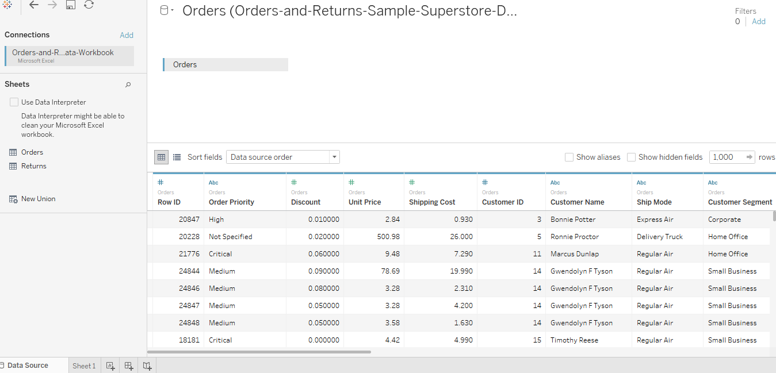

Visualization of Order Details

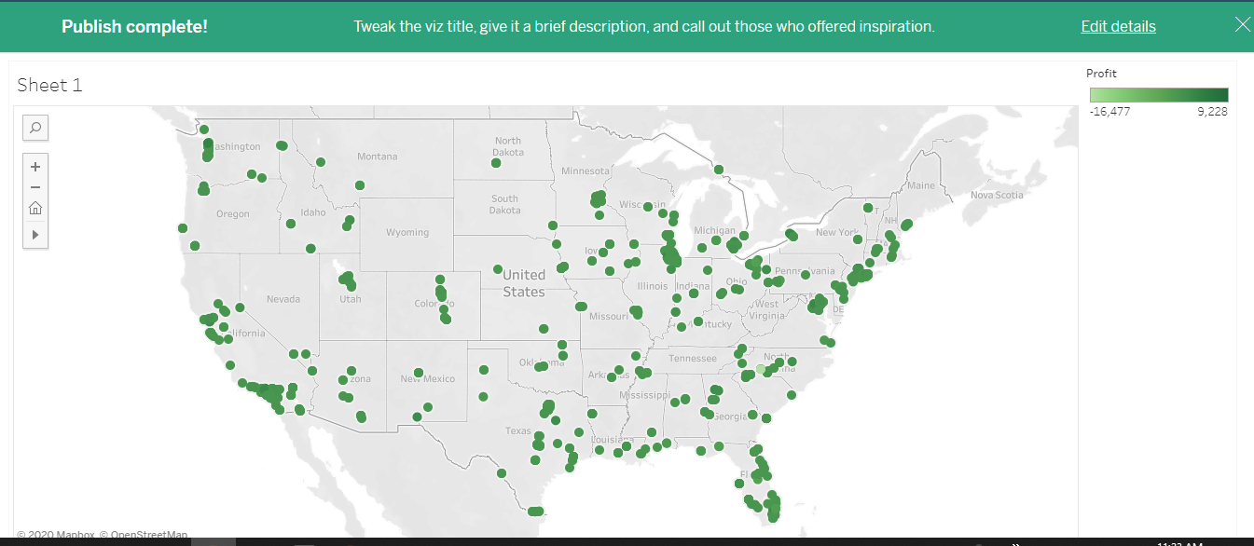

**Part 2:**Using the Orders and Returns Superstore Sales.xls data workbook, connect to the Orders and Returns data sources, and complete the data import process to begin analyzing your data

<https://public.tableau.com/profile/suresh.baskaran#!/vizhome/Returns_ByCity_ByProduct_15816608799900/Returns_ByCity_ByProduct?publish=yes>

Returns Data Source:

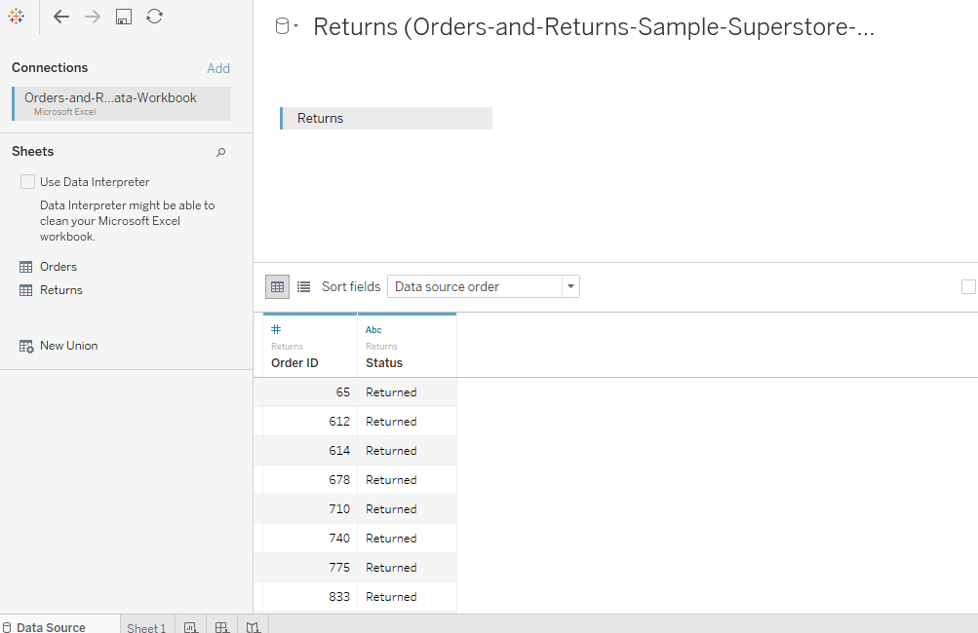

Order Details Visualization:

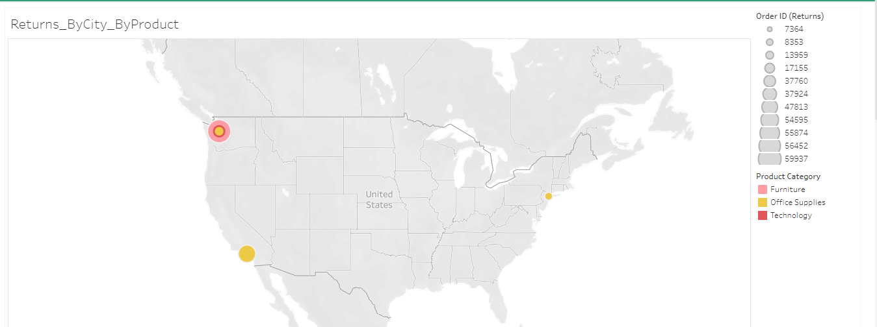

**Part 3:** Using the Orders and Returns Superstore Sales.xls data workbook, connect to and merge the Orders and Returns data sources using a common variable, and complete the data import process to begin analyzing your data.

<https://public.tableau.com/profile/suresh.baskaran#!/vizhome/Orders_Returns_ByCity_ByProduct/Dashboard1?publish=yes>Merge Source:

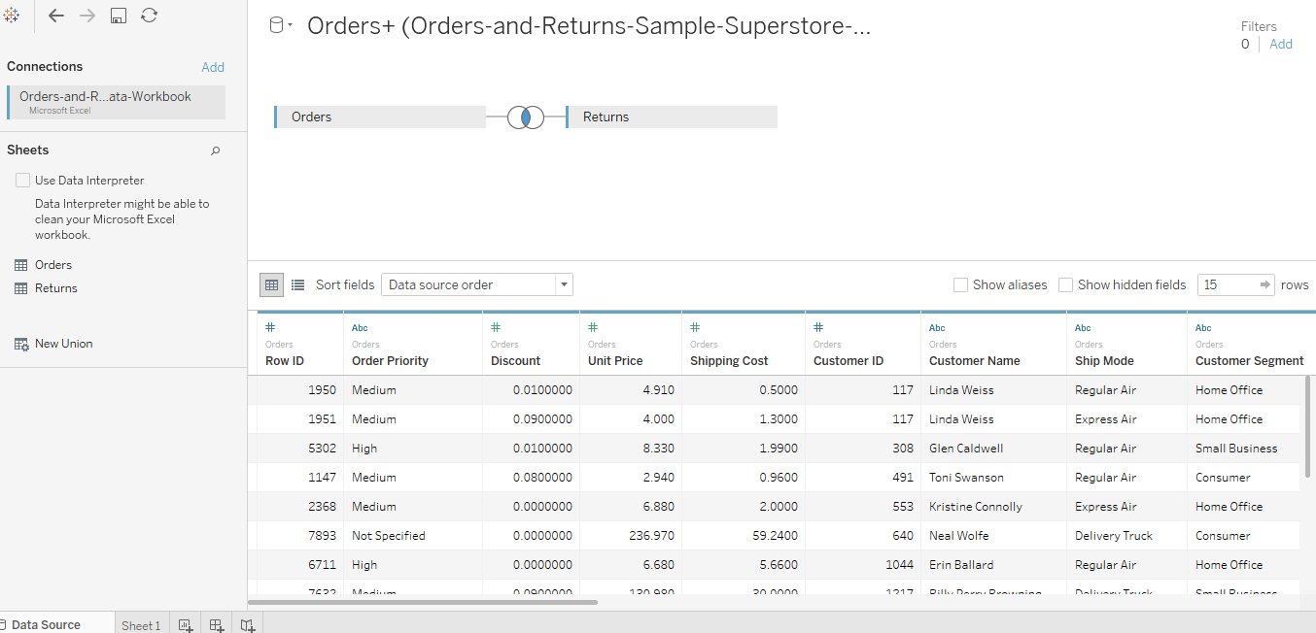

Merge Visualization:

