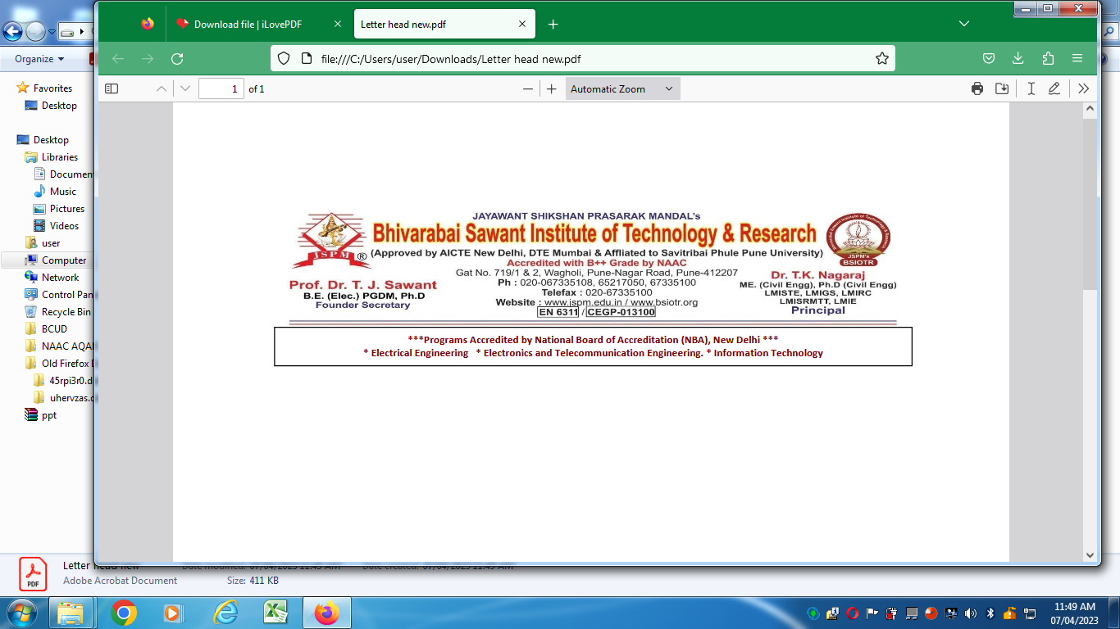**Department of Information Technology**

**Academic Year:-2023-24 Semester:- II**

**Continuous Assessment of Laboratory Work (PR/OR/TW)**

Class :- BE Subject- LP-V Max Marks: 50 Min Marks:20

Name of Student: Roll No:

|  |  |  |  |  |  |  |  |  |  |
| --- | --- | --- | --- | --- | --- | --- | --- | --- | --- |
| Expt No. | Title of Expt/Drf/ Assg. | Date of Conduct | Date of Completion | Timely Submission  (10 M) | (A)Quality of Journal & Content ofSubmission(20M) | (B)Level of Understanding  (20M) | (C)Actual Marks obtained for each expt (Marks out of 50) | Signature of Student Date | Signature of Staff Date |
| 1 | Implement multi-threaded client/server Process communication using RMI. |  |  |  |  |  |  |  |  |
| 2 | Develop any distributed application using CORBA to demonstrate object brokering. |  |  |  |  |  |  |  |  |
| 3 | Develop a distributed system, to find sum of N elements in an array by distributing N/n elements to n number of processors MPI or OpenMP. |  |  |  |  |  |  |  |  |
| 4 | Implement Berkeley algorithm for clock synchronization. |  |  |  |  |  |  |  |  |
| 5 | Implement token ring based mutual exclusion algorithm. |  |  |  |  |  |  |  |  |
| 6 | Implement Bully and Ring algorithm for leader election. |  |  |  |  |  |  |  |  |
| 7 | Create a simple web service and write any distributed application to consume the web service. |  |  |  |  |  |  |  |  |
| 8 | Mini Project (In group): A Distributed Application for Interactive Multiplayer Games |  |  |  |  |  |  |  |  |
|  |  |  |  |  |  | Actual Total marks: |  | | |