Fiserv | SnapPay
Performance Engineering Strategy
Enabling the Next Generation Payments Platform

Supporting SnapPay's Enterprise Modernization Journey

Prepared for  Fiserv | Prepared by  Coforge
Author  Suresh Pittala  Technical Architect – QE | Version  1.0
Date
July 2026

Document Control and Version History
Document Information
Field | Details
Document Name | SnapPay Performance Testing and Engineering Strategy
Customer | Fiserv
Program | SnapPay Modernization Program
Prepared by | Coforge
Author | Suresh Pittala
Designation | Technical Architect – QE
Document Version | 1.0
Status | Draft
Classification | Confidential – Internal Use Only
Approved by

Version History
Version | Date | Authored by / Reviewed by | Description
0.1 | 10-07-2026 | Suresh Pittala | Initial Draft
0.2 | 14-07-2026 | Suresh Pittala | Update approach, NFR, batch jobs, tools, etc.,
0.3 | 17-07-2026 | Deepak Khatri | Review comments
0.4 | 17-07-2026 | Saran Natarajan | Updated project description
0.5 | 07-08-2026 | Madhuri Tsundupalli | Add milestones, RACI, efforts. Refine environment section

Table of Contents
1. Executive Summary 1
Purpose 1
Business Objectives 1
2. SnapPay Overview & Reasons for Modernization 1
SnapPay Overview 1
Current State Challenges 2
Why Modernization Is Needed 2
3. Performance Challenges & Current State Baseline 2
Current Performance Baseline 2
Performance Contention 2
Strategy Focus 3
4. Performance Engineering Objectives 3
5. Scope 3
In Scope 3
User Channels / Web Screens 4
APIs 4
Batch Jobs 5
Platform Gateways 6
Out of Scope 6
6. Non-Functional Requirements 7
7. Workload Modeling Strategy 8
8. Performance Testing Methodology 9
Tools 11
Observability Strategy 11
9. Test Environment 12
10. Test Data Strategy 12
11. Performance Test Types 13
Comparison Testing 13
Load Testing 13
Stress Testing 14
Spike Testing 14
Scalability Testing 15
Endurance Testing 16
Failover Testing 17
12. Defect Management 18
13. Application Framework Overview 18
14. Major Milestones 19
15. Entry Criteria 21
16. Exit Criteria 22
17. Key Assumptions 22
18. Dependencies 23
19. Risks and Mitigation 23
20. RACI Matrix 24
21. Effort Estimation 24
22. Performance Test Deliverables 24
23. Appendices 25

1. Executive Summary

Purpose
The purpose of this Performance Test Strategy is to establish a comprehensive performance engineering approach for validating the scalability, reliability, resilience, availability, and operational readiness of the modernized SnapPay platform throughout its transformation journey.

Business Objectives
These business objectives define the expected outcomes of the SnapPay modernization program and establish the performance, scalability, availability, and operational targets required to support future business growth and customer demand.
- Improve customer experience
- Reduce platform operational costs
- Enable cloud-native scalability
- Improve resiliency and availability
- Establish end-to-end observability
- Reduce operational risk during and after modernization

2. SnapPay Overview & Reasons for Modernization

SnapPay Overview
Fiserv SnapPay is a secure, enterprise-grade electronic payments platform designed to facilitate fast, reliable, and compliant processing of consumer and business transactions. The solution supports a broad range of payment capabilities—card payments, ACH, recurring billing, invoicing, and customer self-service—while integrating seamlessly with upstream and downstream financial systems. SnapPay enables organizations to streamline payment acceptance, enhance customer experience, reduce operational friction, and maintain alignment with evolving industry standards.
Over time, SnapPay has become a mission-critical application within the payment processing ecosystem. Its capabilities span administrative tools, customer service functions, reporting interfaces, batch processing, APIs, integrations, and various internal services responsible for communication, logging, and configuration management. Serves multiple segments (Enterprise, eCommerce, Government) across two production platforms.

Current State Challenges
The current platform is built as a tightly coupled monolithic application resulting in:
- Limited scalability
- High operational risk
- Slow deployment cycles
- Complex maintenance processes
- Limited observability
- Technology obsolescence

Why Modernization Is Needed
Business growth objectives require:
- Cloud-native architecture
- API-first design
- Independent service scaling
- Faster feature delivery
- Enhanced resilience
- Active-active deployment architecture
- Improved operational efficiency

3. Performance Challenges & Current State Baseline

Current Performance Baseline
The existing platform exhibits significant performance constraints –
Metric | Current State
Throughput | ~17 TPS
DB Calls per Charge | ~47
Architecture | Monolithic
Caching | Not Available
Tracing | Not Available

Performance Contention
Payments, invoice queries, funding calculations, admin searches, and purge jobs compete for CPU, memory, I/O, tempdb, and locks
Blocking and deadlocks from large tables with concurrent insert/update/delete/select
Index rebuilds cannot run — relying on reorganizations and stats updates only

Strategy Focus
The Performance Engineering program will verify elimination or significant reduction of the above constraints through modernization initiatives.

4. Performance Engineering Objectives
The performance engineering initiative aims to validate that the modernized platform can
Focus Area | Objective | Success Criteria
Throughput | Support growth transaction volumes | Sustain 500 TPS
Performance | Ensure acceptable customer response times | API response times less than 2 seconds, Consistent customer experience under load
Scalability | Support future business growth | Horizontal scaling, Automatic scale-out capability
Availability | Minimize service disruption | 99.995% availability, Near-zero deployment downtime
Reliability | Ensure application resilience / consistency and fault tolerance | Fault tolerance, Active-active resilience, Failover validation
Observability | Enable rapid issue detection | Full stack monitoring through –  Metrics, Logs, Traces, Business KPIs
Disaster Recovery | Ensure business continuity | Site failover validation, regional recovery

5. Scope

In Scope
This In-Scope describes the business processes / UI scenarios, APIs, batch processes which are in-scope and out of scope for SnapPay performance testing and engineering.
Following are the high-level components which are In-Scope for the SnapPay application

Component Name | Count
REST API Endpoints | 60-70
Batch Process | 14
Web Screens | 20 – 30
Payment Providers | 9

User Channels / Web Screens
There are around 20-30 SnapPay EIPP portal web screens, or the scenarios need to be discussed with the Fiserv team and finalize the scenarios
Example -
- EIPP Portal
  - Admin Portal
  - Merchant / Customer Portal and Insights

APIs
Embedded sheet has the SnapPay business APIs, which needs to discuss and finalize the critical business APIs, along with each individual TPS
Interop API – serves as the core unified payment API, supporting all major payment operations including charge, refund, authorize, capture, void, credit, and tokenization.
Apigee X – acts as the external-facing API gateway layer and manages 14 proxy repositories.
REST API v1 provides merchant-facing payment and operational services.
UPI API is implemented as a standalone .NET 8 microservice for UPI payment integration.
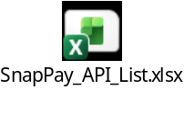

Batch Jobs
SnapPay executes 14 scheduled batch jobs that support background processing across payments, alerts, reporting, reconciliation, integrations, and notifications
Batch Job | Schedule | Purpose
AutoPayBatch | Daily @ 2:00 AM UTC | Recurring payment processing (10K+ transactions)
CardExpirationAlertBatch | Daily @ 6:00 AM UTC | Expiring card notifications (500–2K alerts/day)
FileImportProcess | Scheduled | External file imports
FundingService | Continuous | Reconciliation and merchant payouts
GoldmanSachsStatusBatch | Scheduled | Goldman Sachs transaction status reconciliation
InvoiceAlert | Scheduled | Invoice due/overdue notifications
MasterCardTrackBatch | Scheduled | Mastercard Track integration
OutageBatch | Scheduled | Merchant outage notifications
PaymentDataUpload | Scheduled | Payment data upload to external systems
ReportDataBatch | Scheduled | Report generation and data processing
SchedulePaymentBatch | Scheduled | Future-dated and scheduled payment processing
TransactionDailyReport | Midnight Daily | Daily transaction summary and reporting
TransactionEmailBatch | Scheduled | Transaction confirmation email processing
TranslationUploadBatch | Scheduled | Language and translation file uploads
Note - Performance team along with Fiserv and Coforge has to identify the performance-critical batch jobs

Platform Gateways
SnapPay integrates with 9 payment gateways to support card payments, ACH/eCheck processing, digital wallets, tokenization, hosted payment forms, and card-reader transactions.
Performance team along with Fiserv and Coforge has to identify the performance-critical payment gateways
Gateway | Protocol | Supported Payment Types | Status
CardX | REST | Credit/Debit Cards (Primary) | Active
CardConnect | REST | Credit/Debit Cards, Apple Pay, Tokenization | Active
BluePay | REST + Hosted | Credit/Debit Cards, Hosted Payment Forms | Active
CommerceHub | REST (HMAC) | Digital Wallets (PayPal, Venmo, Samsung Pay) | Active
TeleCheck | REST | ACH/eCheck Payments | Active
PayPoint | REST | Modern Payment Provider (.NET 10) | Active
IPG | SOAP | First Data (Legacy Integration) | Legacy - Active
IPG REST | REST | First Data REST Integration | Legacy - Active
Bolt | REST | EMV Card Readers (CardPoint) | Active

Out of Scope
- Performance testing of non-HTTPS protocols
- Development of any stubs/drivers
- Any infra procurements or deployments
- Testing of Email/SMS
- Any Vendor internal systems
- Legacy systems scheduled for retirement
- User acceptance testing, Functional and Security testing activities
- Any performance testing, performance engineering, capacity assessment, or other non-functional testing activities not explicitly defined within this strategy document shall be considered as out of scope unless formally reviewed, agreed upon, and approved by all relevant stakeholders

6. Non-Functional Requirements
Following are the overall targeted Non-Functional Requirements along with the test types
In scope scenarios -
Component Name | Count
REST API Endpoints | 60-70
Batch Process | 14
Web Screens | 20 – 30
Payment Providers | 9
Key Metrics –
KPI | Target
Sustained TPS | 500
Peak TPS | 1000 - TBD
API Latency | < 2 sec
Availability | 99.995%
Error Rate for UI and API | TBD
Deployment Downtime | Near Zero
Recovery Time | TBD
Transaction Success Rate | TBD
Batch job (each) SLA | TBD
Test Types –
Application / Component | Scenario Type | No. of Scenarios | Test Type | KPIs Target
 |  |  |  | TPS  (Overall) | SLA  sec | Availability | Error Rate
SnapPay | APIs | TBD | Comparison | TBD | TBD | 99.995% | TBD
SnapPay | UI | 20 to 30 | Load | TBD | TBD | 99.995% | TBD
SnapPay | APIs | 71 | Load | 500 | <2 | 99.995% | TBD
SnapPay + Batch Jobs | UI + APIs+ Batch Jobs | 101+(TBD) | Load | 500 | TBD | 99.995% | TBD
SnapPay + Batch Jobs | UI+APIs+ Batch Jobs | 101 (TBD) | Stress | TBD | TBD | 99.995% | TBD
SnapPay + Batch Jobs | UI+APIs+ Batch Jobs | 101 (TBD) | Endurance | TBD | TBD | 99.995% | TBD
SnapPay + Batch Jobs | UI+APIs+ Batch Jobs | 101 (TBD) | Scalability | TBD | TBD | 99.995% | TBD
SnapPay + Batch Jobs | UI+APIs+ Batch Jobs | 101 (TBD) | Failover | TBD | TBD | 99.995% | TBD
Note – Performance Team to discuss with the Fiserv team to finalize the Individual and overall NFRs including TPS, SLA for each UI, API and Batch job scenarios.

7. Workload Modeling Strategy
The workload shall represent the realistic production usage patterns, key business transactions distribution to evaluate the performance, scalability, reliability and resilience of SnapPay platform under expected and peak business usage patterns.
Workloads shall be derived from:
- Production usage patterns
- Business forecasts
- Merchant growth projections
- Peak period expectations
- Transaction type distributions
- Concurrent workload analysis
Workload dimensions:
- Normal Load
- Peak Load
- Stress Load
- Spike Load
- Batch + Online Concurrent Load
Note – The Performance Test and Engineering team shall collaborate with relevant Fiserv stakeholders to prepare the workload model

8. Performance Testing Methodology
The SnapPay Performance Team shall follow a structured and iterative approach to validate performance, scalability, resiliency, observability and production readiness of the modernized platform.
Approach in Phases – The performance testing and engineering activities shall be executed through the following phases
Following is the representation of the Performance Testing and Engineering approach.
Performance team along with Fiserv team has to analyze and select the best model which is applicable based on the resource’s availability and the commercials
Approach#1– Performance Testing e2e approach using Azure DevOps CI/CD
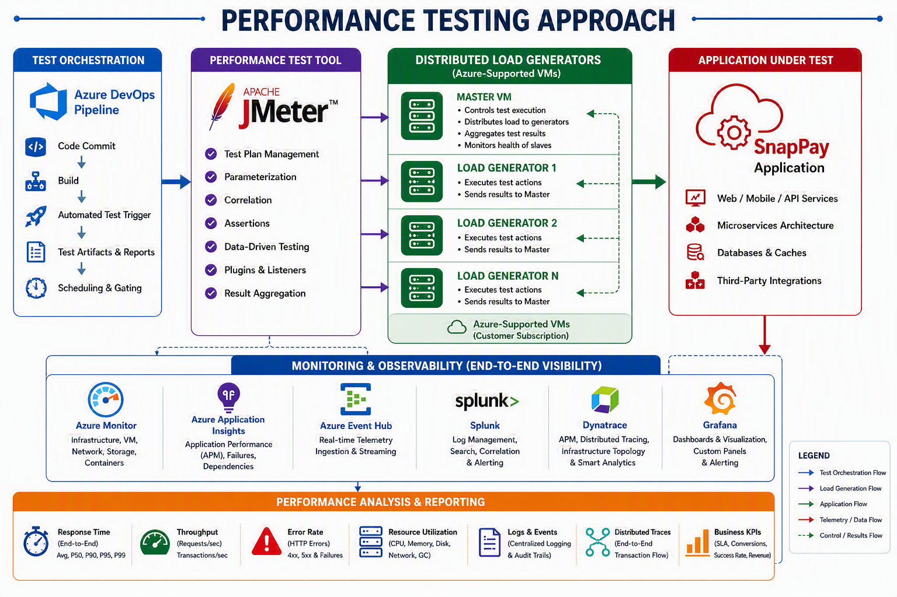
Approach#2 – Performance Testing e2e approach using GitHub or Gitlab, Jenkins CI/CD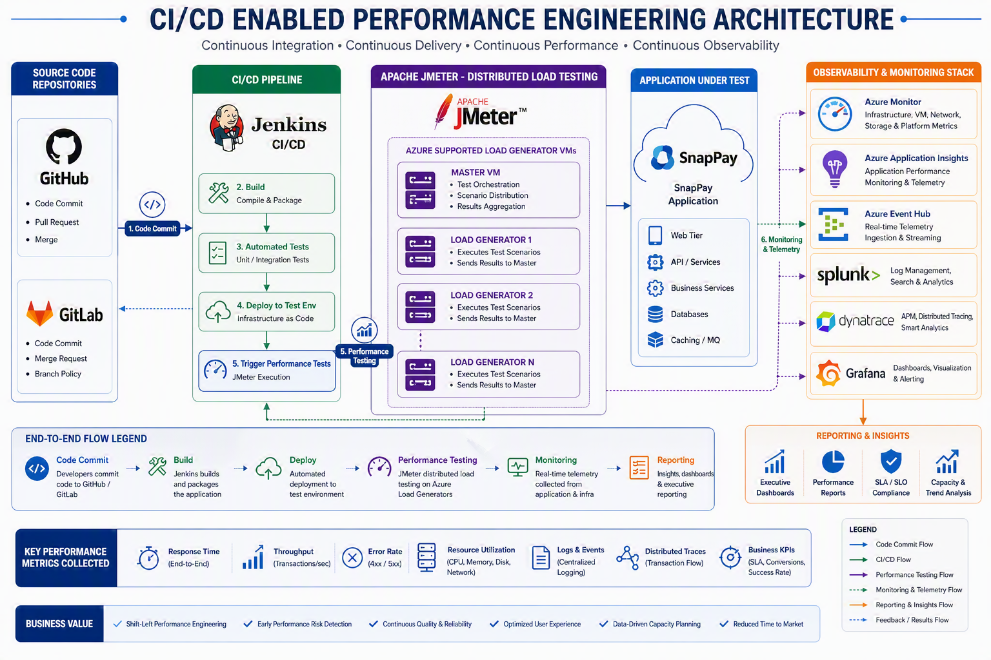

Tools
Below are the proposed tools for the Performance Testing, Engineering and Observability. Performance team to discuss with Fiserv and add any additional or observability tool based on the availability.
Category | Tools
Platform | Azure
CI/CD Orchestration | Azure DevOps, Jenkins
Performance Testing | Apache JMeter 5.6.3
Load Generation | Azure VMs.  Each LG ~ v8 cores, 16gb RAM
Infrastructure Monitoring | Azure Monitor
Application Monitoring | Azure Application Insights
Log Analytics | Splunk
Full-Stack Observability | Dynatrace
Visualization and Reporting | Grafana
Note – During test approach finalization, the performance team shall determine the performance testing tool, load generator requirements, Azure VM sizing, execution timelines, and associated infrastructure costs. SaaS-based solutions such as BlazeMeter may also be evaluated based on scalability, operational requirements, and commercial considerations.

Observability Strategy
Enable full-stack observability through metrics, logs, traces, and business KPIs to support proactive monitoring, rapid incident resolution, performance optimization, and informed operational decision-making
Sl. No | Monitoring Area | Tool | Metrics
1 | Application Monitoring | Azure Application Insights | Response Time, Throughput, Error Rate and Exceptions
2 | Infrastructure Monitoring | Azure Monitor, DynaTrace | CPU, Memory, Disk and Network
3 | Database Monitoring | Azure Log Analytics | Query Performance, Wait Statistics, Blocking, Deadlocks and active connections
4 | Distributed Tracing | Open Telemetry | Transaction Journey, Service Dependencies, External Calls and Provider Integrations
5 | Business Monitoring | Grafana | Payment Success Rate, ACH Success Rate, Merchant Transactions and Business KPIs
6 | Dashboard and Visualization | Grafana | Executive Dashboards
7 | Log Analytics | Splunk | Logs, Events

9. Test Environment
A dedicated Performance environment, i.e., Production like in terms of Infrastructure sizing and capacity, volume, Application deployment and configuration, Integration endpoints like payment gateways availability and mock services to be developed, configured and deployed for Payment gateway external systems like Canada EFT, BluePay, CardConnect and CommerceHub, Database configuration and connectivity, Environment stability, User access and permissions.
The Performance Test Engineering team shall collaborate with relevant Fiserv stakeholders to ensure that the provided environment readiness through verification and validation.

10. Test Data Strategy
Test data requirements shall be identified for each Key Business Transaction (KBT) and performance test cycle to ensure realistic workload simulation, accurate performance results, and repeatable execution.
The Performance Test Engineering team shall collaborate with Business SMEs, Product Owners, Development, QA, Database, and Operations teams to assess existing datasets and identify additional test data requirements.
The test data strategy may include:
- Existing lower-environment datasets
- Production-like datasets (where available)
- Masked production datasets
- Synthetic test data
- High-volume transaction datasets
- Unique datasets for concurrent user execution
- Integration-specific datasets
- Data required for long running and high-volume test scenarios
Depending on the test objectives and test type (Load, Stress, Spike, Endurance, Scalability, and Failover Testing), test data may be sourced, cloned, masked, generated, or provisioned through automated processes.
Wherever feasible, the Performance Test Engineering team shall automate test data creation, provisioning, refresh, and maintenance activities to improve execution efficiency, repeatability, and overall test readiness.

11. Performance Test Types
The following test types will assess the platform's readiness, scalability, resilience, and operational performance

Comparison Testing
Validate and compare the performance characteristics of the modernized SnapPay platform against the existing platform using the same APIs, workloads, and test conditions
Expected Outcome – Identify performance improvements, regressions, scalability benefits, resource optimization, and architectural gains achieved through modernization
Note: Fiserv Performance Team to provide the APIs, performance test suite, data sets knowledge to be executed against the new environment

Load Testing
Validate system performance and stability under expected business workloads and user concurrency
Expected Outcome – Validate SLA compliance under expected business load.
Workload Pattern –
Test Type | Ramp-Up | Steady State | Ramp-Down | Duration
Load Testing | 15 min | 60 min | 15 min | 60 min

Note: Illustration of Load Testing pattern generated through the JMeter or any approved tool.

Stress Testing
Evaluate system behavior beyond expected capacity to identify bottlenecks, breaking points, and recovery characteristics
Expected Outcome – Identify saturation points and system breaking thresholds.
Workload Pattern –
Test Type | Base Users | 3x Increased Users | Duration
Stress Testing | 2000 | Up to 6000 | 90 min

Note: Illustration of Stress Testing pattern generated through the JMeter or any approved tool.

Spike Testing
Assess system responsiveness and stability during sudden and significant increases or decreases in workload
Expected Outcome – Validate elasticity and recovery from sudden workload surges.
Workload Pattern –
Test Type | Base Users | Spike at hours | Spike Duration | Test Duration
Spike Testing | 2000 | Up to 5000 | 10 min | 60 min

Note: Illustration of Spike Testing pattern generated through the JMeter or any approved tool.

Scalability Testing
Evaluate the application's ability to scale efficiently as workload increases and determine whether system resources can support future business growth
Expected Outcome – Verify that application performance remains within defined service levels as workload and resource capacity increase incrementally.
Workload Pattern –
Test Type | Initial Users | Increment pattern | Spike Duration | Total Users | Test Duration
Scalability Testing | 1000 | 1000 users every 5 min | 15 min | 5000 users | 1.5 hours

Note: Illustration of Scalability Testing pattern generated through the JMeter or any approved tool.

Endurance Testing
Verify system stability, resource utilization, and performance consistency over extended periods of sustained load
Expected Outcome – Detect memory leaks, resource exhaustion, and long-term degradation.
Workload Pattern –
Test Type | Ramp-Up | Steady State Duration | Ramp-Down | Total Users | Test Duration
Endurance Testing | 30 min | 12 hours | 30 min | 2000 users | 12 hours

Note: Illustration of Endurance Testing pattern generated through the JMeter or any approved tool.

Failover Testing
Verify business continuity and system recovery during infrastructure, application, or service failures
Expected Outcome – Validate recovery time and uninterrupted business processing.
Workload Pattern –
Test Type | Ramp-Up | Steady State Duration | Ramp-Down | Failover Event | Test Duration
Failover Testing | 15 min | 60 min | 15 min | 45 min | 90 min

Note: Illustration of Failover Testing pattern generated through the JMeter or any approved tool.
Failover event simulated at the 45th minute by intentionally disrupting a critical component (Application Server, API Service, Database Node, AKS Node, or Network Path) to validate recovery and business continuity.

12. Defect Management
Performance defects identified during testing shall be logged, prioritized, tracked, and resolved based on severity and business impact. Regular defect triage meetings will be conducted to review progress, assign ownership, and validate fixes. All critical and high-severity performance defects must be resolved or formally accepted before production readiness approval.
Defect Severity Matrix
Severity | Description
Sev-1 (Critical) | System outage, application crash, severe performance degradation, business-critical transaction failure
Sev-2 (High) | Significant SLA breach impacting multiple virtual users or key business functions
Sev-3 (Medium) | Performance issue impacting limited functionality with available workaround
Sev-4 (Low) | Minor performance observations or improvement recommendations

13. Application Framework Overview
SnapPay is a payment processing platform used by businesses and government agencies to accept payments (credit card, debit card, ACH/bank transfers) and manage invoices. The platform has been in operation for 12 years (2014–2026) and continues to undergo modernization.

SnapPay Application Framework –
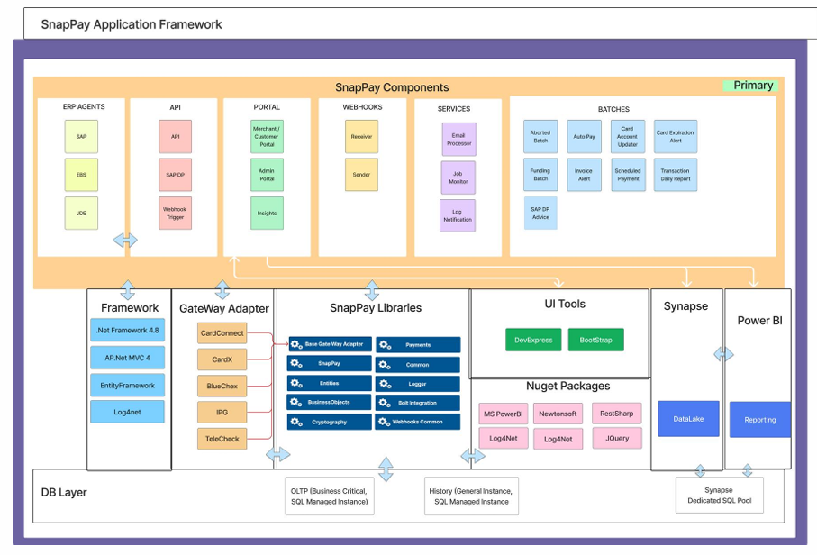
Note – Above application framework is illustration purpose only which is still in draft version. Performance team to connect with Fiserv and Coforge architecture team for better understanding of the architecture.

14. Major Milestones
Please find the complete test schedule for various phases of Performance Testing below.
S. No | Testing Phase | Activities | Efforts In Days | Target date |  | Comments
 |  |  |  | Start Date | End Date | Comments
1 | Discovery Phase | NFR gathering, review and finalization
2 | Test Strategy review and update | Test Strategy review with architecture Performance scope
3 | Script Preparation | All in-scope scripts preparation for GUI, API and Batches (if required)
3 | Script Preparation | Script verification and Validation
3 | Script Preparation | Script finalization and pilot run
4 | Data Setup | Co-ordination with the development team/QA Team to get the necessary data.
4 | Data Setup | Automation of end-to-end test data preparation
5 | Performance test Executions | Workload modeling
5 | Performance test Executions | Scenario Preparation in JMeter
5 | Performance test Executions | Test Execution – Dry Runs
5 | Performance test Executions | Actual test executions Load, Stress and Endurance as per scope
6 | Monitoring | APM tool setup, configure Dynatrace, Azure App Insights and Grafana
6 | Monitoring | Pilot execution to ensure required metrics are captured
7 | Report Preparation | Prepare report for each executed test and upload to the central repository
8 | Analysis & Recommendations | Results Analysis
9 | Test Results Preparation | Summary and Test Completion Report will be published
10 | Walkthrough and Approval | Provide walkthrough of the Performance Test Executive summary report and get the approval
Note – Performance team would discuss with the Project team and update the timelines aligning with the project timelines.

15. Entry Criteria
Ensure all prerequisites, environments, test data, monitoring, and dependencies are available and validated before performance testing begins
- Environment available
- Monitoring enabled
- Test data available
- Functional testing completed
- Critical defects resolved
- Integrations available
- Required application, database, infrastructure, and monitoring access provisions.

16. Exit Criteria
Confirm performance objectives, service level targets, and readiness criteria have been successfully achieved and validated
- Performance objectives achieved
- SLA targets achieved, API latency remains below 2 seconds
- Active-active failover validated
- No Sev-1 performance risks remain
- Observability goals achieved
- Executive approval obtained

17. Key Assumptions
Following are the key Assumptions for the SnapPay application
Assumptions
All Performance test scenarios related to UI and API to be finalized prior to test scripts preparation
Workload model for UI and API has to be finalized before start of the test executions
NFRs w.r.t to TPS and SLA to be finalized and signed off before start of the test executions
Production like Performance Test environment to be made available before start of the scripting phase
Production forecasts for the workflows and APIs to be provided to work and finalize the workload model
Performance testing tools and engineering tools JMeter, Azure monitoring, App Insights, Grafana, Splunk, CI/CD to be made available
Any required stubs/drivers will be made available for Performance testing
Any Captcha/OTPs/MFAs will be disabled for Performance Testing or appropriate workarounds will be made available
Batch Jobs configuration to be done at the time of environment setup

18. Dependencies
Following are the few Dependencies for the SnapPay application
Dependencies
Regression Performance test suite to be provided to the Coforge performance team by Fiserv Performance Engineering team
Relevant test data to be provided to the Coforge Performance team
Access to be provided to the Performance test environment and Application under test
Access to the Performance testing tool JMeter, Performance monitoring tool Azure monitoring, App Insights, Grafana, Splunk
Mock services to be set up for the payment gateway
Azure Load Generator VMs to be made available before start of the execution or environment setup

19. Risks and Mitigation
Following are few Risks and Mitigation for SnapPay application
Risks | Mitigation
Delayed environment availability which might impact planned executions and cause slippages | Secure environment timelines and track through project team
Testing of Payment gateway services like Card Connect, Card X, Telecheck, BluePay, CommerceHub, Money Network, SlopePay, Bolt and Paypoint | Mock services to be set up, chaos testing to be performed to understand the throttling
Third-party throttling | After the smoke testing, ensure that one round of testing to be performed to understand the external or third-party throttling
Environment instability can cause false failures and inconsistent results | Ensure that the AUT and the infrastructure should be stable
Unclear or evolving NFRs | In Discover phase NFRs to be discussed with Fiserv and Coforge business, Architects team and finalize

20. RACI Matrix
The RACI matrix defines the roles and responsibilities of all stakeholders involved in the Performance Testing lifecycle.
RACI matrix attached
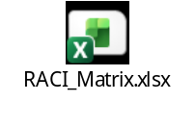
Note – Once the Performance Test team gets onboarded, need to discuss with Project team and Fiserv team to understand the teams involved and their roles and responsibilities. Update the document accordingly.

21. Effort Estimation
The Performance Testing activities will cover planning, workload modelling, scripting, environment validation, test data preparation, test data end-to-end automation, test execution, performance results analysis, defect reporting, results preparation, reporting and executive summary preparation, including stakeholder’s walkthrough of performance test results in accordance with the efforts estimates provided below.
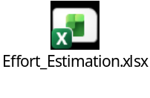
Note – Effort estimates are indicative and will be revisited jointly with the Project and Fiserv teams once the Performance Testing team is onboarded and the scope and timelines are finalized

22. Performance Test Deliverables
- Performance Test Strategy
- Performance Test Plan
- Performance Testing Approach
- Performance Test Scripts
- Performance Test Results and Metrics
- Analysis and Recommendations
- Walkthrough and Review Sessions
- Final Closure metrics

23. Appendices
- Contact Matrix
  - TBD, finalized Contact Matrix document link to be updated here
- Performance Architecture
  - TBD, finalized Performance Architecture link to be updated here
- Solution Architecture
  - TBD, finalized Solution Architecture link to be updated here

