GEETHA JEWELLERS
WEBSITE CREATIVE & ANIMATION MASTER DOCUMENT
PHASE 02 — POST-HERO WEBSITE EXPERIENCE
About • Premium Collection • Rings • Earrings • Bangles • Offer • Trust • Store • App/Footer

CLAUDE BUILD DIRECTIVE — IMPLEMENT THE EXPERIENCE, NOT A STATIC MOCKUP
This document is the implementation specification for the next stage of the Geetha Jewellers website. The supplied images are visual keyframes/reference states. Claude must reproduce the visual composition, content hierarchy, responsive layout and described motion as real website behavior.

1. NON-NEGOTIABLE GLOBAL DIRECTIVE
- Build the sections as real, production-ready web components. Do not turn the supplied images into a slideshow, video, GIF, background movie or sequence of static screenshots.
- The supplied reference images are the visual source of truth for composition, spacing, hierarchy, jewellery placement, typography direction, ornamentation, proportions and overall luxury mood.
- Recreate the designs as closely as possible. Do not redesign the sections simply because another layout is easier to code.
- All animation must be smooth, premium, cinematic and physically believable. Avoid cheap bounce effects, aggressive zooms, random particles, excessive blur or generic template animations.
- Use the exact supplied Geetha Jewellers logo/brand assets wherever available. Never redraw, retype, distort or replace the logo with an AI-generated alternative.
- Preserve the established warm cream / ivory / champagne / gold visual language. Do not introduce a dominant black background into these post-hero sections. Dark brown may be used only as a controlled typography/accent tone where the supplied design requires it.
- Every jewellery image must remain crisp and high-definition. Do not knowingly blur, over-compress, stretch, pixelate or crop away important jewellery details.
- Text shown inside reference images is design guidance. Recreate the text as real HTML text so it remains responsive, accessible and editable; use the reference wording/meaning as the source and refine copy only where necessary to fit the final design.
- The animation must respond naturally to scroll position. Where autoplay is specified, it must run independently but pause/slow appropriately when the section is not visible to protect performance.
- Respect reduced-motion preferences with a graceful fade/opacity fallback while preserving the content and hierarchy.

2. APPROVED VISUAL LANGUAGE
Colour consistency: Use the existing landing/hero palette as the master reference. The page should feel like one continuous luxury environment rather than separate designs. Prioritize warm ivory/cream surfaces, champagne highlights, realistic warm gold, soft brown typography, subtle marble, delicate floral elements and restrained shadows.
Important: Do not use a new colour system for individual collections. Gold, silver and product colours may naturally differ because of the jewellery itself, but the surrounding UI, typography, controls, cards and backgrounds must remain within the established Geetha visual system.

3. REFERENCE IMAGE / KEYFRAME MAP
Ref. | Section | Implementation role
01 | OUR STORY / ABOUT SECTION | Primary visual keyframe
02 | SIGNATURE GOLD NECKLACE / PREMIUM COLLECTION | Primary visual keyframe
03 | GOLD RINGS COLLECTION | Primary visual keyframe
04 | SILVER RINGS COLLECTION | Primary visual keyframe
05 | EARRINGS COLLECTION | Primary visual keyframe
06 | GOLD BANGLES / CLOSED STATE | Closed/open scroll state pair
07 | GOLD BANGLES / OPEN STATE | Closed/open scroll state pair
08 | SILVER BANGLES / OPEN STATE | Gold → silver transformation target
09 | OFFER + TESTIMONIALS + WHY CHOOSE US | Primary visual keyframe
10 | VISIT OUR STORE / STORE EXPERIENCE | Primary visual keyframe
The ten supplied images below must be kept with this specification and treated as implementation references. They are not slideshow slides.

4. EXISTING HERO / INTRO — APPROVED BASELINE
Purpose: The cinematic intro and hero are already built. Preserve their approved behavior and make the next section feel like a seamless continuation. The intro should remain the source of the global motion language.

Approved intro behavior to preserve
Time | State | Required behavior
0.00–0.15s | Near-black opening | Extremely brief opening; no loading flash.
0.15–0.55s | Gold emergence | Tiny central glow; gold material begins approaching from depth.
0.55–0.95s | Gold structure / wave | Metallic structure grows toward camera with controlled light sweep.
0.95–1.45s | Logo reveal | GJ emblem emerges from the gold; it must feel embedded, not pasted.
1.35–1.75s | Brand text | GEETHA JEWELLERS + SINCE 1998 reveal elegantly.
1.75–2.05s | Final lockup | Centered, polished, short settle.
2.05–2.60s | Shrink into header | The same logo composition scales down and travels upward into the final header.
2.60–3.00s | Website handoff | Header/first section appears without a hard cut.
Target total intro duration: approximately 2–3 seconds. This is intentionally fast; do not slow the opening down simply to showcase the animation.

5. ABOUT / OUR STORY — FIRST SECTION AFTER HERO
Purpose: Introduce Geetha Jewellers immediately after the hero with a calm, editorial transition. The section must feel like the same luxury world continuing rather than a new page.
REFERENCE KEYFRAME 01
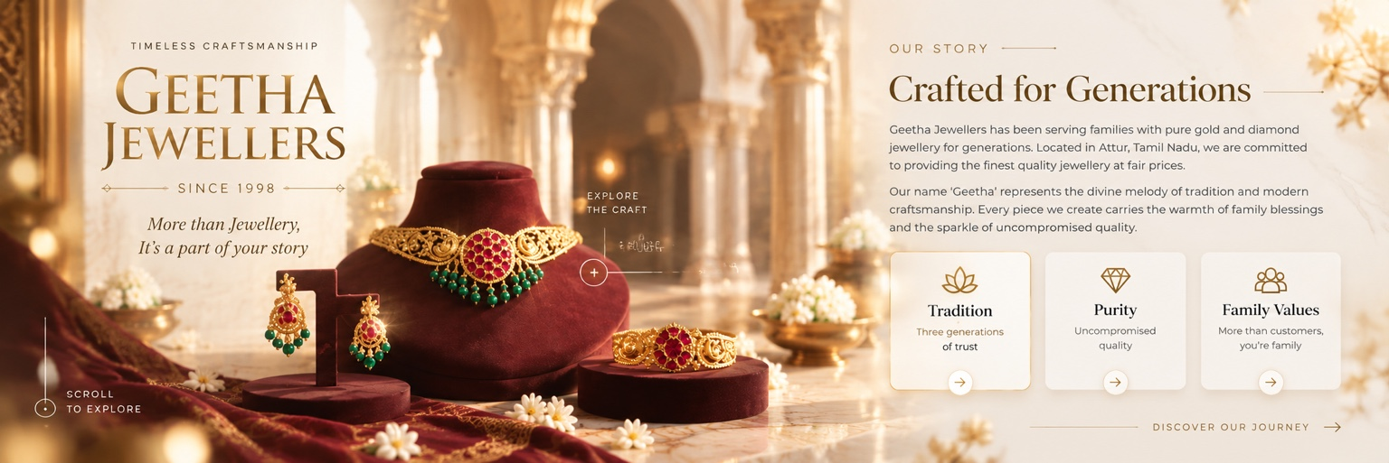
01 — OUR STORY / ABOUT SECTION

Scroll / entrance choreography
- Start the section in a composed resting state with the reference composition preserved.
- Use a soft section-level fade as the user enters the viewport; no abrupt image swap.
- LEFT JEWELLERY VISUAL: the jewellery/model composition should enter subtly from the left with a small translate + opacity reveal and restrained scale/parallax. It should feel as though the visual is arriving into the frame, not sliding like a presentation.
- RIGHT TEXT: the 'Our Story / Crafted for Generations' content should reveal from right to left using opacity + horizontal movement. The movement should be slightly delayed relative to the image so the section reads naturally.
- VALUE BOXES: the Tradition / Purity / Family Values boxes should appear from bottom to top, one-by-one, with a small stagger. Each box should settle crisply without bounce.
- CTA / discovery control, if retained, should reveal after the main copy and remain visually secondary.
- On reverse scroll, the elements should gracefully reverse their movement or settle back; do not repeatedly hard-reset the section.

Suggested copy direction for Claude
Headline: “Crafted for Generations”
Body: “Geetha Jewellers has been serving families with pure gold and diamond jewellery for generations. Rooted in Attur, Tamil Nadu, we combine trusted craftsmanship with timeless design and uncompromised quality.”
Supporting line: “Every piece carries the warmth of tradition, the precision of skilled craftsmanship and the promise of something worth passing on.”
Value labels: “Tradition” / “Purity” / “Family Values” with concise supporting descriptions.
CTA: “Discover Our Story →”

6. SIGNATURE GOLD NECKLACE — SCROLL-REVEAL MASTERPIECE
Purpose: This is the main premium collection showcase. The necklace must be the visual hero of the section while the information remains highly readable.
REFERENCE KEYFRAME 02
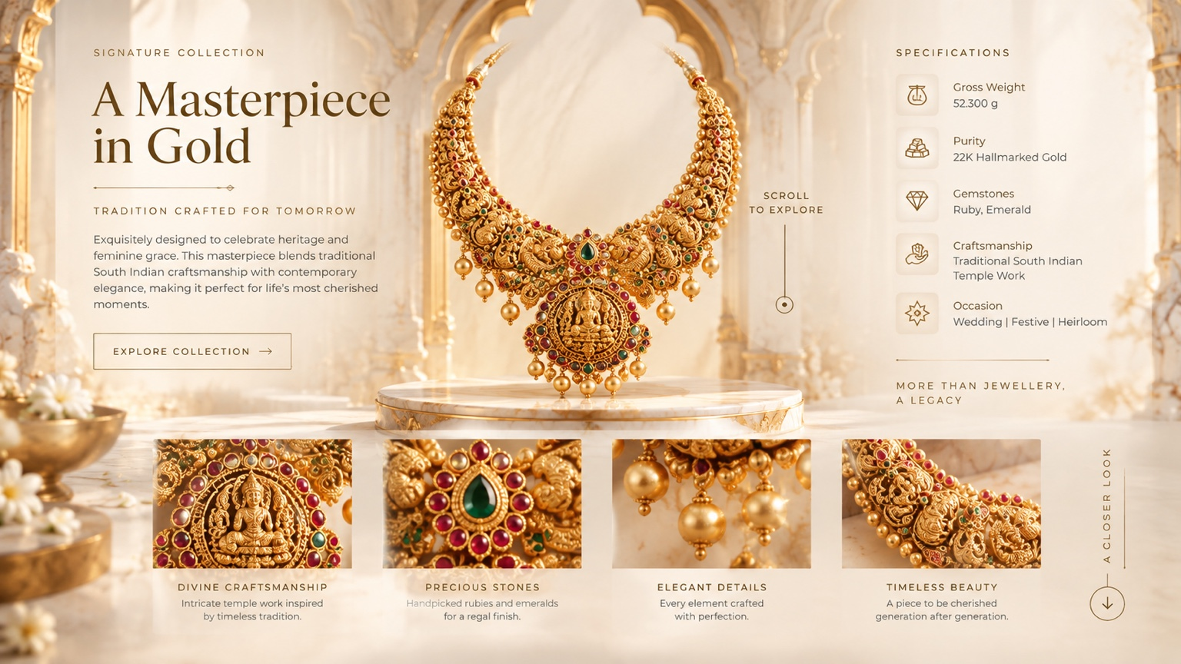
02 — SIGNATURE GOLD NECKLACE / PREMIUM COLLECTION

Required initial state
- When the section first enters, do not immediately show the necklace at full prominence. Establish the content and environment first.
- The left-side content should fade/reveal from depth, using a subtle opacity + translate effect. It should feel anchored to the section, not float independently.
- The necklace begins hidden/very subtle in the middle/back of the scene.

Scroll-driven necklace reveal
- As the user scrolls deeper into the section, the necklace must emerge from the CENTER / BACK of the composition toward the viewer.
- Use scroll progress as the primary driver: depth/scale/opacity/vertical position should interpolate continuously with the scroll, not jump between predefined slides.
- The necklace gets a controlled premium light/flash sweep during its main reveal. This is a highlight transition, not a strobe effect.
- Once fully revealed, the necklace should settle into the reference composition with a subtle breathing/parallax effect rather than continuous spinning.
- The specifications panel on the right should reveal in coordination with the necklace so the user can read the product story and technical details.
- The lower four detail images should enter from BOTTOM → TOP with quick, elegant staggered 'flash-in' reveals. They should feel like supporting detail cards, not the main animation.
- The necklace itself gets the stronger light sweep; the lower detail cards use only a clean upward reveal + opacity.

Suggested content
Headline: “A Masterpiece in Gold”
Subheading: “Tradition Crafted for Tomorrow”
Description: “Exquisitely designed to celebrate heritage and feminine grace, this masterpiece blends traditional South Indian craftsmanship with contemporary elegance.”
Specifications: Gross Weight / 22K Hallmarked Gold / Ruby & Emerald / Traditional South Indian Temple Work / Wedding • Festive • Heirloom
CTA: “Explore Collection →”

7. GOLD RINGS — EXPLODED / OPEN SCROLL EXPERIENCE
Purpose: Create a tactile ring showcase where the user feels they are revealing the construction and craftsmanship of the rings through scrolling.
REFERENCE KEYFRAME 03
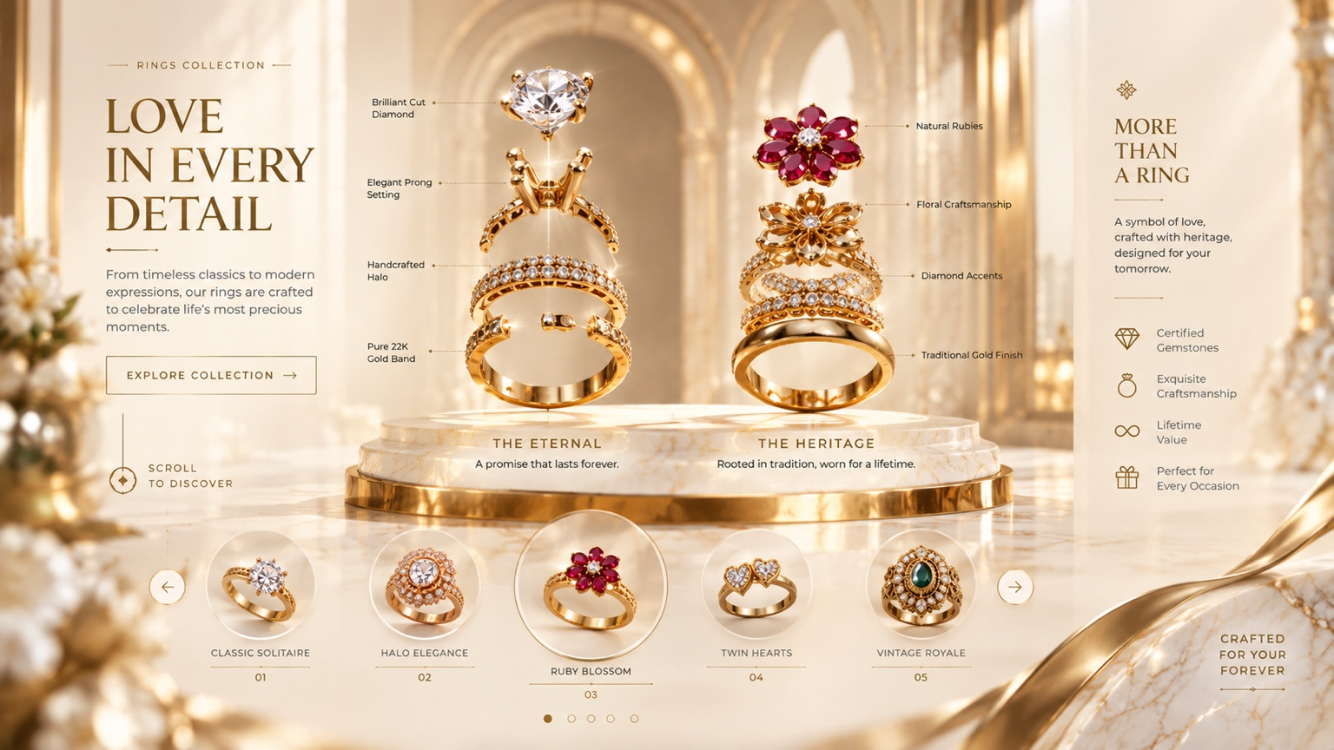
03 — GOLD RINGS COLLECTION

Animation sequence
- Initial state: the selected rings appear smaller and visually compact, matching the supplied reference composition.
- On scroll, the rings progressively open / separate into their designed exploded arrangement. This must be driven continuously by scroll progress.
- The ring group then rises slightly into its final display position as the user reaches the section's key scroll point.
- Only after the product composition is established should the specification callouts reveal.
- Specification labels should fade/slide into their anchor positions and remain readable while the rings are stable.
- The bottom collection thumbnails must AUTO-PLAY from LEFT → RIGHT. The autoplay should feel slow and premium, not like a fast carousel advertisement.
- Use the active thumbnail/state to control the main featured ring where appropriate, but keep the scroll reveal and autoplay visually coherent.
- No hard image cuts. Use opacity, position and scale interpolation to transition between states.

Suggested content
Headline: “Love in Every Detail”
Description: “From timeless classics to modern expressions, our rings are crafted to celebrate life’s most precious moments.”
Featured labels: “The Eternal” / “The Heritage”
Collection examples: “Classic Solitaire” / “Halo Elegance” / “Ruby Blossom” / “Twin Hearts” / “Vintage Royale”
CTA: “Explore Collection →”

8. SILVER RINGS — SAME SYSTEM, SILVER TRANSFORMATION
Purpose: Reuse the established ring interaction language, but transform the gold collection into a refined silver collection without breaking the continuity of the page.
REFERENCE KEYFRAME 04
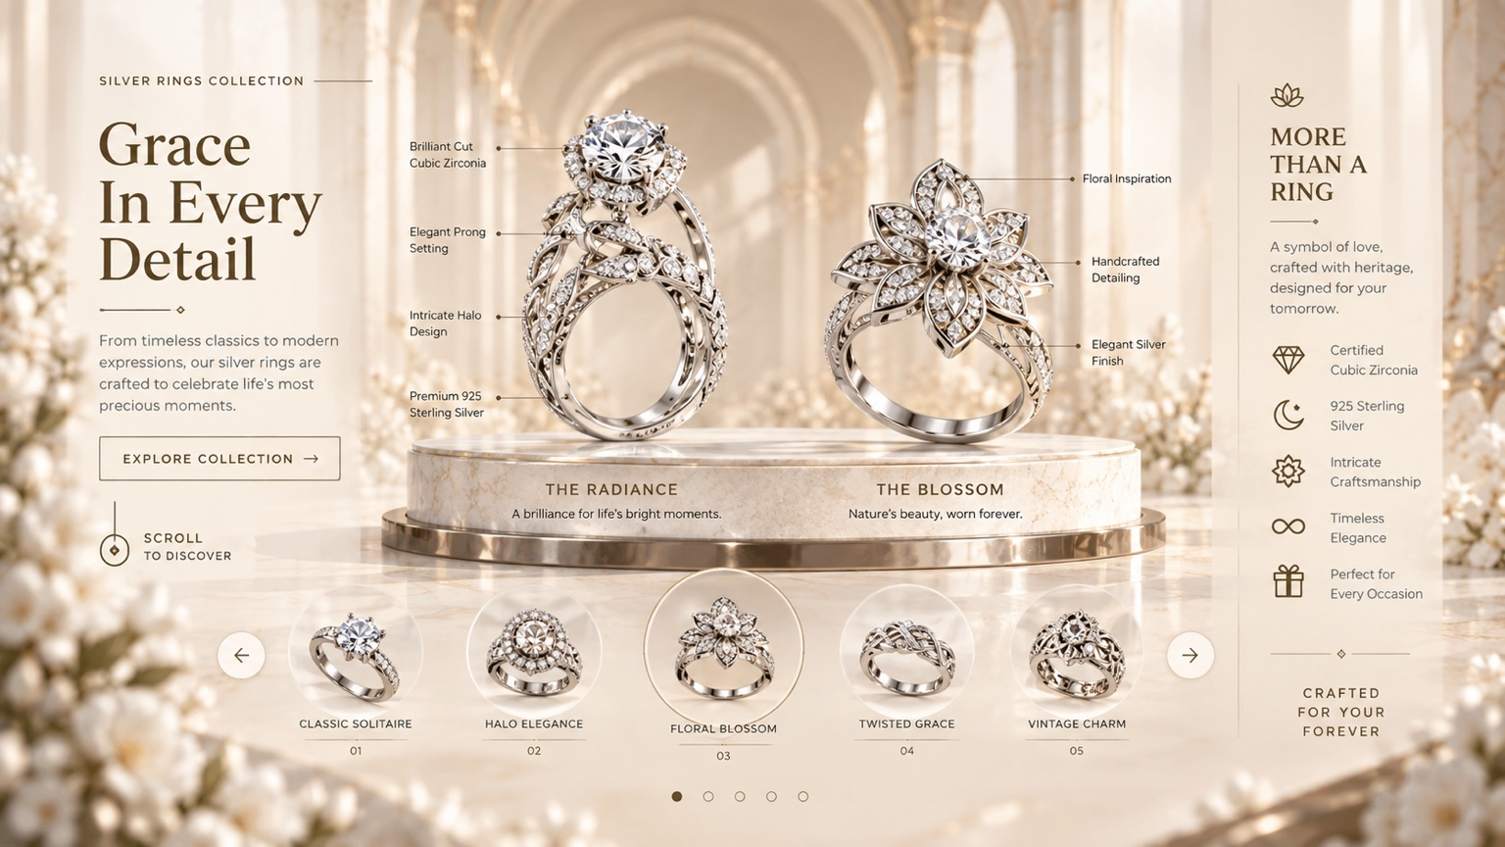
04 — SILVER RINGS COLLECTION

Gold → Silver transition
- Do not navigate to a separate page just to show silver rings. The collection should transform within the same section/experience.
- As the user reaches the silver state, the gold product imagery should gracefully transition out and the silver ring imagery should appear in the same compositional framework.
- Preserve the same spatial logic and design quality while changing only the jewellery/product state and relevant copy/specifications.
- Use a controlled crossfade/morph-like transition, supported by opacity + scale + position. Avoid a generic dissolve where the jewellery simply disappears.
- The silver rings should have a subtle, premium rotation/turntable behavior while active, but it must never interfere with reading the specifications.
- The bottom thumbnails AUTO-PLAY from RIGHT → LEFT for this silver state, creating a deliberate contrast with the gold ring section.
- Specifications must update to the currently active silver ring state and remain synchronized with the visual.

Suggested content
Headline: “Grace in Every Detail”
Description: “From timeless classics to modern expressions, our silver rings are crafted to celebrate life’s most precious moments.”
Specifications: Premium 925 Sterling Silver / Brilliant Cut Cubic Zirconia / Intricate Halo / Elegant Silver Finish
Collection examples: “Classic Solitaire” / “Halo Elegance” / “Floral Blossom” / “Twisted Grace” / “Vintage Charm”

9. EARRINGS — A DIFFERENT INTERACTION LANGUAGE
Purpose: Keep the same premium visual system but deliberately avoid repeating the ring/bangle interaction pattern. The earrings should feel lighter, more graceful and naturally suspended.
REFERENCE KEYFRAME 05
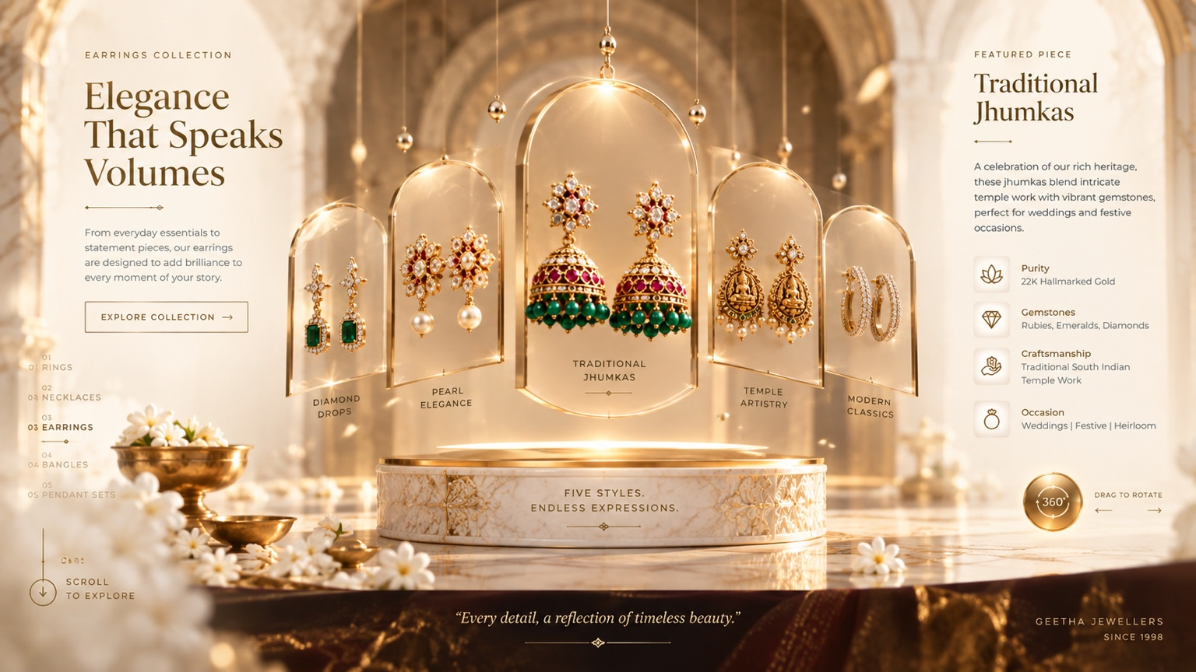
05 — EARRINGS COLLECTION

Required behavior
- Begin with a soft section-level fade/reveal rather than the explosive scroll opening used for the necklace.
- The main earring display should feel suspended and delicate. Introduce subtle vertical/horizontal movement that resembles the natural motion of hanging jewellery.
- When the user triggers the interactive area with mouse movement/hover, supporting content and specification elements may pop/reveal with a refined scale + opacity effect.
- Do not use exaggerated 3D rotations. The interaction should remain elegant and jewellery-like.
- The earring collection thumbnails should AUTO-PLAY from RIGHT → LEFT.
- Autoplay movement should be continuous and natural, with a gentle pause when the user interacts.
- The featured piece/specification area should update cleanly when the active earring changes.

Suggested content
Headline: “Elegance That Speaks Volumes”
Description: “From everyday essentials to statement pieces, our earrings are designed to add brilliance to every moment of your story.”
Featured piece: “Traditional Jhumkas”
Specifications: 22K Hallmarked Gold / Rubies • Emeralds • Diamonds / Traditional South Indian Temple Work / Weddings • Festive • Heirloom
Collection examples: “Diamond Drops” / “Pearl Elegance” / “Traditional Jhumkas” / “Temple Artistry” / “Modern Classics”

10. GOLD BANGLES — CLOSED FLOWER → OPEN REVEAL
Purpose: This is a signature interaction. The flower acts as the container for the bangle reveal and must open through scroll, making the jewellery feel unveiled rather than simply displayed.
REFERENCE KEYFRAME 06
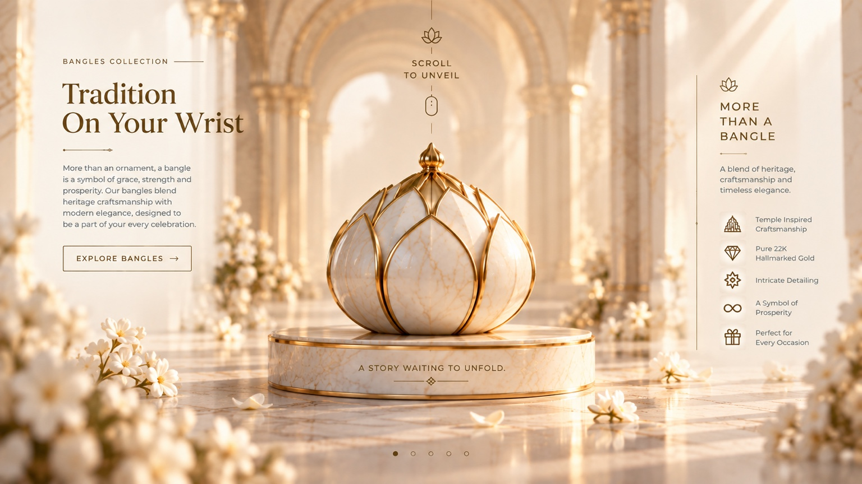
06 — GOLD BANGLES / CLOSED STATE

Closed-state requirements
- The section begins with the flower completely CLOSED, matching the supplied closed-state reference.
- Do not show the final open bangle arrangement at the start.
- The user must clearly understand that the section is waiting to be unveiled; use the existing 'SCROLL TO UNVEIL' visual cue or an equivalent minimal cue.

Scroll → opening choreography
- As the user scrolls, the flower petals open progressively. The opening must be directly tied to scroll progress.
- As the petals separate, the bangle arrangement is revealed from within/behind the flower.
- The central hero bangle should rise into the dominant position while supporting bangles fan outward into the supplied open-state arrangement.
- The specifications on the right should reveal after the primary jewellery becomes visible.
- The lower five collection images should appear BOTTOM → TOP with quick flash-like opacity/translate reveals, staggered one after another.
- Do not use a generic card carousel animation. The opening flower + bangle reveal is the defining interaction.

Suggested content
Headline: “Tradition on Your Wrist”
Description: “More than an ornament, a bangle is a symbol of grace, strength and prosperity. Our bangles blend heritage craftsmanship with modern elegance.”
Specifications: Temple Inspired Craftsmanship / Pure 22K Hallmarked Gold / Intricate Detailing / A Symbol of Prosperity / Perfect for Every Occasion
Collection examples: “Temple Heritage” / “Diamond Radiance” / “Royal Tradition” / “Everyday Elegance” / “Modern Minimal”

11. GOLD BANGLES — OPEN STATE / COLLECTION INTERACTION
Purpose: The open-state image is the target visual result of the previous scroll reveal. It must not be treated as a separate slide.
REFERENCE KEYFRAME 07
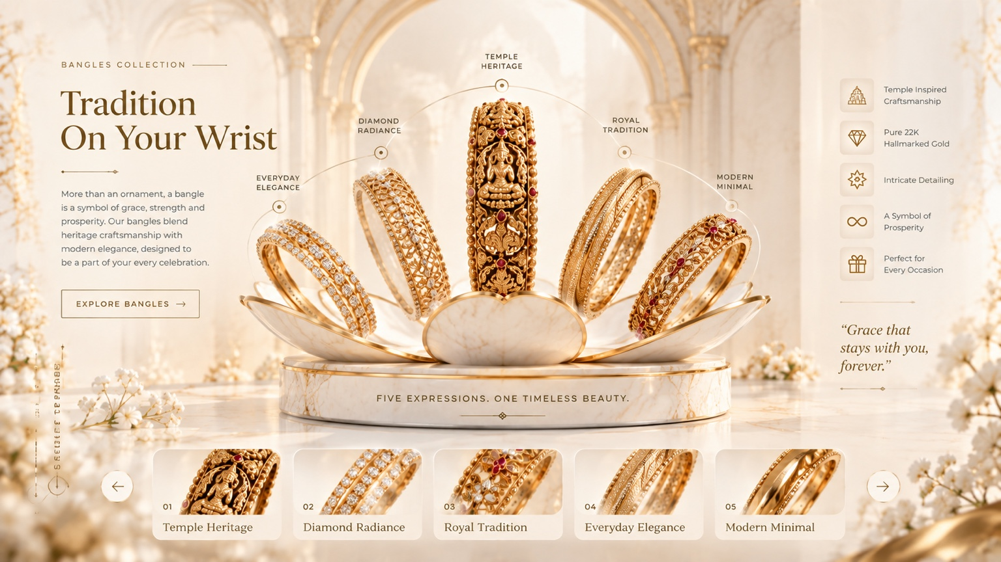
07 — GOLD BANGLES / OPEN STATE
- Use the open-state reference as the exact composition target after the flower-opening scroll reaches its key point.
- The five bangle positions and central hierarchy should match the reference closely.
- The circular/arc annotation system around the bangles should remain aligned with the correct product positions.
- The lower collection thumbnails should support selection and autoplay without disturbing the main open arrangement.
- Use subtle depth/parallax on the bangle group and background only; the jewellery must remain sharp.

12. SILVER BANGLES — GOLD → SILVER TRANSFORMATION
Purpose: After the gold bangle experience, transform the same design language into the silver bangle collection within the page. This should feel like a premium material transition, not a page reload.
REFERENCE KEYFRAME 08
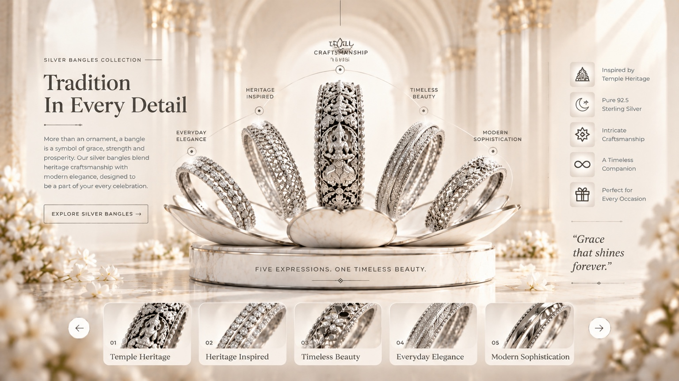
08 — SILVER BANGLES / OPEN STATE

Required transition
- The gold bangle composition should gradually disappear/transform and the silver version should emerge from the same spatial position.
- Use the supplied silver open-state image as the visual target. Preserve the layout, annotation structure and hierarchy.
- The jewellery itself changes from warm gold to refined silver; the surrounding cream/ivory/gold design system remains consistent.
- Silver specifications must update to 925 sterling silver and the supplied silver-specific terminology.
- The collection thumbnails should remain interactive and use a refined pop/reveal behavior.
- The transition should be driven by scroll progress where possible, with a clean settle at the silver state.

Suggested content
Headline: “Tradition in Every Detail”
Description: “More than an ornament, a bangle is a symbol of grace, strength and prosperity. Our silver bangles blend heritage craftsmanship with modern elegance.”
Specifications: Inspired by Temple Heritage / Pure 925 Sterling Silver / Intricate Craftsmanship / A Timeless Companion / Perfect for Every Occasion
Collection examples: “Temple Heritage” / “Heritage Inspired” / “Timeless Beauty” / “Everyday Elegance” / “Modern Sophistication”

13. 50% OFFER → TESTIMONIALS → WHY CHOOSE US
Purpose: Turn the promotional and trust content into a premium editorial sequence rather than a wall of cards. The 50% offer is the visual attention point, followed by social proof and brand reasons.
REFERENCE KEYFRAME 09
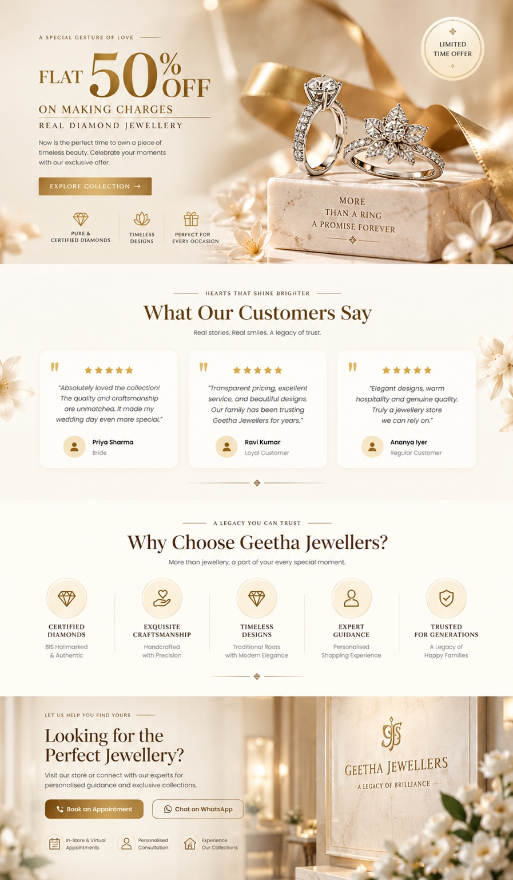
09 — OFFER + TESTIMONIALS + WHY CHOOSE US

A. 50% offer block
- Make “50% OFF” the dominant typographic moment of the promotional block.
- Clearly state that the offer is on making charges and keep the supporting line readable.
- Use the ring imagery as the product focus and preserve the elegant cream/gold atmosphere.
- CTA must be prominent but refined: “Explore Collection →” or equivalent.
- The offer should enter with a smooth editorial reveal, not a flashy sales animation.
Suggested headline: “Flat 50% Off”
Supporting line: “On Making Charges — Real Diamond Jewellery”
CTA: “Explore Collection →”

B. Customer testimonials
- Reveal testimonial cards with subtle staggered fade + upward movement.
- Keep the cards visually light, spacious and premium; avoid heavy borders or oversized shadows.
- Stars, customer name and short review should appear together as one coherent content block.
- Use realistic, restrained micro-interaction on hover rather than large card lifts.

C. Why Choose Geetha Jewellers
- The five value items should reveal ONE BY ONE from LEFT → RIGHT.
- The line/connector motif should draw or extend from left to right as the items appear.
- Each icon should reveal with a small scale/opacity entrance, followed by the label and supporting line.
- Do not use a card-heavy layout if it weakens the editorial appearance. Treat the five reasons as a refined trust system.
Suggested reasons: Certified Diamonds / Exquisite Craftsmanship / Timeless Designs / Expert Guidance / Trusted for Generations.

14. VISIT OUR STORE — PHYSICAL STORE EXPERIENCE
Purpose: This is not a generic contact section. The physical Geetha Jewellers store must be the hero of the experience, with the real supplied storefront image and verified store information.
REFERENCE KEYFRAME 10
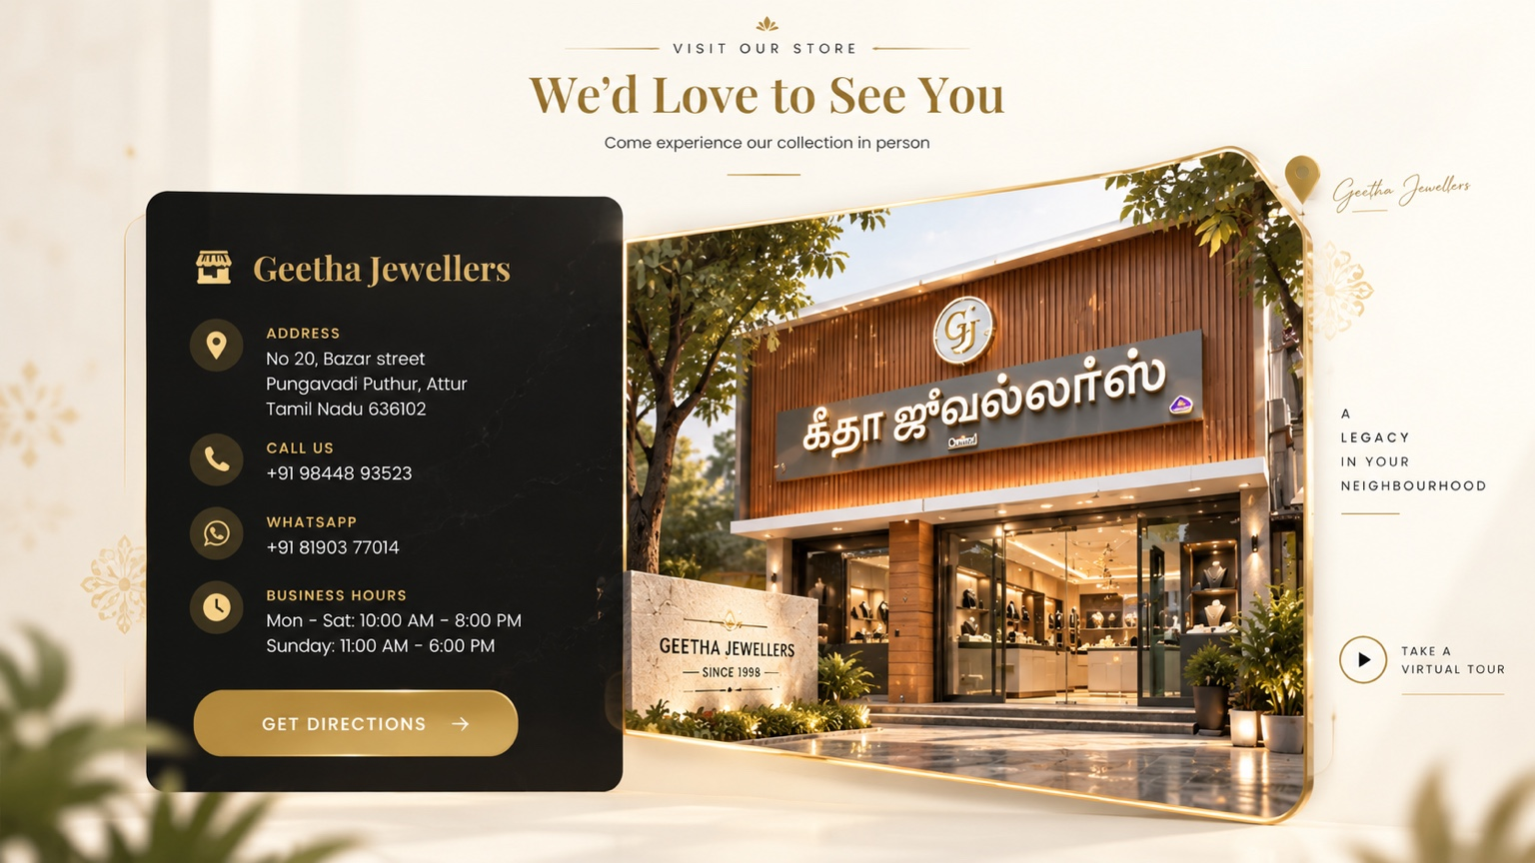
10 — VISIT OUR STORE / STORE EXPERIENCE

Required visual behavior
- Do not replace the actual Geetha Jewellers storefront with a generic jewellery-shop image.
- The storefront image should enter with a soft fade and controlled scale from depth, creating the feeling that the store is approaching the viewer.
- Use a subtle vertical movement/settle from bottom toward the final composition; avoid a template-style slide.
- The store information panel should reveal in coordination with the storefront, then the CTA should settle last.
- Use a premium framed image treatment / layered composition inspired by the supplied reference, while keeping the actual store photo intact.
- Only the Geetha Jewellers store should be the focal location. Do not add unrelated branches, generic malls or other shops.
- CTA should be action-oriented: “Get Directions →” and, if the project supports it, “Take a Virtual Tour”.

Store information to preserve
Geetha Jewellers — No 20, Bazar street, Pungavadi Puthur, Attur, Tamil Nadu 636102.
Use the approved project contact details and business hours from the existing site/project assets. Do not invent new contact data.
Suggested section heading: “We’d Love to See You”
Supporting line: “Come experience our collection in person.”

15. APP DOWNLOAD + FOOTER — FINAL PAGE
The supplied app/footer reference is included as an additional reference asset from the existing project workflow. This final page should continue the same cream/ivory/gold visual language; do not introduce a dominant black footer if it breaks the established page continuity.
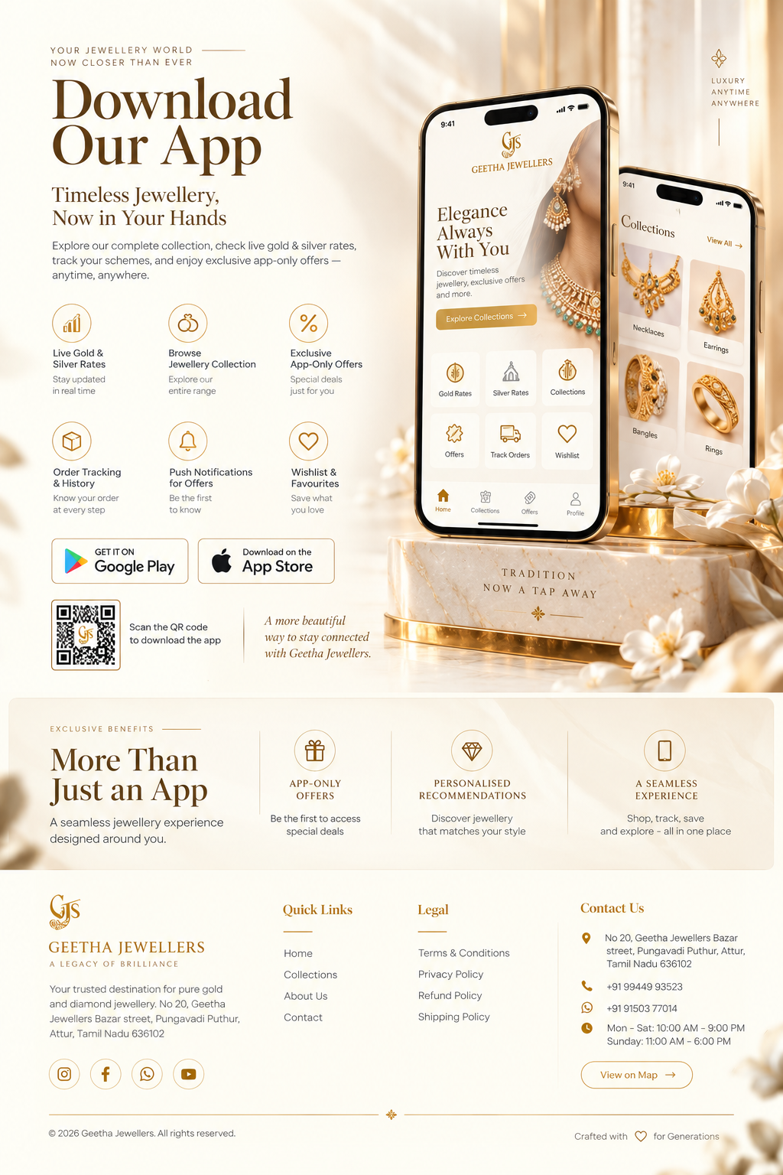
ADDITIONAL REFERENCE — APP DOWNLOAD + FOOTER

App section behavior
- Reveal the app section as a premium continuation after the store/trust journey.
- The phone mockups should enter with subtle depth/scale and settle into position; do not use generic spinning-phone effects.
- Feature items can reveal in small staggered groups, keeping the information easy to scan.
- App Store / Google Play buttons and QR code should remain crisp and functional if the actual app links are available.
- The final page should feel like a deliberate stopping point, not an unfinished footer.

Footer behavior
- Use a refined cream/ivory footer with gold/brown typography and thin decorative rules so it belongs to the same page system.
- Reveal the footer columns with a calm upward fade as the user reaches the bottom.
- Social icons, quick links, legal links and contact details should remain usable and accessible.
- Do not introduce a heavy black block simply because the previous mockup used one. The established colour continuity takes priority.

16. GLOBAL ANIMATION SYSTEM

Scroll-driven rules
- Use normalized scroll progress per section so each interaction has a predictable start, active range and settle range.
- Prefer transform and opacity for high-performance motion; avoid animating layout-heavy properties unnecessarily.
- Use GPU-friendly transforms and requestAnimationFrame or the project's established animation framework.
- Do not create competing scroll listeners for every element. Build reusable section animation controllers/components.
- Use IntersectionObserver or equivalent visibility detection to start/pause autoplay and expensive effects only when needed.
- Ensure reverse scrolling behaves gracefully and does not create flashing, snapping or unexpected state resets.

Autoplay rules
- Rings gold: left → right.
- Rings silver: right → left.
- Earrings: right → left.
- Gold/silver bangle collection thumbnails: use the supplied reference order and keep the autoplay subtle.
- Autoplay must pause or reduce speed while the user actively interacts with the component and resume naturally afterward.

Performance / HD rules
- Use the highest-quality supplied source assets available; do not knowingly upscale low-resolution images to fake HD.
- Serve responsive image sizes and modern formats where supported, while preserving visual fidelity.
- Preload the intro/first visible assets and progressively load below-the-fold jewellery assets.
- Do not sacrifice jewellery detail for excessive compression.
- Avoid giant unoptimized background images when a responsive image strategy can preserve the same visual result.
- Prevent layout shift by reserving image dimensions/aspect ratios before assets load.

Responsive behavior
- Desktop: preserve the full editorial composition and intended spatial relationships.
- Tablet: simplify spacing and reduce simultaneous motion where needed, while retaining the interaction concept.
- Mobile: stack content intelligently, preserve the main jewellery focus and convert complex multi-column layouts into controlled vertical sequences.
- Do not simply shrink the desktop screenshot. Recompose it responsively while keeping the same visual identity and animation intent.

17. CLAUDE — REQUIRED IMPLEMENTATION WORKFLOW
- Read this entire document before modifying the website.
- Audit the project folder and identify the exact logo, jewellery images, store image, fonts, existing header and existing hero/intro implementation.
- Do not replace the already-approved hero/intro. Build the post-hero experience after it.
- Map every supplied reference image to its section and animation state before coding.
- Build ONE section at a time in the exact order in this document.
- After each section, compare the live implementation against the supplied reference image for composition, typography, spacing, jewellery scale, lighting, crop and animation.
- Only after the static composition is correct should the scroll/autoplay interactions be layered on top.
- Keep all copy as real HTML content and make it responsive.
- Refactor reusable animation primitives instead of duplicating code for every section.
- Run desktop, tablet and mobile QA after each major collection group.
- At the end, test the entire page as one continuous experience from the hero → About → collections → trust/offer → store → app/footer.

18. FINAL ACCEPTANCE CHECKLIST
☐ Hero/intro remains approved and transitions seamlessly into the post-hero sections.
☐ About / Our Story elements enter in the specified left/right/bottom directions.
☐ Necklace reveal is genuinely scroll-driven and includes the controlled premium light sweep.
☐ Necklace detail images rise from bottom to top with quick, elegant reveals.
☐ Gold rings open/explode through scroll and then reveal specifications.
☐ Gold ring thumbnails autoplay left → right.
☐ Gold rings transform into silver rings within the same experience.
☐ Silver rings rotate subtly and their specifications stay synchronized.
☐ Silver ring thumbnails autoplay right → left.
☐ Earrings use a distinct suspended/natural interaction and autoplay right → left.
☐ Gold bangle section starts CLOSED and opens through scroll.
☐ Gold bangle open state matches the supplied reference.
☐ Gold bangles transform into the supplied silver version through a controlled transition.
☐ Offer section strongly highlights 50% OFF and includes a clear CTA.
☐ Testimonials and Why Choose Us reveal cleanly without a card-heavy/template feel.
☐ Why Choose Us items appear one-by-one from left → right.
☐ Store section uses the actual Geetha Jewellers storefront as the focal point.
☐ No unrelated shops or generic storefronts are introduced.
☐ App/footer maintains the same cream/ivory/gold colour continuity.
☐ All supplied images remain crisp and high quality.
☐ No hard cuts, loading flashes, layout jumps or accidental black sections.
☐ Reduced-motion fallback works.
☐ Desktop, tablet and mobile layouts are responsive and stable.
☐ The final website behaves like a continuous luxury brand experience, not a collection of static mockups.

19. APPENDIX — ALL SUPPLIED KEYFRAME REFERENCES
Keep these references attached to the implementation task. Claude should inspect the actual image files in the project folder and use them as visual source material. The order below is the intended section mapping for this phase.
01. 01 — OUR STORY / ABOUT SECTION
KEYFRAME REFERENCE — NOT A SLIDESHOW FRAME

02. 02 — SIGNATURE GOLD NECKLACE / PREMIUM COLLECTION
KEYFRAME REFERENCE — NOT A SLIDESHOW FRAME

03. 03 — GOLD RINGS COLLECTION
KEYFRAME REFERENCE — NOT A SLIDESHOW FRAME

04. 04 — SILVER RINGS COLLECTION
KEYFRAME REFERENCE — NOT A SLIDESHOW FRAME

05. 05 — EARRINGS COLLECTION
KEYFRAME REFERENCE — NOT A SLIDESHOW FRAME

06. 06 — GOLD BANGLES / CLOSED STATE
KEYFRAME REFERENCE — NOT A SLIDESHOW FRAME

07. 07 — GOLD BANGLES / OPEN STATE
KEYFRAME REFERENCE — NOT A SLIDESHOW FRAME

08. 08 — SILVER BANGLES / OPEN STATE
KEYFRAME REFERENCE — NOT A SLIDESHOW FRAME

09. 09 — OFFER + TESTIMONIALS + WHY CHOOSE US
KEYFRAME REFERENCE — NOT A SLIDESHOW FRAME

10. 10 — VISIT OUR STORE / STORE EXPERIENCE
KEYFRAME REFERENCE — NOT A SLIDESHOW FRAME

20. CLAUDE HANDOFF NOTE
Claude: treat every requirement above as an implementation responsibility. Do not stop after reproducing the static visuals. The finished work must include the described scroll choreography, autoplay behavior, transformations, responsive behavior, performance handling, asset fidelity and seamless transitions. When a reference image and a written animation instruction are both present, use the image for the exact visual state and the written instruction for how the user reaches that state.
GEETHA JEWELLERS • MASTER CREATIVE SPECIFICATION • PHASE 02

