GEETHA JEWELLERS
Website Creative & Animation Master Document
PHASE 01 — CINEMATIC WEBSITE INTRO / LOGO OPENING
Version 01 • Reference keyframes supplied by client

1. Purpose of This Document
This document is the first part of the Geetha Jewellers website master creative specification. It defines the opening animation that plays when the website first loads. More sections, images, content, and animation rules will be added to this same document later.
The uploaded images are KEYFRAME REFERENCES. They are not intended to be shown as a slideshow. Claude/development must recreate the motion and transitions between them using the actual supplied assets.

2. Core Creative Direction
- Luxury jewellery-film feeling: cinematic, elegant, premium and refined.
- Very fast opening: target approximately 2–3 seconds for the complete intro.
- The motion must feel continuous rather than like separate image slides.
- The Geetha Jewellers logo must remain visually consistent throughout the sequence.
- Use the supplied logo/animation assets from the project files whenever available; do not redraw or replace the brand mark.
- Lighting, gold reflections, glow, particles and depth should feel physically connected.
- After the logo reveal, the brand mark transitions naturally into the website header.

3. Intro Animation Sequence
Stage | Approx. timing | Visual action | Implementation intent
01 — Black opening | 0.00–0.15s | Start from a near-black screen. | Immediate, clean opening. No loading flash or visible page jump.
02 — Gold begins | 0.15–0.55s | A tiny gold point/glow appears and the golden material begins to emerge from darkness. | Use scale/depth/light movement. The reveal should feel like the viewer is approaching the gold.
03 — Gold structure / wave | 0.55–0.95s | Golden surface/wave structure becomes visible and expands toward camera. | Use smooth zoom/parallax and a controlled metallic light sweep.
04 — Logo reveal | 0.95–1.45s | The GJ emblem/logo emerges from the golden surface. | The logo should feel embedded/emerging from the gold, not pasted on top.
05 — Brand text | 1.35–1.75s | GEETHA JEWELLERS and SINCE 1998 appear beneath the emblem. | Use elegant fade/scale/reveal. Preserve exact brand wording and proportions.
06 — Final brand frame | 1.75–2.05s | Logo and brand lock into a centered composition. | Very short settle; retain glow/reflection without overdoing the effect.
07 — Shrink into header | 2.05–2.60s | The complete logo composition smoothly becomes smaller and moves upward to its final header position. | The movement should feel like the logo is travelling into the website header.
08 — Website appears | 2.60–3.00s | Header and first website section become fully visible. | No hard cut. Transition should feel like one continuous brand film.

4. Detailed Motion Choreography
A. Black screen — Begin almost completely black. Keep this moment extremely short. The purpose is to create contrast for the first gold light.
B. Gold point / emergence — A controlled gold glow appears near the center. The viewer should feel that a large golden object is approaching from depth.
C. Zoom / approach — The golden structure grows toward the viewer. Use smooth easing, subtle camera depth and metallic reflections. Avoid an abrupt scale-up.
D. Logo formation — As the gold settles, the GJ emblem becomes visible. The reveal should feel integrated with the gold material and lighting.
E. Geetha Jewellers + Since 1998 — The wordmark and 'SINCE 1998' appear elegantly after/with the emblem. They should not pop in. Use a refined fade + slight upward/scale reveal.
F. Light sweep — A narrow cinematic gold highlight travels across the logo/gold surface. Keep it stylish and controlled—no giant white flash.
G. Shrink + travel upward — The completed logo composition scales down smoothly and travels upward to the exact center position of the website header.
H. Header lock — Once the logo reaches the header, it becomes the normal static header logo. Navigation appears clearly and the main website experience takes over.

5. Supplied Keyframe References
The following three supplied images define the visual progression. They should be treated as consecutive reference states for the intro. The implementation should animate between these states rather than simply cross-fading from one image to another.
KEYFRAME A — GOLD / LOGO CLOSE REVEAL
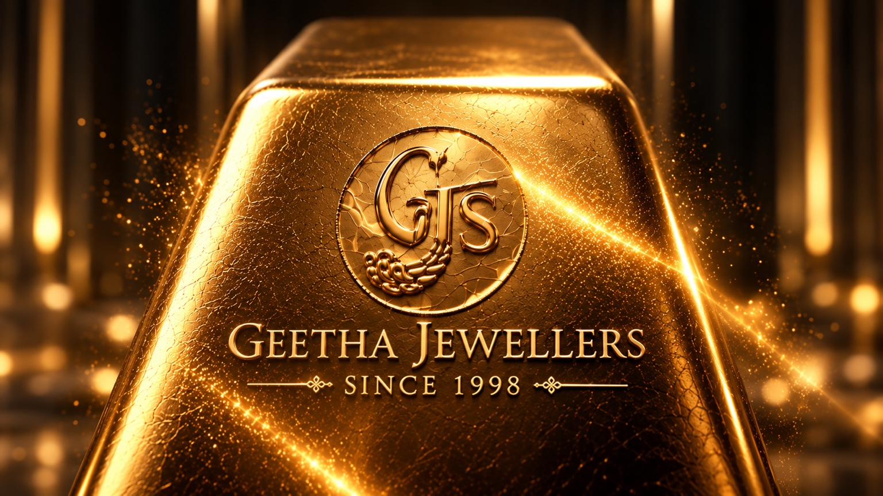
Large gold surface with the GJ emblem and full Geetha Jewellers branding.
KEYFRAME B — BRAND LOCKUP / MEDIUM SCALE
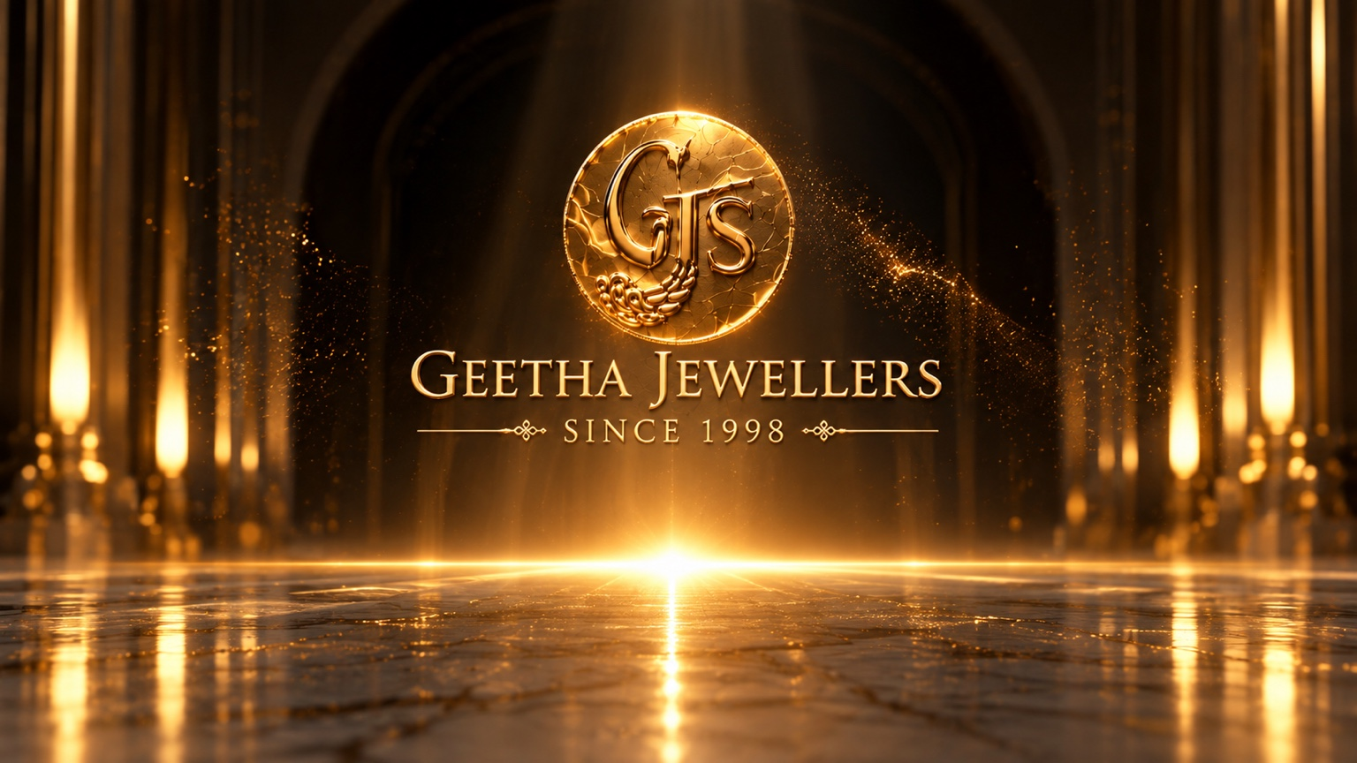
Logo and brand lockup become smaller and the surrounding architectural environment becomes more visible.
KEYFRAME C — SMALL CENTERED BRAND
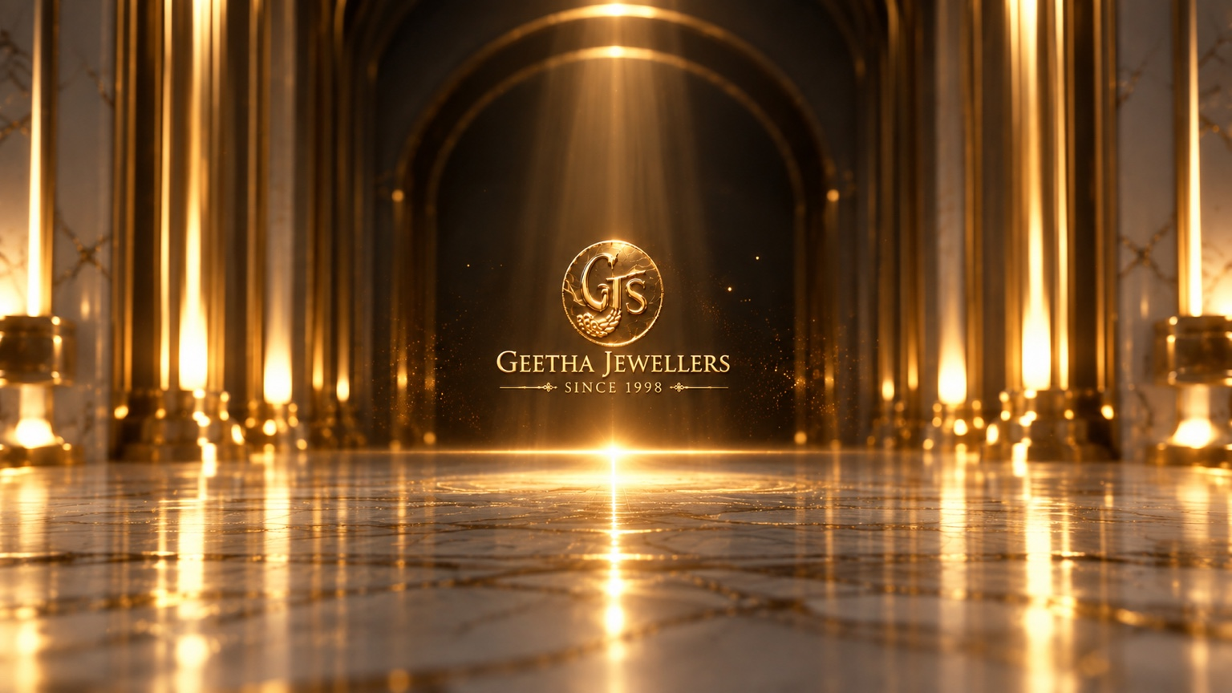
The logo/brand composition becomes smaller, centered in the environment, ready to travel into the website header.

6. Claude / Development Implementation Instructions
- Use the uploaded Geetha Jewellers project files as the source of truth for logos, backgrounds and visual assets.
- Do not replace the supplied logo with an AI-generated or newly typeset logo.
- Do not treat the three keyframes as a normal carousel or slideshow.
- Interpolate the motion between keyframes with smooth easing and requestAnimationFrame / GPU-friendly transforms where applicable.
- The intro should be fast enough that returning visitors are not delayed. Target 2–3 seconds maximum.
- Preload the critical intro assets so the animation does not begin with missing images.
- Avoid layout shift while the intro is running.
- The logo must arrive at the exact final header position and scale so the transition into the header feels seamless.
- The header must remain readable against the background; remove any unwanted white/blurred overlay that reduces text visibility.
- The menu must have a clear close/X control after opening.
- Respect prefers-reduced-motion with a short fade-based fallback.

7. Brand Consistency Rules
Element | Rule
Logo | Use the exact supplied Geetha Jewellers logo/mark. Do not redesign it.
Wordmark | Use the exact wording: GEETHA JEWELLERS.
Heritage line | Use the exact wording: SINCE 1998.
Gold language | Warm luxury gold, realistic metallic highlights, subtle bloom.
Motion language | Smooth, restrained, cinematic. No cheap flashes or excessive effects.
Composition | Centered, symmetrical and premium.

8. Future Sections — To Be Added
This document is intentionally structured as a living master specification. When additional designs are supplied, add them as new sections without changing the approved intro unless explicitly instructed.
- Phase 02 — Website Header
- Phase 03 — Interactive Jewellery Collection / Scroll Experience
- Phase 04 — About Us / Brand Story
- Phase 05 — Collections / Supporting Content
- Phase 06 — Contact
- Phase 07 — Terms & Privacy
- Phase 08 — Responsive / Mobile behavior
- Phase 09 — Final transitions, performance and QA

9. Intro Animation Acceptance Checklist
☐ Starts with a brief black screen.
☐ Gold emerges from darkness with depth and light.
☐ Logo remains consistent and recognizable.
☐ GEETHA JEWELLERS appears smoothly.
☐ SINCE 1998 appears smoothly.
☐ Light sweep feels premium and metallic.
☐ The logo/brand composition shrinks and travels upward.
☐ It lands naturally in the website header.
☐ Total intro duration is approximately 2–3 seconds.
☐ No hard cuts, stutters, loading flashes or image popping.
☐ The supplied keyframes are used as visual references, not displayed as a slideshow.

GEETHA JEWELLERS • MASTER CREATIVE SPECIFICATION • PHASE 01

