MACHINE LEARNING ASSIGNMENT -2

BITS ID: 2025ab05129

NAME :Suresh BABU V

EMAIL ID : 2025ab05129@wilp.bits-pilani.ac.in

1.GITHUB LINK

https://github.com/sureshbabuveluswamy/Credit-Card-Default

2.STREAMLIT APP:

https://credit-card-default-2025ab05129.streamlit.app/

3. Screenshot

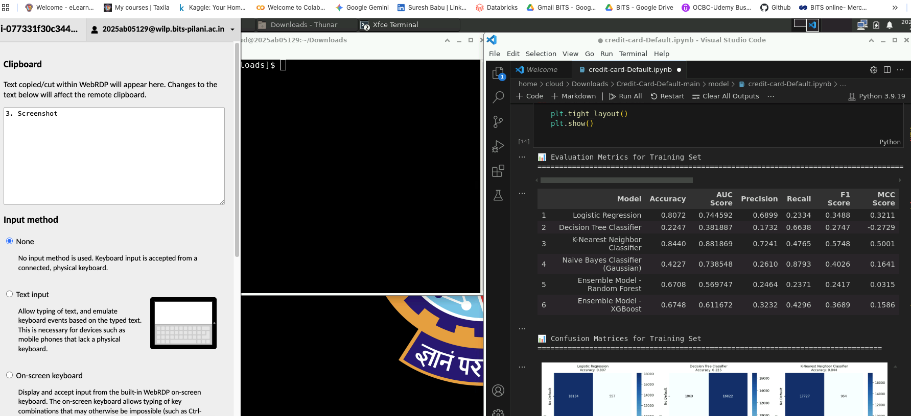

4.README File

