**National University of Computer and Emerging Sciences**



**Laboratory Tasks 07**

*for*

# Web Engineering

*Instructor: Saqib Ameer*

*Email: saqib.ameer@nu.edu.pk*

# Spring 2024

**FAST School of Computer Science**

Part A)

This part is query based and done on the compass mongoshell command prompt

Check this tasks within the LAB.

For syntax related help you can visit the

<https://www.w3schools.com/mongodb/>

Create DB with name test also create a collection with name student and apply some queries on this collection

1. InsertOne name , rollno(as a id) , age , marks
2. Insertmany minimum insert 5 students record
3. Update the record of student whose name is ABC and just add new column with name idcard which is again an array like

Idcards:{hasidcard:false , hasunicard: true}

1. UpdateMany query run this query to update all the students record and add new column with name hobbies like given

Hobbies:[‘Anime’ , ‘Cooking’]

1. Find those students record whose unicard is missing
2. Find those students record whose age is less than 12 and also find greater than equal to 15
3. Update many to update the record of all those students whose age is 13 and add the new column with name iselgible which is false
4. Find all record just name and age no need to display other record(specially rollno)
5. Insert the record in new collection with name company the record is given below.

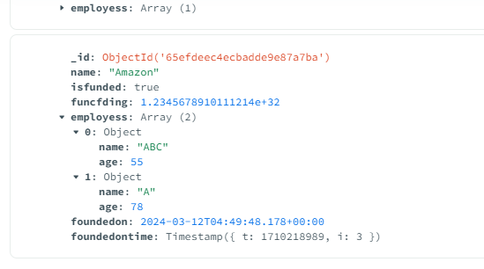

1. Write a query to delete collection , document and also db
2. InsertMany using option ordered
3. Write a Query to implement the following keywords $eq , $in , $nin , $ne
4. Increment the marks of all students by 5 using $inc operator
5. Create collection with name books and you need to validate this book record like that

Name and price of book must be enter

Validation Action is warn

Properties for name is bsontype String and description must be in string required

Price besontype is number and description must be in number format required

Author is also required but author besontype is array and in array items entered beson type of array item is json object and required things in author is name and email

QNO2:- In this part make simple Resfull API’s for CRUD System using nodejs and mongodb and mongoose dependcy use

Dependcies required for this task is

Express body-parser mongoose(for Database)

APIS which is required in this task

1. GET ii) POST iii) PUT iv) Delete

Files you need to create

1. Config.js ii) modelname.js iii) index.js or server.js all APIS in this file

Make async functions of get , post , Put and delete

In Last for test use the POSTMAN or thunderclient fpr testing of your API endpoints

Simple API endpoint is like

<http://localhost:4077/create> this is test against the post api for inserting the data

 GET / empty : Retrieves all students.

POST /create: Creates a new student.

PUT /update/:id: Updates an existing student by ID.

DELETE /delete/:id: Deletes a student by ID.

QNO3:-

Create a Node.js email sender application, in which you need to take subject, content, and receiver email from user, using HTML forms. Then you need to send the email to the requested email.

UI should display one form for taking information, and one button to send the email.