National University of Computer and Emerging Sciences Chiniot-Faisalabad Campus



**game-APPLICATION TESTING**

Software Quality Engineering

### Semester Project

### Summary report on Slack

### BS (SE) 5A

## Team Name: zzwave-testing

## Team Member’s:

## 21F-9516 -> Suresh Kumar

## 21F-9519 -> Rai umer farooq

## 21f-9510 -> mian fahad akhtar

**Table of Contents**

1. BVA: - 2

**2.** **ECP: -** 3

**3.** **Risk Analysis: -** 4

# BVA: -

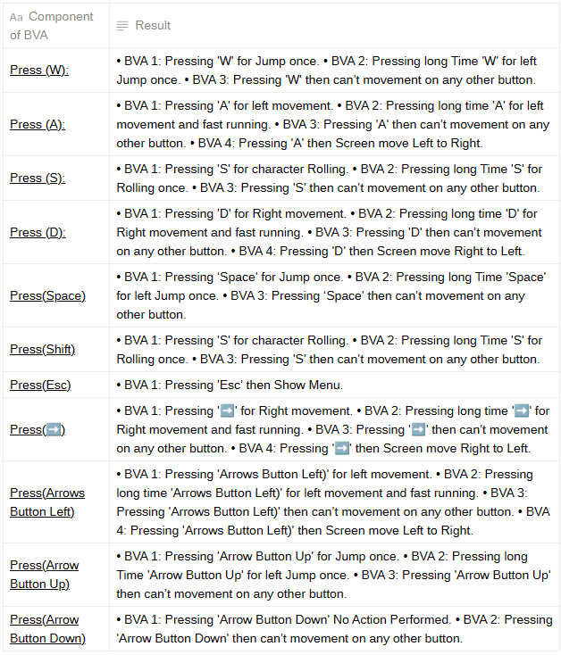

# **ECP: -**

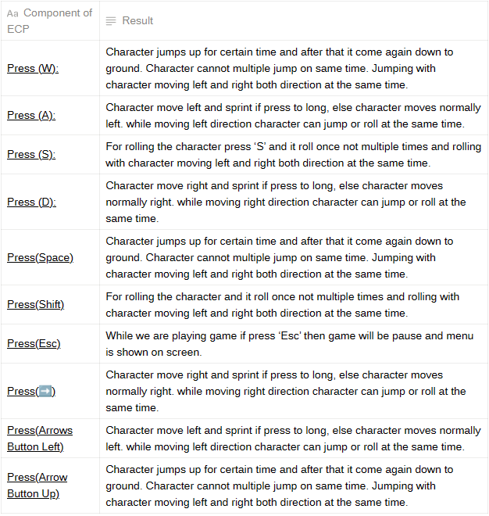

# **Risk Analysis: -**

