CO-2 ASSESSMENT TOOL -DEBUGGING
COUSE CODE: CSA0307 NAME:D.SURESH
COUSE NAME : DATA STRUCTURES REG NO: 192525305
DATE : 31/07/26
QUESTION 1 FIND MISSING LINES
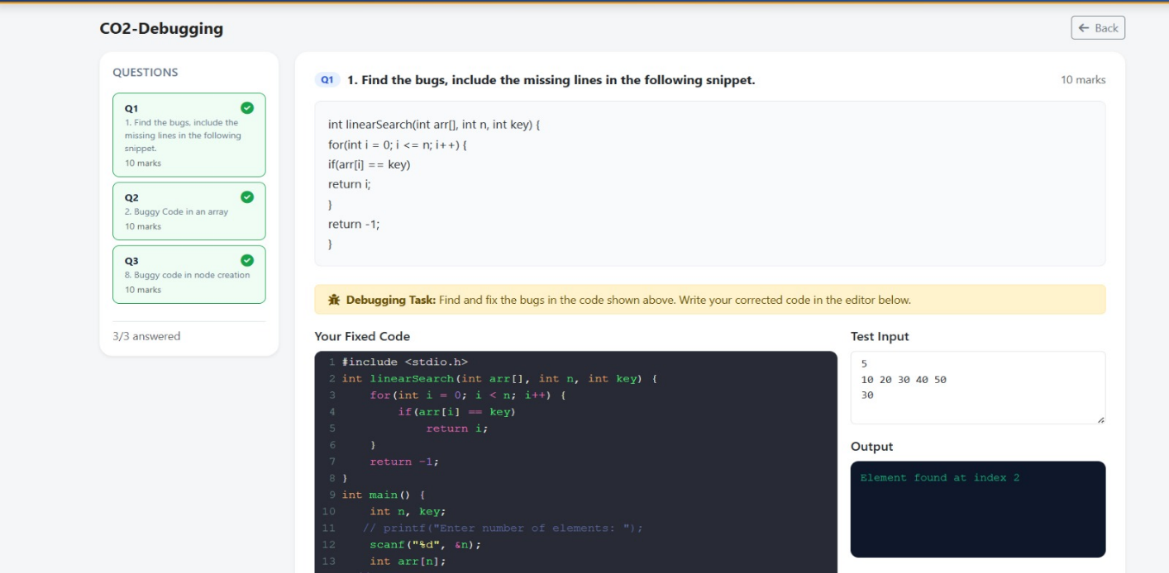
QUESTION 2 BUGGY CODE IN ARRAY
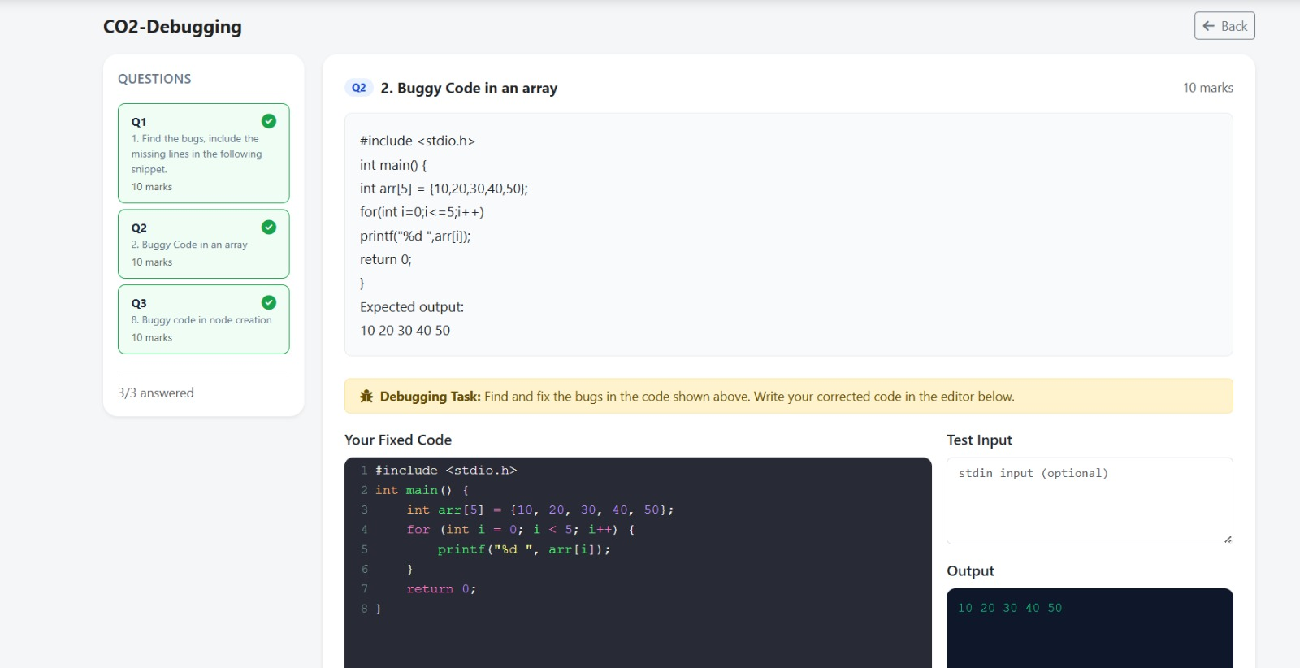

QUESTION 3 BUGGY CODE IN NODE CREATION
