Key Points:-

Narrow Transformations are performed on data in single partition (in this single stage all the transformations can be done at once in one partition/task).

Wide transformations are performed on data in multiple partitions and this will lead to new stage.

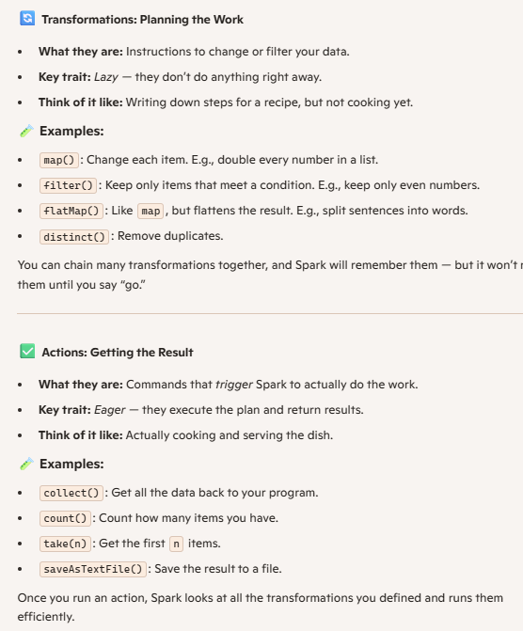

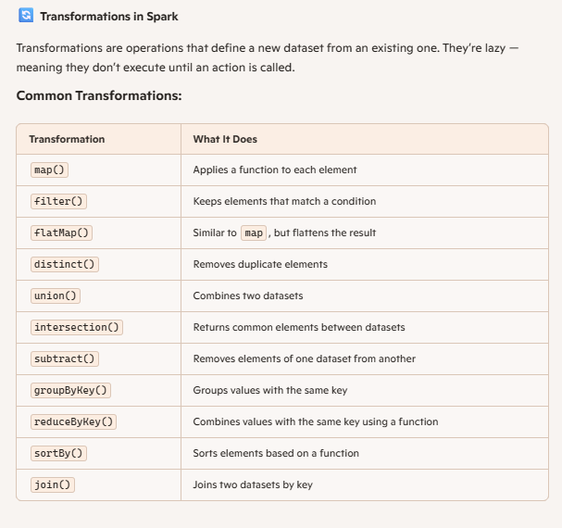

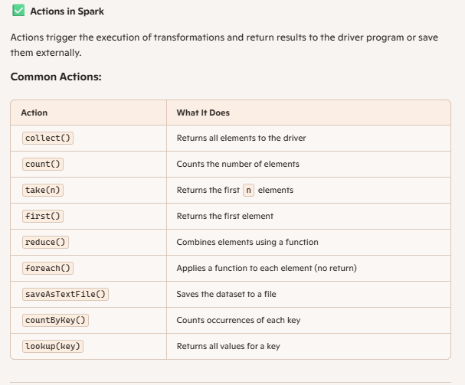

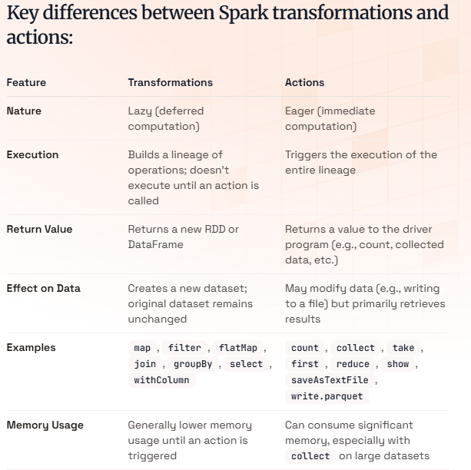

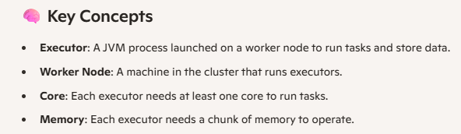

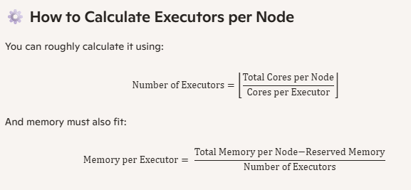

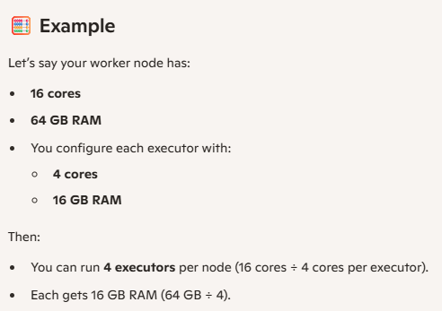

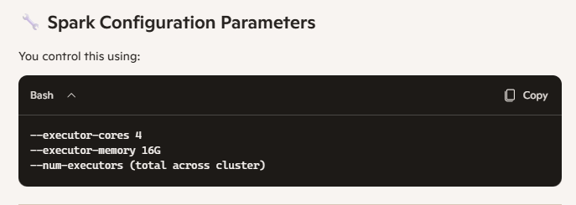

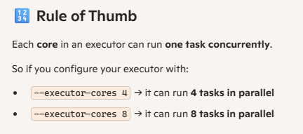

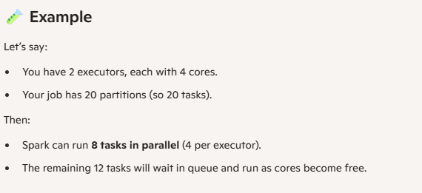

Worker Node (Contains More than 1 Executers)

Executers (Contains More than 1 Tasks)

Tasks (Contains only 1 partition, can run multiple transformers one after another for single partition)

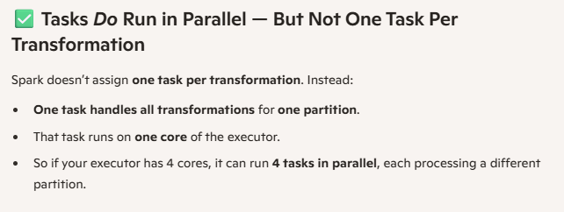

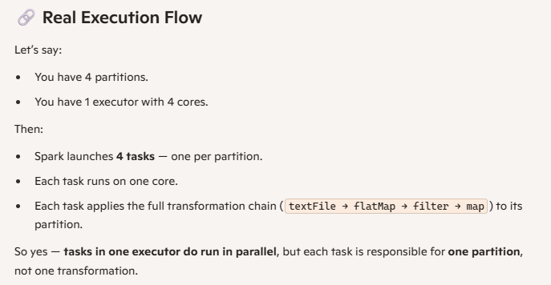

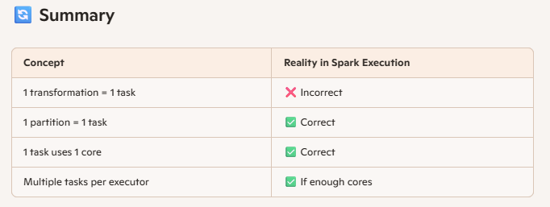

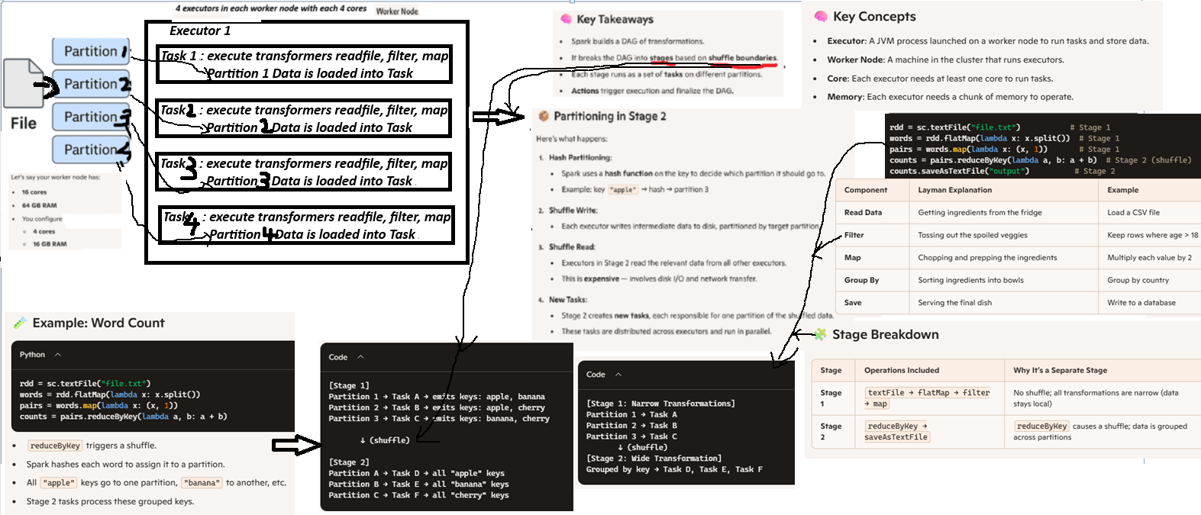

What Is a Partition?
A partition is a chunk of your data. Spark processes each partition independently and in parallel across the cluster. Think of it like slicing a big pizza into smaller slices so multiple people can eat at the same time

How Spark Splits Data into Partitions:

1. Reading from Files (e.g., textFile, CSV, Parquet)
- Spark splits files based on block size (typically 128 MB or 256 MB in HDFS).
- Each block becomes a partition.
- For example, a 1 GB file with 128 MB blocks → ~8 partitions.

2. From Collections (e.g., sc.parallelize)
- You can specify the number of partitions: sc.parallelize(data, numSlices=4)
- Spark will divide the data into 4 partitions.

3. Transformations That Change Partitioning
- repartition(n): Increases or reshuffles partitions (causes a shuffle).
- coalesce(n): Reduces partitions without full shuffle (more efficient for downscaling).
- reduceByKey / groupByKey: These cause shuffles and redistribute data based on keys, creating new partitions.

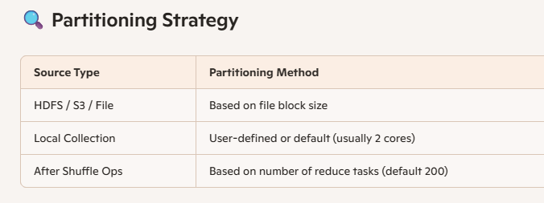

What is a DAG in Spark?
A DAG is like a recipe that Spark follows to cook your data. It’s a map of steps that Spark needs to take to go from raw ingredients (your data) to the final dish (your results).

