VARUNA AI POD
Step-by-step build guide
An enclosed, solar-powered river and pond cleanup boat made from thermocol, 600 x 300 x 200 mm. It collects floating plastic in a pull-out drawer, watches the water with two cameras, measures water quality, avoids obstacles and can spray a water treatment.
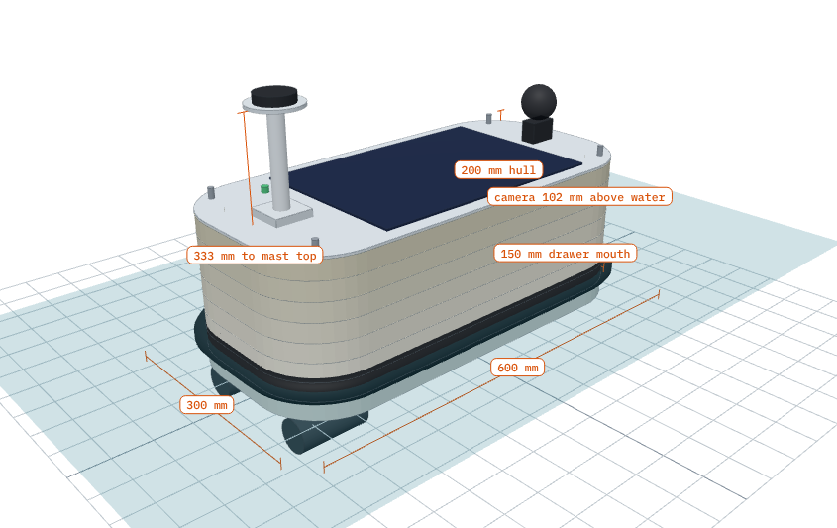
The finished VARUNA AI Pod (3D model). The drawer opening is at the front.
Size | Weight | Floats | Run time | Collects
600 x 300 x 200 mm (348 mm to GPS) | 4.2 kg empty | 38 mm deep | about 4.4 h (5.2 h in sun) | 1.9 L drawer

Companion files: ai-pod_A3.pdf (real-size cutting templates, 7 pages) and boat-3d.html (3D model). Both are in the boat-design folder of the varuna-gcs repository.

Contents
1. Before you start: 6 golden rules
2. What you need
3. How the boat is built
4. Build steps (Steps 1 to 12)
5. Where every part goes
6. Wiring
7. Float test and balance
8. Software setup
9. First run checklist
10. Fixing common problems

1. Before you start: 6 golden rules
- Print the templates at 100% (Actual size). Always print the test page first and check the 100 mm square.
- Use only Fevicol SH (white PVA) or low-temperature hot glue on thermocol. Fevikwik, rubber glue (SR 998), spray paint and petrol-based paint melt thermocol.
- Use sunboard (PVC foam board), not cardboard, for anything that can get wet. Cardboard goes soft in water.
- Heavy things go low. The battery sits on the floor of the boat. This is what stops the boat from rolling over.
- Never charge or store the battery unattended, and always fit the fuse and main switch.
- Test in a tub before a pond. Check that it floats level and does not leak before fitting any electronics.
CAREFUL The 4-way spray is for a water treatment such as PAC (poly aluminium chloride). Use it only in tanks and pools you look after, at the dose written on the pack. Do not spray rivers or ponds with fish. A camera with UV light cannot detect bacteria: use the pH, TDS, turbidity and temperature readings, and send water samples to a lab for bacteria tests.

2. What you need

Hull materials
Item | Size | Qty
Thermocol (EPS) sheet, 25 mm (1 inch) thick | 1000 x 500 mm, or 2 x 3 ft (610 x 915 mm) | 8 sheets, or 3 sheets of 2 x 3 ft
Sunboard (PVC foam board) 3 mm | A2 or larger | 2 sheets (lid, shelf, drawer)
Sunboard 5 mm | A3 | 1 sheet (tunnel roof, small parts)
Wooden strip (pine) | 230 x 40 x 20 mm | 1 (thruster beam)
Wooden strip | 190 x 10 x 10 mm | 2 (drawer rails)
Plastic mesh (kitchen sink or gutter mesh) | 300 x 500 mm | 1
Clear PET sheet (bottle or transparency) | 120 x 70 mm | 1 (drawer flap) + 1 small (camera window)
Black foam pipe insulation, 32 mm | 1.6 m | 1 (bumper)
PVC electrical conduit 20 mm + end cap | 150 mm | 1 (GPS mast)
Bamboo skewers | 3 to 4 mm | 1 pack
Fevicol SH, low-temp hot glue sticks, glue stick (paper) |  | 1 each
Brown packing tape or tissue paper |  | for waterproofing
Water-based acrylic or emulsion paint | white + black | small tins
Foam tape (weather strip) + 4 rubber bands or Velcro |  | for the lid seal

Electronics
Part | Size (mm) | Weight
Pixhawk 2.4.8 (ArduRover) | 82 x 50 x 16 | 38 g
Raspberry Pi Zero 2 W | 65 x 30 x 5 | 10 g
Pi Camera Module 3 Wide (front camera) | 25 x 24 x 12 | 5 g
USB webcam on MG90S servo (360 deg camera) | webcam about 60 x 30 x 30 | 75 g
GPS + compass (M8N) | 50 dia x 15 | 30 g
Li-ion 3S6P 20 Ah pack + 3S BMS (18 x 18650) | 115 x 60 x 70 | 960 g
2 x 12 V brushless underwater thruster, 2 kg class | 45 dia x 95 each | 360 g
2 x 30 A bidirectional ESC | 50 x 25 x 10 each | 50 g
10 W flexible solar panel | 340 x 230 x 3 | 220 g
CN3791 3S solar charge module | 50 x 30 x 15 | 15 g
Power module + 12 V to 5 V 5 A buck | 25 x 21 / 60 x 35 | 45 g
2-channel relay module | 50 x 38 x 19 | 30 g
ADS1115 ADC | 28 x 18 x 3 | 3 g
pH probe + board | 12 dia x 150 / 42 x 32 | 60 g
TDS probe + board | 42 x 32 | 25 g
Turbidity probe + board | 30 dia x 70 / 38 x 28 | 33 g
DS18B20 waterproof temperature probe | 6 dia x 50 | 15 g
3 x JSN-SR04T waterproof ultrasonic sensor | 23 dia, board 41 x 28 | 90 g
12 V diaphragm pump + 4 nozzles + tube | 90 x 40 x 35 | 150 g
365 nm UV LEDs, front LED strip, status RGB LED |  | 35 g
XT60 connectors, 20 A blade fuse + holder, 20 A on/off switch |  | 30 g
Silicone wire 14 AWG (power) and 22 AWG (signals), cable glands |  | 120 g
Resistors: 10k, 20k (x2 each), 1k, 2k (x3 each), 4.7k, 220 ohm (x3)

Tools
- Hot-wire foam cutter (best) or a snap-off cutter with new blades
- Steel ruler (at least 300 mm), measuring tape, set square, marker pen
- Hot glue gun (low temperature), soldering iron, multimeter, small screwdrivers
- A3 printer (or a print shop), scissors, sandpaper 120 grit
- A laptop with Mission Planner and the VARUNA app

3. How the boat is built
The hull is 8 layers of 25 mm thermocol stacked and glued on skewers, like a layer cake. The first three are solid (the floor and buoyancy). The next four are rings, which leave a hollow dry bay in the middle. The eighth ring is glued under the lid so the whole top lifts off.
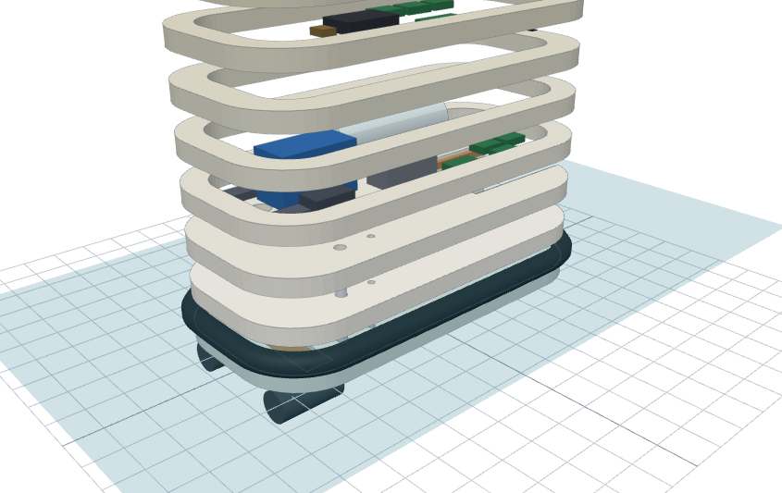
Exploded view: base layers at the bottom, then the wall rings, the shelf and the lid.
Layer | Height (mm from bottom) | Template | What it is
1 | 0 to 25 | Base half template | Floor, with drawer tunnel, sensor wells and thruster beam slot
2 | 25 to 50 | Base half template | Floor, with drawer tunnel and sensor wells
3 | 50 to 75 | Base half template | Floor of the dry bay, with drawer tunnel and wells
4 | 75 to 100 | Ring half template, red line | Wall ring
5 | 100 to 125 | Ring half template, red line | Wall ring + 3 ultrasonic sensor holes
6 | 125 to 150 | Ring half template, blue line | Ledge ring: the shelf rests on it; camera window
7 | 150 to 175 | Ring half template, red line | Wall ring
8 | 175 to 200 | Ring half template, red line | Lid rim: glued under the lid, lifts off with it

Inside, the lower bay (on layer 3) holds the battery, thruster speed controllers, power converter, relays, spray pump and tank. The shelf holds the Pixhawk, Raspberry Pi and sensor boards. The drawer slides into a tunnel under the front of the boat.

4. Build steps

Step 1: Print the templates
- Open ai-pod_A3.pdf. Print page 2 only, on A3, landscape, with scaling set to Actual size or 100%. Turn off Fit to page.
- Measure the square on page 2 with a steel ruler. Both sides must be 100 mm. If not, fix the printer setting and print page 2 again.
- Print the rest of the pages with the same settings.
- Pages 3 and 4 make one long sheet: overlap page 4 on the grey strip of page 3, line up the grey 50 mm grid, and tape. Do the same with pages 5 and 6.
- Check the joined sheet: the blue 570 mm measurement must measure 570 mm with a tape.
CHECK every measurement line on the paper matches your ruler.

Step 2: Cut the thermocol layers
- Draw a straight centreline along the middle of each thermocol sheet with a ruler.
- Cut the base half template out of the paper along its black line.
- Lay the template's CENTRELINE edge on the line on the thermocol. Trace round it with a marker. Flip the paper over and trace the other half. Do this on 3 sheets (layers 1, 2, 3).
- Cut the ring half template out on its outer black line. Trace and flip on 5 sheets (layers 4 to 8).
- Cut the paper along the blue dashed line. Trace this inner line on ONE ring sheet: that is layer 6.
- Cut the paper along the red line. Trace this inner line on the other 4 ring sheets.
- Mark the sensor holes and skewer points by pushing a pencil through the template. The left and right sides have different holes; both are labelled.
- Cut every layer with the hot-wire cutter, keeping it upright. Cut the drawer tunnel out of layers 1 to 3 and the beam slot out of layer 1 only.
CHECK each layer is 570 x 270 mm. The rings' walls are 35 mm thick, the ledge ring's 45 mm.
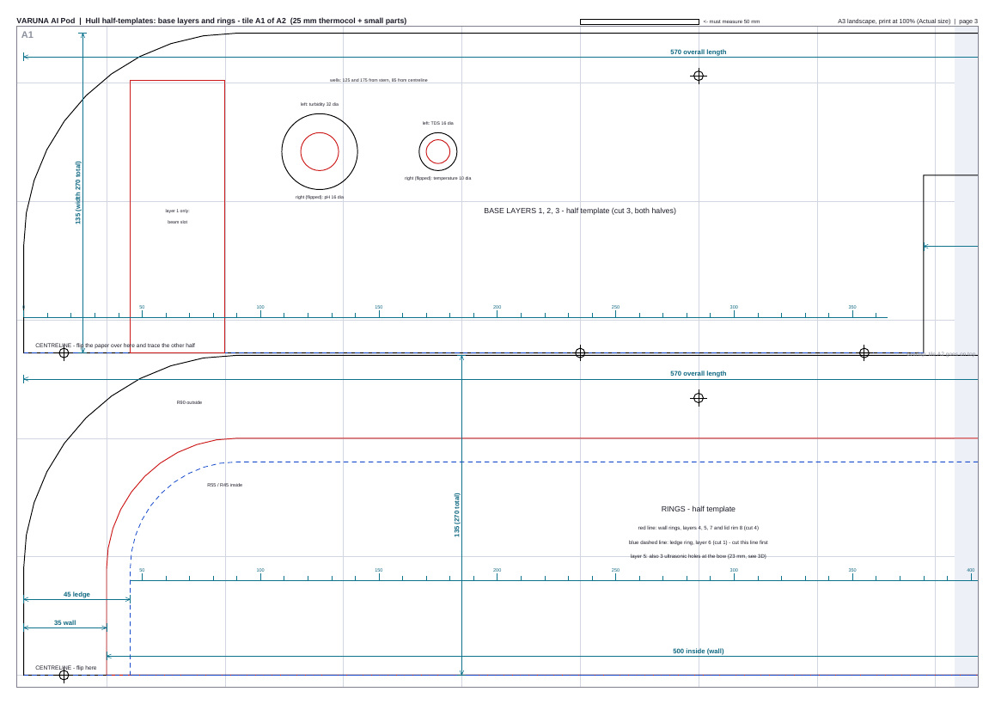
Template page 3: base half template (top) and ring half template (bottom). The CENTRELINE edge is where you flip.

Step 3: Build the base
- Push skewers through all the + marks of layer 1 so they stand up.
- Spread Fevicol SH thinly on layer 1, press layer 2 down over the skewers, then layer 3 the same way.
- Glue the 230 x 40 x 20 mm wooden thruster beam into the slot in layer 1, flush with the bottom.
- Put weights (books) on top and leave it overnight.
CHECK the drawer tunnel is 150 mm wide and 190 mm deep, and the 4 sensor wells go right through.

Step 4: Roof the tunnel and fit the drawer rails
- Cut the tunnel roof from 5 mm sunboard (small-parts template).
- Glue it on top of layer 3 over the tunnel, and run hot glue round every edge. This plate is the floor of the dry bay at the front, so it must not leak.
- Glue the two 10 x 10 mm wooden rails along the tunnel walls, 60 mm up from the bottom, so the drawer can hang from them.
CHECK pour a cup of water into the tunnel from below; nothing should come through the roof.

Step 5: Build the walls
- Before gluing layer 5, make the 3 ultrasonic holes (23 mm) through its bow wall: one straight ahead, one each side at the front corners.
- Before gluing layer 6, cut a 28 x 16 mm camera window in the centre of its bow wall and glue clear PET over it from inside.
- Glue layers 4, 5, 6 and 7 onto the base in that order, lining them up on the skewers and the outside edge.
- Keep layer 8 separate: it is the lid rim.
CHECK the shelf (Step 9) sits flat on the ledge of layer 6 all the way round.

Step 6: Shape and waterproof the hull
- Sand the outside lightly so the layers blend.
- Brush on Fevicol SH mixed 1:1 with water and lay tissue paper on it; do two coats. Or wrap the whole hull tightly in brown packing tape.
- Paint with water-based acrylic or emulsion paint: white body, black base band.
- Glue the black pipe insulation (split in half) round the hull at the waterline, about 25 to 55 mm up. Leave the drawer opening clear.
CHECK no bare thermocol is visible anywhere, inside or out.

Step 7: Make the drawer
- Cut the drawer bottom, two sides, back and front from 3 mm sunboard using the small-parts templates. Cut out the red windows.
- Hot-glue plastic mesh over every window.
- Glue the box together: 203 long, 140 wide, 70 tall. The front panel with the handle goes at the bow.
- Tape the PET flap inside the front, hanging over the entrance, so it swings inward only.
- Slide the drawer into the tunnel on its rails.
CHECK the drawer slides in and out easily and the flap swings only inwards.

Step 8: Make the lid
- Cut the lid top from 3 mm sunboard with the lid half template (trace and flip). Cut the holes.
- Glue the lid top onto layer 8 (the lid rim ring).
- Stick foam tape on top of layer 7 all round; the lid presses on it to seal.
- Glue the solar panel in its dashed box, the mast socket and the 120 mm GPS mast at the back, the servo plate at the front, the status LED and the 4 spray nozzles.
- Fit 4 hooks on the hull sides for the rubber bands that hold the lid down.
CHECK with the bands on, the lid does not move when you tilt the boat.

Step 9: Fit the thrusters
- Bolt the two underwater thrusters under the wooden beam, 80 mm each side of the centre, pointing straight forward.
- Run their wires up through a hole sealed with a cable gland or hot glue into the dry bay.
CHECK both propellers turn freely and sit fully under the hull.

Step 10: Electronics in the lower bay
- Glue the paper placement guide on the floor of the bay (it is printed on base layer 3's template), or measure positions from the table in section 5.
- Fix the battery with a Velcro strap, 85 to 200 mm from the back edge. Fix the two ESCs, the 5 V converter, the relay module, spray pump, spray tank and solar charger on their outlines.
- Fit the fuse and main switch between the battery and everything else.
CHECK nothing heavy is loose; tilt the boat 45 degrees and nothing slides.

Step 11: Fit the shelf and upper bay
- Cut the shelf from 3 mm sunboard with its half template, and its two cable slots.
- Fix the Pixhawk (arrow towards the bow) on the centreline, the Pi Zero, ADS1115 and the three sensor boards on their outlines.
- Lay the shelf on the ledge with the cables running through the slots.
CHECK the Pixhawk arrow points to the bow.

Step 12: Sensors, cameras and lights
- Push the turbidity, pH, TDS and temperature probes through their wells so the tips stick out 15 mm under the hull. Seal round each with hot glue.
- Fit the 3 ultrasonic sensors in their holes in layer 5 and seal with hot glue.
- Fix the Pi Camera 3 Wide behind the window in layer 6, tilted 10 degrees down (use the camera wedges).
- Put the USB webcam in its dome on the servo on the lid. Fit the UV LEDs and the LED strip at the bow.
CHECK every probe tip is under water when the boat floats; every hole is sealed.

5. Where every part goes
Distances are measured from the back edge of the hull. Left and right are as you look towards the bow. Height is from the bottom of the hull; a minus height means below the hull.
Part | Size (mm) | From back edge | Across | Height
Li-ion 3S6P 20 Ah battery (18 x 18650 + BMS) | 115 x 60 x 70 | 85 mm | centre | 75 mm
ESC 30 A bidirectional (left) | 50 x 25 x 10 | 50 mm | 50 mm left | 75 mm
ESC 30 A bidirectional (right) | 50 x 25 x 10 | 50 mm | 50 mm right | 75 mm
12 V to 5 V 5 A buck converter | 60 x 35 x 20 | 105 mm | 50 mm right | 75 mm
2-channel relay module | 50 x 38 x 19 | 105 mm | 50 mm left | 75 mm
CN3791 solar charge module | 50 x 30 x 15 | 325 mm | 75 mm right | 75 mm
Spray pump 12 V (385 diaphragm) | 90 x 40 x 35 | 225 mm | 40 mm right | 75 mm
Spray tank (500 ml bottle) | 65 dia x 200 long | 225 mm | 60 mm left | 80 mm
Pixhawk 2.4.8 | 82 x 50 x 16 | 195 mm | centre | 153 mm
Power module | 21 x 25 x 9 | 165 mm | centre | 153 mm
Raspberry Pi Zero 2 W | 65 x 30 x 5 | 295 mm | 50 mm right | 157 mm
ADS1115 ADC | 28 x 18 x 3 | 370 mm | 50 mm right | 157 mm
pH sensor board | 42 x 32 x 10 | 295 mm | 45 mm left | 153 mm
TDS sensor board | 42 x 32 x 10 | 345 mm | 45 mm left | 153 mm
Turbidity sensor board | 38 x 28 x 10 | 395 mm | 45 mm left | 153 mm
Pi Camera 3 Wide (front, 10 deg down) | 12 x 25 x 24 | 556 mm | centre | 128 mm
Solar panel 10 W (flexible) | 340 x 230 x 3 | 135 mm | centre | 203 mm
GPS mast (20 mm PVC conduit) | 20 dia x 120 | 65 mm | centre | 213 mm
Pan servo MG90S (360 deg camera) | 40 x 22 x 30 | 495 mm | centre | 203 mm
Collection drawer (mesh basket, pulls out forward) | 203 x 140 x 70 | 382 mm | centre | 0 mm
Thruster beam (wood 230 x 40 x 20) | 40 x 230 x 20 | 45 mm | centre | 0 mm
Underwater thruster (left) | 44 dia x 95 long | 18 mm | 80 mm left | -54 mm
Underwater thruster (right) | 44 dia x 95 long | 18 mm | 80 mm right | -54 mm

6. Wiring
CAREFUL Do all wiring with the battery unplugged. Check every connection with a multimeter before plugging in.
From | To | Notes
Battery 3S | Fuse, then main switch | 20 A blade fuse, XT60 connectors
Main switch | Power module, both ESCs, 5 V converter, solar charger, LED strip | 14 AWG wire
Power module | Pixhawk POWER | powers and measures the battery
Left ESC signal | Pixhawk MAIN OUT 1 | left thruster
Right ESC signal | Pixhawk MAIN OUT 3 | right thruster
GPS + compass | Pixhawk GPS and I2C ports | arrow to the bow
5 V converter | Pi Zero pin 2 (5 V) and pin 6 (GND), servo, relay module | never power the servo from the Pi
Pi Zero pin 8 (TX) / pin 10 (RX) / GND | Pixhawk TELEM2 RX / TX / GND | MAVLink link
Pi Camera 3 Wide | Pi Zero camera connector | Zero ribbon cable, 300 mm
USB webcam | Pi Zero USB (OTG adapter) | 360 degree camera
Pan servo signal | Pi Zero pin 12 (GPIO18) | power from the 5 V converter
ADS1115 VDD / GND / SDA / SCL | Pi pins 1 / 6 / 3 / 5 | I2C address 0x48
Turbidity board out | ADS1115 A0 through 10k (top) / 20k (to GND) | keeps the signal under 3.3 V
pH board out | ADS1115 A1 through 10k / 20k | calibrate with pH 4 and 7 buffer
TDS board out | ADS1115 A2 | direct
Temperature probe data | Pi pin 7 (GPIO4), 4.7k to 3.3 V | DS18B20, one-wire
Relay IN1 / IN2 | Pi pin 11 (GPIO17) / pin 13 (GPIO27) | pump / UV LEDs; use a relay that triggers at 3.3 V
Status RGB LED | Pi pins 15, 16, 18 through 220 ohm each | red, green, blue
Ultrasonic Trig / Echo (x3) | Pixhawk AUX pins; Echo through 1k / 2k divider | Echo is 5 V; the divider protects the Pixhawk
Solar panel | CN3791 module, then battery charge lead | set the module for 3S (12.6 V)

7. Float test and balance
- With everything fitted and the drawer empty, draw a line round the hull 38 mm up from the bottom. This is the expected waterline.
- Put the boat in a tub or bucket of water with the lid on.
- It should float with the water close to the line (calculated draft 37.7 mm, about 4.2 kg).
- If the nose is low, slide the battery back on its Velcro. If the tail is low, slide it forward. Stop when it is level.
- Leave it floating for 30 minutes, then open the lid and check that the inside is completely dry.
- Push one side down gently and let go. It should roll back upright straight away.
CHECK with a full drawer the nose sits about 2 cm lower. That is normal. The boat can carry 10.5 kg more before the deck goes under.

8. Software setup

Pixhawk (ArduRover) in Mission Planner
Parameter | Value | Why
FRAME_CLASS | 2 | boat
SERVO1_FUNCTION | 73 | throttle left (left thruster on MAIN 1)
SERVO3_FUNCTION | 74 | throttle right (right thruster on MAIN 3)
SERVO1_TRIM, SERVO3_TRIM | 1500 | stop point for reversible ESCs
SERVO1_MIN / MAX, SERVO3_MIN / MAX | 1000 / 2000 | full reverse / full forward
SERIAL2_PROTOCOL | 2 | MAVLink 2 on TELEM2 for the Pi
SERIAL2_BAUD | 115 | 115200 baud
RNGFND1_TYPE (and 2, 3) | 30 | HC-SR04 type ultrasonic sensors
RNGFND1_ORIENT / 2 / 3 | 0 / 7 / 1 | front / front-left / front-right
PRX1_TYPE | 4 | use the ultrasonic sensors for obstacle avoidance
AVOID_ENABLE | 2 | stop for obstacles
Parameter names can change between firmware versions; search for each in Mission Planner's Full Parameter List. The ultrasonic sensors also need their Trig and Echo pins set (RNGFND1_STOP_PIN and RNGFND1_PIN) to the AUX pins you used, with those AUX outputs set to GPIO.

VARUNA app
- Boat Vision settings: camera height 0.10 m, tilt 10 degrees down.
- Calibrate turbidity in clear water and pH with the 4 and 7 buffer solutions before the first trip.
- Test the pump and UV LED relays from the app on dry land first.

9. First run checklist
- Battery charged, fuse fitted, main switch off until the boat is in the water.
- Drawer in and empty, flap swinging inwards.
- Lid sealed with all 4 rubber bands.
- GPS has a fix and the app shows the boat on the map.
- Thrusters spin the right way: both push water backwards when you give forward throttle.
- Start in manual mode close to the shore, then try a short automatic mission.
- After the run: empty the drawer, rinse the probes in clean water, dry the boat, charge the battery.

10. Fixing common problems
Problem | Likely cause | Fix
Thermocol melts or goes rough | Wrong glue or paint | Use only Fevicol SH, low-temp hot glue and water-based paint
Boat leans to one side | Battery or tank off-centre | Move them back onto the centreline outlines
Nose too low | Weight too far forward | Slide the battery towards the stern
Water inside | Unsealed hole or lid | Re-seal probe wells, cable holes and the tunnel roof; renew the lid foam tape
Boat turns instead of going straight | A thruster is reversed or mounted crooked | Swap two motor wires on that ESC, or re-align it
Plastic escapes from the drawer | Flap not swinging back | Make the flap lighter or trim it so it hangs freely
Pi resets when the servo moves | Servo powered from the Pi | Power the servo from the 5 V converter
pH or turbidity readings jump | Signal over 3.3 V or no calibration | Check the 10k / 20k dividers and calibrate

