Pwd – Print Working Directory, prints the current working directory or simply the directory user is, at present
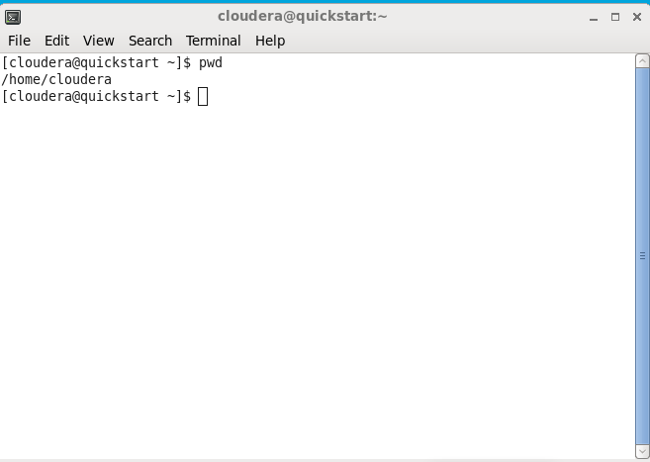
vi - visual text editor Using vi you can insert text anywhere in the file very easily. Most of the vi commands move the cursor around in the file
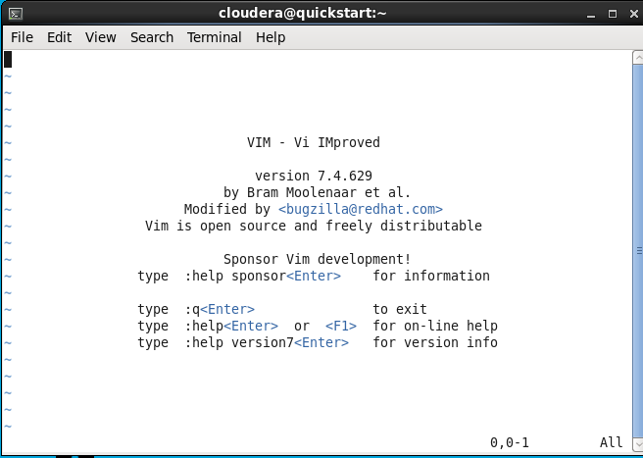

Touch-used to create, modify files and edit timestamps with the files.
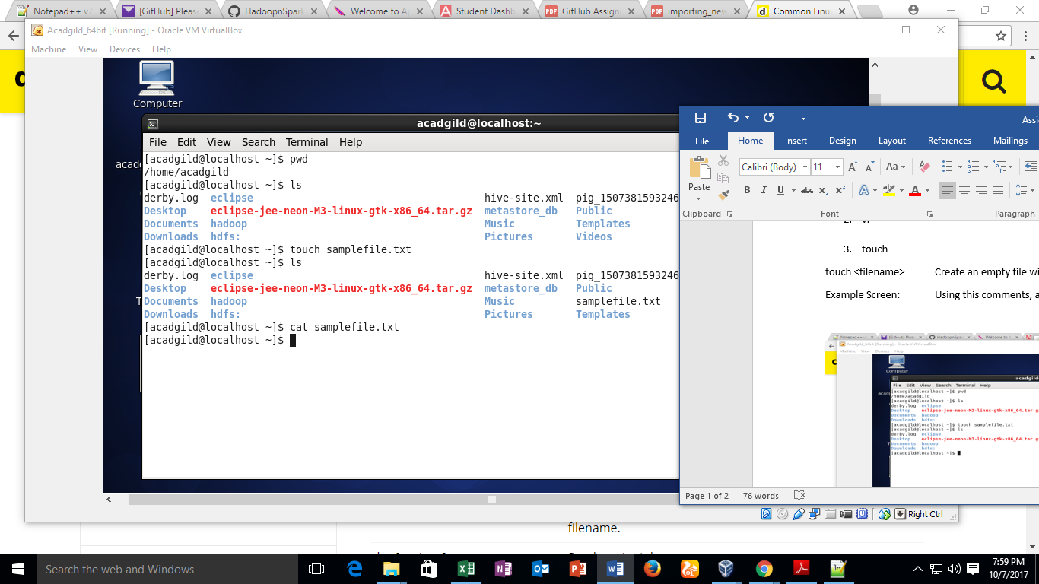
touch testfile.txtThe example touch command effectively created the file testfile.txt. As noted by the extension, the file created is a .txt or text file. To equate, a .txt file in Linux is akin to a .txt notebook file within a Windows or Mac OS.

Mkdir -used to create directory
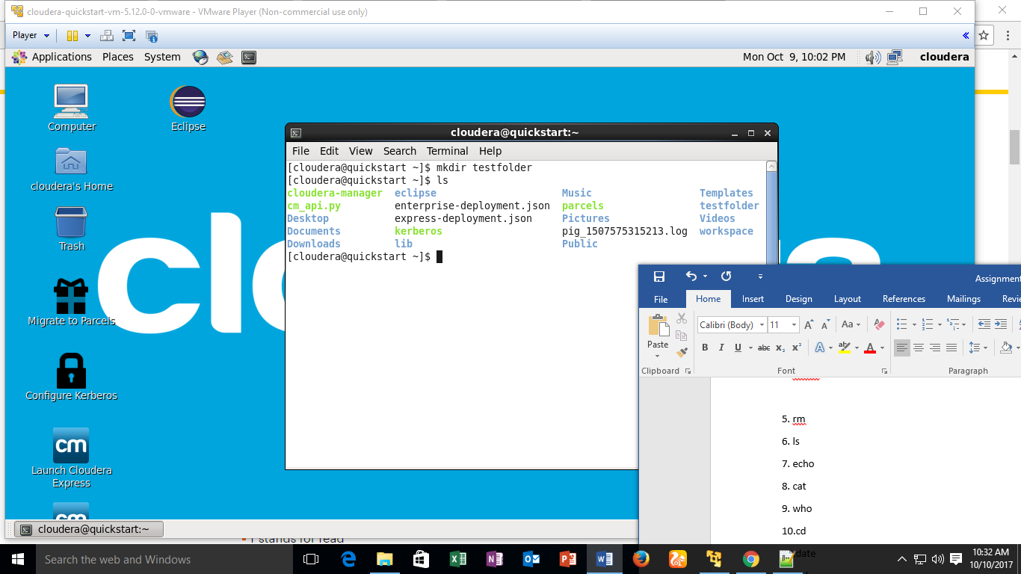
mkdir testdirectory The example command made the directory "testdirector.

rm - remove - like the rmdir command is meant to remove files from your Linux OS. Whereas the rmdir command will remove directories and files held within, the rm command will delete created files. An example of the rm command:

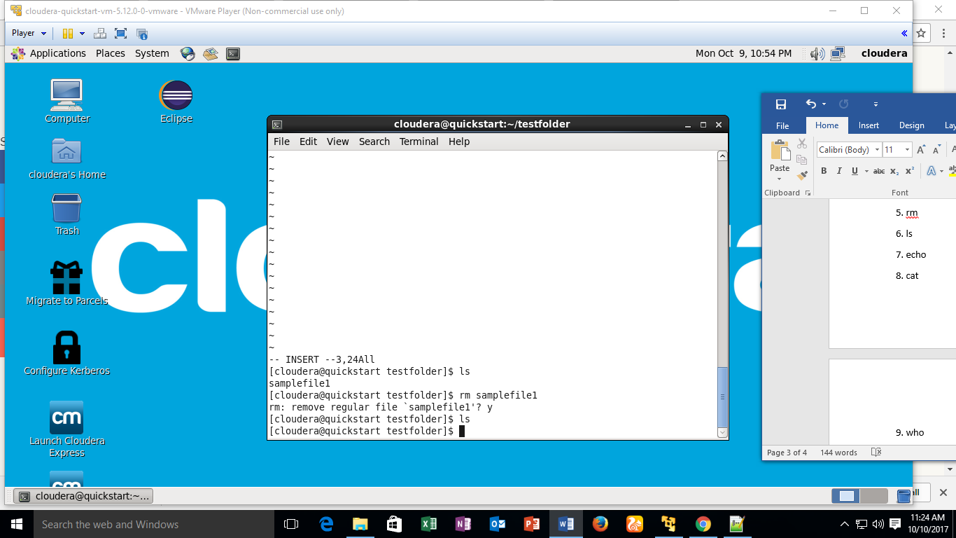
rm testfile.txt The aforementioned command removed testfile.txt. Interestingly, whereas the rmdir command will only delete an empty directory, the rm command will remove both files and directories with files in it. This said, the rm command carries more weight than the rmdir command and should be used with more specificity
ls-list
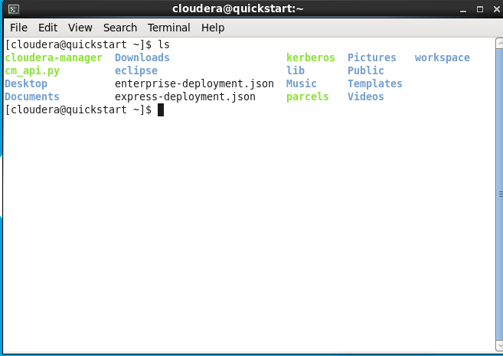
ls /applications will show the user all of the folders stored in the overall applications folder.
The ls command is used for viewing files, folders and directories.

Echo-used to display a text or line to a file or output
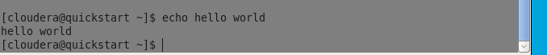
Cat- cat command allows us to create single or multiple files, view contain of file, concatenate files and redirect output in terminal or file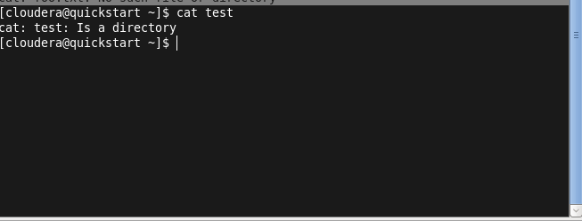
Who-The who command prints information about all users who are currently logged in.
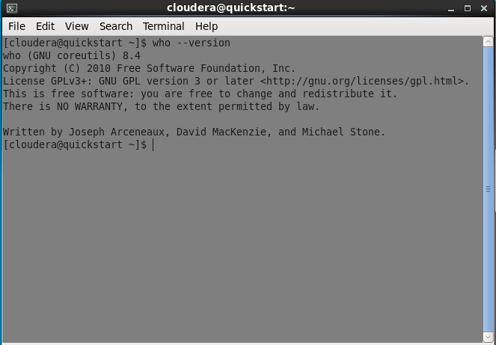

Cd – change directory , cd command is one of the commands you will use the most at the command line in linux. It allows you to change your working directory
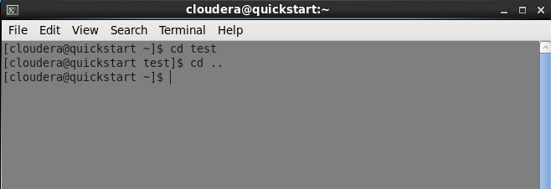
cd/arora/applications As you might have noted, the path name listed lists in reverse order. Logically cd/arora/applications reads change to the arora directory which is stored in the applications directory. All Linux commands follow a logical path.

Date- displays current date and time
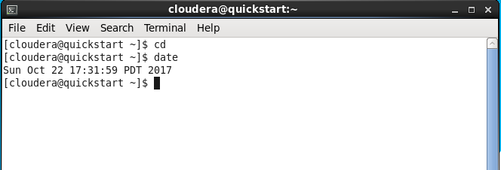
Cal - displays the calendar
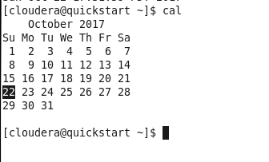
mv-move or rename files
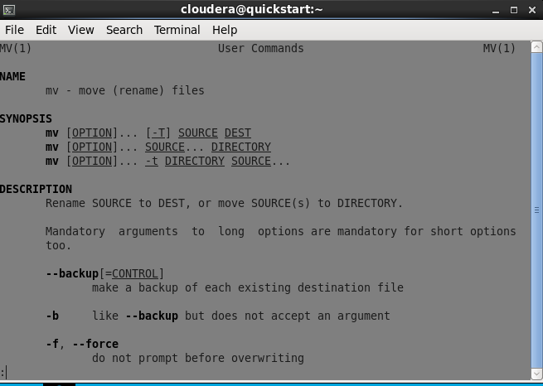
mv/arora/applications/majorapps /arora/applications/minorapps The first part of the command mv/arora/applications/majorapps lists the application to be moved. In this case, arora. The second part of the command /arora/applications/minorapps lists where arora will be moved to - from majorapps to minorapps.
cp- copy files
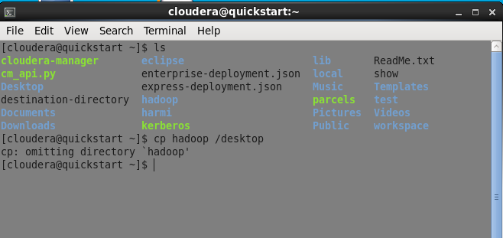
Which - locates the given filename

