**Project: Smart Locker**

**Developer: Suresh K [ PGP FSD MAR 2022 Cohort 1 ]**

**Submission Date: 06-May-2022**

**Product Description:**

Smart Locker is a console-based application for managing the files in a folder. User will be provided with Options to view a list of all files present in the folder, Perform Operations on the folder like creating a new file, deleting an existing file and also search for a specific file. These options are provided as a menu which the user can select by providing the corresponding option number as an input.

**Java Concepts used in the project**

1. Exception handling
   1. In case of incorrect options selected, Program will catch the exception and throw appropriate error messages to the user to take corrective action
   2. Exception is handled, if an invalid file or Folder names are provided
2. Switch case
   1. Used for navigating between various menu options
3. Array List feature used for storing and iterating the files
4. File Operations features used for creating, searching and deleting files
5. Sorting operation for storing all file names in ascending order

**Sprint Planning**

The project development and testing will be divided in to two Sprints. The tasks to be covered in each sprint is detailed below.

|  |  |
| --- | --- |
| **Sprint 1** | 1. Develop main menu UI and navigation 2. Develop File Operations Sub menu and navigate back to main Menu 3. Handle exceptions for incorrect menu options selection |
| **Sprint 2** | 1. Develop Search File operation 2. Develop Add file operation 3. Develop Delete file operation   Testing:   1. Test menu navigation 2. Test all file Operations |

**Application Flow chart**

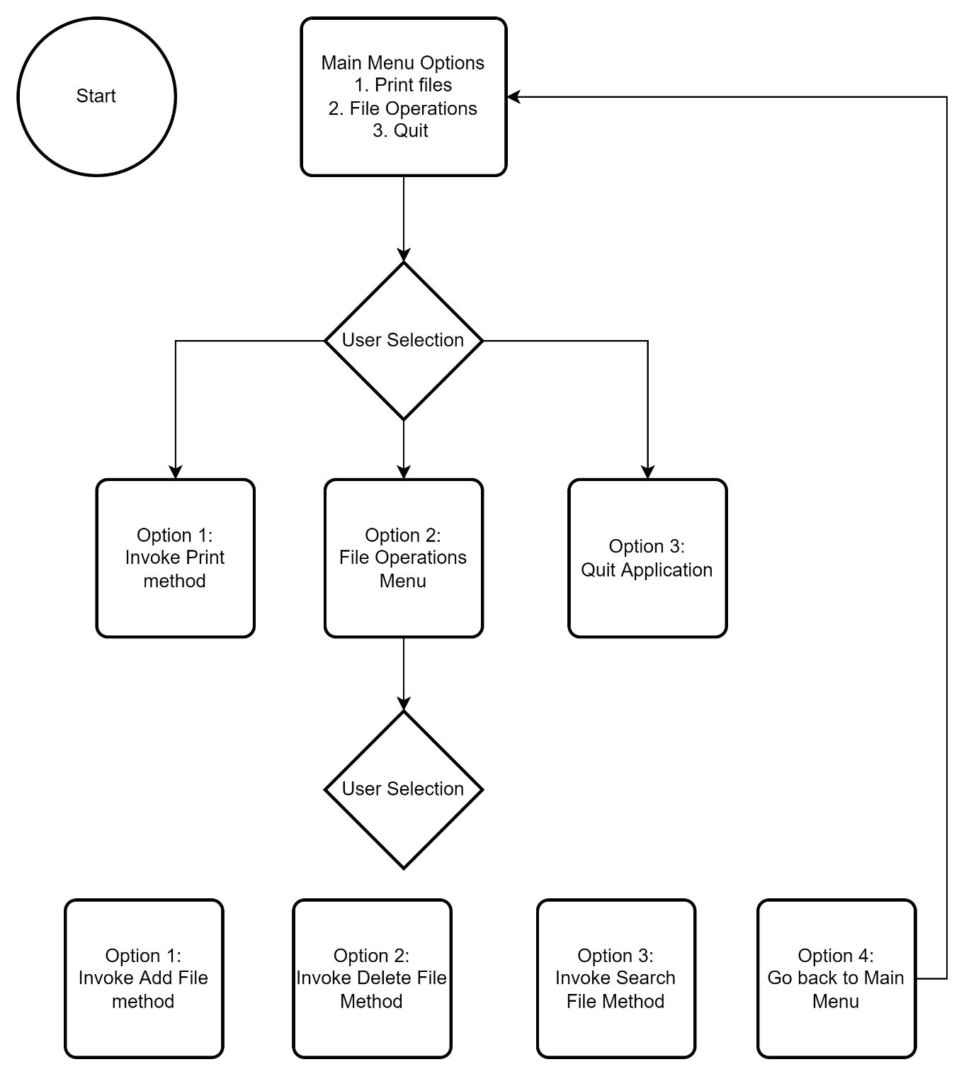

**GIT Link**

**Conclusion**

This project can be enhanced by providing below features.

1. UI driven menu options instead of console based
2. Interactive and suggestive user input screen. Ex: Auto fill file / folder names while typing