**Project: FlyAway (An Airline Booking Portal )**

**Developer: Suresh K [ PGP FSD MAR 2022 Cohort 1 ]**

**Submission Date: 21-Jun-2022**

**Product Description:**

FlyAway Airline booking portal provides a web UI based interactive portal for customers to book a flight based on the source & destination places, number of passengers and flight date.

The portal also provides an admin login where an admin can setup various places which can be chosen as source or destination. New Airlines can also be defined as well along with the flight details.

Customers will get a list of flights available based on the search criteria and one of them can be selected by providing personal information along payment info (only credit card supported)

**Java Concepts used in the project**

1. Servlets for controller
2. JSP for web pages
3. Hibernate for database connection
4. Maven as a build tool
5. MVC architecture

**Sprint Planning**

The project development and testing will be divided in to two Sprints. The tasks to be covered in each sprint is detailed below.

|  |  |
| --- | --- |
| **Sprint 1** | 1. Database modelling and table creation 2. Bean classes creation 3. Admin login and controls |
| **Sprint 2** | 1. Flight search for customers 2. Selection of flight 3. Payment and final confirmation   Testing:   1. Test admin and customer features |

**Application Flow chart**

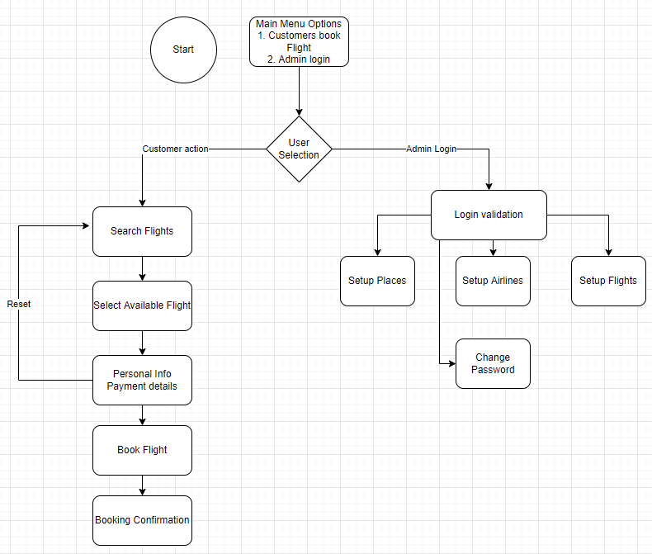

**GIT Link**