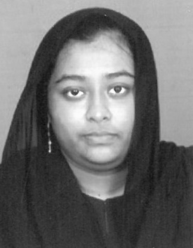
RESUME
RILWANA SAJRIN
No.306A, Kamaliya Street,
Athikadai,
Thiruvarur District -613 702.
Email : rilwanasherkhan123@gmail.com
Cell : 8526754292, 6382731544

CAREER OBJECTIVE

Intend to work with commitment and dedication in any given situation to add value to the success of the organization by applying experience knowledge and personal strength

EDUCATIONAL PROFILE

Name of the Course | University / Board of Education | Year of Passing | Percentage
SSLC | St. Joseph Girls Higher Secondary School, Mannargudi | 2013 | 75%
Diploma in ECE | A.R.J. Polytechnic College, Mannargudi | 2016 | 80%  (Distinction)

ADDITIONAL QUALIFICATION

- Having knowledge in MS-Office

PERSONAL DETAILS

Husband Name : A. Mohammed Sherkhan
Date of birth : 26.12.1997
Gender : Female
Marital Status : Married
Nationality : Indian
Religion : Muslim

Known Languages : Tamil, English

Declaration
I do hereby declare that the above information and particulars are true and correct to the best of my knowledge.

Place: Thanjavur Yours faithfully,
Date :
(RILWANA SAJRIN)

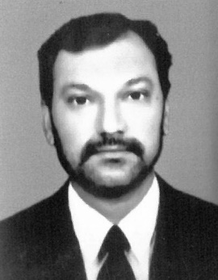
RESUME

A. MOHAMMED SHERKHAN
No.306A, Kamaliya Street,
Athikadai,
Thiruvarur District -613 702.
Email : mohamedsherkhan@gmail.com
Cell : 9788772299

CAREER OBJECTIVE

Intend to work with commitment and dedication in any given situation to add value to the success of the organization by applying experience knowledge and personal strength

EDUCATIONAL PROFILE

Name of the Course | University / Board of Education | Year of Passing | Percentage
SSLC | St. Antony’s Higher Secondary School, Thanjavur | 2002 | 55%
Diploma in Computer Science | Manali Ramakrishna Polytechnic, Thanjavur | 2005 | 65%

ADDITIONAL QUALIFICATION

- Having knowledge in MS-Office
- Completed Certificate course in Information Technology

WORKING EXPERIENCE

- Worked as a Data Entry Operator / Picker in Axiom Telecom (Logistics), UAE from 2011 to 2019.

- Worked as a Dispatch Co-ordinator in Talabat, Kuwait from 2022 to 2023.

- Worked as a Cashier in a Restaurant (Karaikal) from 2024 to Dec. 2025

PERSONAL DETAILS

Father’s Name : Abdul Hackim
Date of birth : 05.09.1985
Gender : Male
Marital Status : Married
Nationality : Indian
Religion : Muslim

Known Languages : Tamil, English, Hindi, Malayalam

Declaration
I do hereby declare that the above information and particulars are true and correct to the best of my knowledge.

Place: Thanjavur Yours faithfully,
Date :
(A. MOHAMMED SHERKHAN)

