BIODATA
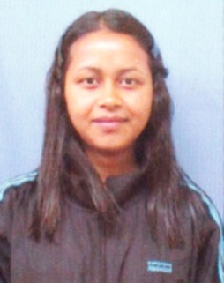
- PERSONAL DETAILS:-
- NAME : manalinda Lyngdoh
- GENDER : FEMALE
- MARITAL STATUS : UNMARRIED
- DATE OF BIRTH : 25th OCTOBER, 2001
- FATHER’S NAME : Lt. PHIRIN KHARJAHRIN
- MOTHER’S NAME : DELIN LYNGDOH
- CASTE/TRIBE : SCHEDULE TRIBE (ST)
- NATIONALITY : INDIAN
- RELIGION : CHRISTIAN
- PERMANENT ADRESS : MAWLANGWIR, MAWKYRWAT (P.O)
SOUTH WEST KHASI HILLS DISTRICT, MEGHALAYA PIN: 793114
- MOBILE NUMBER : 8974240068/9366500310
- EMAIL ID : lyngdohmana@gmail.com

- ACEDEMIC PROFILE:-
EXAM | NAME OF INSTITUTION | BOARD | YEAR | PERCENTAGE
SSLC | PRESBYTERIAN SECONDARY SCHOOL, MAWLANGWIR | MBOSE | 2017 | 81.50%
HSSLC | LADY KEANE COLLEGE, SHILLONG | MBOSE | 2019 | 53.8%
BSc | ST. MARY'S COLLEGE, SHILLONG | NEHU | 2022 | 70.13%

OTHER QUALIFICATION : Diploma in Computer Application (DCA), Computer
Course Beginner Module (MS Windows and MS Office)
ACHIEVEMENT:
- Won district and state level in National Children’s Science Congress (NCSC-2013).
WORK EXPERIENCE:
- Fresher.
LANGUAGE KNOWN : KHASI, ENGLISH

DECLARATION
I hereby declare that the information mention above are correct and complete to the best of my knowledge and belief.

Dated: Mawlangwir
The: __________________
Signature of the Applicant

