Errors
- Docker container not starting even though pipeline success .
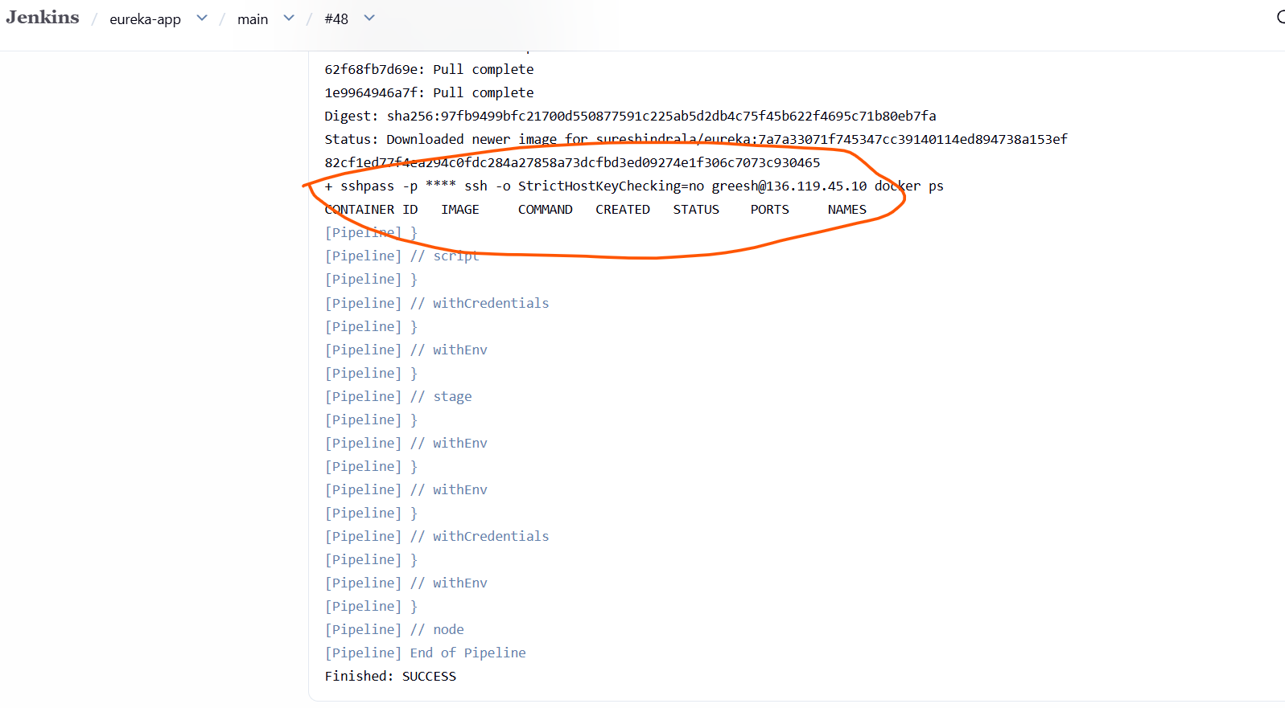
Trouble shooting
- Checked logs – docker logs <container-name>
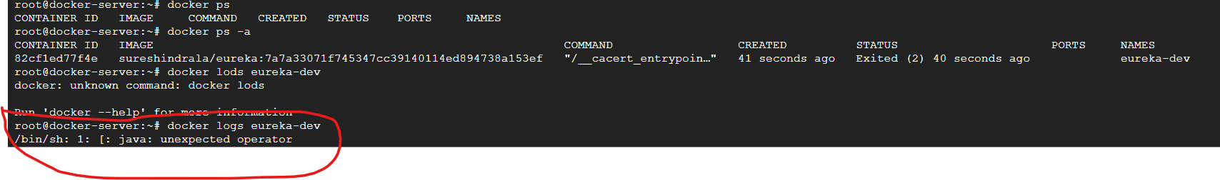
Found that command not running in docker image

- Checked Docker file - Found – error in docker file 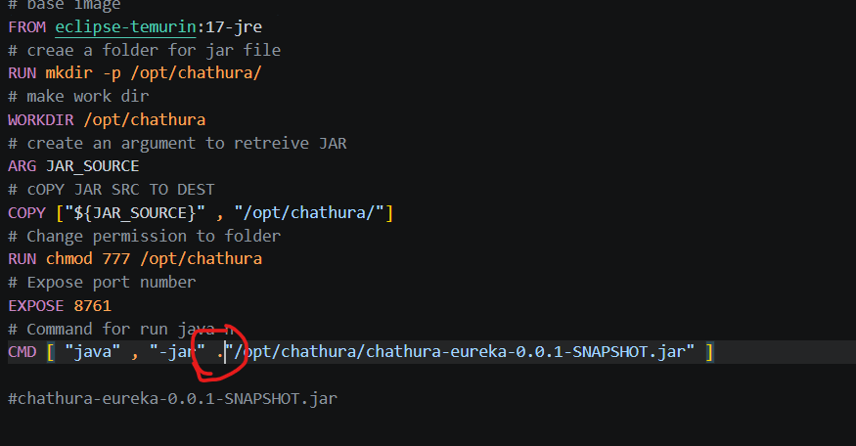
Resolved

