|  |  |  |  |  |
| --- | --- | --- | --- | --- |
| 1 | Display of data on detailed - matched queue | This TC will test the trades data on matched queue | 1.Open trade activity screen for account which has trades on manually matched queue.  2. Check trade data. Verify Result1 | Result 1 - The trades data where no difference in price, quantity but difference in commission in broker and system side will appear there |

PASS

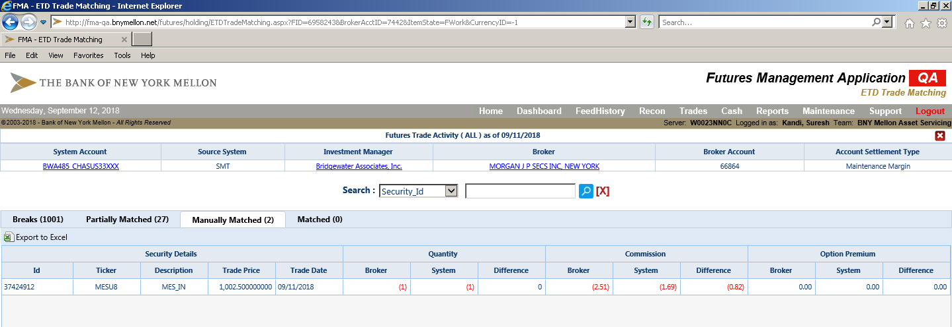

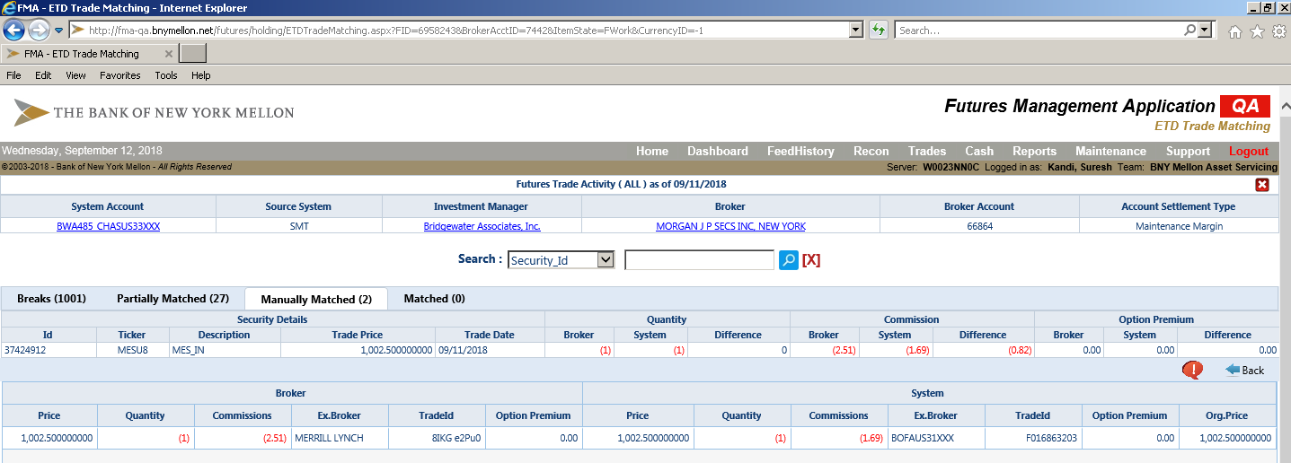

|  |  |  |  |  |
| --- | --- | --- | --- | --- |
| 2 | Info Button | This TC will test the inform button | Go to trade activity screen for account which as trades in manually matched queue 1. Take cursor over info button. Verify Result 1 | Result 1 - The trade variance details will display as tool tip which include - Broker Amount, System Amount, Variance Reason code & Comments |

**PASS**

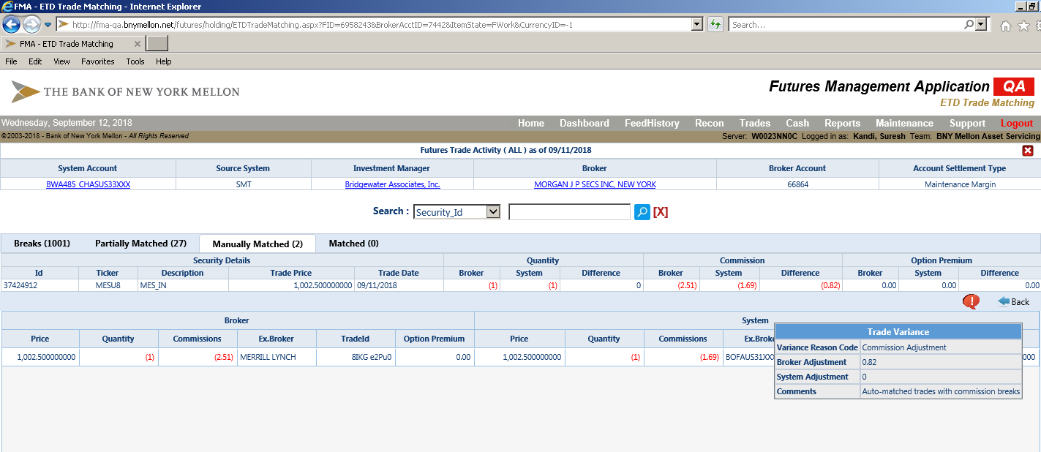

|  |  |  |  |
| --- | --- | --- | --- |
| Security details on Mouse over action | This TC will check for security details on mouse over | 1.Open trade activity screen for account which has trades on manually matched queue 2. Mouse over the security ID and verify Result1 3. take cursor to another place on screen. Verify result2 | Resutl1 - The security details with price and description will appear on screen as tooltip Result 2 - The tooltip will be not displayed on screen |

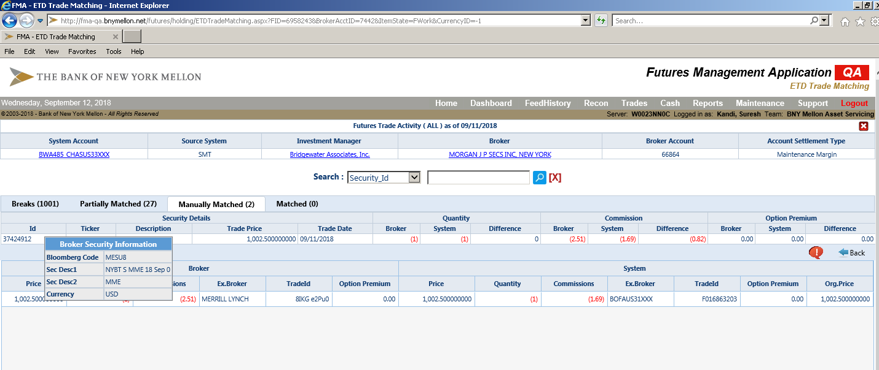

|  |  |  |  |  |
| --- | --- | --- | --- | --- |
| 4 | Delete action - for manually posted trades | This TC will test delete function | 1.Open trade activity screen for account which has trades on partially matched queue by manual posting 2. Click on delete. Verify Result 1 3. Click on cancel. Verify Result 2 4. Click on delete and then Click on OK. Verify Result 3 | Result 1 - A message box will appear, "Are you sure you want to move all trades to earlier stage?" Result 2- Nothing will happen, trades will be as they are in partially matched queue Result 3 - All trades will move to breaks queue. Check the same under breaks queue |

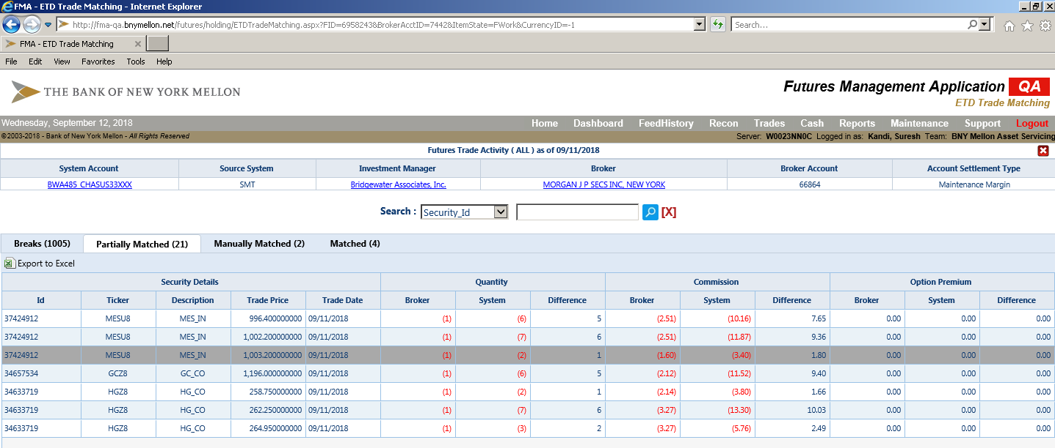

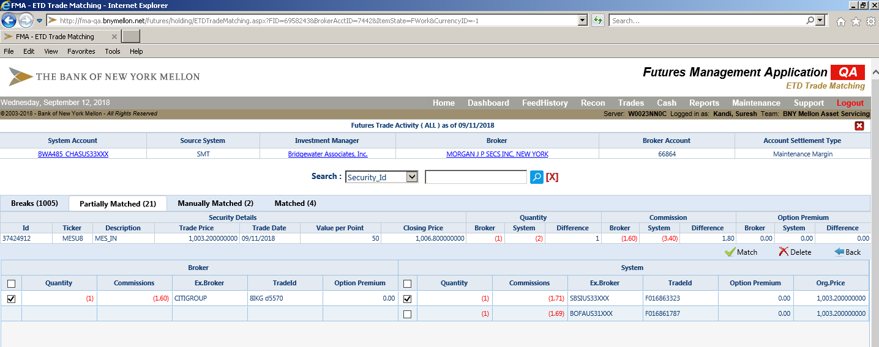

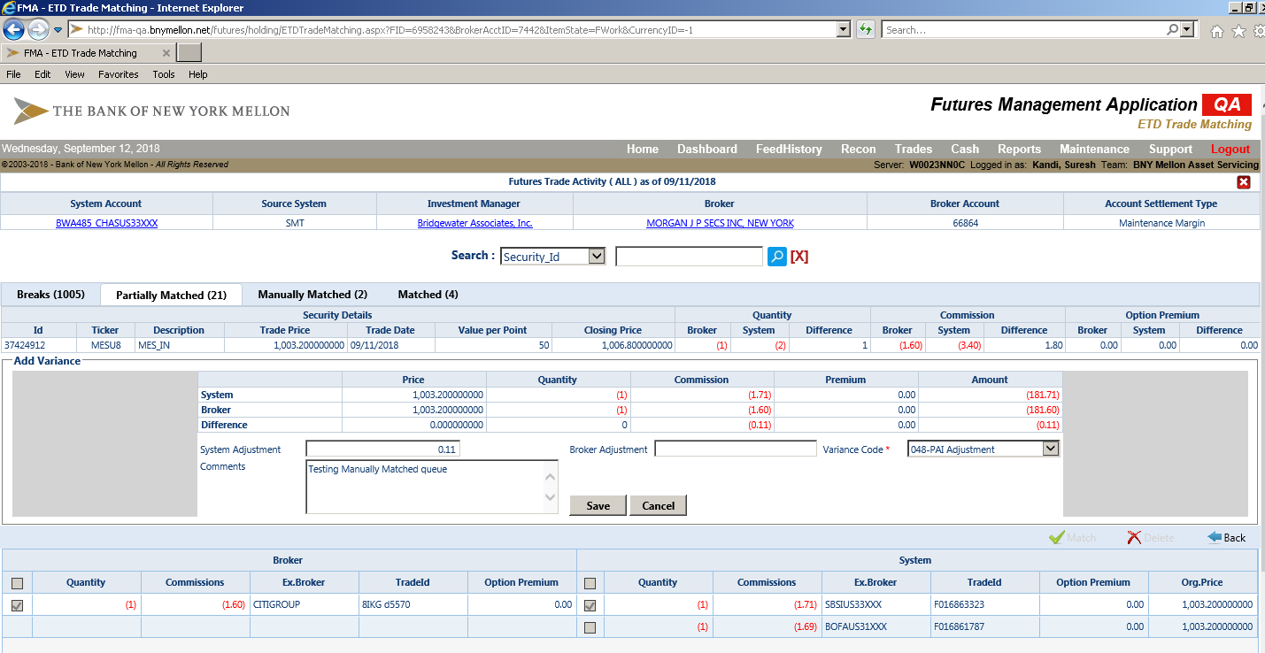

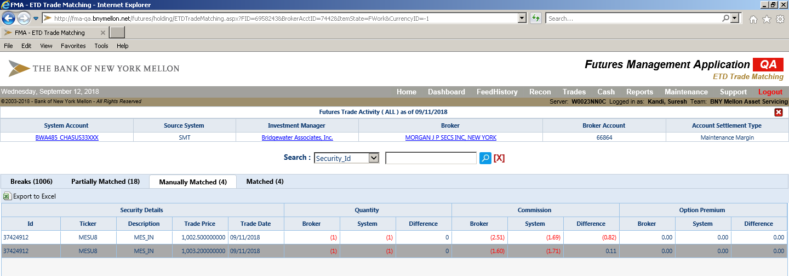

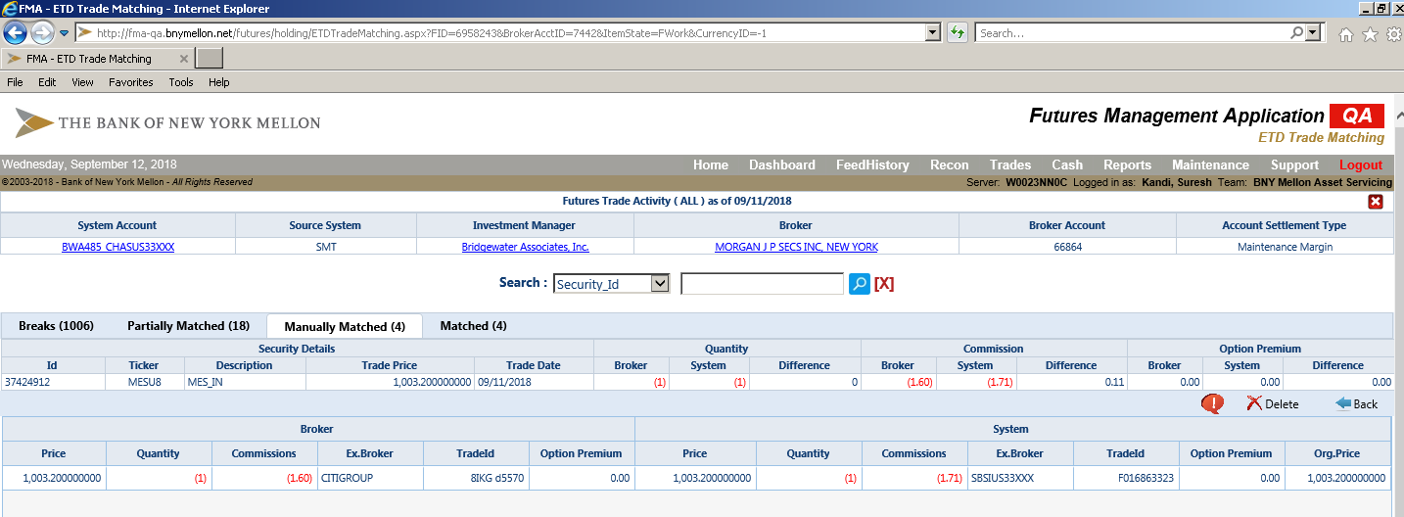

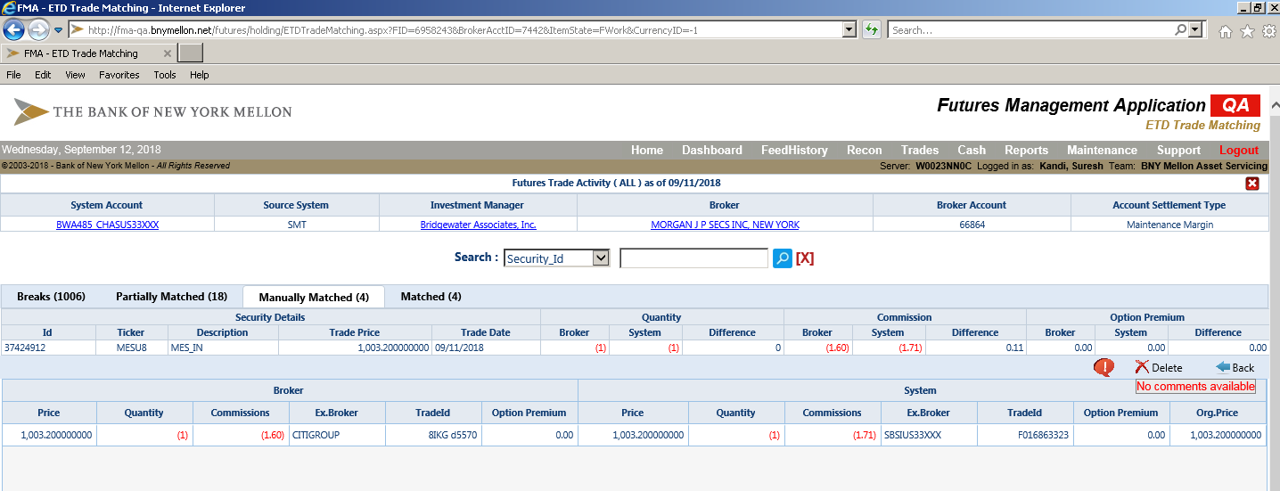

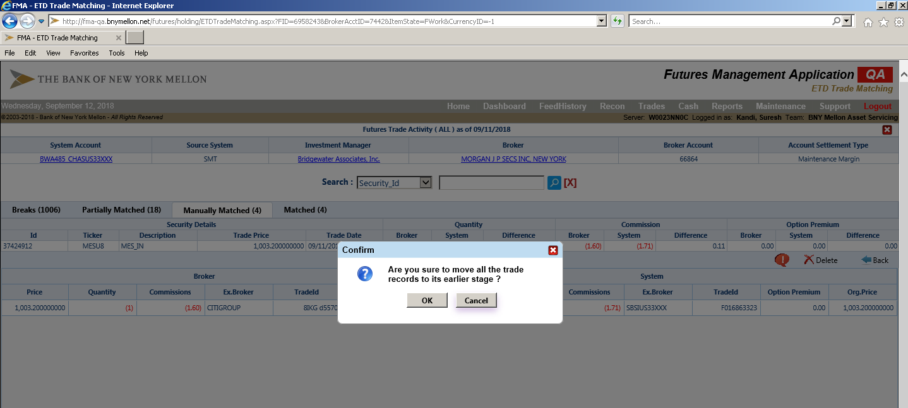

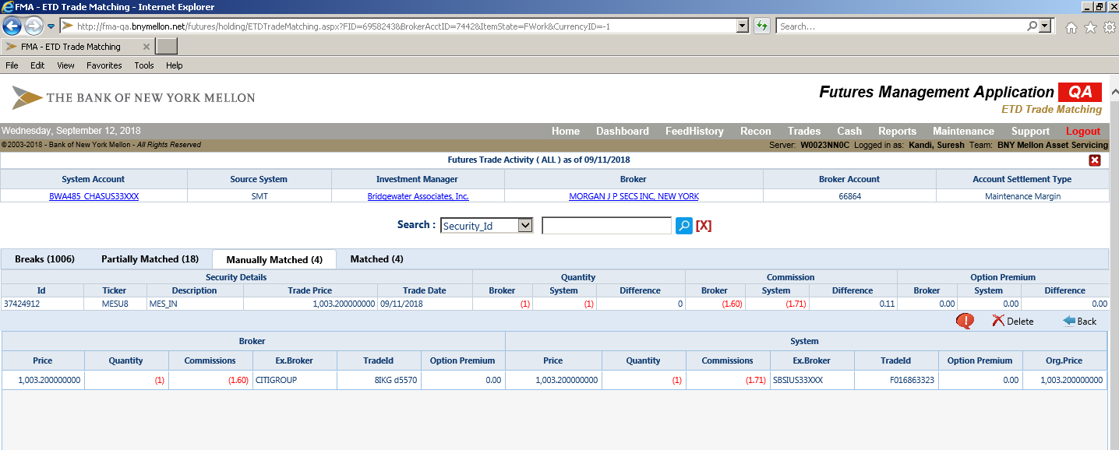

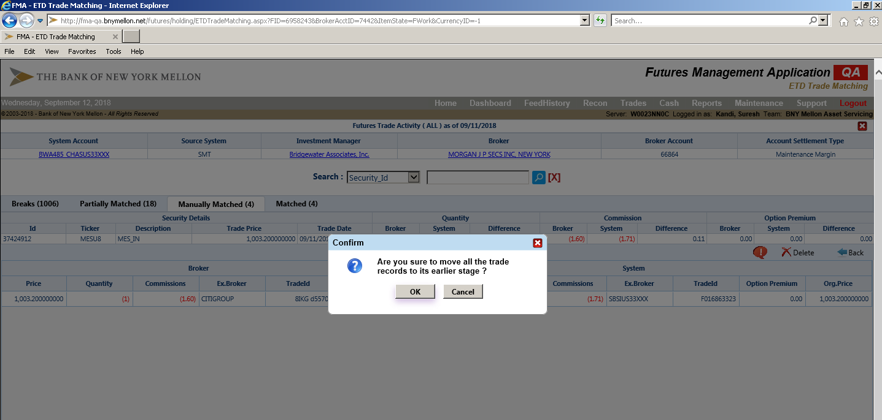

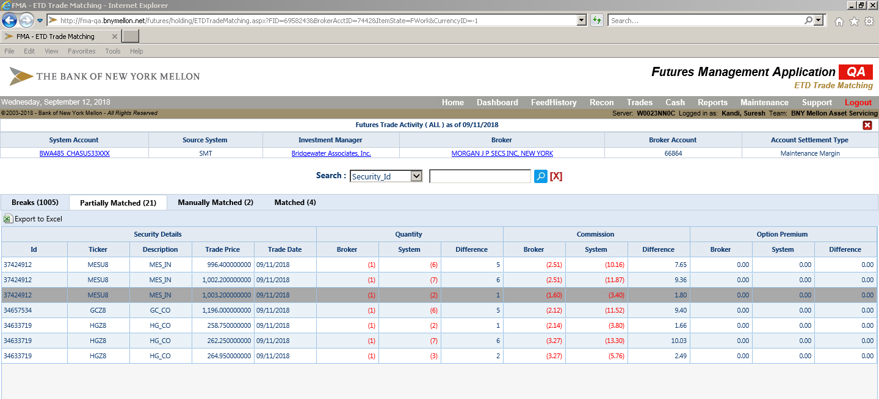

The security 34748240 available on Trade Matching page in MM queue

Result 1 – Click on Delete:- A message box will appear, "Are you sure to move all the trade records to its earlier stage?" **PASS**

Result 2- Click on Cancel :- Nothing will happen, trades will be as they are in partially matched queue **PASS**

Result 3 - Click on delete and then Click on OK. :- All trades will move to breaks queue. Check the same under breaks queue

|  |  |  |  |  |
| --- | --- | --- | --- | --- |
| 5 | Export to Excel | This TC will export trades to excel button | 1.Open trade activity screen for account which has trades on manually matched queue 2. Click on export to excel button. Verify Result1 3. A pop up will appear which will ask to open file. Click on open. Verify Result 2 | Result 1 - All trades will be exported to excel.  Result 2 - Excel will open which will have all the trades details from broker and system sides |

Defect **60** and **61** has been raised