# CSC 225

**Program 1**

Due: Friday, October 21, 2022 at 11:59pm

# Instructions

|  |
| --- |
| 1. **You must work on this assignment individually.** You may ask another person to look over your project for errors, but they cannot instruct you the correct way to write. (For example: the person helping can say “The problem is in the ‘switch’ statement” or “Your logic is incorrect in the second ‘if’ statement.”) In addition, you may not use code from other sources, such as the Web or other students. 2. You will need to upload the .cpp and .h files from your solution to eLearn. |

Your task in this program will be to develop an electronic version of the Sneaky Snacky Squirrel Game. The rules for the game and a video of gameplay can be found in the assignment description on eLearn.

You will need to define a Log class for this program, as described in the slides from October 7.

When the program begins, it should ask the user for the number of players (2 to 4). Then, for each turn, the program should print the current state of the game, as well as indicate whose turn it is. A keypress will have the user spin the wheel, and the program will indicate the result, and, if necessary, ask for more information. After the turn is complete, the program will then either move on to the next player, or indicate that a player has won the game.

You must also create the following functions as specified and use them in your main program. You may create other functions as you see fit.

| **Function Prototype** | **Description** |
| --- | --- |
| long spin() | Simulates a spin of the wheel by returning a number from 0 to 9. |
| void printState(Log[], long) | Clears the screen and then prints the current state of the game when passed the array of Log objects and the number of players. |
| char pickColor() | Asks the user to enter a character representing one of the five colors. It should validate the letter selected, allowing either upper or lower case letters to be entered. It should always return the upper case version. |
| void playTurn(Log[], long, long) | Simulates one turn. It is passed the array of Log objects, current player, and total number of players. |

In addition to the program functioning correctly as described above, you will also be graded on:

* Using appropriate variable names, data types, and constants
  + Limit globals
  + Declare variables at the beginning of your functions
  + Name constants using all capital letters
* Using comments appropriately, including header comments
* Formatting your code appropriately using tabs and blank lines
* Having user-friendly and well-formatted input and output
* Appropriate data validation

Additional information:

* Make sure you understand the above requirements before you begin. Dr. Thompson can provide any clarifications you need
* When printing the current state of the game, it should look as follows (depending on the spin result):

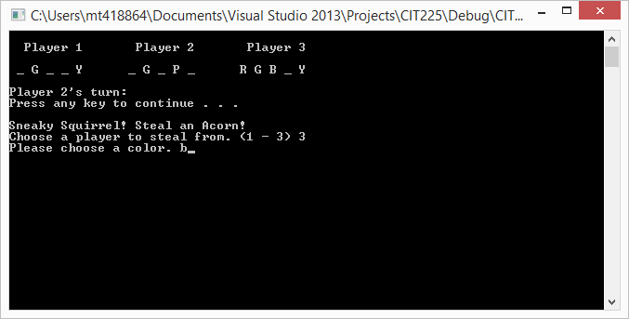

* To clear the screen, use the call system(“cls”)
* To wait for the user to press any key, use the call system(“pause”)
* If a player has the opportunity to choose two colors, but only needs one to win, the game should end immediately after they choose the correct color
* When a player has the opportunity to steal an acorn, the program should make sure they do not choose themselves, but they can choose a player who has no acorns.
  + Any color they choose should be allowed
    - If the player they choose does not have that color, they do not get that color, and lose their turn
    - If they already have that color, the other player should still lose that color

In order to receive *any* credit for this assignment, **all** of the following must be completed:

* Your *Log* class should compile and pass all the tests in *TestLog.cpp* (on eLearn)
* Your main program should compile with no errors and:
  + The *spin*, *printState*, and *pickColor* functions should be implemented correctly