Hi Deb and Suresh,
Please see the following,

Food Database
Problem.
The purpose of the food database is to:
Allow the user to see clearly how many carbs, Protein,fats and calories are eaten in a day and through the weeks/ months/year.
Currently importing the database as discussed with Suresh was not possible. Due to it being overly complicated.
With this in mind, we require the functionality within the admin area to build up a database from scratch. A database of all foods, that we can add to the system.
The system will work as follows.

Within the admin area we need to be able to enter information with this format.
Please follow the table from your mail

Please see the example.
Here they click add food, it does not matter if they pick Breakfast, Snack, Lunch, it all goes to the same database.
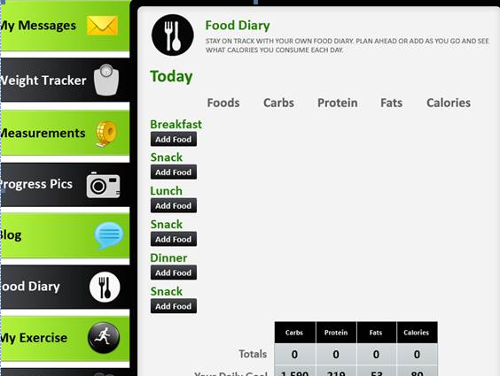
Once they have clicked add food. A search box will appear. This is a rough draft, but will look similar to this:
The system based on the data that has been entered will then display search results.
Once the user selects for example white bread it will deliver the following information
here you can see exactly the information that we have provided.
The user can see the white, bread, from the drop down they can select
Additional Options
100 Grams
Thin 25 g slice
Thick 50 g slice

This information is finally added
I hope that makes sense?

Let me know.

From your mail we understand that you want to develop the food diary in the following way you just check the procedure and let us confirm
When the user click on add Food it will display a text search box where the user enter a food name like Bread Then it will display the result as follows

Food Name | Food Unit | Protein (g) | Fat (g) | Carbohydrate (g) | Energy (kcal) | Action
White bread, sliced | 100 Grams | 7.9 | 1.6 | 46.1 | 219 | Add
White bread, sliced | Thin 25 g slice | 1.97 | 0.4 | 11.52 | 54.75 | Add
 |  |  |  |  |  | Add

From the action part when the user clicks on add then it will add to that user’s food diary. The date should be added internally.
In the preference section the user will add his Daily Crabs, Protein, Fats, Calories goal.
If you thought this procedure is right for you then let us confirm so that we will start work on Food Diary Menu.
If you think this is the right way then provide the base in the above format in an excel sheet so that we will import that excel sheet in our data base. One more thing do not give any color in the excel sheet and also fill all the data in excel sheet.

