Definition of Class
Oct 3rd, 2022
Class are a blueprint or a set of instructions to build a specific type of object. It is a basic concept of Object-Oriented Programming which revolve around the real-life entities. Class in Java determines how an object will behave and what the object will contain.
Class is called logical entity.
A Class is like an object constructor(TBD), or a “blueprint” for creating objects.

Real time example of class
Some of the real world examples of class are Person, Vehicle, House, Tree, Dog etc. For an example a Person class have properties like name, age, height etc. and behaviors like walk, talk, eat, sleep etc. Now if you create an object of this class, it will have these properties and behaviors inside it. Once you created a class, you can create multiple objects of that class.
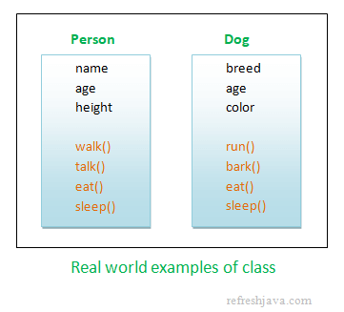
Definition of Object
Object is an instance of a class. An object in OOPS is nothing but a self-contained component which consists of methods and properties to make a particular type of data useful. For example color name, table, bag, barking. When you send a message to an object, you are asking the object to invoke or execute one of its methods as defined in the class.
Reference
https://www.guru99.com/java-oops-class-objects.html
https://www.w3schools.com/java/java_classes.asp
https://refreshjava.com/java/classes-in-java

