Java is Platform Independent

The meaning of platform-independent is that the java compiled code(byte code) can run on all operating systems
For the source code to be understood by the machine, it needs to be in a language understood by machines, typically a machine-level language. So, here comes the role of a compiler

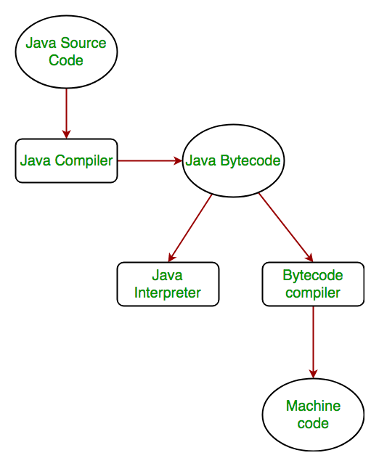

In case of C or C++ (language that are not platform independent), the compiler generates an .exe file which is OS dependent. When we try to run this .exe file on another OS it does not run, since it is OS dependent and hence is not compatible with the other OS.
In Java, the main point here is that the JVM depends on the operating system – so if you are running Mac OS X you will have a different JVM than if you are running Windows or some other operating system.
Important Points:
it is the magic of Bytecode that makes it platform independent.
Every system has its own JVM which gets installed automatically when the jdk software is installed.
JAVA is platform-independent language, the JVM is platform-dependent. Different JVM is designed for different OS and byte code is able to run on different OS.

