Object Memory Creation
Oct 6th, 2022
Object is nothing but class reference.
to create new object
new classname() – new memory will be created for the class
to give the name for the memory
classname class = new classname();
new keyword allocates memory.
Dynamic memory size.
This is the most common and basic way of creating an object in Java. In this method, we can call constructors with parameters or with no arguments. The new keyword allows us to create a new object.
Syntax
1 | class_name object_name = new class_name();

Other type of memory creation
Using Object Serialization and Deserialization(TBD)
Using the clone() method(TBD)
Using the newInstance() method of the Constructor class(TBD)
Objects in Java are allocated from a system heap space, much like malloc‘ed storage in C or C++. Unlike in C or C++, however, we needn’t manage that memory ourselves. Java takes care of memory allocation and deallocation for you. Java explicitly allocates storage for an object when you create it with the new operator. More importantly, objects are removed by garbage collection when they’re no longer referenced.
Method Calling in Java
calc.add()
dot is an operator
before dot which class is going to perform.
After dot is a method what kind of action is going to perform.
() – to give input.
Method is nothing but action.
We can have method definition with out calling the method.
Method calling statement – object reference .method name enclosed by bracket with semi colon.
calc.add();
from the main method we can call another method
Java Method
A method is a block of code which only runs when it is called.
You can pass data, known as parameters, into a method.
Methods are used to perform certain actions, and they are also known as functions.
Why use methods? To reuse code: define the code once, and use it many times
Sample Java method program
class calculator
{
void divide()
{
System.out.println(30%20);
}
void multiply()
{
System.out.println(30*20);
}
void subtract()
{
System.out.println(30-20);
}
void add()
{
System.out.println(10+20);
}
public static void main(String[] args)
{
calculator cal = new calculator();
cal.add();
cal.subtract();
cal.multiply();
cal.divide();
}
}
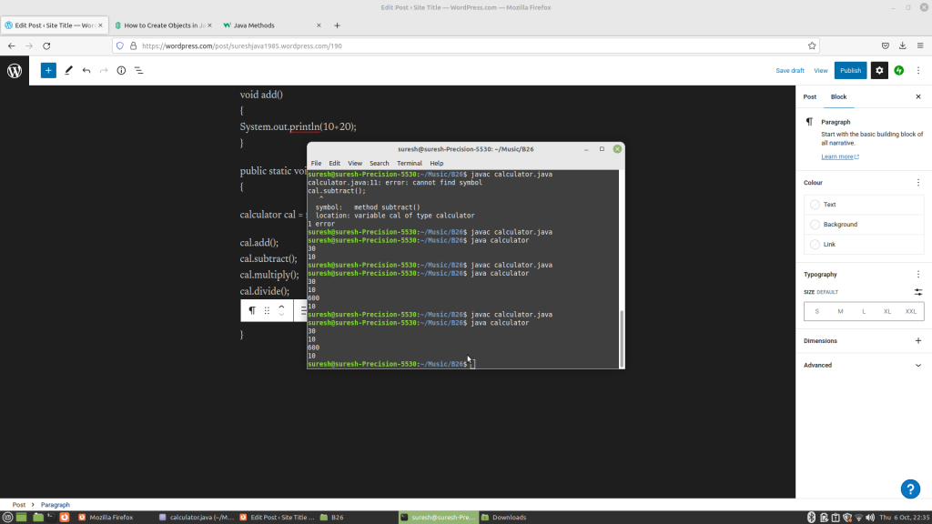
Reference
https://www.section.io/engineering-education/different-ways-to-create-objects-in-java/
https://www.w3schools.com/java/java_methods.asp
https://www.oreilly.com/library/view/learning-java/1565927184/ch05s03.html

