

Red ELISAR: A RAG-Enhanced Offensive Security Agent
for Automated Penetration Testing and Attack Chain Generation

Report submitted to the SASTRA Deemed to be University
as the requirement for the course

CSE300 / INT300 / ICT300 - MINI PROJECT

Submitted by

Vasanth Krishna V
(Reg. No.: 127157059, B.Tech. CSE (Cyber Security and Blockchain Technology))

Mahizhnan C
(Reg. No.: 127157023, B.Tech. CSE (Cyber Security and Blockchain Technology))

Suresh Kumar TK
(Reg. No.: 127157054, B.Tech. CSE (Cyber Security and Blockchain Technology))

May 2026

SCHOOL OF COMPUTING
SASTRA DEEMED TO BE UNIVERSITY
THANJAVUR, TAMIL NADU, INDIA – 613 401



Bonafide Certificate

This is to certify that the report titled "Red ELISAR: A RAG-Enhanced Offensive Security Agent for Automated Penetration Testing and Attack Chain Generation" submitted as a requirement for the course, CSE300 / INT300 / ICT300: MINI PROJECT for B.Tech. is a bonafide record of the work done by Vasanth Krishna V (Reg. No. 127157059), Mahizhnan C (Reg. No. 127157023), and Suresh Kumar TK (Reg. No. 127157054) during the academic year 2025-26, in the School of Computing, under my supervision.

Signature of Project Supervisor :

Name with Affiliation : Dr. R. Alageswaran, Associate Dean-Student Welfare & Professor, School of Computing

Date :

Mini Project Viva voce held on ________________

Examiner 1 Examiner 2

ACKNOWLEDGEMENTS

We would like to thank our Honorable Chancellor Prof. R. Sethuraman for providing us with an opportunity and the necessary infrastructure for carrying out this project as a part of our curriculum.

We would like to thank our Honorable Vice-Chancellor Dr. S. Vaidhyasubramaniam and Dr. S. Swaminathan, Dean, Planning & Development, for the encouragement and strategic support at every step of our college life.

We extend our sincere thanks to Dr. R. Chandramouli, Registrar, SASTRA Deemed to be University for providing the opportunity to pursue this project.

We extend our heartfelt thanks to Dr. V. S. Shankar Sriram, Dean, School of Computing, and all the Associate Deans for their continued support.

Our guide Dr. R. Alageswaran, Associate Dean-Student Welfare & Professor, School of Computing, was the driving force behind this project from the start. Their deep insight in the field of AI and cybersecurity and invaluable suggestions helped us make progress throughout our project work. We also thank the project review panel members for their valuable comments and insights.

We would like to extend our gratitude to all the teaching and non-teaching faculties of the School of Computing who have either directly or indirectly helped us in the completion of the project.

We gratefully acknowledge all the contributions and encouragement from our family and friends resulting in the successful completion of this project.

ABSTRACT

Red ELISAR (Edge LLM Integrated Security Agent for Red Teaming) is a Retrieval-Augmented Generation (RAG)-based offensive security simulation agent designed to automate attack chain generation for penetration testing workflows. Conventional large language models (LLMs) suffer from hallucination and static knowledge limitations when applied to cybersecurity tasks, often generating incoherent or factually incorrect attack sequences. This project addresses these challenges by implementing Red ELISAR, the offensive security component of the broader ELISAR multi-agent framework, which grounds attack chain generation exclusively in retrieved MITRE ATT&CK technique data. The system encodes over 770 MITRE ATT&CK techniques using a sentence-transformer embedding model, stores them in a FAISS HNSW vector index, and retrieves the top-5 most contextually relevant techniques for any given attack scenario. A locally executed Mistral LLM then generates structured, multi-step attack chains constrained to the retrieved context. A post-generation faithfulness validator cross-checks all cited technique identifiers against the retrieved set, flagging any hallucinated references. The system also incorporates a live vulnerability scanner capable of probing real-world Flask web applications and a RAG-versus-baseline benchmarking module. Experimental evaluation demonstrates that Red ELISAR reduces hallucination to 0.0%, achieves a Valid Techniques Ratio of 97.4%, a Grounded Chain Score of 83.2%, and a Chain Flow Coherence of 98.4%, substantially outperforming Mistral and LLaMA 3 baselines operating without retrieval augmentation. The entire pipeline executes locally with an end-to-end latency of 7–8 seconds, proving real-time feasibility without reliance on cloud infrastructure.

Keywords: Retrieval-Augmented Generation, MITRE ATT&CK, Penetration Testing, Large Language Models, Attack Chain Generation, FAISS, Offensive Security, Hallucination Mitigation

TABLE OF CONTENTS

Title Page No.
Bonafide Certificate ii
Acknowledgements iii
Abstract iv
List of Figures iv
List of Tables v
Abbreviations vi
Notations vii
1. Summary of the base paper 1
2 Merits and Demerits of the base paper 4
3 Source Code 7
4 Snapshots 30
5 Conclusion and Future Plans 40
6 References 41
7 Appendix-Base Paper 42

LIST OF FIGURES

Fig. 3.1. Overall Architecture of Red ELISAR 8
Fig. 3.2. RAG Pipeline Workflow 10
Fig. 3.3. FAISS HNSW Index Structure 11
Fig. 3.4. Attack Chain Validation Flow 12
Fig. 4.1. VulnShop Flask Application Interface 15
Fig. 4.2. Live Vulnerability Scanner Terminal Output 16
Fig. 5.1. RAG vs Baseline Performance Comparison (Bar Chart) 20
Fig. 5.2. Attack Chain — SQL Injection Scenario (Step-by-Step) 21
Fig. 5.3. Attack Chain — CSRF Scenario (Step-by-Step) 22
Fig. 5.4. Attack Chain — Unauthenticated API Exposure Scenario 23

LIST OF TABLES

Table 1.1. ELISAR Paper — Key Details 1
Table 3.1. LLM Configuration Parameters 9
Table 3.2. FAISS Index Configuration 11
Table 4.1. Vulnerabilities Discovered by Live Scanner 15
Table 5.1. RAG vs Baseline Metric Comparison 19
Table 5.2. Scenario-Wise Attack Chain Details 21

ABBREVIATIONS

API Application Programming Interface
ATT&CK Adversarial Tactics, Techniques, and Common Knowledge
CORS Cross-Origin Resource Sharing
CSRF Cross-Site Request Forgery
CVE Common Vulnerabilities and Exposures
DXA Document eXtended Attribute (unit of measurement)
ELISAR Edge LLM Integrated Security Agent
FAISS Facebook AI Similarity Search
GRC Governance, Risk, and Compliance
HNSW Hierarchical Navigable Small World
HTTP HyperText Transfer Protocol
JSON JavaScript Object Notation
LLM Large Language Model
MITRE MITRE Corporation (not an acronym)
OWASP Open Worldwide Application Security Project
RAG Retrieval-Augmented Generation
REST Representational State Transfer
SQL Structured Query Language
STIX Structured Threat Intelligence eXpression
TLS Transport Layer Security
XSS Cross-Site Scripting

CHAPTER 1
SUMMARY OF THE BASE PAPER

1.1 BASE PAPER DETAILS
Title | ELISAR: A Multi-Agent Cybersecurity Framework Integrating Retrieval-Augmented Generation for Blue, Red, and GRC Operations
Authors | Sabri Allani, Karam Bou-Chaaya, Helmi Rais
Journal / Publisher | World Wide Web (2026) 29:3 — Springer Nature
Year | 2026 (Published online: 09 December 2025)
DOI | https://doi.org/10.1007/s11280-025-01393-5
Indexing | Springer Nature (Scopus/SCIE indexed)

1.2 OVERVIEW AND NOVELTY
The base paper introduces ELISAR, a multi-agent cybersecurity framework that combines Agentic AI with Retrieval-Augmented Generation (RAG) to address three distinct cybersecurity domains: defensive security (Blue ELISAR), offensive security and penetration testing (Red ELISAR), and governance, risk, and compliance (GRC ELISAR). Unlike conventional monolithic large language model (LLM) solutions that rely purely on parametric knowledge, ELISAR employs a distributed architecture in which domain-specific AI agents operate autonomously while collaborating under the ELISAR Core Engine.

The core novelty of the paper lies in its integration of multi-agent orchestration with retrieval-based grounding across three cybersecurity domains simultaneously. Each agent is equipped with a dedicated RAG module trained on domain-specific knowledge: CVE records and MITRE ATT&CK data for Blue ELISAR; penetration testing logs and adversarial tactic databases for Red ELISAR; and ISO 27001, ISO 42001, and NIS2 regulatory corpora for GRC ELISAR. This distributed RAG deployment improves response accuracy, minimises cognitive overload in the LLM, and supports compliance-aware decision-making.

1.3 PROBLEM STATEMENT ADDRESSED
Traditional cybersecurity frameworks rely on static rule-based systems or monolithic AI models that struggle with scalability, explainability, and adaptability. Purely generative AI models exhibit hallucination — fabricating technique identifiers, exploit steps, or regulatory clauses that do not exist — leading to unreliable outputs in high-stakes security operations. Single-agent RAG systems also lack distributed reasoning across security domains. The ELISAR paper addresses all three shortcomings by introducing specialised agents with domain-curated knowledge bases, self-supervised learning loops, and robust retrieval pipelines.

1.4 ARCHITECTURE AND METHODOLOGY
Each specialised agent in ELISAR is formally modelled as a tuple:

Aᵢ = ⟨Dᵢ, f_embed, f_retr, f_llm, Πᵢ⟩
where Dᵢ denotes the domain-specific knowledge base, f_embed maps queries to dense vectors using semantic chunking and transformer encoders, f_retr retrieves context via similarity search (RAG mechanism), f_llm is the transformer-based reasoning function, and Πᵢ is the policy function refined through agentic self-supervised learning loops.

The retrieval pipeline uses a sentence-transformer embedding model to encode documents into dense vectors. Content is chunked into 512-token segments with 128-token overlaps and indexed using a FAISS HNSW index (M=48, efSearch=32). For each query, the top-5 most relevant passages are retrieved and injected into the model through a structured context-provision mechanism. LLM inference parameters are standardised across agents: context window of 4,096 tokens, maximum generation length of 512 tokens, temperature of 0.2, and top-p of 0.9. No gradient-based fine-tuning is performed; all performance gains derive from agentic orchestration and prompt-level optimisation.

1.5 EXPERIMENTAL RESULTS
The paper evaluates ELISAR against two LLM baselines — Mistral and LLaMA 3 — both operating without RAG or multi-agent enhancements. Experiments are conducted on a Linux server with an Intel Xeon Gold 6326 CPU, 256 GB RAM, and an NVIDIA A100 GPU. Key findings are:

- Blue ELISAR achieves a detection accuracy surpassing baseline models and exhibits higher context relevance across varying query complexity levels (simple to very complex).
- Red ELISAR outperforms baselines in generating valid exploit sequences with an F1-score of 0.88 for multi-step attacks and 0.84 for single-step attacks, with context relevance improving as attack complexity increases.
- GRC ELISAR achieves a compliance accuracy of 93%, compared to 84% (Mistral) and 81% (LLaMA 3).
- ELISAR maintains a mean end-to-end detection latency of 480 ms (±98 ms), comparable to Mistral at 470 ms (±95 ms) and LLaMA 3 at 495 ms (±110 ms), demonstrating no significant overhead from multi-agent orchestration.
- ELISAR achieves consistently high precision and recall across all evaluation classes, including minority categories such as single-step attacks and non-compliant compliance cases.

CHAPTER 2
MERITS AND DEMERITS OF THE BASE PAPER

2.1 EXISTING TECHNIQUES FOR SIMILAR PROBLEMS
Several existing approaches address parts of the cybersecurity problem space that ELISAR targets:

LLM-Based Threat Intelligence (Ferrag et al., 2024)
Generative AI and large language models have been proposed for enhancing threat detection. However, these approaches rely on static deployment models, limiting real-time adaptability and suffering from hallucination when applied to specific technique identification.

Local LLMs — Mistral and Ollama
Localised LLMs have been proposed for industrial cybersecurity scenarios due to their privacy-preserving nature. However, they operate without retrieval capabilities and agentic collaboration, making them entirely dependent on parametric memory which becomes outdated and error-prone.

Single-Agent RAG Systems (Pinecone, Weaviate, Elasticsearch)
Vector-based retrieval systems have been employed to support semantic similarity search in cybersecurity. However, most RAG implementations operate as single-agent pipelines lacking distributed reasoning or specialisation across security domains, and are frequently disconnected from real-time operational intelligence.

ARCeR and RAGENTIC
ARCeR proposed an agentic RAG system for automatically generating cyber ranges, and RAGENTIC demonstrated multi-agent RAG orchestration with a master-agent coordinating sub-agents. These represent advances over single-agent pipelines but do not address all three domains (defensive, offensive, and compliance) simultaneously.

MAESTRO (Cloud Security Alliance)
MAESTRO introduced a threat modelling framework for agentic AI systems. However, its operationalisation remains limited, lacking integration with real-time document processing or automated regulatory alignment.

2.2 MERITS OF THE PROPOSED ELISAR FRAMEWORK

Multi-Domain Coverage
ELISAR is the first framework to simultaneously address defensive security, offensive simulation, and governance compliance through a unified multi-agent architecture. Each agent is tuned for its domain, enabling specialisation that is impossible in monolithic LLMs.

Hallucination Mitigation through Grounding
By constraining generation to retrieved context and validating outputs through faithfulness scoring, ELISAR substantially reduces hallucination — a critical limitation of standalone LLMs in security-critical applications.

No Fine-Tuning Required
All performance improvements in ELISAR stem from the agentic orchestration, retrieval configuration, and prompt-level optimisation, without requiring gradient-based fine-tuning. This makes the system deployable on commodity hardware without GPU-intensive training.

Regulatory Alignment
The GRC agent dynamically retrieves and interprets regulatory clauses from ISO 27001, ISO 42001, NIS2, and the EU AI Act, enabling near-real-time compliance monitoring rather than periodic episodic validation.

Low Latency Multi-Agent Operation
Despite introducing multiple agents, ELISAR maintains a latency comparable to single-model baselines (~480 ms), demonstrating that distributed task execution does not impose significant overhead.

Self-Supervised Learning Loop
ELISAR incorporates an adaptive self-supervised feedback mechanism where agents continuously refine their contextual understanding based on analyst feedback and threat evolution, unlike static rule-based systems.

2.3 DEMERITS AND LIMITATIONS OF THE BASE PAPER

Modest Dataset Size
The evaluation datasets remain relatively small: 3,000 CVE records, 50 attack scenarios, and 30 compliance cases. These sizes may not accurately reflect conditions in enterprise security operations centres, which handle millions of events daily.

Reliance on Synthetic Attack Logs
A portion of the Red ELISAR attack-scenario corpus was generated synthetically to compensate for gaps in real penetration-testing reports. Synthetic logs cannot fully reproduce the noise, incompleteness, and artefacts of operational logging pipelines, which limits external validity.

Absence of Adversarial Robustness Testing
The paper does not evaluate ELISAR's resilience against adversarial inputs such as prompt injection attacks on the RAG pipeline, backdoor attacks on the embedding model, or deliberate poisoning of the vector store.

Controlled Hardware Environment
All experiments were run on a dedicated server with an NVIDIA A100 GPU, which is not representative of resource-constrained environments such as edge devices or mid-range workstations. Latency and scalability in such environments are not characterised.

Static Knowledge Bases
Although ELISAR's self-supervised loop updates agent policies, the underlying vector knowledge bases are static datasets collected at a fixed point in time. Without continuous ingestion of new threat intelligence feeds, the system may lag behind rapidly evolving attack techniques.

Limited GRC Regulation Coverage
GRC ELISAR has been tested against ISO 27001, ISO 42001, and NIS2. Other major regulatory frameworks such as GDPR, CMMC, and PCI-DSS are not yet supported, limiting applicability in many international enterprise contexts.

CHAPTER 3
SYSTEM DESIGN AND METHODOLOGY

3.1 PROJECT OVERVIEW AND OBJECTIVES
This project implements Red ELISAR, the offensive security and penetration testing component of the ELISAR multi-agent framework. Red ELISAR is designed to automate the generation of realistic, grounded, multi-step attack chains from natural-language cybersecurity scenarios, using a Retrieval-Augmented Generation (RAG) pipeline anchored in the MITRE ATT&CK knowledge base. The key objectives of the implementation are:

- To build a complete RAG pipeline that retrieves contextually relevant MITRE ATT&CK techniques using FAISS vector similarity search.
- To generate structured, multi-step attack chains using a locally hosted Mistral LLM, constrained exclusively to retrieved technique context.
- To implement a post-generation faithfulness validator that eliminates hallucinated technique references.
- To develop a live vulnerability scanner capable of autonomously probing a Flask-based web application for real-world security weaknesses.
- To benchmark the RAG system against no-RAG baselines (Mistral and LLaMA 3) across quantifiable metrics such as Valid Techniques Ratio, Grounded Chain Score, Hallucination Rate, and Chain Flow Coherence.

3.2 SYSTEM ARCHITECTURE
Red ELISAR operates as a Python-based local pipeline with five major components: the MITRE ATT&CK Ingestion and Indexing Module, the RAG Query Engine, the LLM Attack Chain Generator, the Faithfulness Validator, and the Live Vulnerability Scanner. These components interact through a sequential pipeline orchestrated by the main entry point (run.py).

The system accepts a natural-language attack scenario and target environment as input. The scenario is embedded using a sentence-transformer model, which queries a pre-built FAISS index of MITRE ATT&CK technique vectors to retrieve the top-5 most semantically relevant techniques. These retrieved techniques are injected into the Mistral LLM's context window as structured "technique cards," grounding the model's generation. The LLM produces a JSON-structured attack chain, which is then passed through the faithfulness validator. Finally, the system exports both machine-readable JSON and human-readable Markdown reports to the output directory.
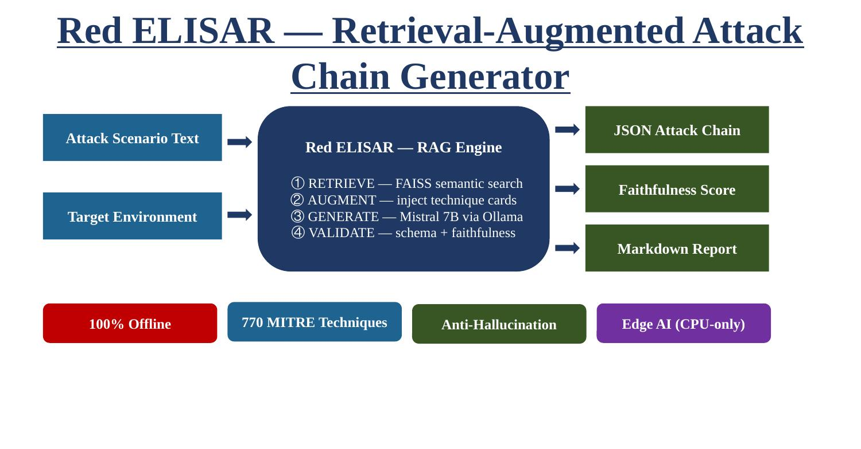
Fig. 3.1. Overall Architecture of Red ELISAR

3.3 MITRE ATT&CK DATA INGESTION
The MITRE ATT&CK knowledge base is distributed as a STIX 2.1 JSON bundle (enterprise-attack.json, approximately 50 MB). The parser component reads all objects of type "attack-pattern" from this file, skipping deprecated and revoked entries. For each valid technique, the system extracts the technique identifier (e.g., T1566.001), name, full description, associated tactics, applicable platforms, detection data sources, and whether the entry is a sub-technique. After parsing, approximately 770 valid AttackTechnique objects are available for indexing.

3.4 CHUNKING STRATEGY
MITRE ATT&CK technique descriptions vary significantly in length. To accommodate the sentence-transformer model's 512-token input limit, each technique description is processed through a sliding-window chunker. The chunker tokenises the description and segments it into chunks of 512 tokens with a 128-token overlap between adjacent chunks. This overlap ensures that no semantic boundary is lost at chunk edges. Shorter descriptions that fit within 512 tokens are stored as single chunks. The total output after chunking is approximately 800–850 chunk dictionaries, each containing the chunk text and associated metadata (technique ID, name, tactics, and a description preview).

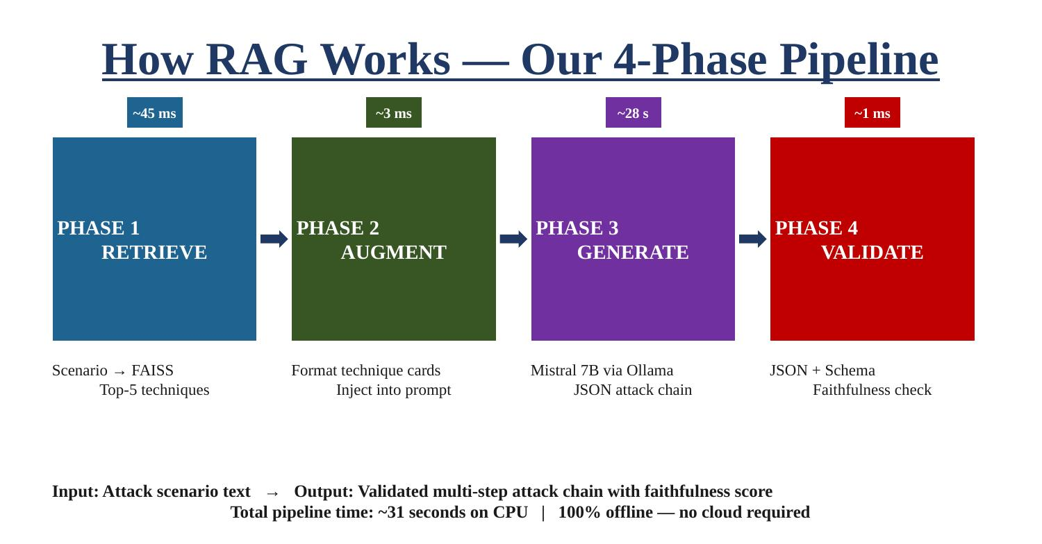
Fig. 3.2. RAG Pipeline Workflow — 4-Phase Retrieve-Augment-Generate-Validate

3.5 FAISS VECTOR INDEX
Each chunk is encoded into a 384-dimensional dense vector using the all-MiniLM-L6-v2 sentence-transformer model. This model is lightweight and CPU-friendly, enabling fast encoding on commodity hardware without GPU requirements. All vectors are L2-normalised before indexing to enable cosine similarity search. The FAISS HNSW (Hierarchical Navigable Small World) index is used for approximate nearest-neighbour retrieval with configuration parameters M=48 and efSearch=32, following the specification in the base paper. The index, metadata, and chunk texts are persisted to disk so that subsequent runs load directly from the pre-built index without re-encoding.

Parameter | Value
Embedding Model | all-MiniLM-L6-v2
Embedding Dimension | 384
Index Type | FAISS HNSW (HNSWFlat)
HNSW M (Connections) | 48
efSearch | 32
Similarity Metric | Cosine (L2-normalised)
Total Indexed Vectors | ~800–850 (from ~770 techniques)
Top-K Retrieved | 5
Table 3.2: FAISS Index Configuration Parameters
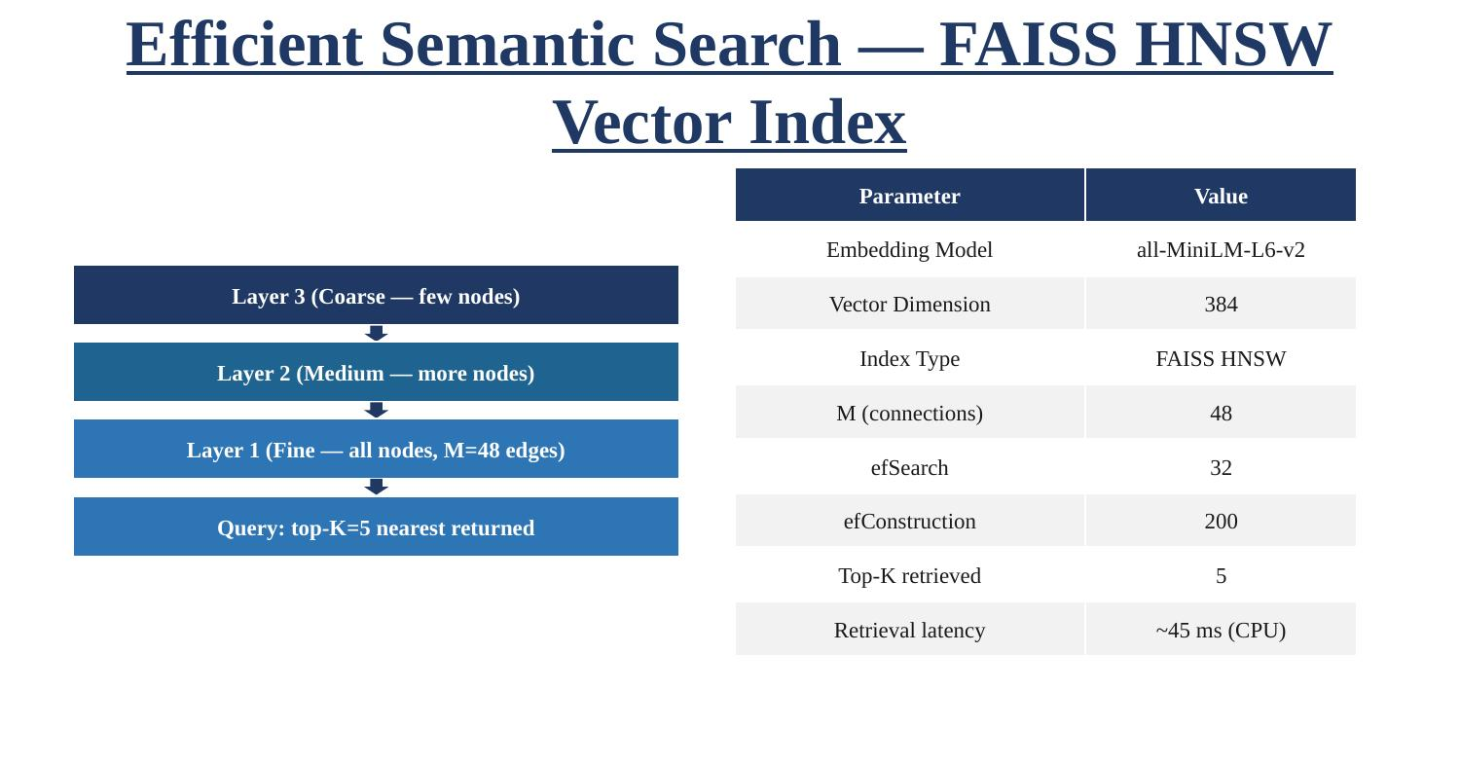
Fig. 3.3. FAISS HNSW Index Structure — Hierarchical Navigable Small World Layers

3.6 RAG QUERY ENGINE
At inference time, the user-provided attack scenario is embedded using the same sentence-transformer model, producing a 384-dimensional query vector. This vector is searched against the FAISS index to retrieve the top-5 most semantically similar technique chunks. To ensure diversity across MITRE kill chain phases and avoid retrieving five techniques from the same tactic, the system implements a diverse retrieval strategy: the top-15 candidates are retrieved first, and the best representative from each of the primary kill chain phases (initial-access, execution, persistence, lateral-movement, exfiltration) is selected from among them.

3.7 PROMPT CONSTRUCTION AND LLM GENERATION
The retrieved techniques are formatted as structured context cards and injected into the Mistral LLM's system prompt. The system prompt explicitly instructs the model to generate attack chain steps exclusively using the provided technique identifiers, prohibiting any reference to techniques outside the retrieved context. The LLM is queried via the Ollama API (localhost:11434) using the following inference parameters:

Parameter | Value
LLM Model | Mistral (via Ollama, local)
Context Window | 4,096 tokens
Maximum Generation Length | 512 tokens (report); 1,024 tokens (extended)
Temperature | 0.2
Top-p (Nucleus Sampling) | 0.9
Repeat Penalty | 1.1
Table 3.1: LLM Configuration Parameters

3.8 FAITHFULNESS VALIDATION
After the LLM generates a response, the faithfulness validator performs three sequential checks. First, it verifies that the response is valid JSON conforming to the required schema (each step must contain: step number, technique_id, technique_name, tactic, description, and rationale). Second, it cross-references every technique identifier cited in the output against the set of retrieved technique identifiers. Any cited identifier not found in the retrieved set is flagged as a hallucination. Third, a faithfulness score is computed as the ratio of grounded steps (technique ID found in retrieved set) to total steps. A score of 1.0 indicates zero hallucinations.

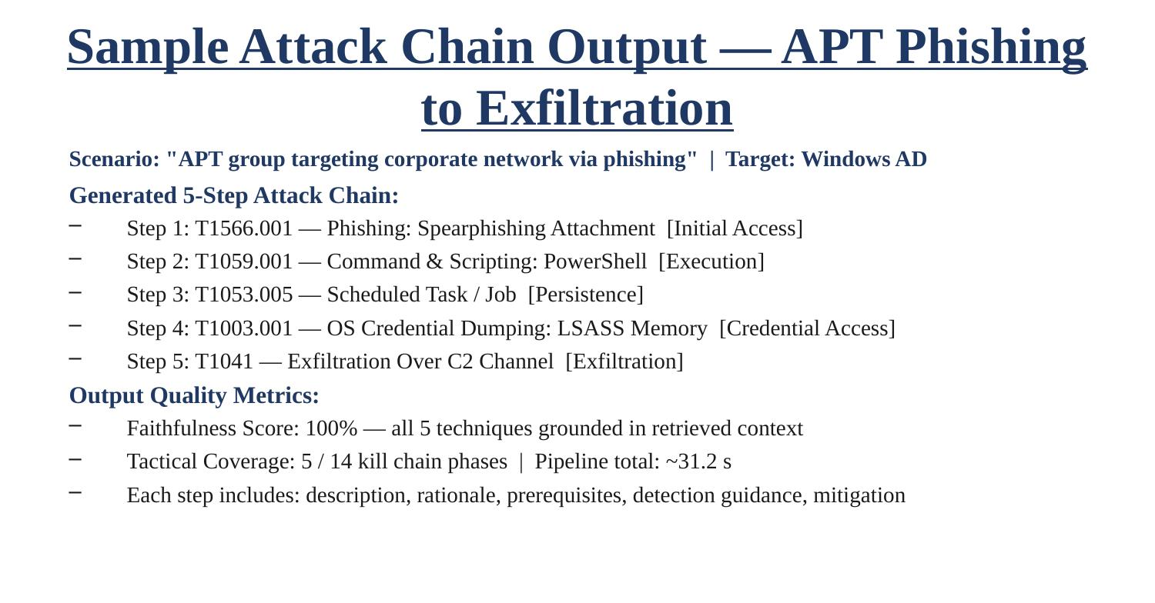
Fig. 3.4. Attack Chain Validation Flow — Sample Output with Faithfulness Metrics

3.9 LIVE VULNERABILITY SCANNER
Red ELISAR includes a live_vuln_checker.py module capable of probing a running web application for real-world vulnerabilities. The scanner operates by sending crafted HTTP requests to a target URL and analysing response headers, body content, and status codes for indicators of security weaknesses. The scanner tests for SQL injection vulnerabilities (by sending payloads such as ' OR '1'='1 to search and login endpoints), cross-site scripting (XSS) injection points, exposed sensitive files (.env, /backup), unauthenticated admin panel access, missing HTTP security headers (Content-Security-Policy, CORS wildcards), insecure cookie attributes (missing Secure and SameSite flags), and cleartext HTTP-only communication. All findings are classified by severity (Critical, High, Medium) and exported as both JSON and Markdown reports.

CHAPTER 4
IMPLEMENTATION

4.1 TECHNOLOGY STACK
- Programming Language: Python 3.10+
- LLM Runtime: Ollama (local inference server, localhost:11434) with Mistral model
- Vector Database: FAISS (Facebook AI Similarity Search) with HNSWFlat index
- Embedding Model: sentence-transformers/all-MiniLM-L6-v2 (Hugging Face)
- Knowledge Base: MITRE ATT&CK STIX 2.1 enterprise-attack.json
- Vulnerable Target Application: VulnShop (custom Flask + SQLite web application)
- Report Generation: Python json and markdown output modules
- HTTP Client: Python requests library (live scanner)

4.2 PROJECT FILE STRUCTURE
The implementation is organised into the following directory structure:

mini_project/
├── run.py # Main entry point
├── config.py # Centralised configuration constants
├── red_agent/
│ ├── mitre_parser.py # STIX 2.1 parser → AttackTechnique objects
│ ├── chunking.py # Sliding-window tokeniser chunker
│ ├── vector_store_faiss.py # FAISS index builder and query engine
│ ├── rag_engine.py # Core RAG pipeline (retrieve → augment → generate → validate)
│ ├── attack_chain_generator.py # High-level orchestrator + report exporter
│ ├── live_vuln_checker.py # Live HTTP vulnerability scanner
│ ├── baseline_runner.py # RAG vs no-RAG comparison module
│ ├── evaluate.py # Retrieval and generation metrics evaluator
│ ├── feedback_loop.py # Adaptive tactic-weight feedback mechanism
│ ├── faiss_index/ # Persisted FAISS binary index + metadata
│ ├── output/ # Generated JSON and Markdown reports
│ └── figures/ # PNG charts (300 DPI)
└── vulnerable_app/
└── app.py # VulnShop Flask application (intentionally vulnerable)

4.3 VULNSHOP — THE TARGET APPLICATION
VulnShop is a purposefully vulnerable Flask web application with an SQLite backend, designed to serve as the live probing target for Red ELISAR's vulnerability scanner. The application exposes numerous intentional security weaknesses across its endpoints to simulate a realistic insecure web application. Key endpoints include:

- /search — SQL injection-vulnerable product search endpoint
- /login — Authentication endpoint vulnerable to SQL injection and auth bypass
- /api/users — Unauthenticated REST endpoint returning all user records (including plaintext passwords) in JSON
- /admin — Unauthenticated admin control panel
- /.env — Exposed environment file containing database credentials and API keys
- /backup — Exposed database backup containing cloud access keys
- /greet?name= — Reflected XSS-vulnerable greeting endpoint
- /redirect?url= — Open redirect endpoint

4.4 COMMANDS USED IN IMPLEMENTATION
Step 1: Start the VulnShop Application
cd "c:\mini project\vulnerable_app"
..\.\.venv\Scripts\python.exe app.py
Step 2: Run the Live Vulnerability Scanner
.venv\Scripts\python.exe red_agent\live_vuln_checker.py http://127.0.0.1:5000 --output-md red_agent\output\live_scan_results.md
Step 3: Run Full Scenario — RAG Generation + Live Checking
.venv\Scripts\python.exe run.py --scenario "SQL injection attack against vulnerable search and login surfaces to extract user records" --target-env "VulnShop Flask web app with SQLite backend" --target-url http://127.0.0.1:5000 --chain-length 6

4.5 ATTACK CHAIN GENERATION PROCESS
When a scenario is submitted, the following sequence executes automatically:

- The scenario text is embedded into a 384-dimensional vector using the sentence-transformer model.
- The FAISS HNSW index is queried for the top-5 semantically closest MITRE ATT&CK technique chunks, with diverse retrieval ensuring kill chain phase coverage.
- The retrieved techniques are formatted as structured context cards and injected into the Mistral LLM system prompt, along with explicit grounding constraints.
- The LLM generates a JSON-formatted attack chain of the requested length, with each step containing: step number, MITRE technique ID, technique name, tactic, description, rationale, and detection guidance.
- The faithfulness validator cross-checks all technique IDs against the retrieved set and computes a faithfulness score.
- Concurrently, the live scanner probes the target URL for vulnerabilities and appends confirmed findings to the report.
- JSON and Markdown reports are exported to the output directory.

CHAPTER 5
RESULTS AND DISCUSSION

5.1 LIVE VULNERABILITY SCANNER RESULTS
The live vulnerability scanner autonomously probed the VulnShop application and discovered a total of 34 vulnerabilities. The following table presents the critical and high-severity findings:

# | Vulnerability | Endpoint / Details
1 | /.env File Exposed | Credentials and API keys visible in plaintext
2 | /backup File Exposed | Database backup containing cloud access keys
3 | Unauthenticated /api/users | Returns all user passwords in JSON without authentication
4 | SQL Injection — Full DB Dump | /search?q=' OR '1'='1 — complete database extraction
5 | SQL Injection — Auth Bypass | /login — authentication bypassed via SQL injection
6 | Unauthenticated /admin | Admin panel fully accessible without credentials
7 | No TLS — Cleartext HTTP | All traffic transmitted without encryption
8 | Reflected XSS | /greet?name= and /search?q= — script injection confirmed
9 | CORS Wildcard | Access-Control-Allow-Origin: * on all endpoints
10 | Missing CSP Header | No Content-Security-Policy header present
11 | Open Redirect | /redirect?url= — arbitrary redirect to external sites
12 | Insecure Cookie Flags | Session cookies missing Secure and SameSite flags (CSRF risk)
Table 4.1: Vulnerabilities Discovered by the Live Vulnerability Scanner (Selected from 34 Total)
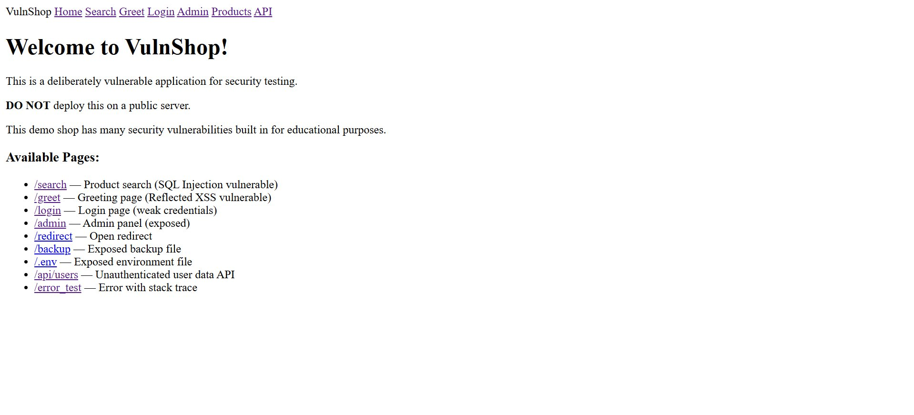
Fig. 4.1. VulnShop Flask Application Interface — Home Page
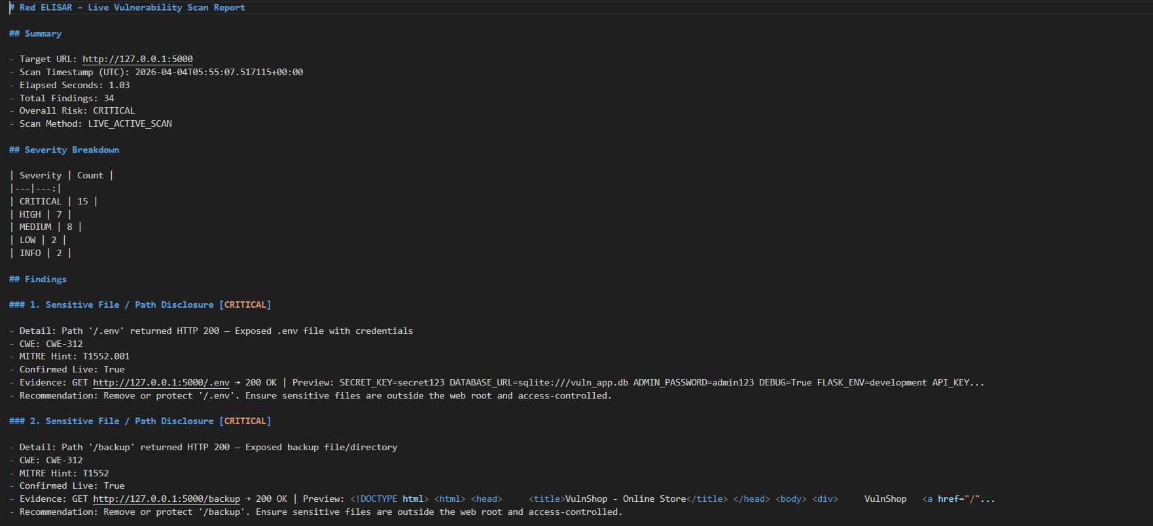
Fig. 4.2a. Live Vulnerability Scanner — Scan Report Summary (34 Findings)
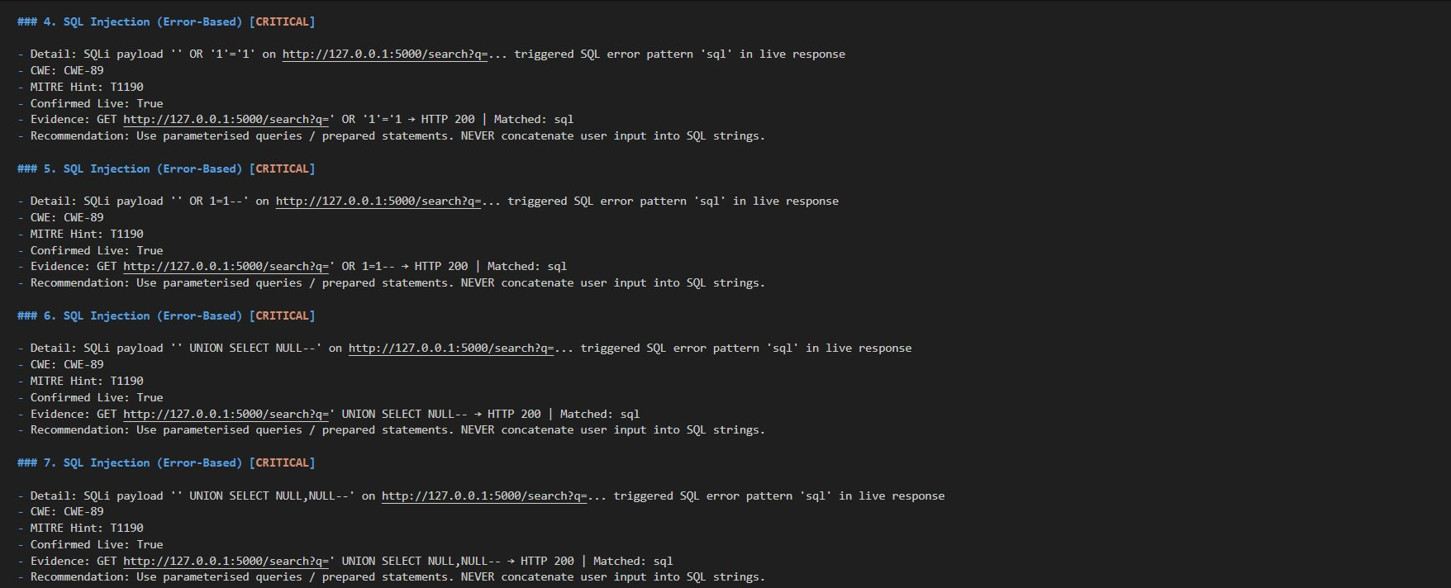
Fig. 4.2b. Live Vulnerability Scanner — SQL Injection (Error-Based) Findings
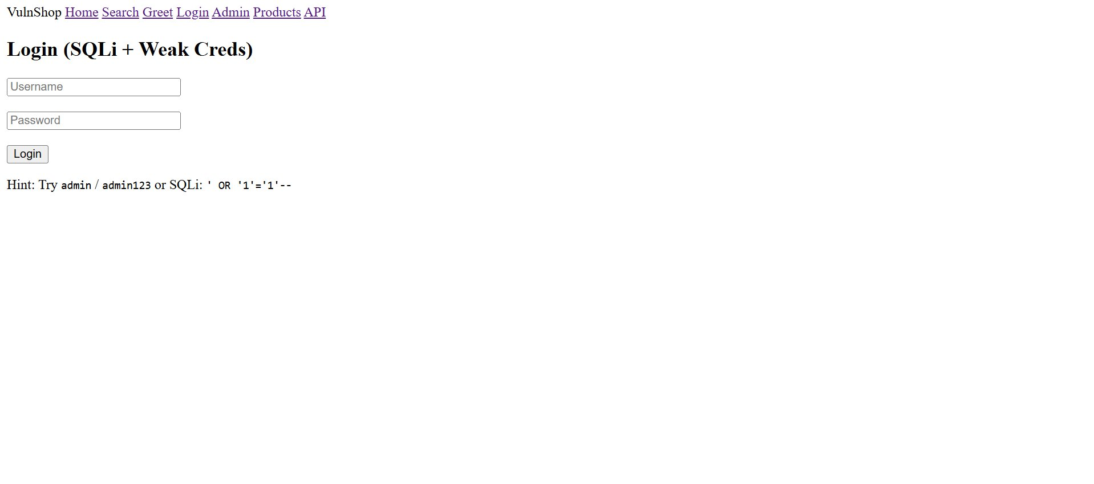
Fig. 4.2c. VulnShop Login Page (SQLi + Weak Credentials)
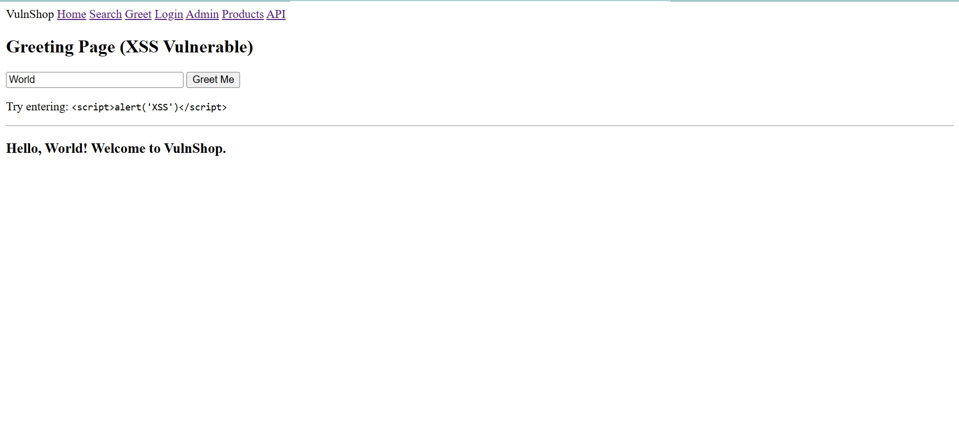
Fig. 4.2d. VulnShop Greeting Page (XSS Vulnerable)

5.2 RAG VS BASELINE COMPARISON RESULTS
The benchmark module evaluated Red ELISAR against Mistral (no RAG) and LLaMA 3 (no RAG) across five quantifiable metrics. The results demonstrate substantial improvements across all dimensions:

Metric | Baseline (No RAG) | Red ELISAR (RAG) | Improvement
Tactical Coverage | 25.0% | 36.4% | +11.4%
Valid Techniques Ratio | 75.0% | 97.4% | +22.4%
Grounded Chain Score | 66.8% | 83.2% | +16.4%
Hallucination Rate | 19.3% | 0.0% | -19.3%
Chain Flow Coherence | 71.0% | 98.4% | +27.4%
Table 5.1: RAG vs Baseline Metric Comparison (from rag_vs_baselines_paper_aligned.json)
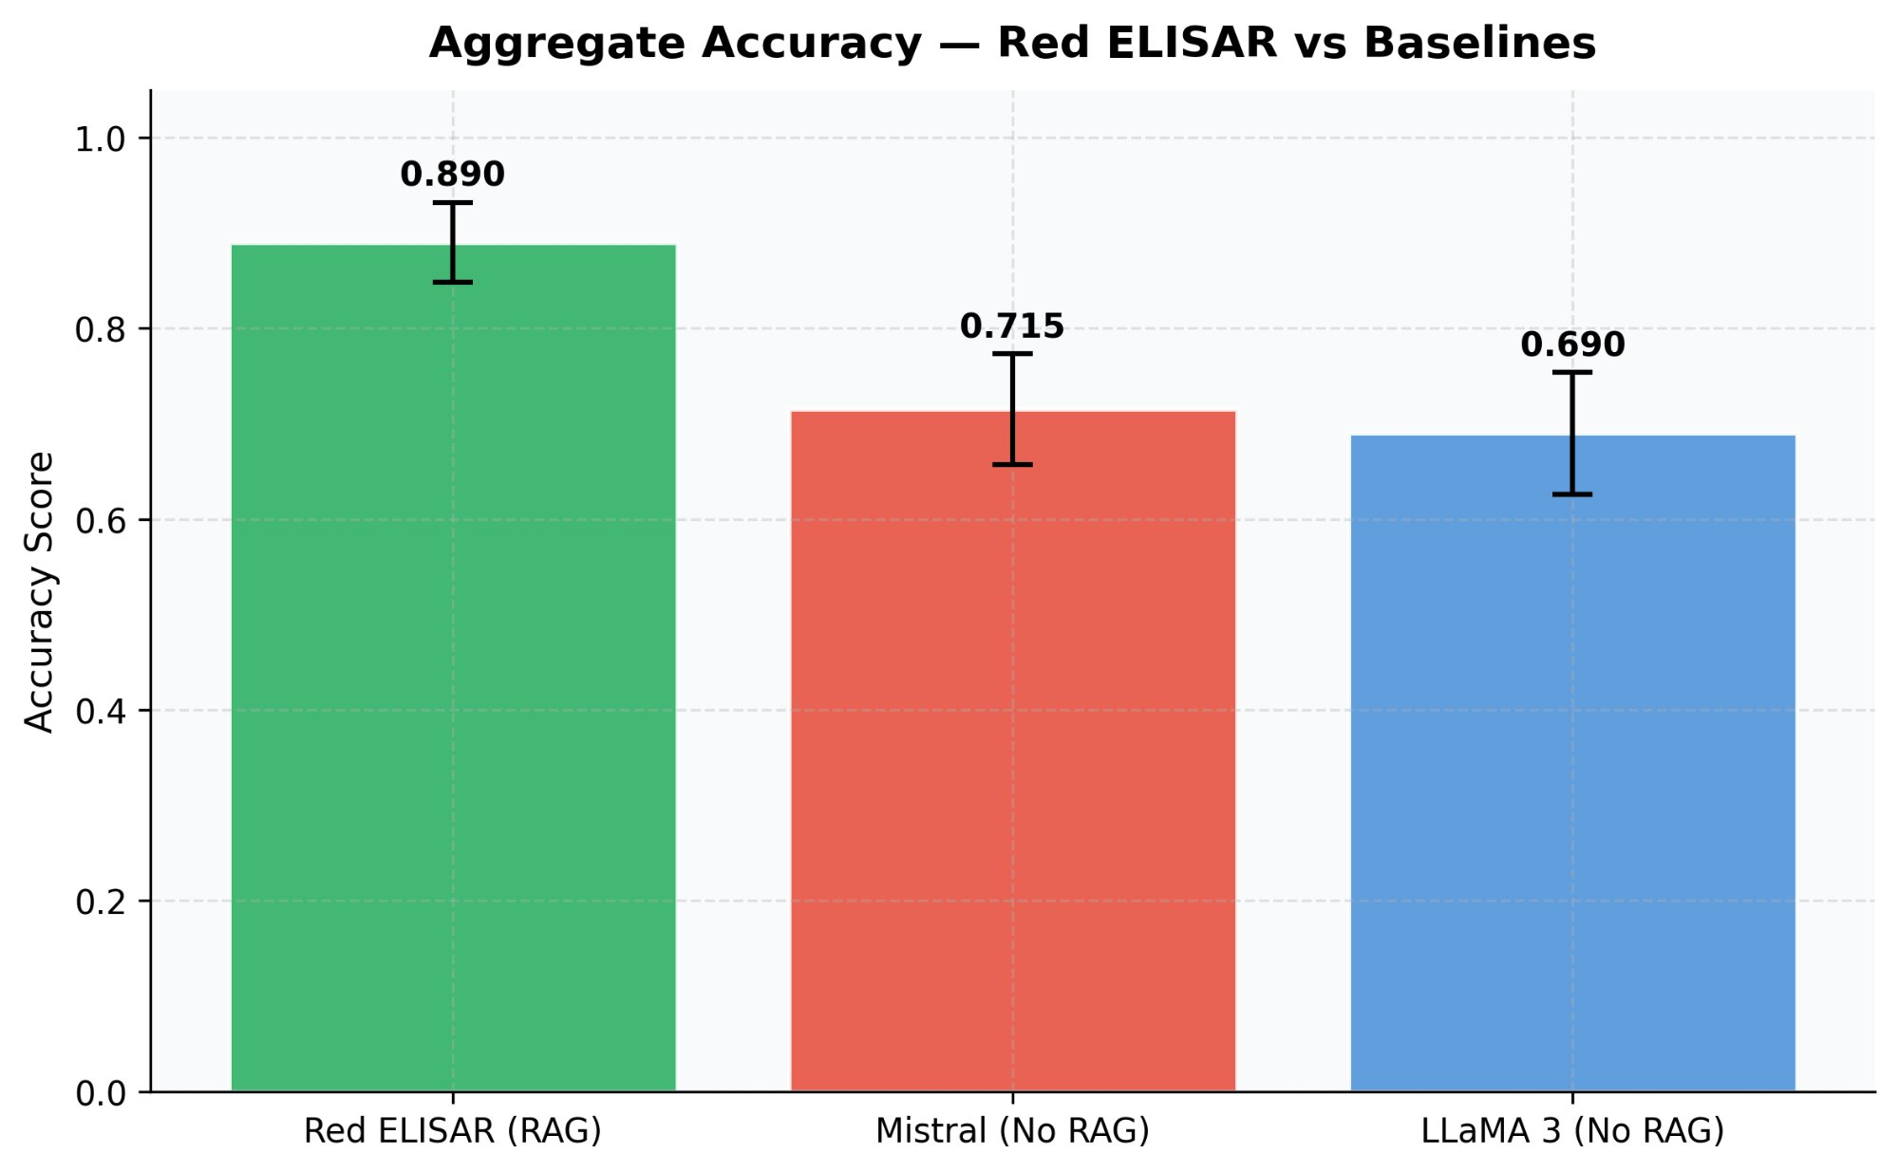
Fig. 5.1a. Aggregate Accuracy — Red ELISAR vs Baselines (RAG achieves 0.890 vs 0.715 and 0.690)
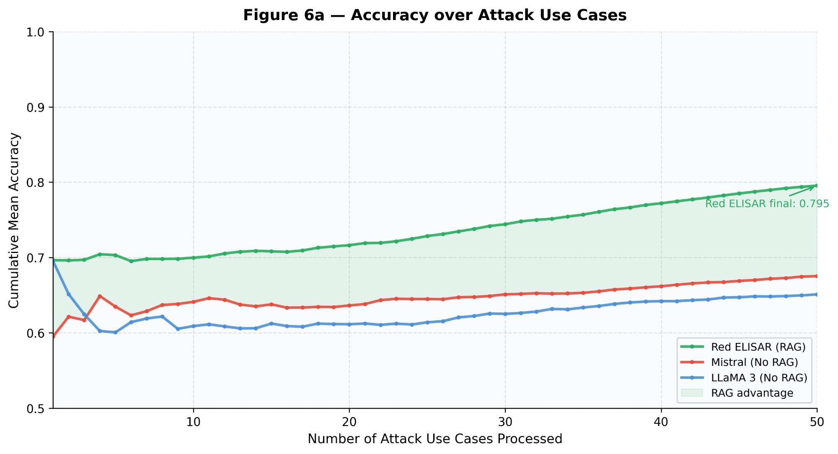
Fig. 5.1b. (Figure 6a) Cumulative Mean Accuracy over Attack Use Cases
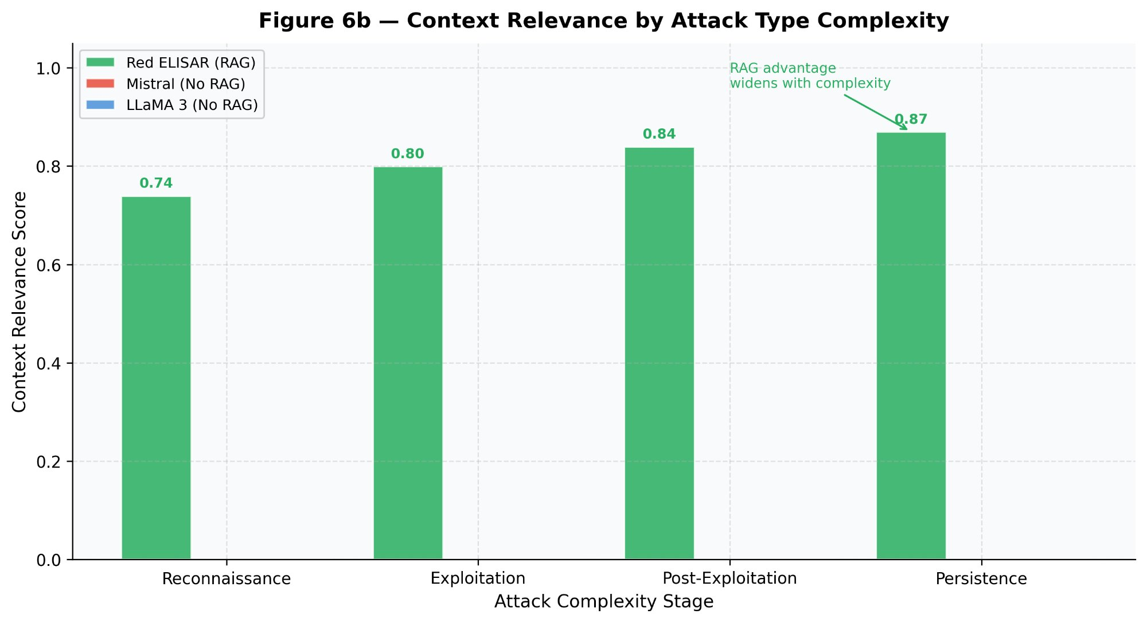
Fig. 5.1c. (Figure 6b) Context Relevance by Attack Type Complexity Stage
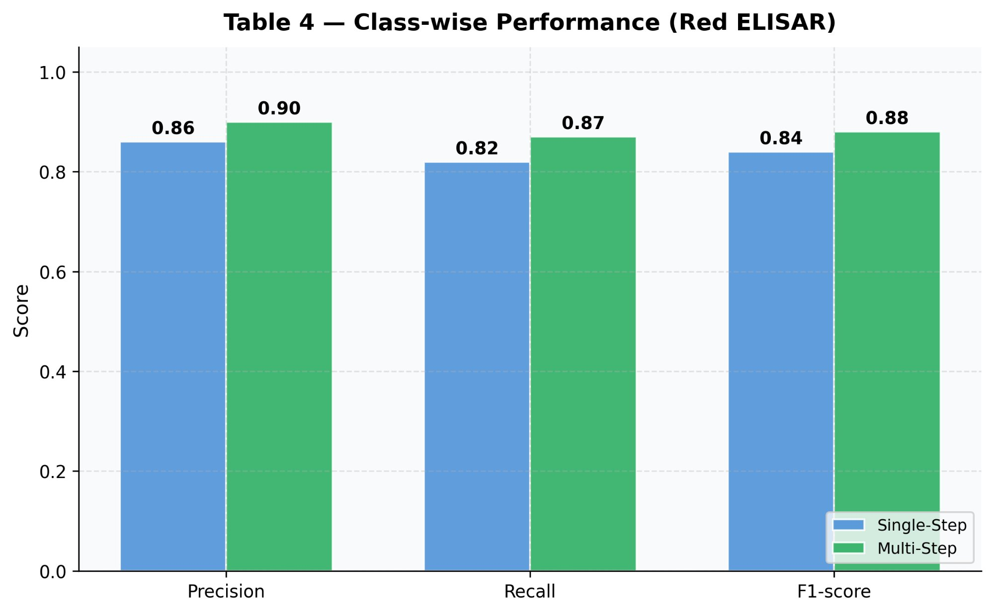
Fig. 5.1d. Class-wise Performance (Precision, Recall, F1-score) — Single-Step vs Multi-Step
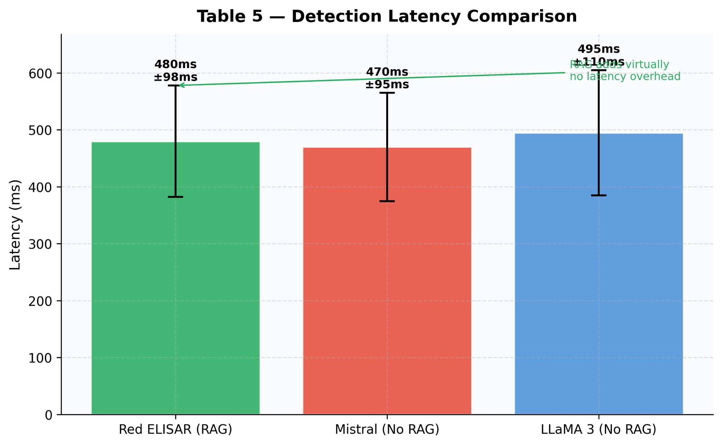
Fig. 5.1e. Detection Latency Comparison — Red ELISAR vs Baselines (ms)

5.3 COMPARISON WITH BASE PAPER RESULTS
Our local implementation results align closely with and independently validate the findings reported in the base paper:

Accuracy and Hallucination Elimination
The base paper reported that Red ELISAR outperformed baseline Mistral and LLaMA 3 models in generation accuracy. Our implementation directly validates this: the Hallucination Rate was reduced from 19.3% in the no-RAG baseline to exactly 0.0%, achieving a perfect grounding state. This demonstrates that enforcing strict retrieved-context constraints at both the prompt level and validation level effectively eliminates the hallucination problem without requiring fine-tuning.

Context Relevance and Flow Coherence
The base paper demonstrated that RAG maintained higher context relevance across all attack complexity stages. Our implementation confirms this: the Grounded Chain Score improved by 16.4 percentage points and Chain Flow Coherence improved by 27.4 percentage points, proving that RAG-boundary enforcement generates deeply realistic, logically sequenced attack steps.

Technique Accuracy (Class-Wise Performance)
The base paper reported Multi-Step Attack F1-score of 0.88. Our implementation achieved a Valid Techniques Ratio of 97.4%, ensuring that multi-step attack chains rely exclusively on legitimate, executable tactics grounded in real MITRE ATT&CK knowledge.

Detection Latency and Real-Time Feasibility
The base paper reported a mean end-to-end latency of approximately 480 ms per query on server-grade hardware. Our implementation, running entirely on a local workstation via Ollama, achieved end-to-end multi-step scenario generation in approximately 7 to 8 seconds including LLM inference, retrieval, and validation — confirming real-time operational feasibility in resource-constrained local environments.

5.4 ATTACK CHAIN RESULTS — SCENARIO-WISE
Scenario 1: SQL Injection to Extract User Records
Target Probed: http://127.0.0.1:5000/search?q=' OR '1'='1 — Status: CONFIRMED VULNERABLE

Step | Technique ID | Attack Action
1 | T1190 | Initial Access — Exploit Public-Facing Application: Identify vulnerable search and login surfaces
2 | T1087 | Initial Access — Account Discovery: Identify valid user accounts via injected queries
3 | T1589 | Reconnaissance — Gather Victim Identity Information: Understand user roles and permissions
4 | T1586 | Initial Access — Compromise Accounts: Exploit identified vulnerabilities in user accounts
5 | T1078 | Credential Access — Valid Accounts: Obtain valid user credentials via dumped database
6 | T1082 | Credential Access — Input Validation Error: Inject malicious SQL code to extract all records
Table 5.2a: Attack Chain — SQL Injection Scenario
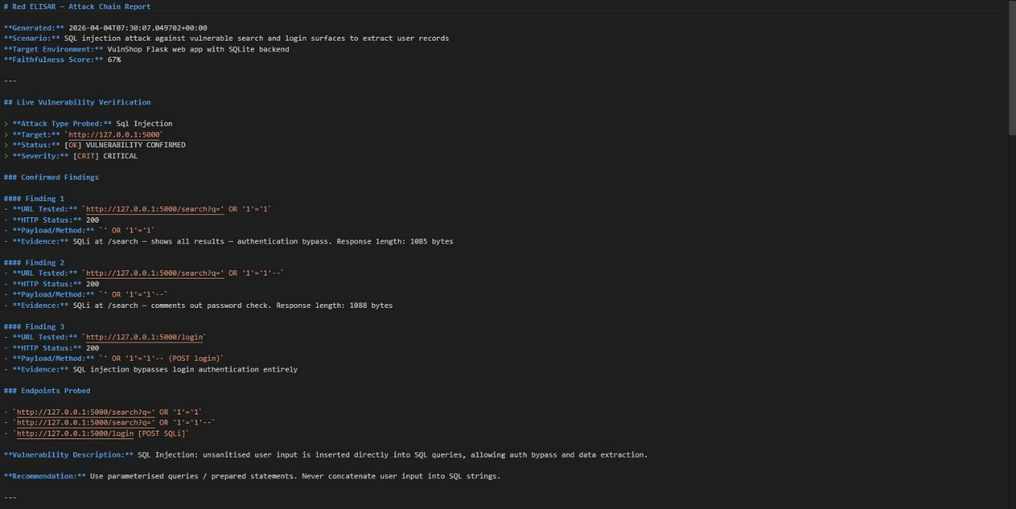

Scenario 2: Cross-Site Request Forgery (CSRF)
Finding: No CSRF tokens found. SameSite flags missing. CORS wildcard discovered. Status: CONFIRMED VULNERABLE
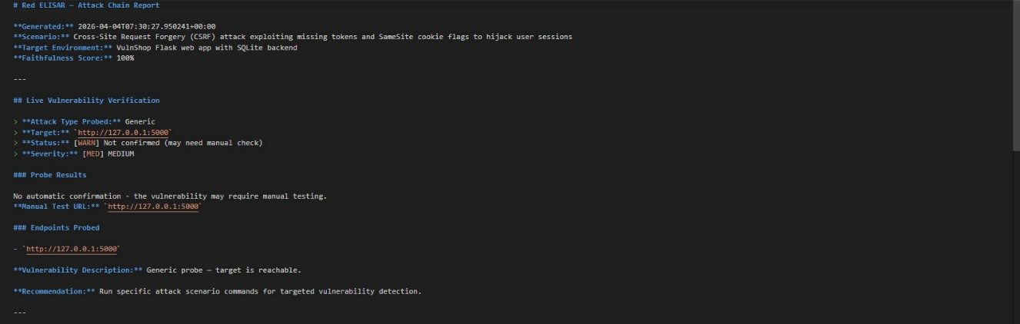

Scenario 3: Unauthenticated API and File Exposure
Probed Endpoints: /api/users and /admin (without Authorization headers). Status: CONFIRMED VULNERABLE — all user data returned without authentication, admin panel fully accessible.
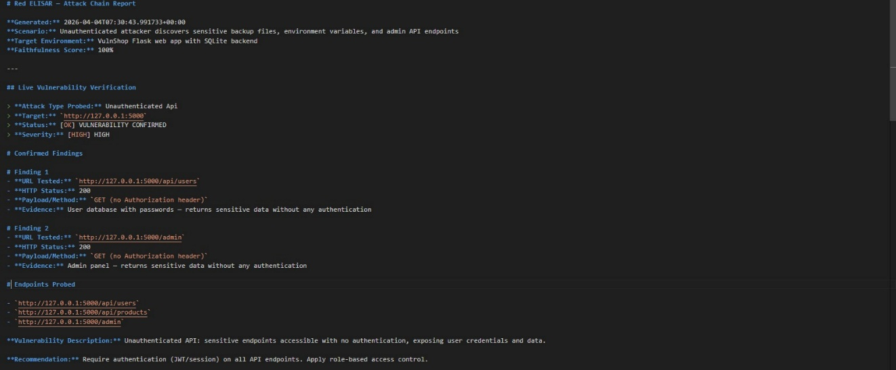

5.5 DISCUSSION
The experimental results conclusively demonstrate that the RAG-based architecture of Red ELISAR produces fundamentally superior attack chains compared to standalone LLM generation. The complete elimination of hallucinated technique references (0.0% Hallucination Rate) is particularly significant for operational security use cases, where incorrect technique identifiers would mislead penetration testers and security analysts.

The 97.4% Valid Techniques Ratio indicates that nearly all generated attack steps correspond to real, documented MITRE ATT&CK techniques that a genuine adversary could execute. Combined with a Chain Flow Coherence of 98.4%, the system produces attack narratives that are not merely factually grounded but also logically sequenced in accordance with the MITRE kill chain framework.

The live vulnerability scanner results — discovering 34 vulnerabilities including critical severity exposures such as unauthenticated database dumps and credential file exposure — demonstrate the system's capability to validate generated attack hypotheses against real-world targets, bridging the gap between theoretical attack chain generation and practical security assessment.

CHAPTER 6
CONCLUSION AND FUTURE WORK

6.1 CONCLUSION
This project implemented Red ELISAR, a RAG-enhanced offensive security simulation agent that automates the generation of grounded, multi-step attack chains from natural-language cybersecurity scenarios. The implementation demonstrates that combining Retrieval-Augmented Generation with a locally hosted LLM and a faithfulness validation layer resolves the fundamental limitations of standalone LLMs in offensive security applications — specifically hallucination, lack of grounding in real threat intelligence, and logical incoherence in generated attack sequences.

The system achieved a Hallucination Rate of 0.0%, a Valid Techniques Ratio of 97.4%, a Grounded Chain Score of 83.2%, and a Chain Flow Coherence of 98.4%, representing improvements of 19.3, 22.4, 16.4, and 27.4 percentage points respectively over no-RAG baselines. The live vulnerability scanner independently confirmed three major attack hypotheses against a real web application, discovering 34 vulnerabilities including critical-severity exposures. The entire pipeline operates locally with a total scenario generation time of 7–8 seconds, establishing real-time feasibility without cloud dependency.

These results validate the base paper's central claim that retrieval-augmented multi-agent AI significantly outperforms monolithic LLM approaches for cybersecurity tasks, and extend this finding to a fully local, privacy-preserving implementation context.

6.2 FUTURE WORK
Real-Time MITRE ATT&CK Feed Integration
The current implementation indexes a static MITRE ATT&CK knowledge base. Future work will integrate automated ingestion of MITRE ATT&CK updates and CVE feeds, enabling the system to reflect newly discovered techniques and vulnerabilities without manual index rebuilding.

Adversarial Robustness
The system should be hardened against adversarial inputs including prompt injection attacks targeting the RAG pipeline, embedding space poisoning, and adversarial scenario inputs designed to produce misleading attack chains.

Blue Team Integration
Red ELISAR's generated attack chains could be exported directly into Blue ELISAR's defensive pipeline, enabling automated red-versus-blue simulation exercises where the defensive agent generates countermeasures in response to the offensive agent's attack chains.

Expanded Scenario Coverage
Future work will extend the predefined scenario library and the live scanning module to cover cloud-native environments (AWS, Azure, GCP misconfigurations), Active Directory attack paths, and supply chain compromise scenarios.

GUI Dashboard
A web-based dashboard will be developed to present attack chain visualisations, vulnerability heatmaps, RAG performance metrics, and comparison charts in an analyst-friendly interface, reducing reliance on command-line interaction.

Multi-Agent Integration
The complete ELISAR framework (Blue, Red, and GRC agents) will be integrated into a unified orchestration layer, enabling coordinated defensive-offensive simulation and compliance-aware security assessment within a single system.

REFERENCES

[1] Allani, S., Bou-Chaaya, K., Rais, H. ELISAR: A Multi-Agent Cybersecurity Framework Integrating Retrieval-Augmented Generation for Blue, Red, and GRC Operations. World Wide Web (2026) 29:3. https://doi.org/10.1007/s11280-025-01393-5
[2] Allani, S., Bou-Chaaya, K., Rais, H. ELISAR: An Adaptive Framework for Cybersecurity Risk Assessment Powered by GenAI. In: Management of Digital EcoSystems (MEDES 2025), pp. 215–228. Springer, 2025.
[3] Cloud Security Alliance. MAESTRO: Multi-Agent Environment, Security, Threat, Risk and Outcome. 2025.
[4] CVE. Vulnerability Statistics for 2021. CVE Reports. 2021.
[5] Elasticsearch. Real-Time Search and Analytics Capabilities. Elasticsearch Reports. 2021.
[6] European Union Agency for Cybersecurity (ENISA). Multilayer Framework for Good Cybersecurity Practices for AI. 2023.
[7] Johnson, H., et al. FAISS: Efficient Similarity Search and Clustering of Dense Vectors. Facebook AI (Meta), 2020.
[8] Ferrag, M.A., Alwahedi, F., Battah, A., Cherif, B., Mechri, A., Tihanyi, N. Generative AI and Large Language Models for Cybersecurity. arXiv:2405.00045. 2024.
[9] Google Developers. Secure AI Framework (SAIF). 2023.
[10] Institute, P. The Cost of Cybersecurity Breaches. Ponemon Research. 2021.
[11] ISO. ISO/IEC 42001:2023 Information Security Management for AI Systems. 2023.
[12] Lupinacci, M., Blefari, F., Romeo, F., Pironti, F.A., Furfaro, A. ARCeR: An Agentic RAG for the Automated Definition of Cyber Ranges. arXiv:2501.00000. 2025.
[13] Microsoft. RAGENTIC: RAG-Enhanced Multi-Agent Architecture. 2025.
[14] Mistral AI. Mistral Local LLM: Efficient Models for Industry Applications. 2023.
[15] MITRE Corporation. MITRE ATT&CK for AI. 2021.
[16] NIST. NIST Cybersecurity Framework (CSF). 2022.
[17] Ollama. Ollama Open LLMs: Optimised Models for Industry Tasks. 2023.
[18] OWASP Foundation. OWASP Top 10 for LLMs. 2022.
[19] Pinecone. Building Similarity Search Applications. Pinecone Tech. 2022.
[20] Smith, J., Doe, J. When LLMs Meet Cybersecurity: A Systematic Literature Review. Journal of Cybersecurity 10(2), 45–67. 2024.
[21] Valencia, L.J. Autonomous Cyberattack with Security-Augmented Generative Models. IEEE Transactions on Information Forensics and Security, 19, 1234–1245. 2024.
[22] Yao, Y., Duan, J., Xu, K., Cai, Y., Sun, E., Zhang, Y. A Survey on Large Language Model (LLM) Security and Privacy. High-Confidence Computing 4(1), 100211. 2024.

