Step 1: Create Empty Repository

Go to the GitHub Account https://github.com/divya131203

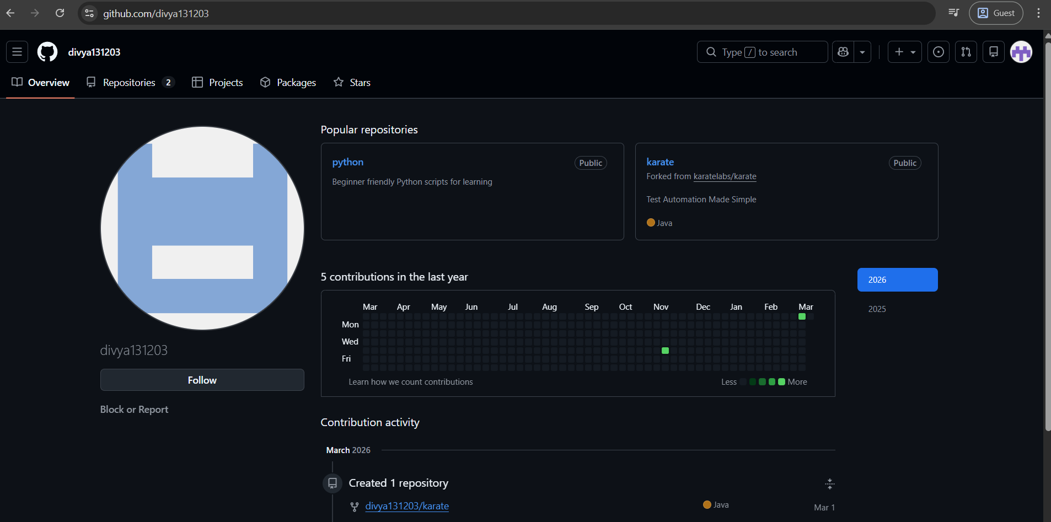

Step 2: Click "New repository"
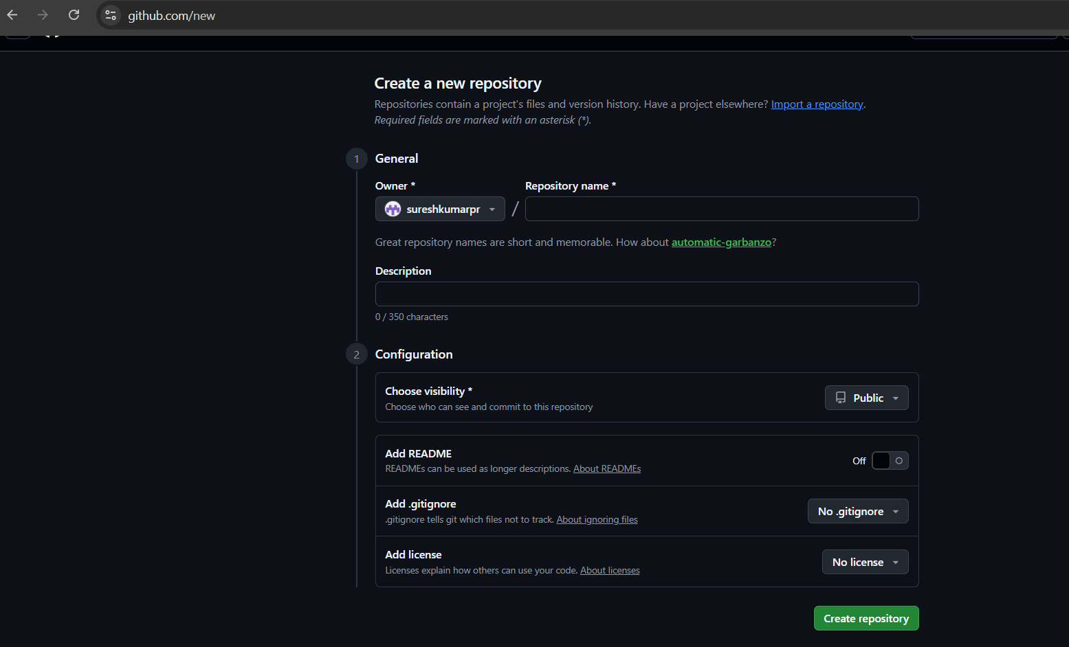
Step 3: Name: karate-api-automation
Step 4: Description: E-commerce API Test Automation Suite - Karate Framework

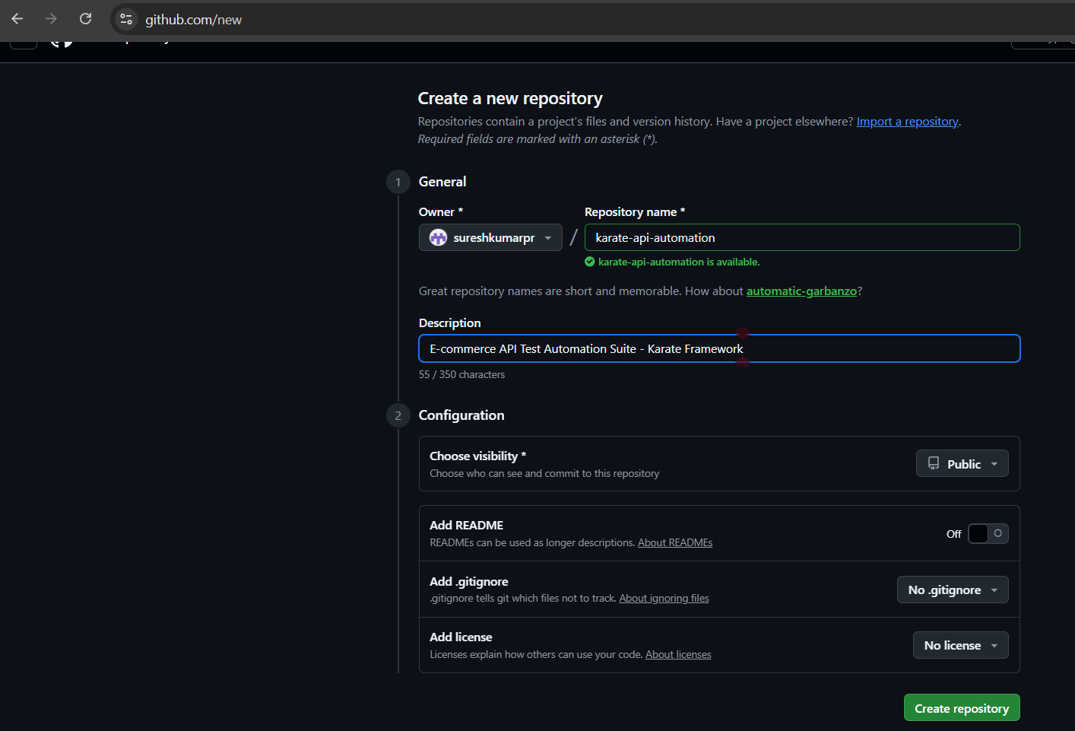

Step 5: DO NOT initialize with README, .gitignore, or license
Step 6: Click "Create repository"

