Lottery Number Generator

Solution contains below projects:

1. NumberGeneratorApi
2. ExceptionLogger
3. ServicesClient
4. LotteryClient
5. **NumberGeneratorApi**:

Purpose: Web API used to generate the series of numbers

Methods: Contains one Get method to Generate the series

Service url : **/api/Generator/series?length={0}&min={1}&max={2}**

Request (Input):

SeriesLength : Count of numbers to generate in the series

MinNumber: starting index from which the series should be generated

MaxNumber: ending index to which the series is to be generated.

Response (Output):

NumberSeries : List of numbers generated

Notes:

Unity (downloaded from nuget) is used implement the dependency injection.

Ex: SeriesLength = 6, MinNumber = 0, MaxNumber = 49 :

Will generate 6 random numbers (not repeated) between 0 and 49.

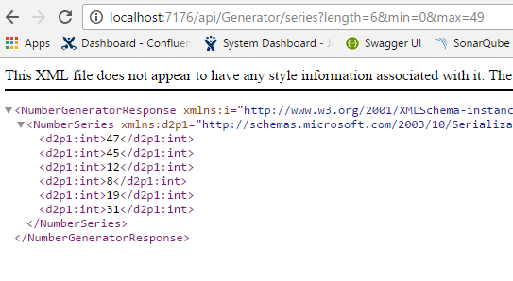

1. **ExceptionLogger:**

Purpose: Class library project used to write the business exceptions in the custom format.

Contains BusinessExceptionClass inherited from Exception class.

1. **ServicesClient:**

Purpose: classes to call the web api services.

1. **LotteryClient**

Purpose: client to show the generated series. This is an MVC application.

Controller: NumberSeriesController

Action Method: Generate

View:

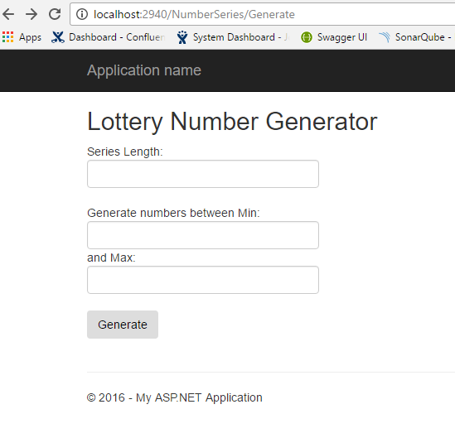

Output:

