Online CBSE Test Platform for School Students
http://cbsetest.in

USER GUIDE

v1.0.1
10/June/2020

FEATURES:

1. Open Source (FREE)
2. Quick Access (Student can register and take the test with in few seconds)
3. Students can enroll the class/subject and practice the tests
4. Students can view their answer sheet , as well as solution of the question.
5. Students can repeat the tests and any number of times.
6. different collection of tests (Unit wise, Model, difficultilevel etc)
7. Built with FOSSEE – online-test (https://github.com/FOSSEE/online_test)
8. Community Contribution: Parents/Teachers can prepare the Questions/Courses, which can be integreated to the system.

As currently the project is in BETA stage, we are adding Questions for all CBSE Classes Maths and science subject.
Volunteer can contact me cbsetest.in@gmail.com

Table of Contents
Online CBSE Test Platform for School Students 1
FEATURES: 1
1. Quick Start 2
Step1: NEW USER SIGN-UP (REGISTERATION) 2
6
Step2: COURSE ENROLLMENT 6
Step3: TAKE TEST 10
Step4: View AnswerSheet 17
2. Collaborate & Contribute to Add More Questions/Tests 20
3. Contributors 21

1. Quick Start

Quick start video tutorial is available in Youtube

https://youtu.be/8AAgWzbk6KE

This section explains, how students can register, enroll the course, take test, view their answer sheet.

1. For new users, Register it (signup) to create username/password.
2. Course Enrollment
3. Start the Course & Take Test
4. View Answer sheet

Step1: NEW USER SIGN-UP (REGISTERATION)

1. Open http://cbsetest.in in Google Chrome browser

2. Click NEW USER SIGN UP Button as below.

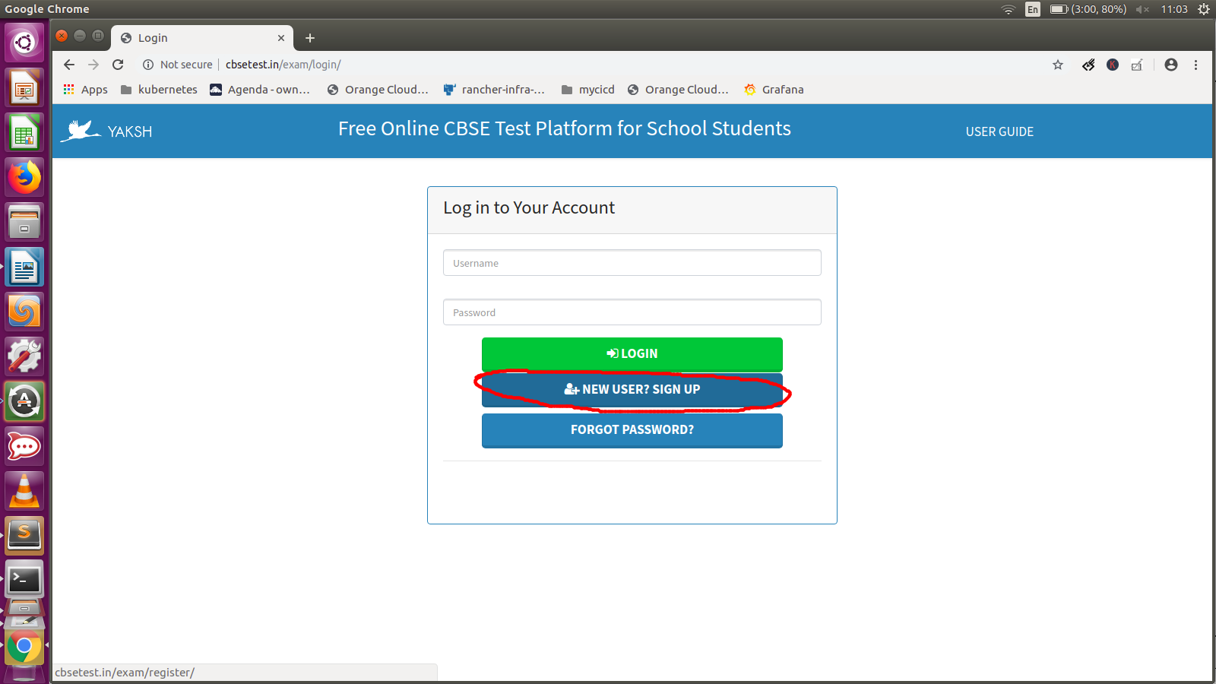
3. You will see the REGISTERATION page.

Enter the required details
Username, email, password, confirm password, firstname, last name, Roll number, Institute, Department, Position
Note : Simple Password is NOT allowed. Use atleast 8 letters in the password, combination alphabets and numbers (example : sch12345ool)

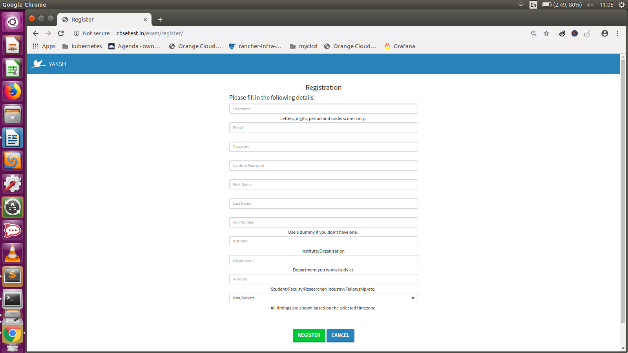

After filled the form ,

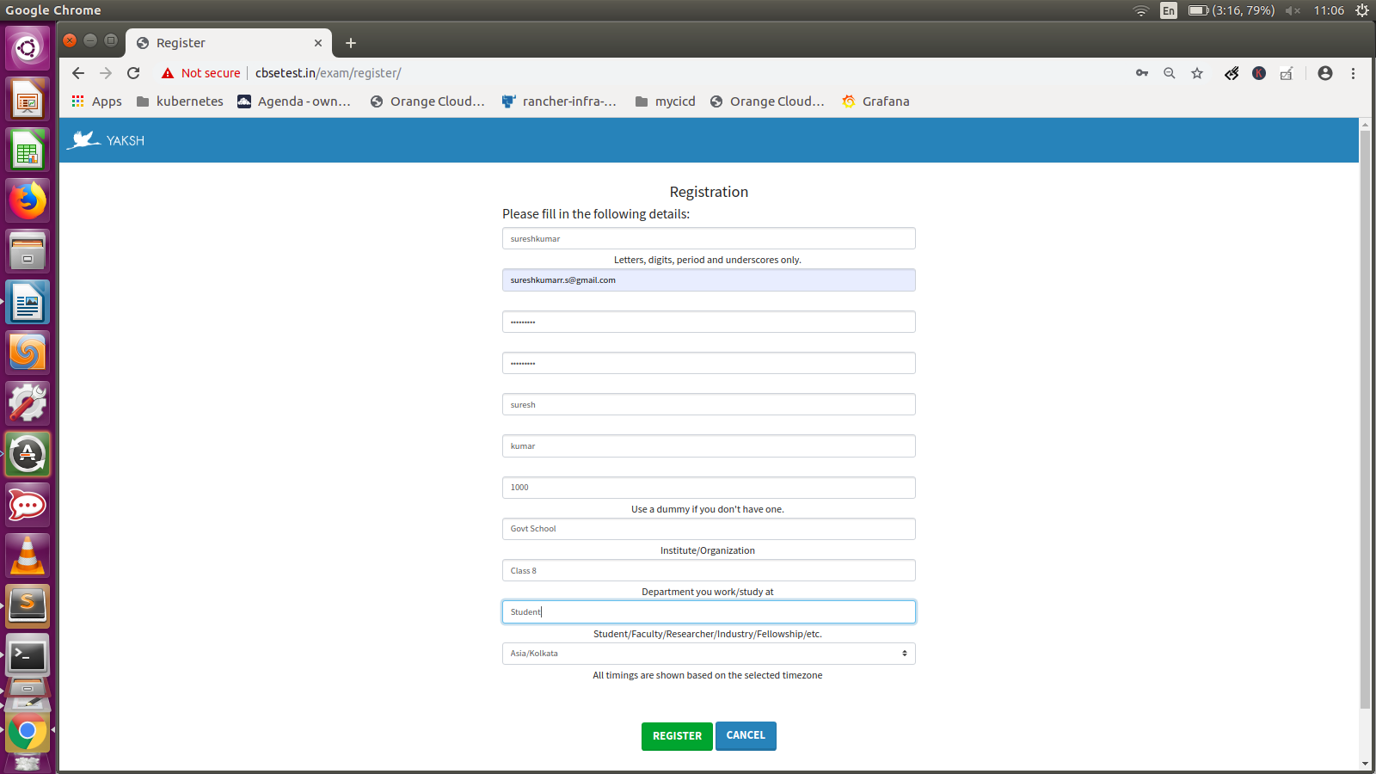

4. Click the REGISTER Button

Now students can see the MAIN Screen, where they can ENROLL the courses.

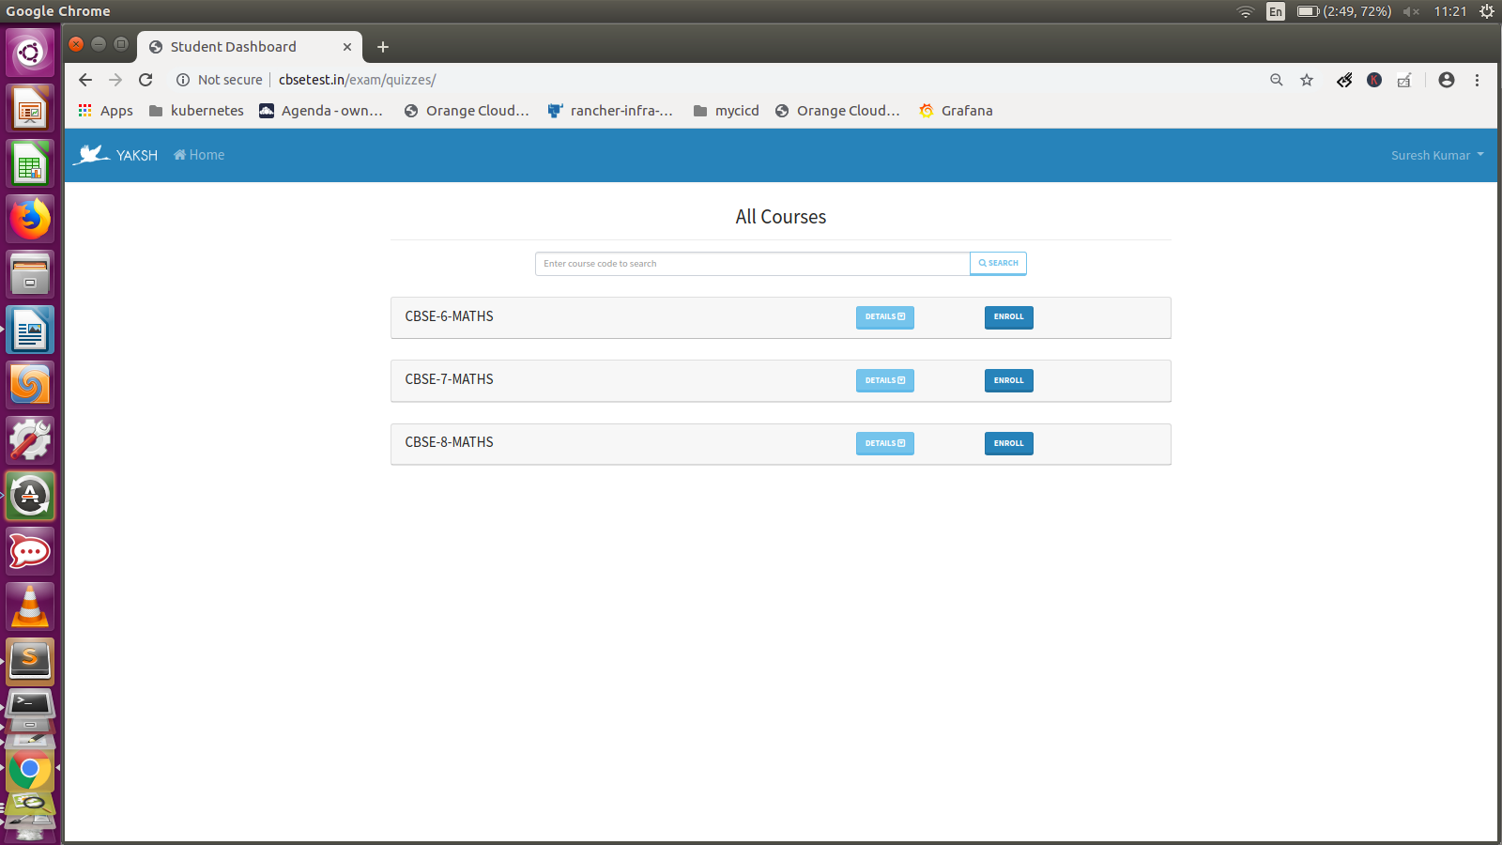

Now you are REGISTERED in the system. Next time onwards you can use your USERNAME and PASSWORD to login to the system.

Step2: COURSE ENROLLMENT

Now students can ENROLL the available COURSE. Its good practice to ENROLL only the relavent course.

1. Click the ENROLL button

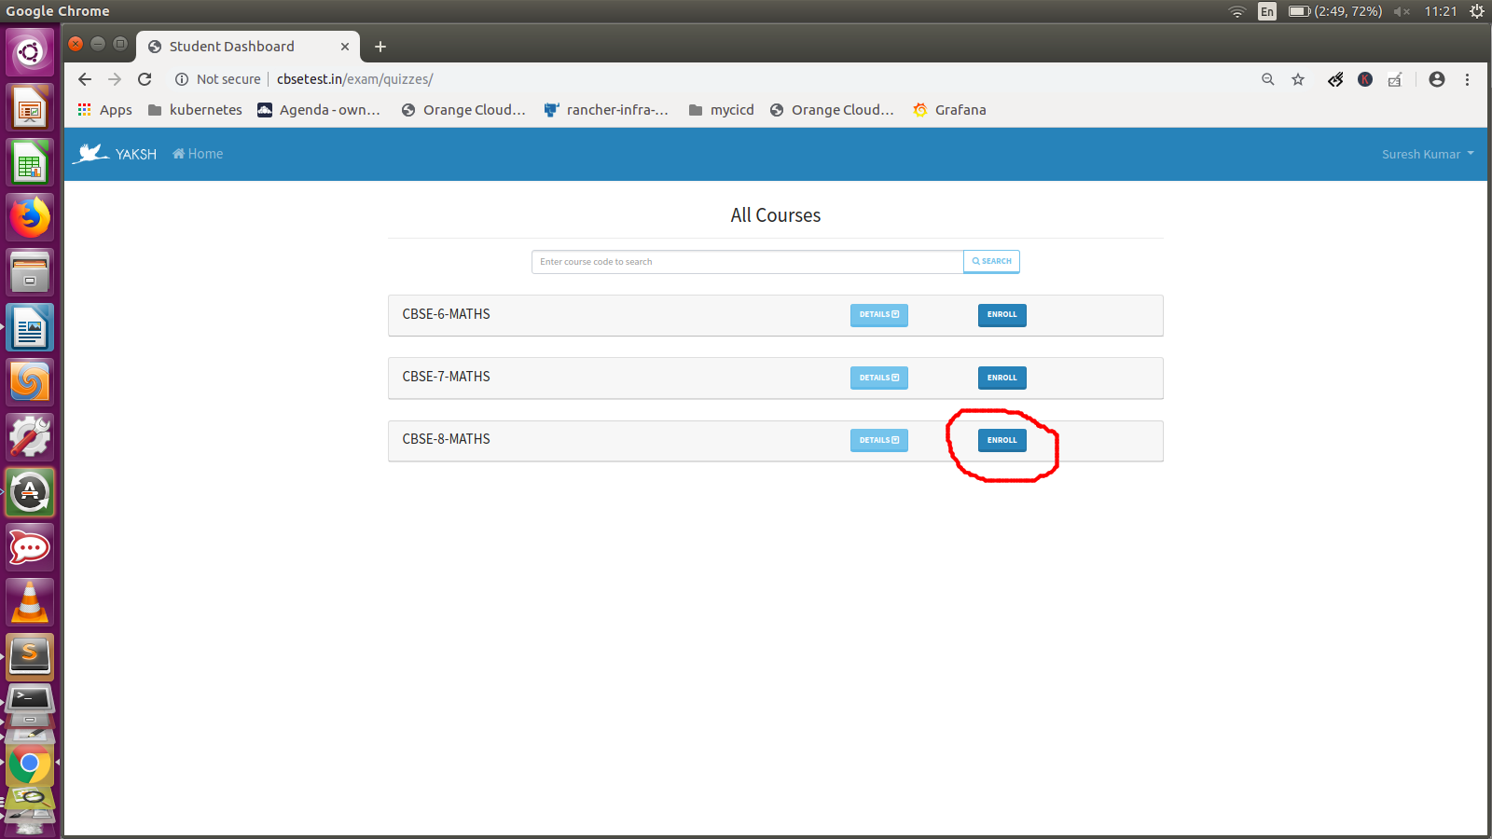

2. Now you are enrolled. The output is as below,

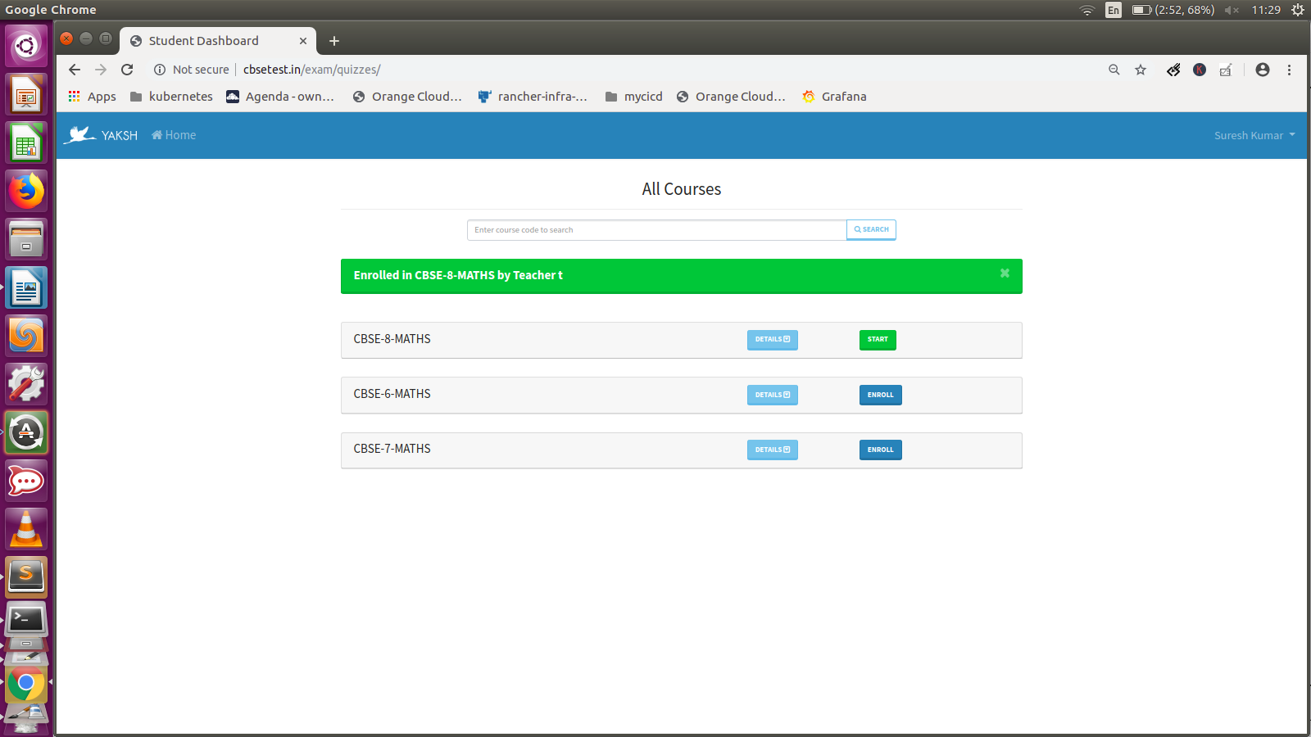

Step3: TAKE TEST

1. Start the Course, CLICK the START Button

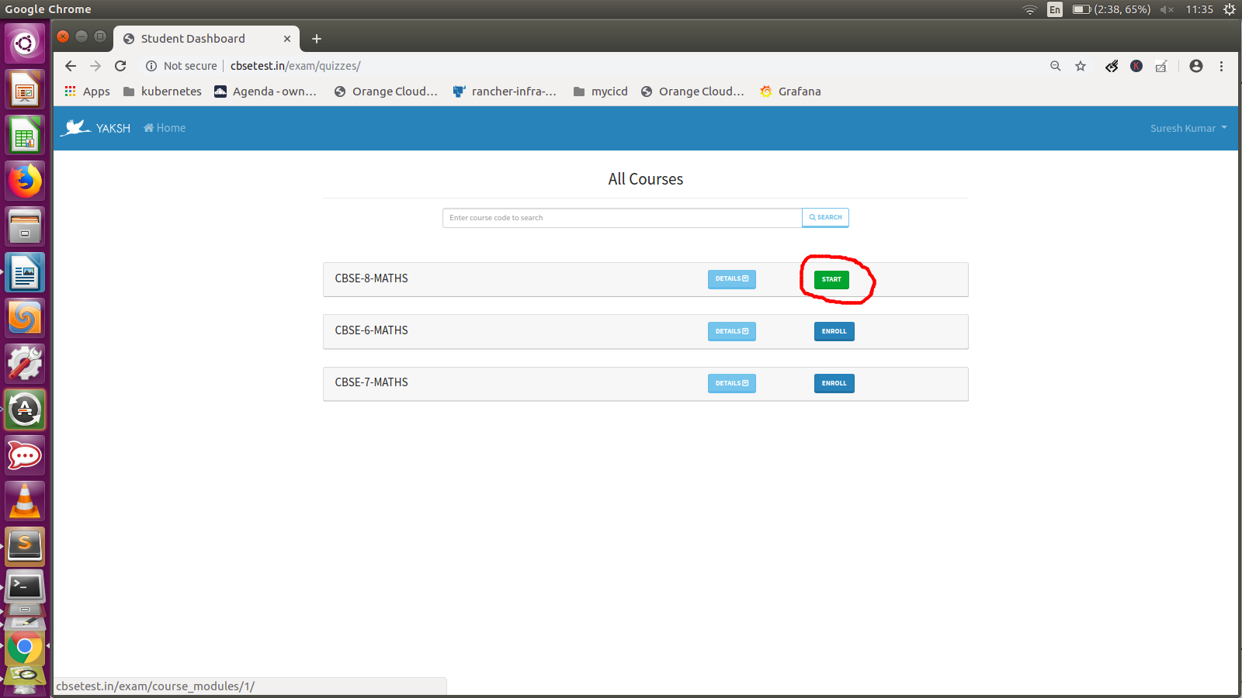

2. You will see the Course Main Page as below,

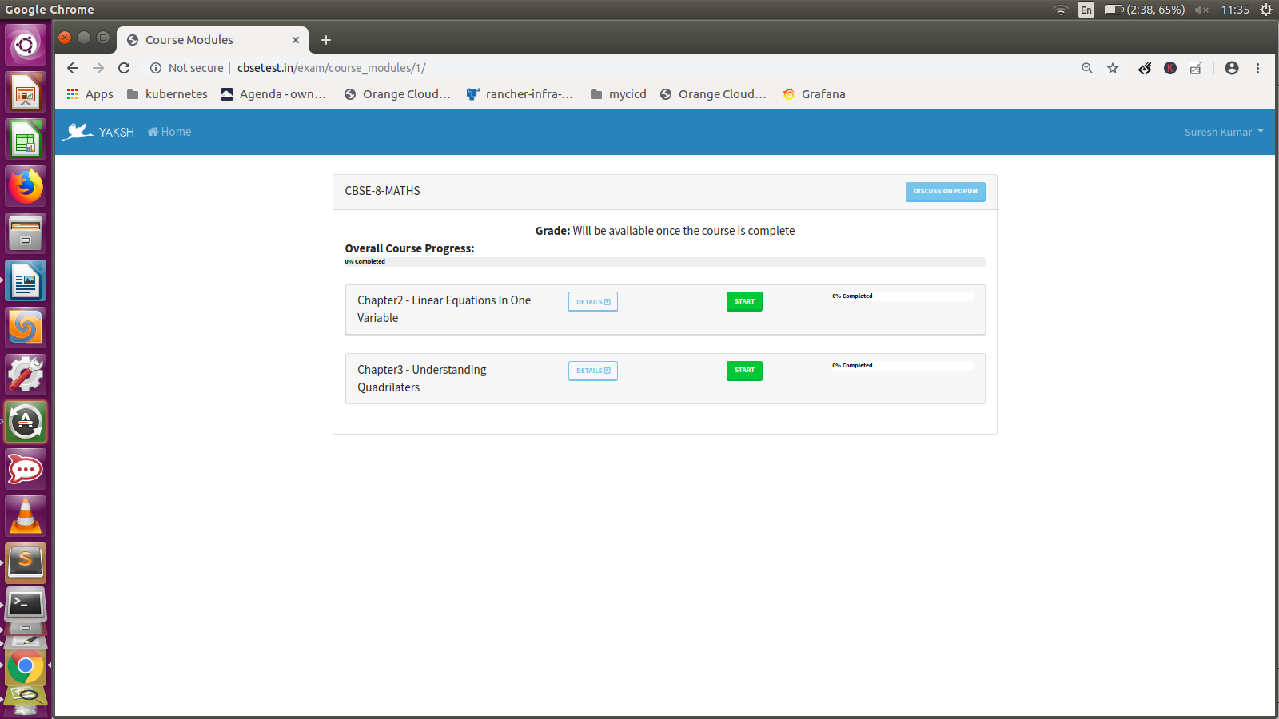

Course contains many number of Chapters / Units. Click DETAILS Button of the CHAPTER to see the number of tests available in that chapter, as below.

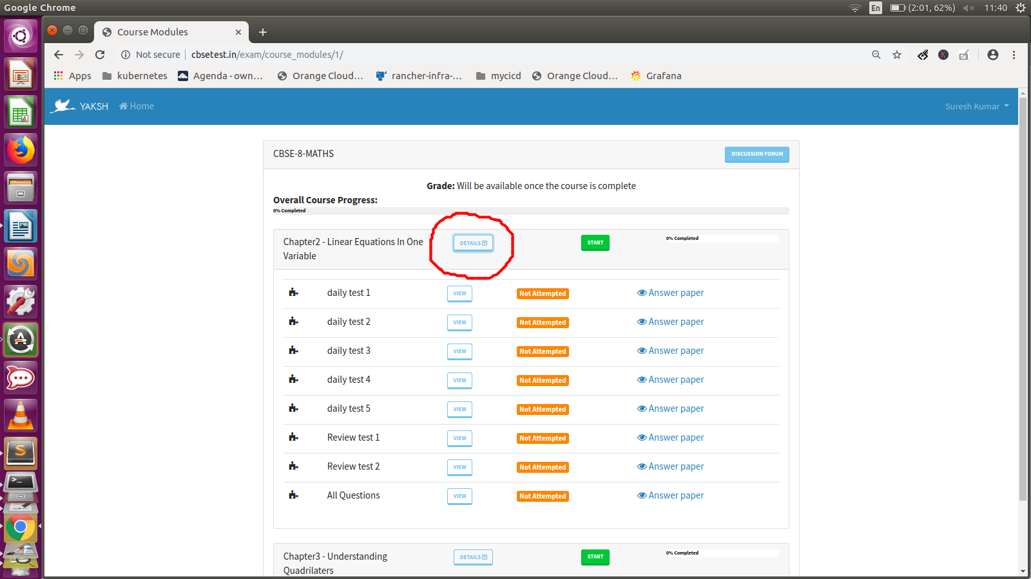

3. Click the START button, to start progressing this unit.

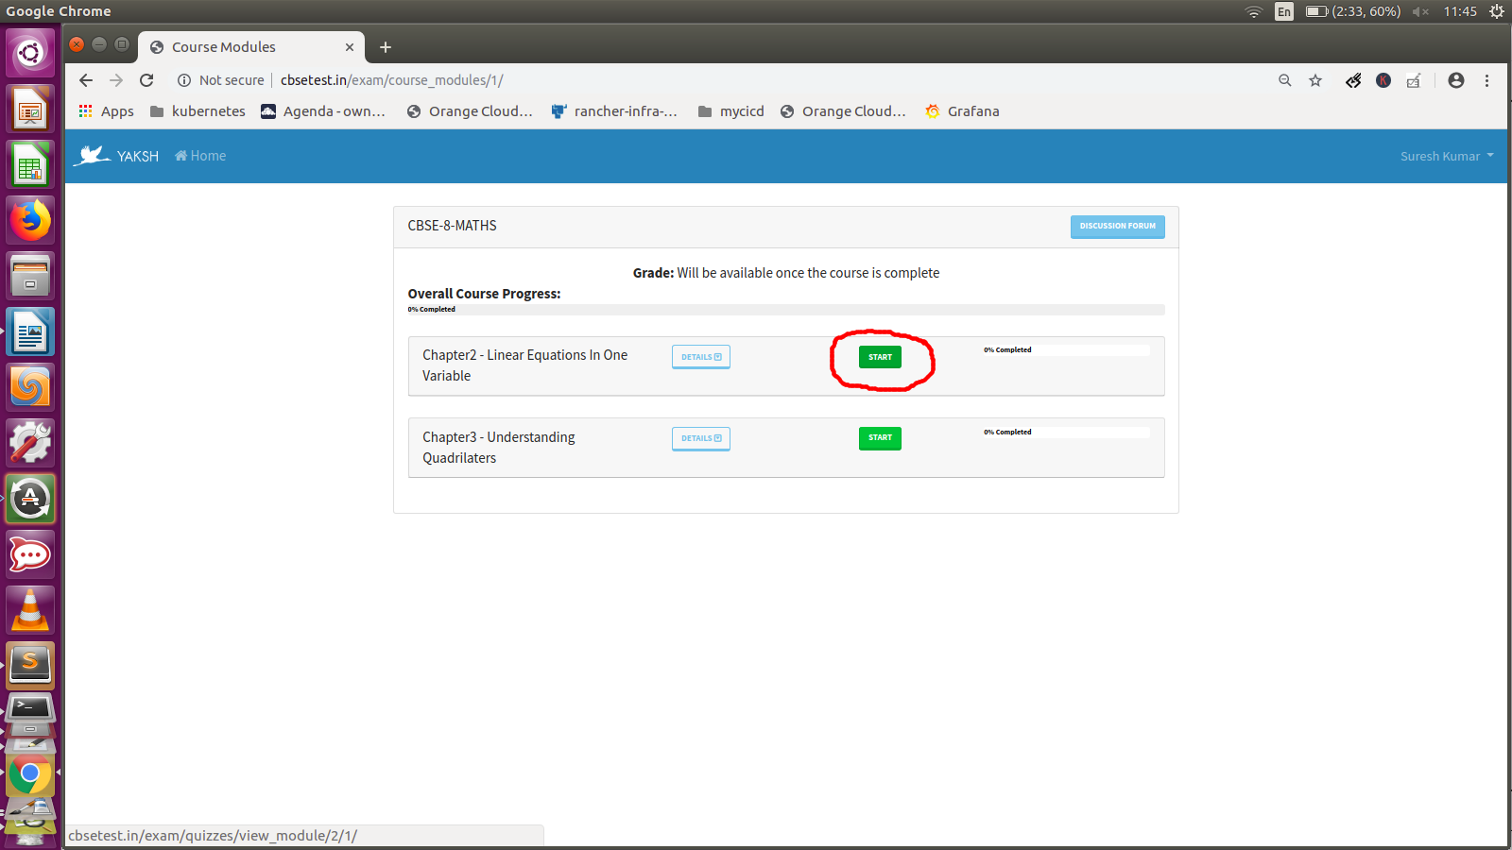
4. You will the see the LIST of TESTS available in this UNIT .
Click the START button to start the test.

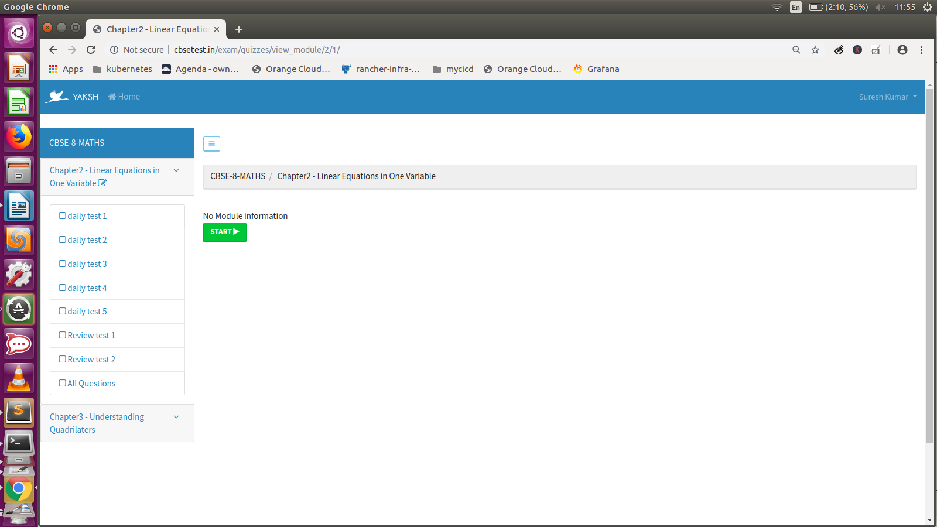
4. You will see the WELCOME PAGE of TEST and TEST Details,
START The TEST as below,

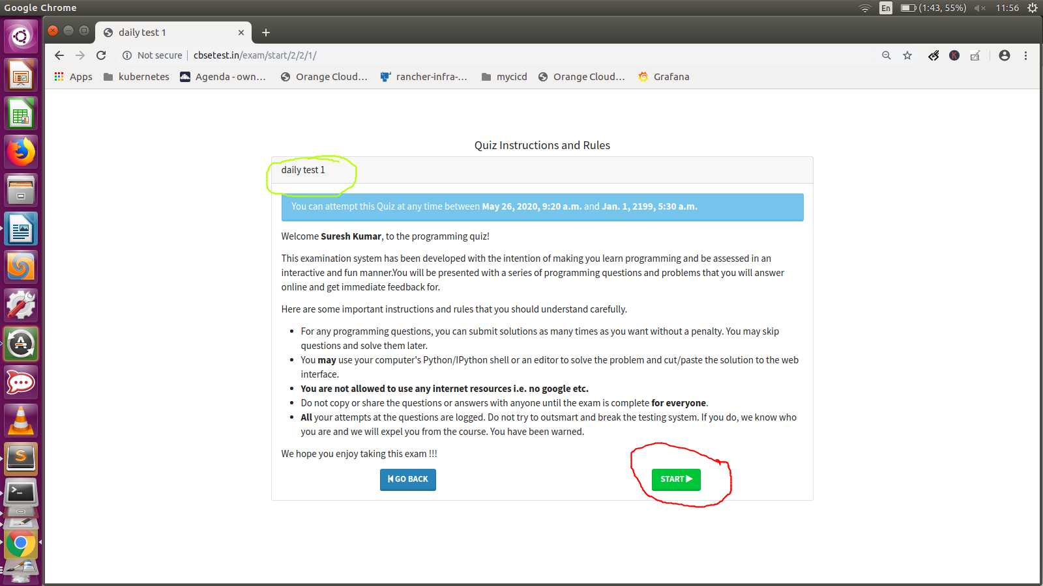
5. TEST Starts

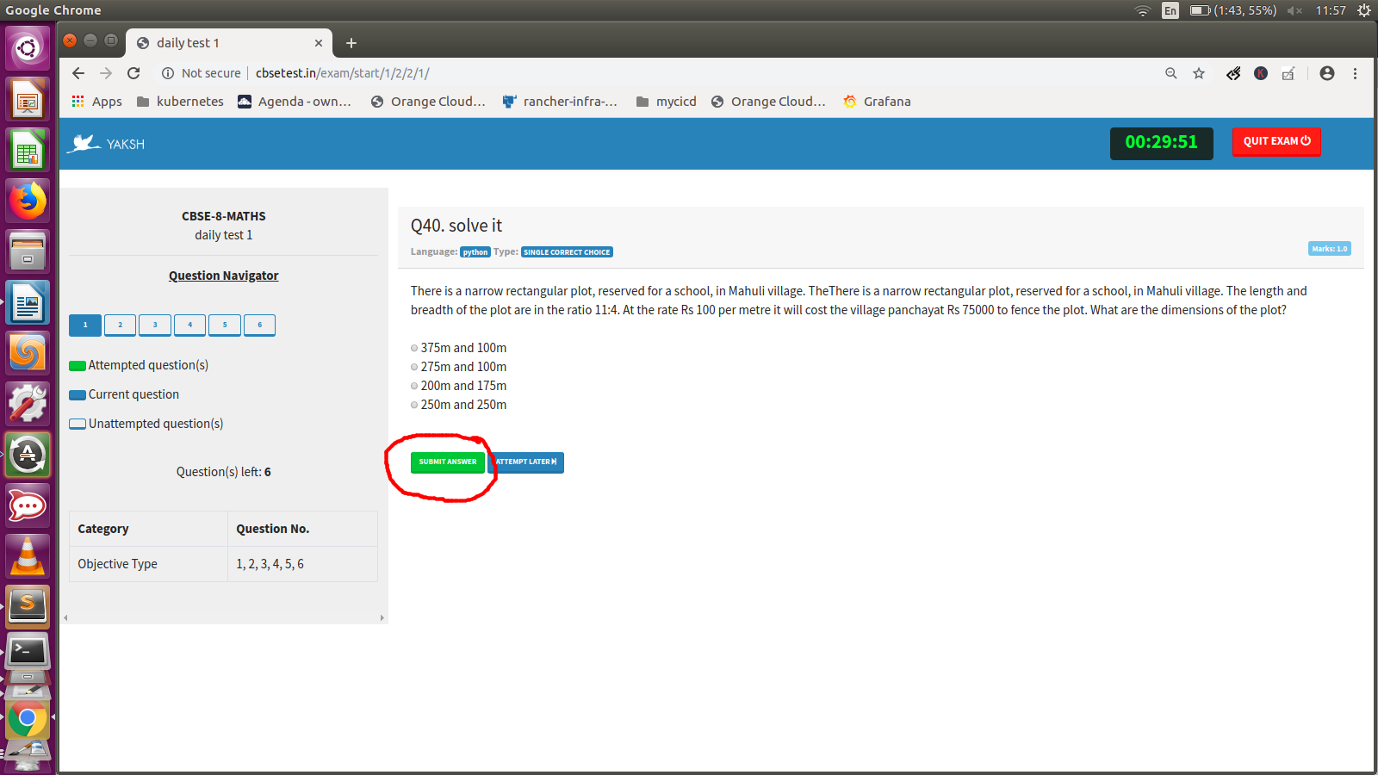
select the answer and click “SUBMIT ANSWER” Button

6. Once you finished all the Questions
Check in the Right Corner, All attended questions will be in GREEN.
CLICK The FINISH EXAM

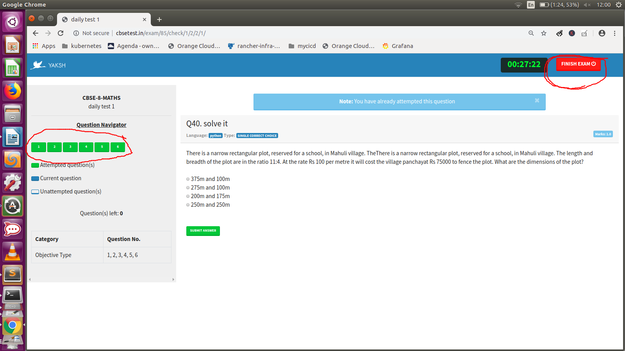

7. Click YES to CONFIRM it

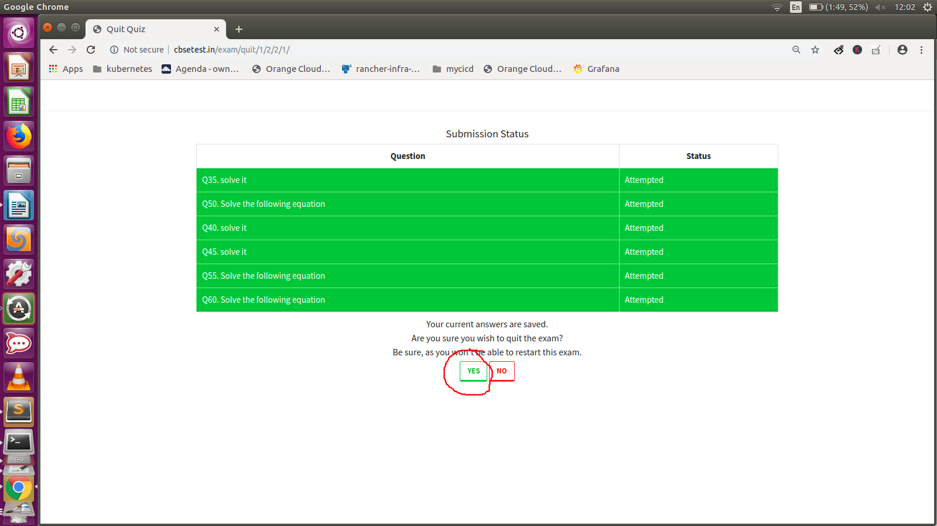

8. Thats all you are done. CLICK Top Left YAKSH IMAGE to go to HOME PAGE, as below.
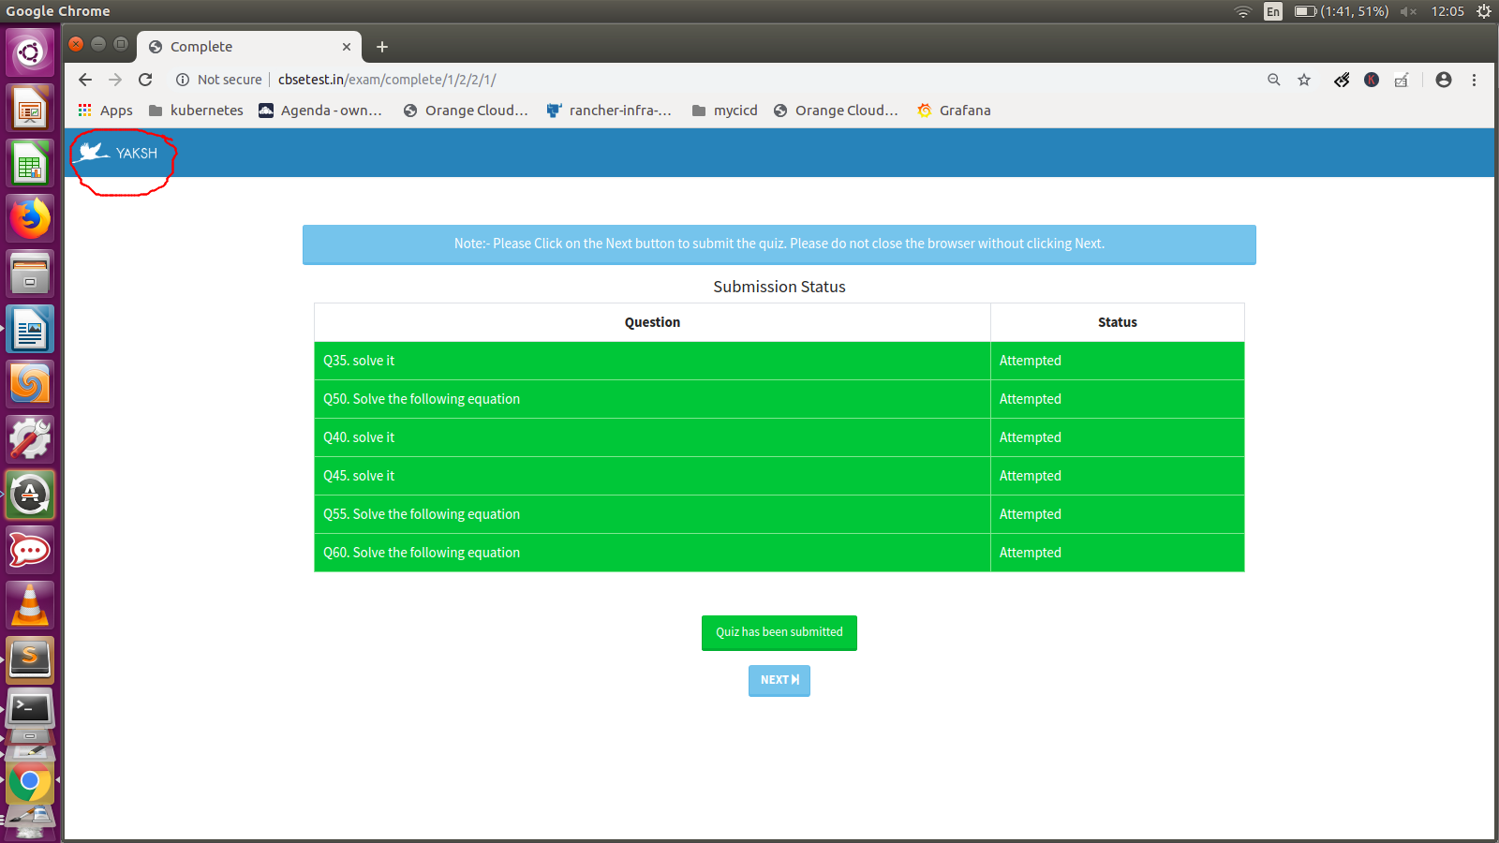

Step4: VIEW ANSWER SHEET

1. In the main page, Click the Respective Course Start button

2. Click the DETAILS button of the respective Chapter
and Click the ANSWER PAPER link from the completed test.
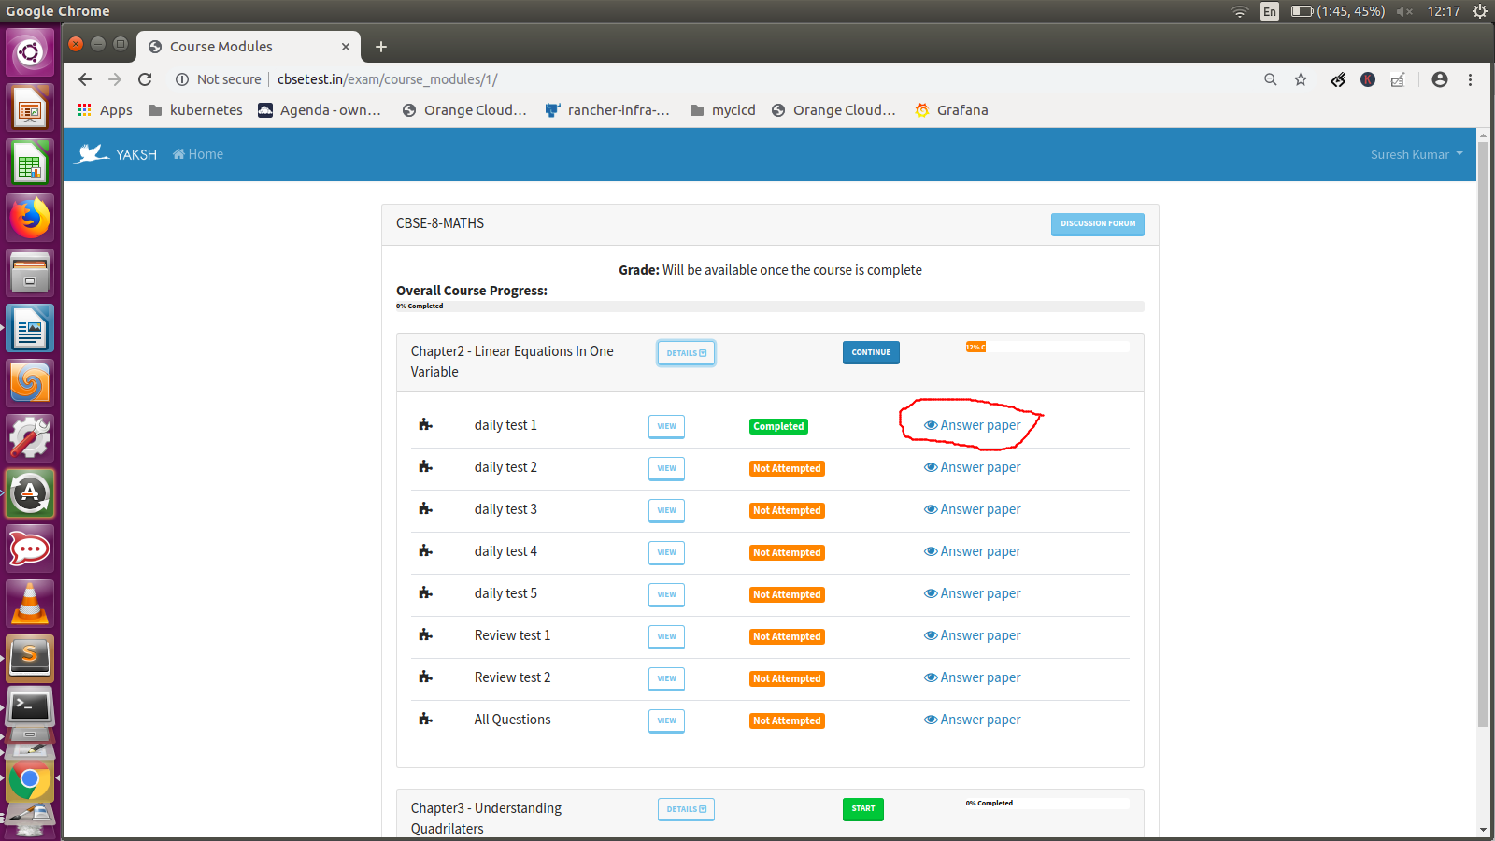

3. In the AnswerSheet , “Scoreboard”, “Summary of the test”, will be displayed.
Also, when you Scroll down and see the SOLUTION for each question.

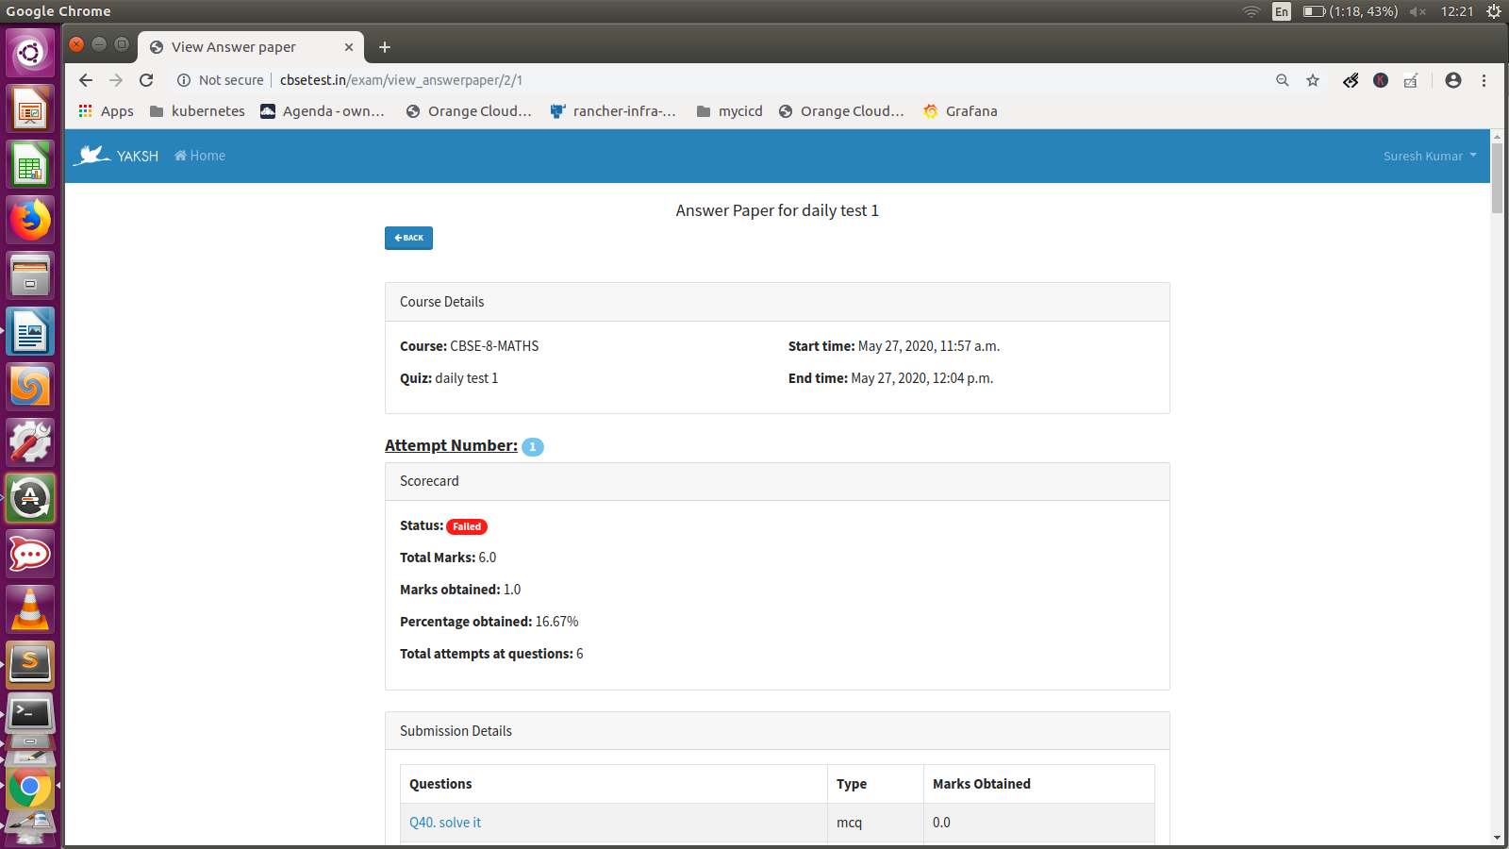

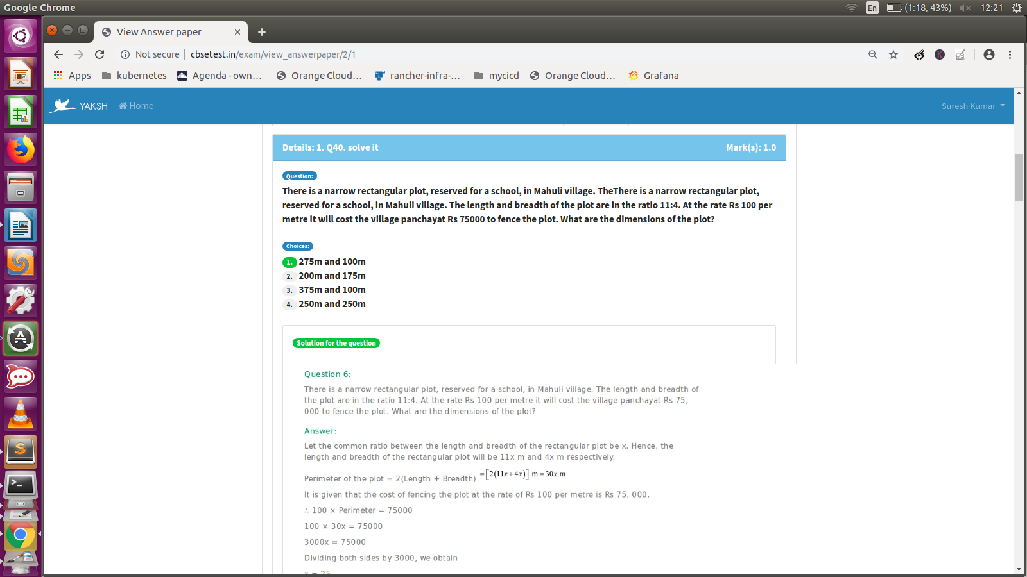

2. How to Contribute/Participate.

This is community driven project. Anyone can contribute in this project.
You can contribute in many ways.
- Contribute in Preparing New Questions and Answers
- report bugs/review the questions and answers
- Train/help the students to use this

As currently the project is in BETA stage, we are adding Questions for all CBSE Classes Maths and science subject.
Volunteer can contact me cbsetest.in@gmail.com

3. Thanks

- Questions are referred from NCERT Books (http://ncert.nic.in/ebooks.html)
- Answer for the NCERT Questions are copied from https://www.freencertsolutions.com/
- YAKSH (https://github.com/FOSSEE/online_test) Software is used to built this platform. Thanks to FOSSEE Team and Aditya (aditya94palaparthy@gmail.com) for extensive support ..

