**PostgreSQL Assignment**

**CLUBDATA**

# **Simple SQL Queries**

* [**Retrieve everything from a table**](https://pgexercises.com/questions/basic/selectall.html)

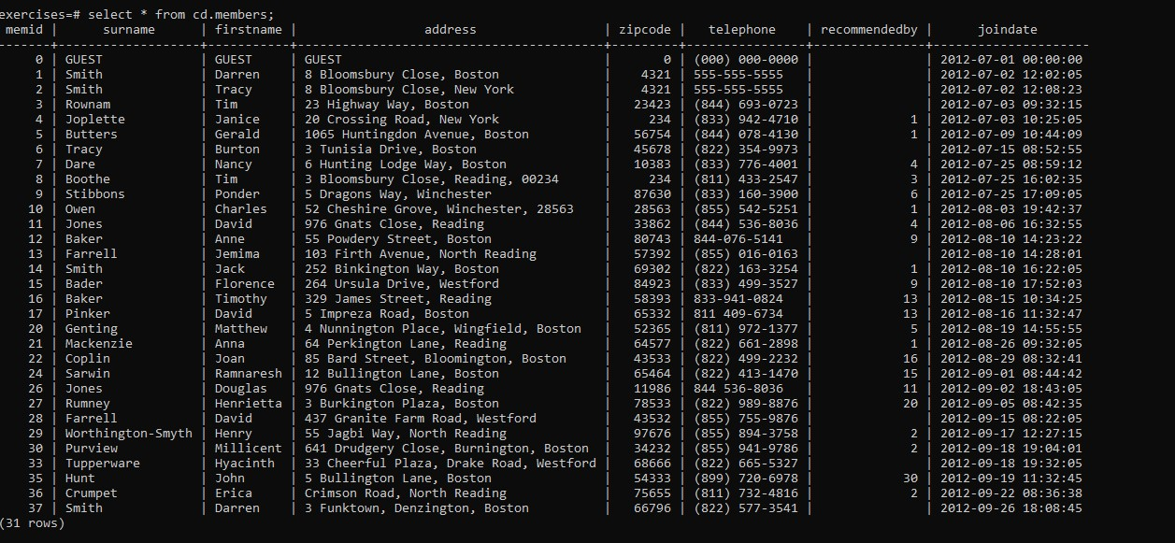

* [**Retrieve specific columns from a table**](https://pgexercises.com/questions/basic/selectspecific.html)

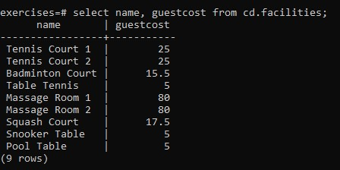

* [**Control which rows are retrieved**](https://pgexercises.com/questions/basic/where.html)

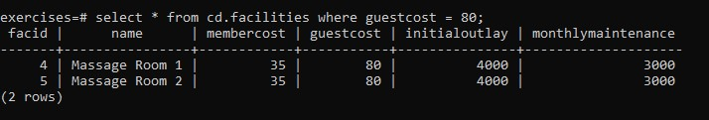

* [**Control which rows are retrieved - part 2**](https://pgexercises.com/questions/basic/where2.html)

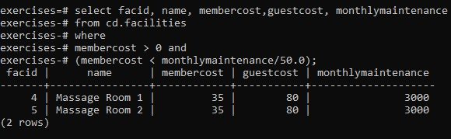

* [**Basic string searches**](https://pgexercises.com/questions/basic/where3.html)

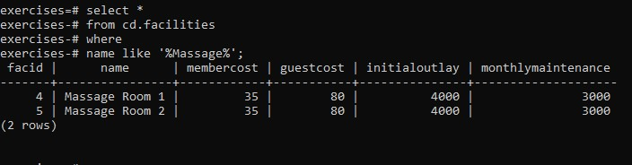

* [**Matching against multiple possible values**](https://pgexercises.com/questions/basic/where4.html)

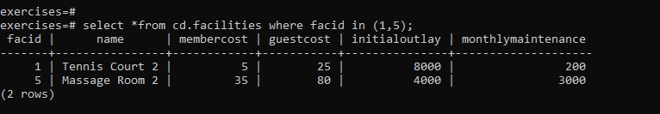

* [**Classify results into buckets**](https://pgexercises.com/questions/basic/classify.html)

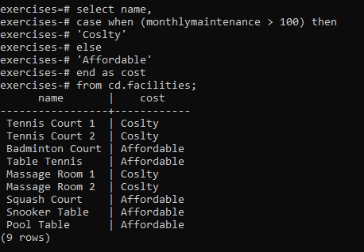

* [**Working with dates**](https://pgexercises.com/questions/basic/date.html)

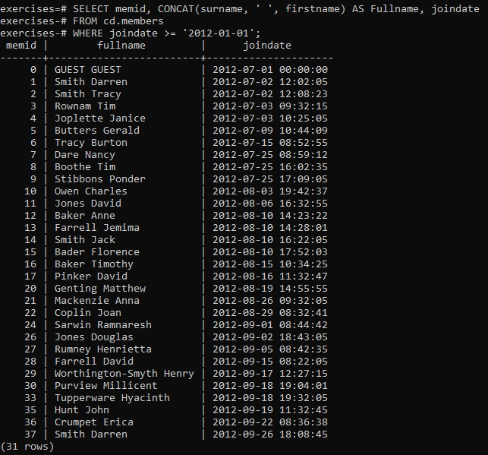

* [**Removing duplicates, and ordering results**](https://pgexercises.com/questions/basic/unique.html)

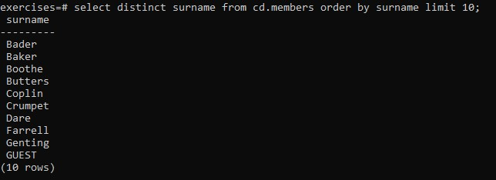

* [**Combining results from multiple queries**](https://pgexercises.com/questions/basic/union.html)

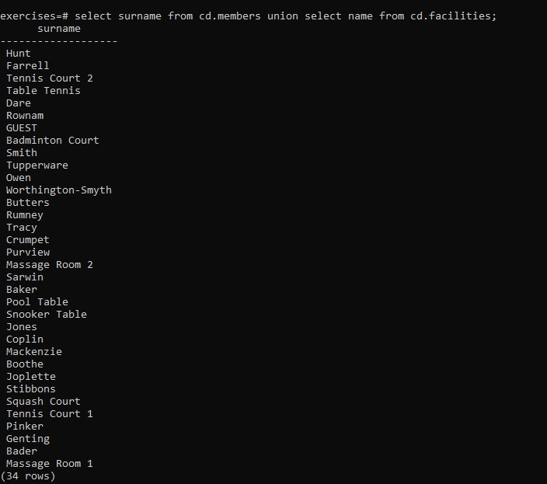

* [**Simple aggregation**](https://pgexercises.com/questions/basic/agg.html)

