**PostgreSQL Assignment**

**CLUBDATA**

Modifying data

Select*from cd.facilities;

1. [Insert some data into a table](https://pgexercises.com/questions/updates/insert.html)

**insert** **into** cd.facilities (facid, name, membercost, guestcost, initialoutlay, monthlymaintenance) **values** (9, 'Spa', 20, 30, 100000, 800);

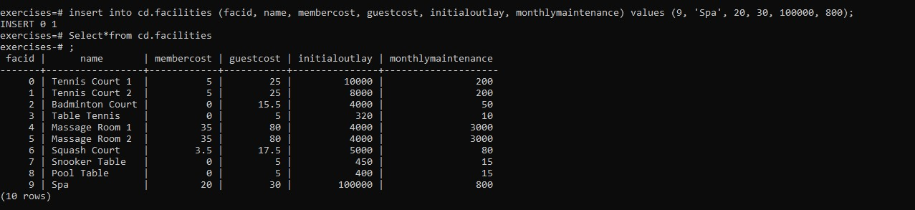

1. [Insert multiple rows of data into a table](https://pgexercises.com/questions/updates/insert2.html)

**insert** **into** cd.facilities (facid, name, membercost, guestcost, initialoutlay, monthlymaintenance) **values** (10, 'Squash Court 2', 3.5, 17.5, 5000, 80);

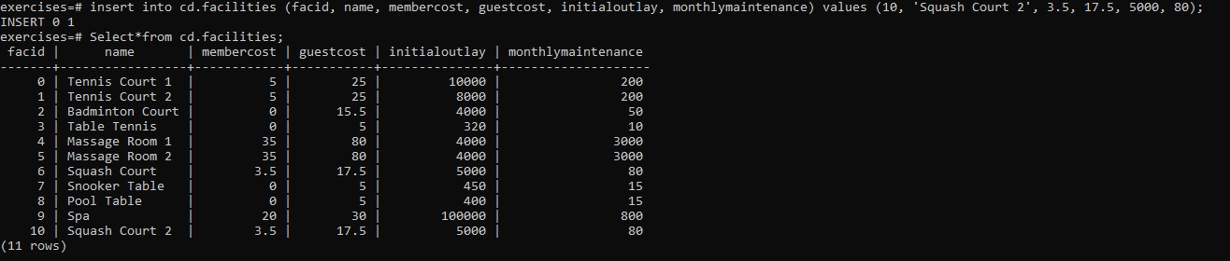

1. [Insert calculated data into a table](https://pgexercises.com/questions/updates/insert3.html)

**insert** **into** cd.facilities (facid, name, membercost, guestcost, initialoutlay, monthlymaintenance) **select** (**select** max(facid) **from** cd.facilities)+1, 'Spa', 20, 30, 100000, 800;

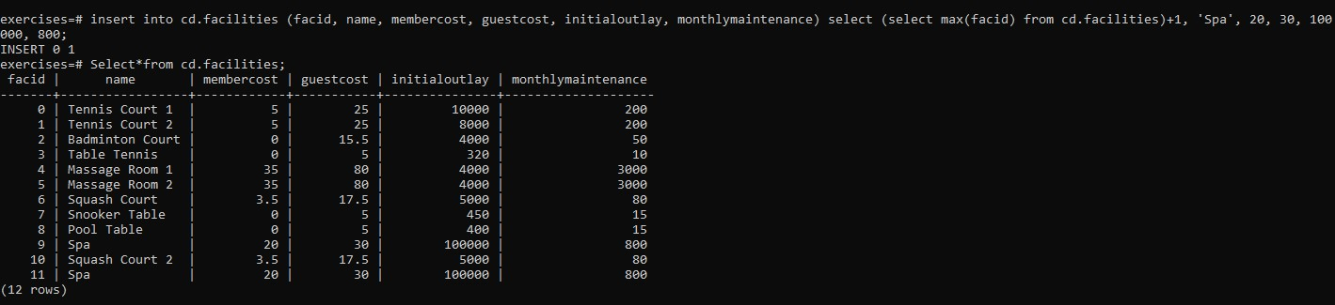

1. [Update some existing data](https://pgexercises.com/questions/updates/update.html)

**update** cd.facilities **set** initialoutlay = 10000 **where** facid = 1;

**update** cd.facilities **set** initialoutlay = 10000;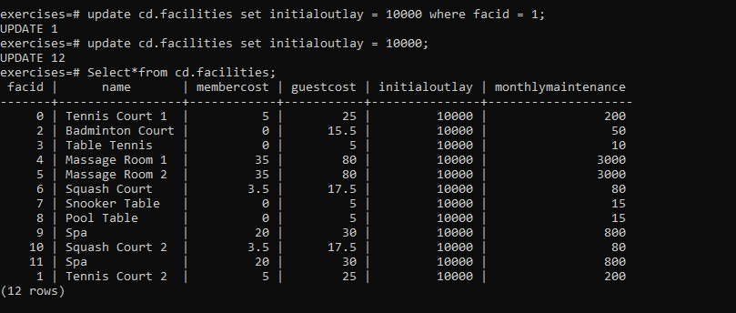

1. [Update multiple rows and columns at the same time](https://pgexercises.com/questions/updates/updatemultiple.html)

**update** cd.facilities **set** membercost = 6, guestcost = 30 **where** facid **in** (0,1);

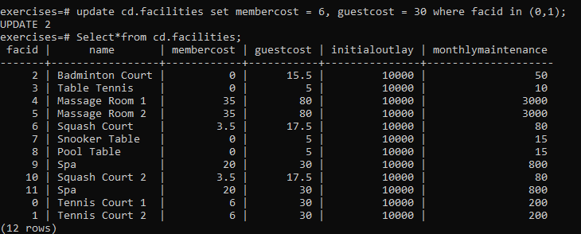

1. [Update a row based on the contents of another row](https://pgexercises.com/questions/updates/updatecalculated.html)
2. **update** cd.facilities facs **set** membercost = (**select** membercost * 1.1 **from** cd.facilities **where** facid = 0), guestcost = (**select** guestcost * 1.1 **from** cd.facilities **where** facid = 0) **where** facs.facid = 1;

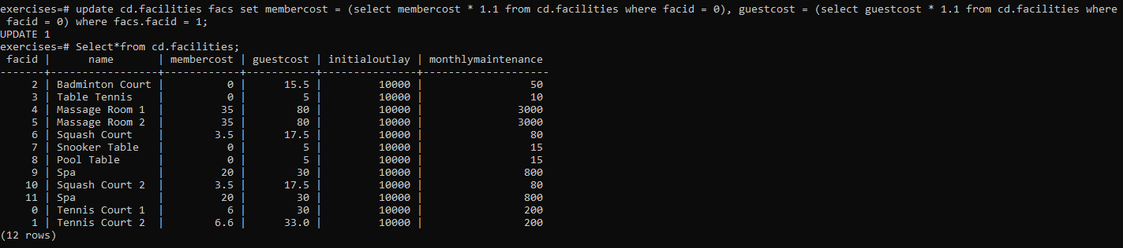

1. [Delete all bookings](https://pgexercises.com/questions/updates/delete.html)

**truncate** cd.bookings;

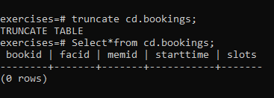

1. [Delete a member from the cd.members table](https://pgexercises.com/questions/updates/deletewh.html)

**delete** **from** cd.members **where** memid = 37;

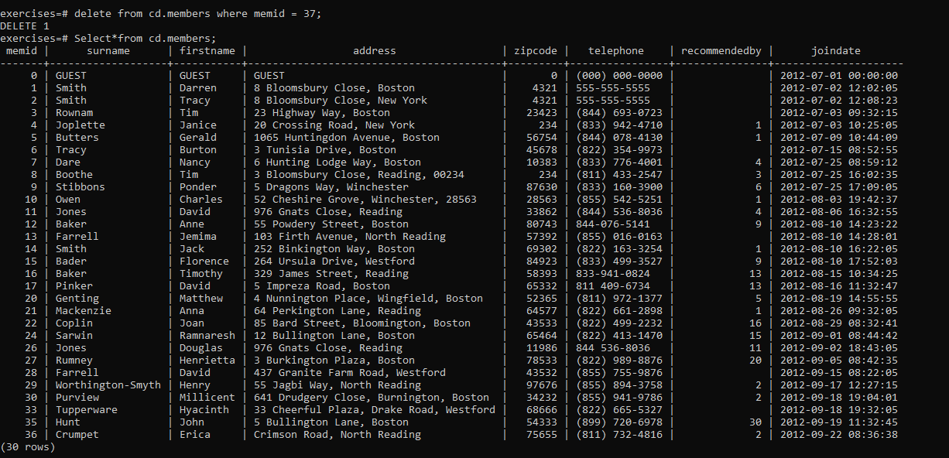

1. [Delete based on a subquery](https://pgexercises.com/questions/updates/deletewh2.html)

**delete** **from** cd.members **where** memid **not** **in** (**select** memid **from** cd.bookings);

