**PostgreSQL Assignment**

**CLUBDATA**

**Date Working with Timestamps**

**1.[Produce a timestamp for 1 a.m. on the 31st of August 2012](https://pgexercises.com/questions/date/timestamp.html)**

select timestamp '2012-08-31 01:00:00';

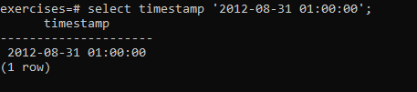

**2.[Subtract timestamps from each other](https://pgexercises.com/questions/date/interval.html)**

select timestamp '2012-08-31 01:00:00' - timestamp '2012-07-30 01:00:00' as interval;

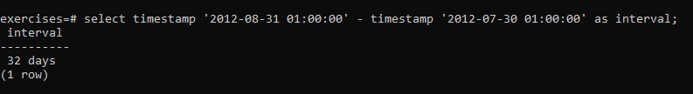

**3.[Generate a list of all the dates in October 2012](https://pgexercises.com/questions/date/series.html)**

select generate_series(timestamp '2012-10-01', timestamp '2012-10-31', interval '1 day') as ts;

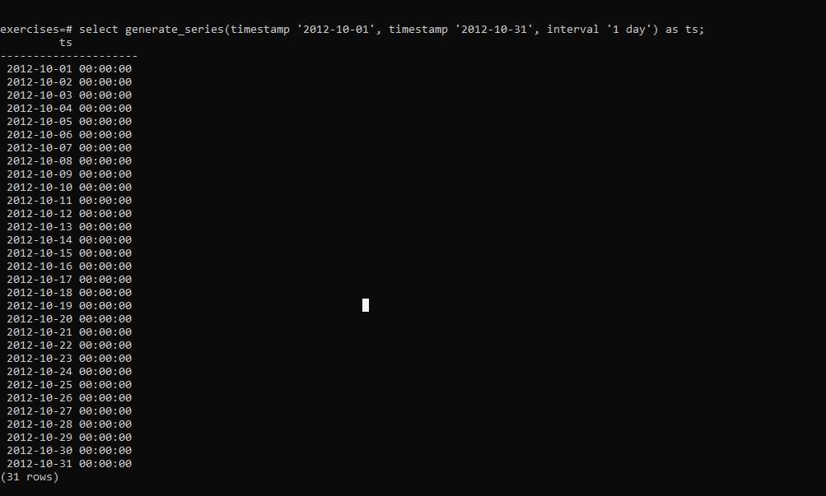

**4.[Get the day of the month from a timestamp](https://pgexercises.com/questions/date/extract.html)**

select extract(day from timestamp '2012-08-31');

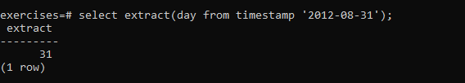

**5.[Work out the number of seconds between timestamps](https://pgexercises.com/questions/date/interval2.html)**

select extract(epoch from (timestamp '2012-09-02 00:00:00' - '2012-08-31 01:00:00'));

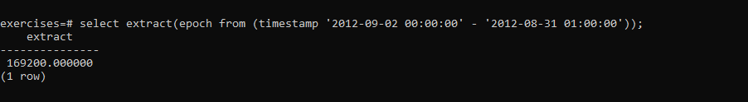

**6.[Work out the number of days in each month of 2012](https://pgexercises.com/questions/date/daysinmonth.html)**

select extract(month from cal.month) as month, (cal.month + interval '1 month') - cal.month as length from ( select generate_series(timestamp '2012-01-01', timestamp '2012-12-01', interval '1 month') as month ) cal order by month;

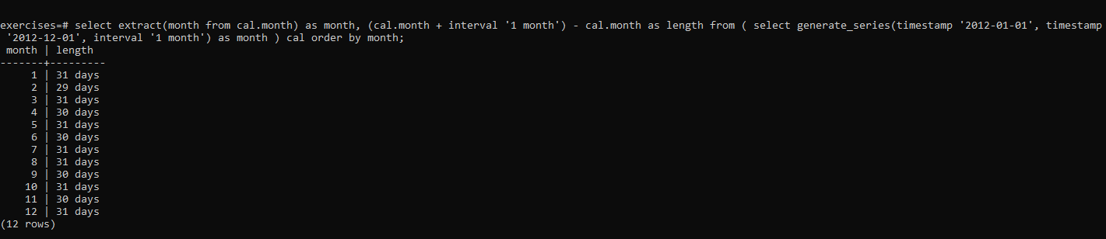

**7.[Work out the number of days remaining in the month](https://pgexercises.com/questions/date/daysremaining.html)**

select (date_trunc('month',ts.testts) + interval '1 month') - date_trunc('day', ts.testts) as remaining from (select timestamp '2012-02-11 01:00:00' as testts) ts;



**8.[Work out the end time of bookings](https://pgexercises.com/questions/date/endtimes.html)**

select starttime, starttime + slots*(interval '30 minutes') endtime from cd.bookings order by endtime desc, starttime desc limit 10;

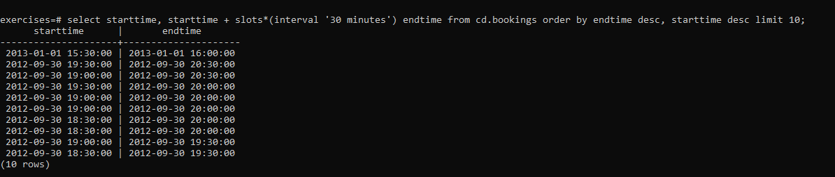

**9.[Return a count of bookings for each month](https://pgexercises.com/questions/date/bookingspermonth.html)**

select date_trunc('month', starttime) as month, count(*) from cd.bookings group by month order by month;

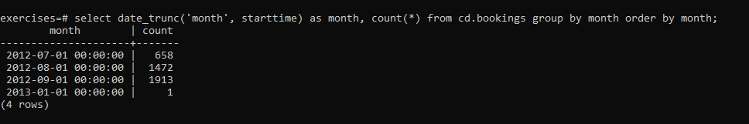

**10.**[**Work out the utilisation percentage for each facility by month**](https://pgexercises.com/questions/date/utilisationpermonth.html)

select name, month, round((100*slots)/ cast( 25*(cast((month + interval '1 month') as date) - cast (month as date)) as numeric),1) as utilisation from ( select facs.name as name, date_trunc('month', starttime) as month, sum(slots) as slots from cd.bookings bks inner join cd.facilities facs on bks.facid = facs.facid group by facs.facid, month ) as inn order by name, month;

