**Machine Learning**

* Subset of AI techniques which **uses statistical methods** to enable machines to improve **with past experiance**.
* Which **predicts the outcome based on the input variables**.

### Types of ML Algorithms

* Supervised Learning
* UnSupervised Learning
* Reinforcement Learning

**Supervised Learning**

* Supervised learning is the machine learning task of learning. **Learning under the supervision of teachers**.
* Supervised learning is where we have the dataset and we build model to **predict dependant variable from the independant variables**

### Types of Supervised Learning

a. Regression

i) Linear Regression

ii) Non Linear Regression

b. Classification

i) Linear Models

1. Logistic Regression

2. Support Vector Machine

ii) Non Linear Models

1. Desition Tree

2. Random Forest

3. Naive Bayes

4. KNN

#### 1. Classification Algorithms

* When the labels of the data are **categorical** or when we want our machine learning model to **predict categorical value** we use classification algorithms.

**Ex of Categorical Labels** :

* + dog, cat, 1, 2, 5, blue, happy, positive, apple etc.
  + Email Spam detection

- Speech Recognition

#### 2. Regression Algorithms

* When the labels of the data are **numerical** or when we want our machine learning model to **predict numerical value** we use regression algorithms.

**Ex of Numerical Labels** :

* + 1.3, 2.33, 17.3, 1.0 etc. All fractions are Numerical values,they are also called as 'Continuous values'.
  + Stock prices prediction
  + Rainfall prediction

**UnSupervised Learning**

* UnSupervised Learning is a machine learning technique, where you **do not need to supervise the model**. Instead, you need to allow the **model to work on its own** to discover information. It mainly deals with the **unlabelled data**.
* UnSupervised Learning is where we **have the dataset but the output is not labled**. The **model will find the correlation between the datapoints**.

Unsupervised Learning

a. Clustering

b. Association analysis

c. Dimensionality reduction

# Clustering:

Automatic grouping of similar objects into sets

Application : Customer Segmentation

**Reinforcement Learning**

* Learning data provides feedback so that the system adapts to dynamic conditions in order to achieve a certain goal in the end. The system evaluates its performance based on the feedback responses and reacts accordingly.
* Ex: self driving cars and the chess master

**Types of Reinforcement Learning:**

- Model Free

- Q Learning

- Hybrid

- Policy optimization

- Model Based

- Learn the model

- Given the model

# Regression Vs Classification

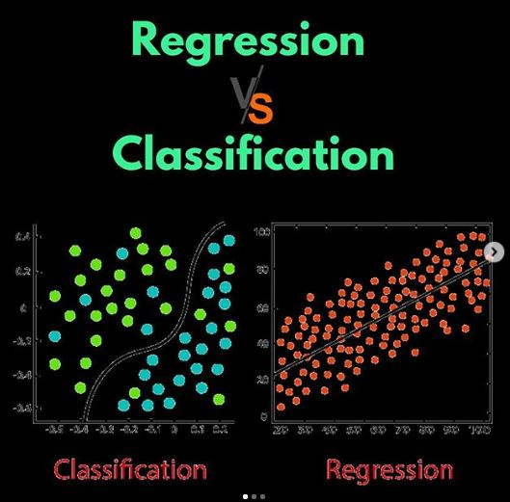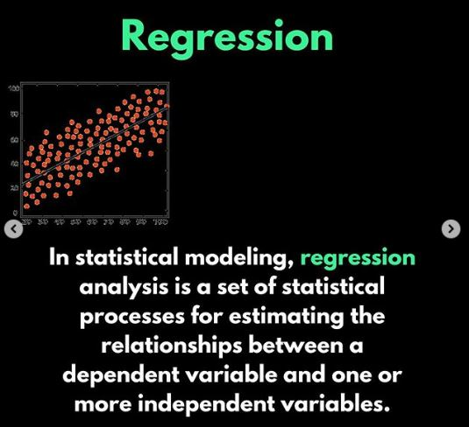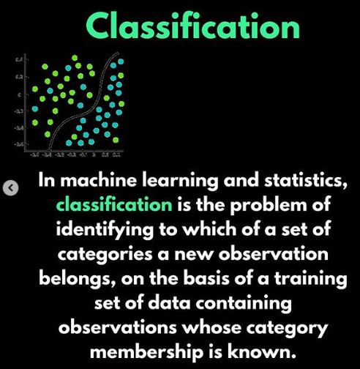

**Steps of ML**

* Problem Understanding
* Gathering data
* Data pre-processing
* Model Selection
* Training and testing the data
* Evaluation
* Parameter tuning
* Prediction