**Getting started with GITHUB workflow for the Training session**

1. Start a powershell session on your windows machine

Search > Powershell > and open the powershell app to get started.

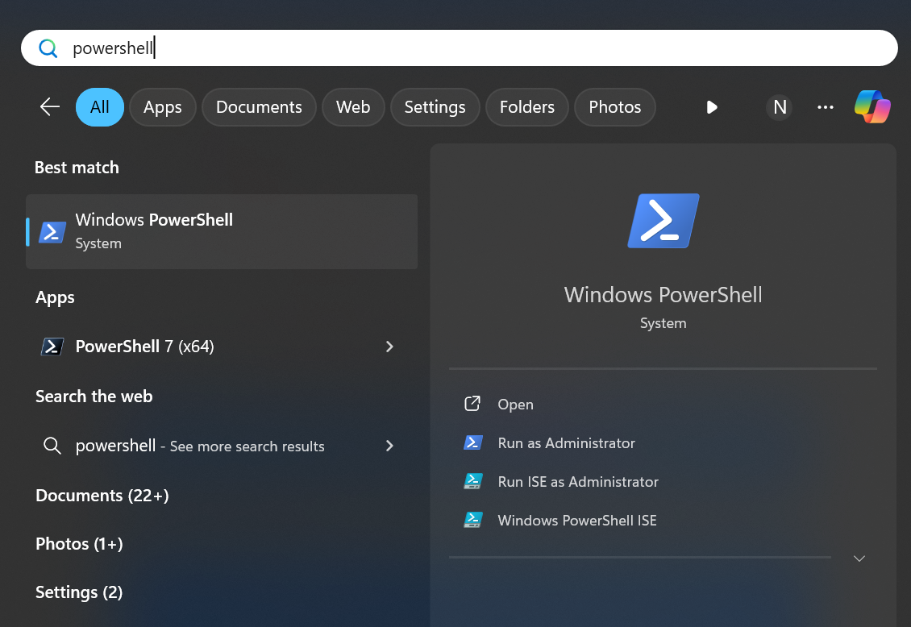



1. Once inside the powershell prompt execute the below command (replace with your name for log file name)
   1. Start-Transcript -Path <yourname>.txt
2. Create a working folder for your training “path/to/workingfolder” is some empty folder you need for keeping your project files
   1. New-Item -Path <path/to/workingfolder> -Name ‘QA-Training’ -ItemType Directory
   2. Set-Location <path/to/workingfolder>\QA-Training
3. Checking for prerequisite git command-line for windows and installing git if not already installed
   1. git --version (If you get the output move on to step 5 else do the below to install git client of your machine)
   2. Invoke-WebRequest -Uri https://github.com/git-for-windows/git/releases/download/v2.44.0.windows.1/Git-2.44.0-64-bit.exe -OutFile git-installer.exe
   3. .\git-installer.exe /VERYSILENT /NORESTART
   4. git –-version

git version 2.32.0.windows.2 (this is the output )

1. Cloning the playwright training repository to local machine
   1. git clone https://github.com/sureshnanjan/cognixia042025.git
   2. Set-Location cognixia042025
   3. git status

On branch master

Your branch is up to date with 'origin/master.

1. Creating your own feature branch and adding initial changes to the project ( replace <yourname> accordingly)
2. git checkout -b <yourname>-branch
3. git status

On branch suresh-branch

nothing to commit, working tree clean

1. Adding your initial project files to your branch and committing changes
   * 1. Stop-Transcript
     2. Get-ChildItem -Name *.log

suresh.log (reference output you should see a log in your name)

* + 1. Move-Item ..\<yourname>.log .

* + 1. git add .
    2. git commit -m “Adding first file to branch”
    3. git status

On branch <yourname>-branch

nothing to commit, working tree clean

1. Nice work , now you have done all that is needed for working with git feature branch workflow. All that remains is that now you be able to push you local code to the remote branch on GitHub for which I need to make you a collaborator to this repository , please consolidate the list with all participants **github username / email** and send me so that I can add it in the code repository.

Happy Learning All , Meet you in the Session