<https://petstore.octoperf.com/actions/Catalog.action>

Referring to the functional flows in the above application prepare the

1) Flow Diagram:- Understanding the basics of anything. How system works at high or detail level

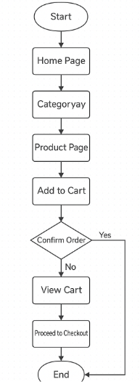

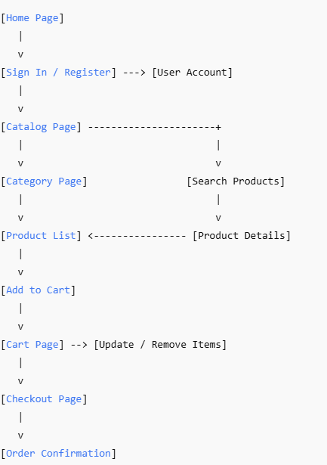

2) Transition Diagram:- Good when there is an object which changes states

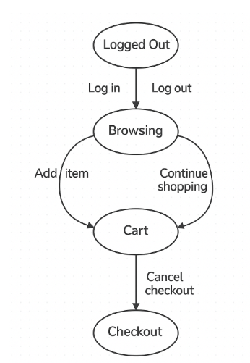

3) Contextual Diagram:- To connect various system to understand a larger picture like you have taken example how a software interacts with time sheets, employee system

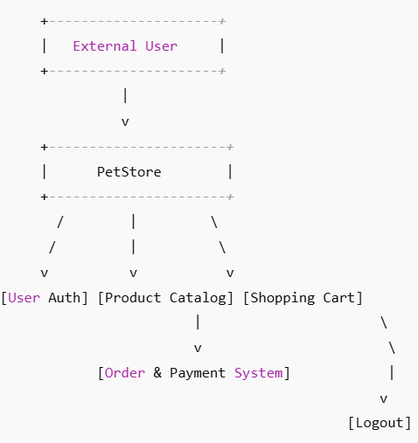

4) Mind Map:- Create a central topic and you can generate various ideas around it.

