1. PS-HOME-Logo

This test cases verifies the position of logo on home page

Inputs: Defaut – Top Left

Output Spec: Top Left

Environment: Windows 11, Chrome Browser

Special Procedures: None

Inter-case Dependency:

Properties:

|  |  |  |
| --- | --- | --- |
| **Step#** | **Step Details** | **Expected Results** |
| 1 | Navigate to the  https://petstore.octoperf.com/actions/Catalog.action - PET Store | Site should open |
| 2 | Check the PS-home-logo | Logo should be displayed in the left side of the page |

1. PS Sign in/create account

This testcase will verify that if a user is already having an account then is he able to sign in or not.

If the user is a new user, then is he/she able to create a account or not.

Inputs:

For signin we should provide username and password which might be alphanumeric.

For creating account, user should be able to provide personal details.

The signin text should be able to be identified by the user

Outputs:

The user should be able to get into the page if the credentials are correct and if it is incorrect it should show error message

The user should be able to create an account

Environment: Windows 11, Chrome Browser

Special Procedures: None

Inter-case Dependency:

Properties:

|  |  |  |
| --- | --- | --- |
| **Step#** | **Step Details** | **Expected Results** |
| 1 | Check and click on the signin text in the center | It should redirect for signin |
| 2 | Enter valid credentials for signin.  If new user then give all the details. | It should be able to take the credentials and able to take all the details |
| 3 | Click the signin button. | It should be able to signin |

1. Add pet to the cart

The testcase will verify whether the user is able to add the pets in the cart or not

Input**:** Verify that a logged-in user can add a pet to the shopping cart.

Output**:** User must be logged in and must be able to see the details he added in the cart.

Environment: Windows 11, Chrome Browser

Special Procedures: None

Inter-case Dependency:

Properties:

|  |  |  |
| --- | --- | --- |
| **Step#** | **Step Details** | **Expected Results** |
| 1 | Add the pet in the cart after logging in | The details of the pet must be show in the cart |
| 2 | The pet is added to the cart | The cart must be updated and the icon should be updated |

1. Checkout Process

This testcase verify the checkout process after adding the pet in the cart.

A pet must be in the cart to do the checkout process.

Input**:** Verify that a user can successfully check out with a pet in the cart.

Output:

If the user added the pet in the cart then it need to be do the checkout process. And after doing checkout order confirmation details, and the user receives a confirmation email.

If the cart is empty, it needs to show something as cart is empty and it should not go to the checkout process

Environment: Windows 11, Chrome Browser

Special Procedures: None

Inter-case Dependency:

Properties:

|  |  |  |
| --- | --- | --- |
| **Step#** | **Step Details** | **Expected Results** |
| 1 | Go to the cart and click on the checkout process | It should ask for all the details to complete the checkout process |
| 2 | Completing the order in the checkout process | User should get the order confirmation and able to see the order details |

Flow chart for the above Case study

Context diagram for the above testcase:

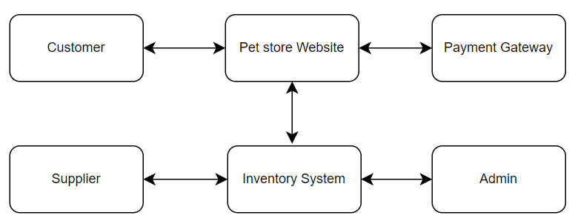

State Transition Diagram:

