**1.Which actors have the first name ‘Scarlett’**

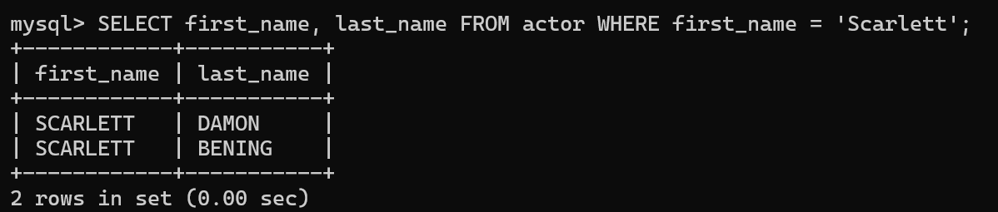

**2. Which actors have the last name ‘Johansson’**

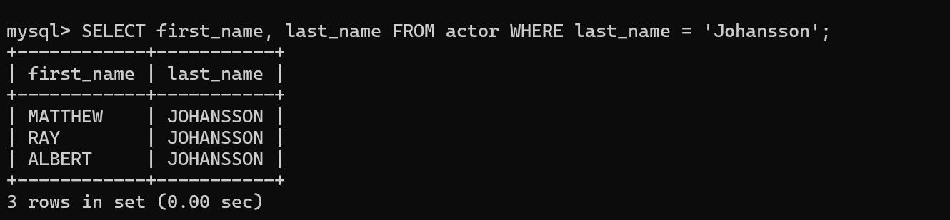

**3. How many distinct actors last names are there?**

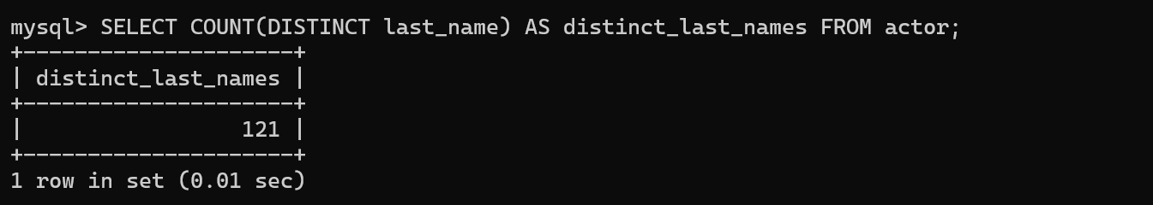

**4. Which last names are not repeated?**



**5. Which last names appear more than once?**



6. **Which actor has appeared in the most films?**

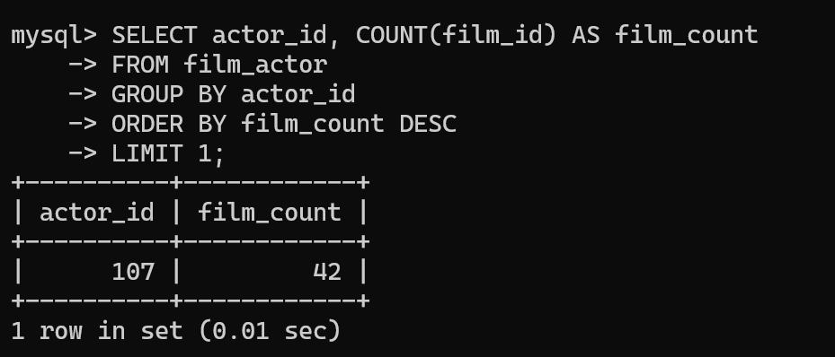

**7. Is ‘Academy Dinosaur’ available for rent from Store 1?**

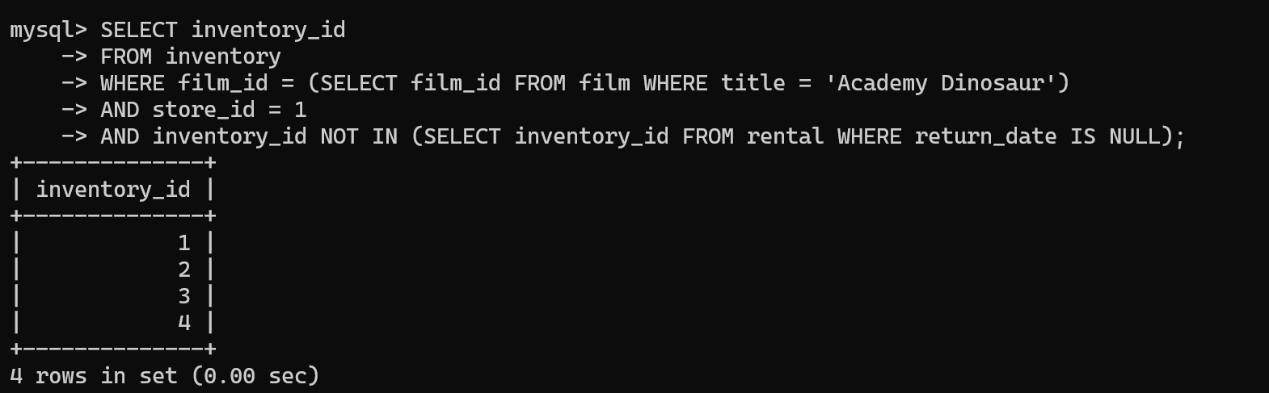

**8.Insert a record to represent Mary Smith renting ‘Academy Dinosaur’ from Mike Hillyer at Store 1 today**

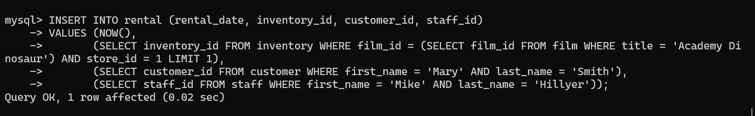

**9. When is ‘Academy Dinosaur’ due?**

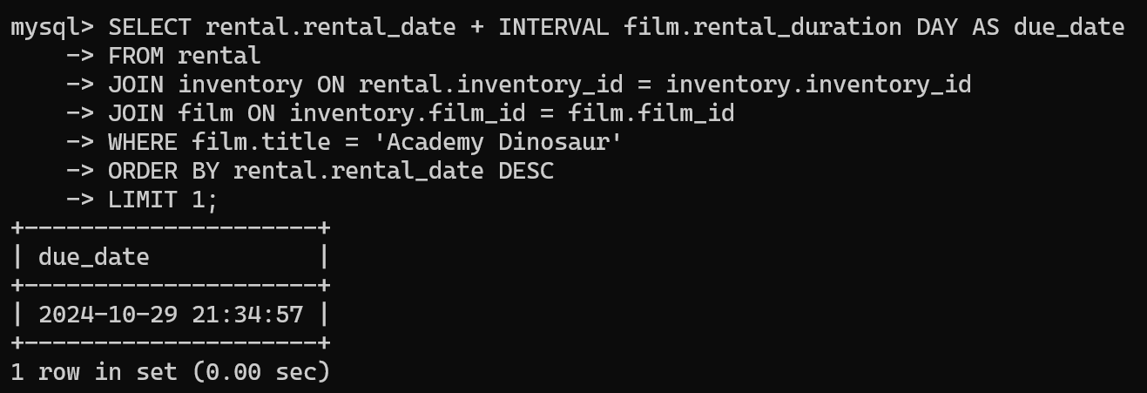10. **What is the average running time of all the films in the sakila DB?**

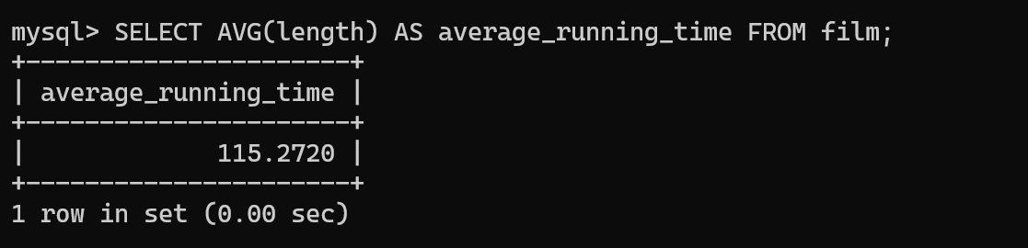

11. **What is the average running time of films by categor**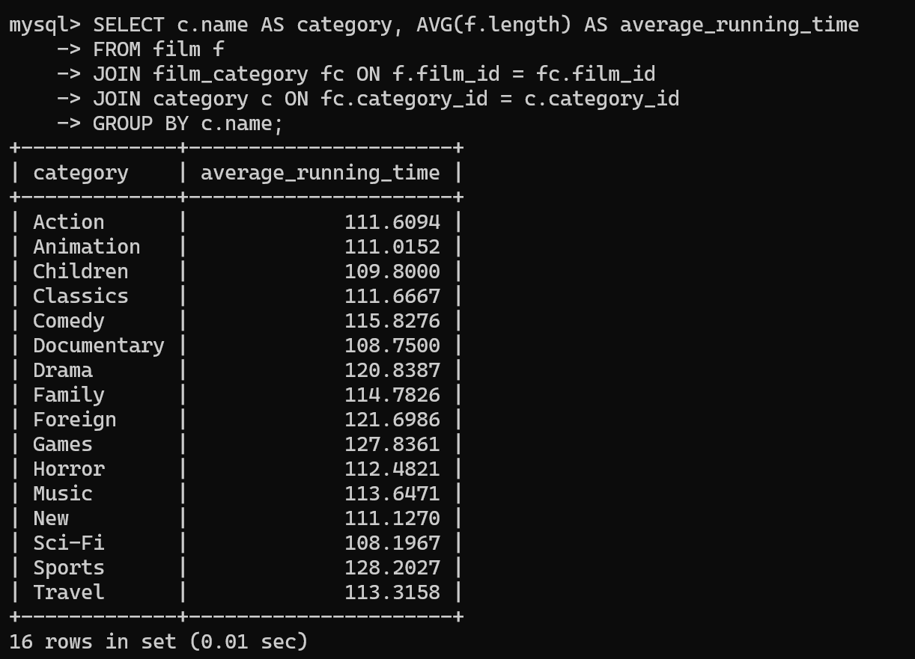

**12. Why does this query return the empty set?**

You haven't provided the specific query that's returning the empty set. The answer would depend on factors such as missing records, incorrectly written joins, or incorrect filters/conditions in the query.

If you have a particular query returning an empty result, feel free to share it, and I can help troubleshoot!